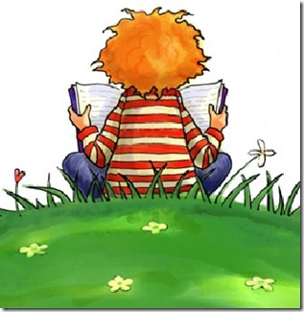
Choose two of the following books for your summer reading.
This Photo by Unknown Author is licensed under CC BY-SA

The One and Only Ivan by Katherine Applegate
Cinder by Marissa Meyer
Enders Game by Orson Scott Card
Where the Red Fern Grows by Wilson Rawls
When You Reach Me by Rebecca Stead
Sunny Side Up by Jennifer L. Holm and Mathew Holm

2023

RISING SIXTH
GRADE SUMMER READING

Complete an activity from the list below from ONE book.

(1) Write a letter to your best friend explaining why they should read this book.
Use evidence from the text.
(2) Give a detailed character analysis of your favorite character: List 3 Traits your
character exhibits using evidence from the text.
(3) Write a Gist Statement for each chapter-One to two sentence summary per chapter.



