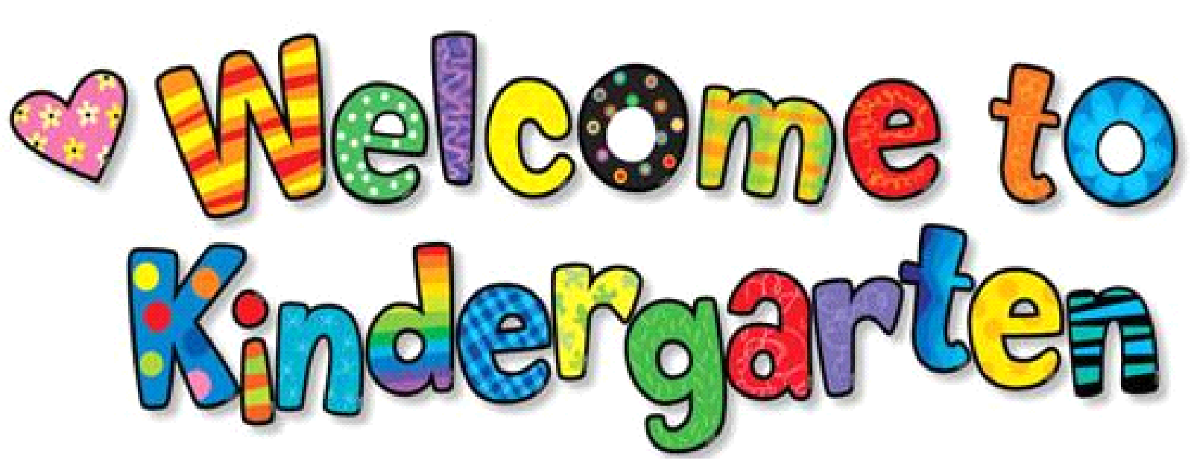
Suggested Supply List
2025 / 2026

1 pack of 24 Crayola Twistable Crayons in classic colors

1 pack of 24 Crayola standard/regular crayons

1 pack of 8 Washable Crayola Markers in classic colors

6 large Jumbo Glue Sticks

4 Black Dry Erase Marker (Thin size)

4 Pack playdoh

1 Pack of 8 1/2 by 11 Copy Paper

2 Boxes of Kleenex (Boys)

2 Rolls of paper towels (Girls)

1 extra change of clothes (Labeled) to keep in backpack/classroom

1 Pair of Headphones (NOT wireless)

