New Student Online Enrollment
Information for Parents

1. Click on the following link:
https://skyward.redoakisd.org/scripts/wsisa.dll/WService=wsSky/skyenroll.w
2. Please enter Account Information. If you do not have email, go to 3a

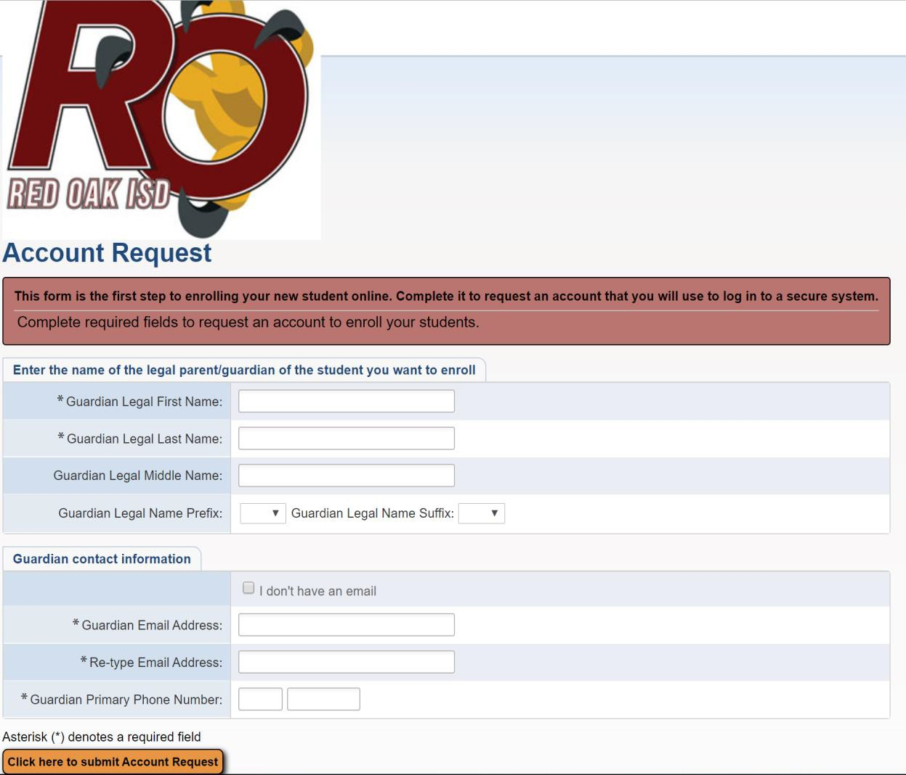
Enter name, email address and Primary Phone number. ‘Right click’ on the screen and select, ‘Translate to …’ to translate screen.
After account information is entered, you will see the following box. Click OK to continue.
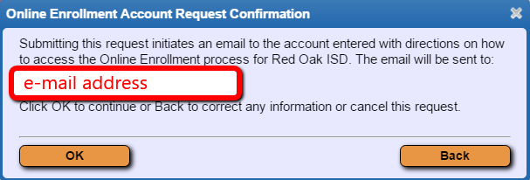

Please click OK and access your email for instructions.
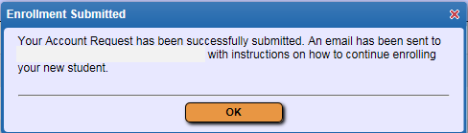

You will receive an email with the link to click in order to access the New Student Online Enrollment Portal and account information to enroll your child.

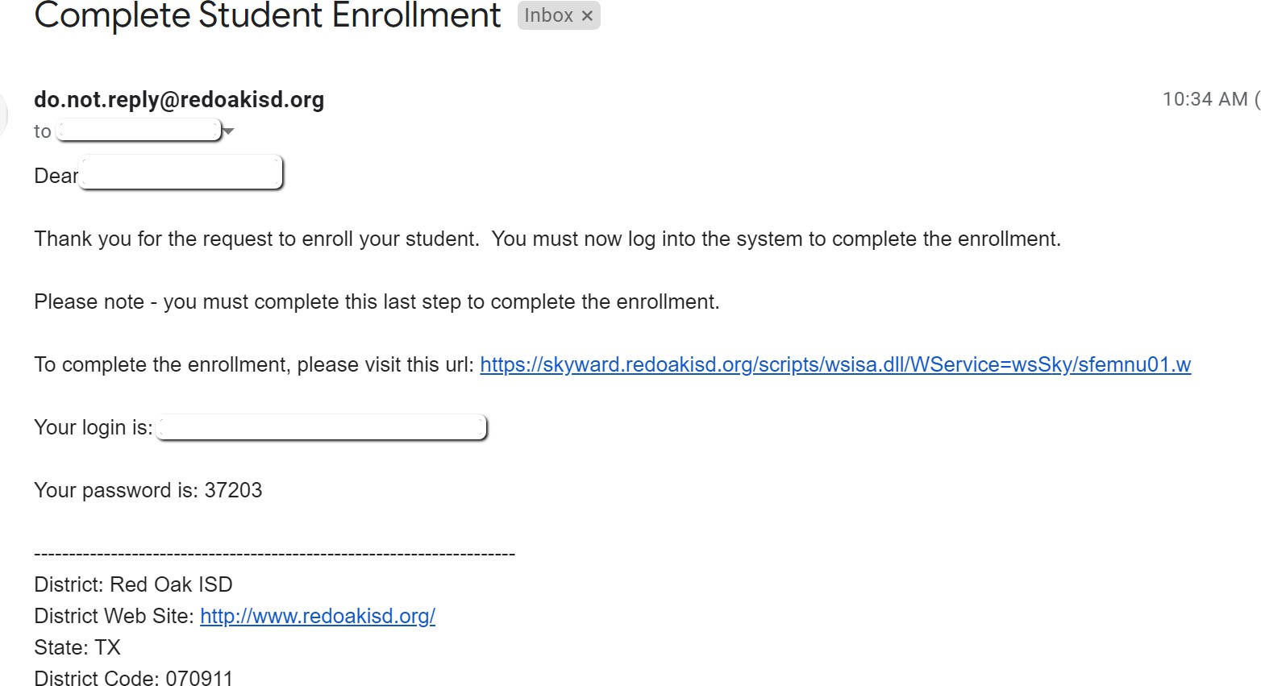
3. Enter portal login and password from the email
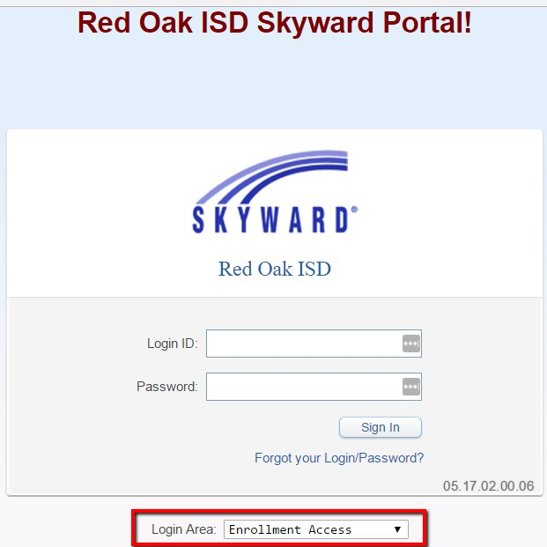

3a. If you do not have an email address, check the box “I don’t have an email” and create a username – Parent/Guardian first and last name (example: Red Oak Hawk) and enter your Primary Phone Number.

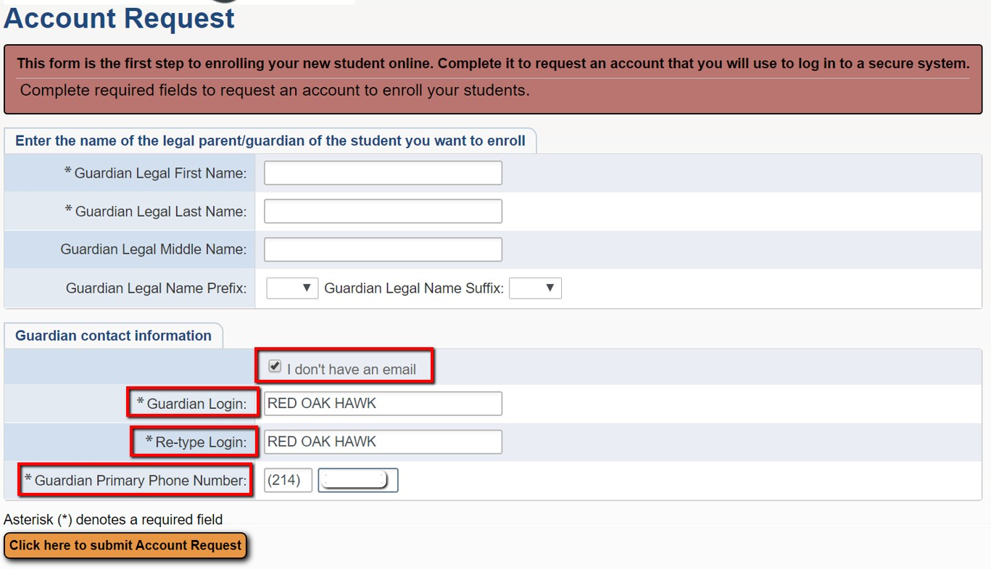

A new box will appear. Click, ‘OK.’

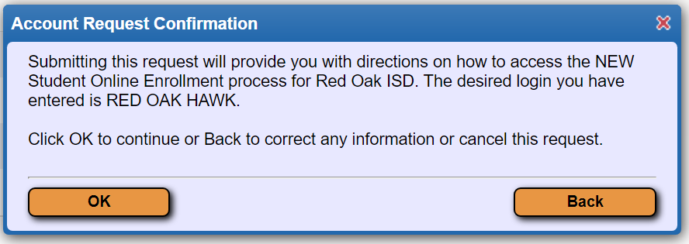

The box below with the link to start Application, login and password will appear:

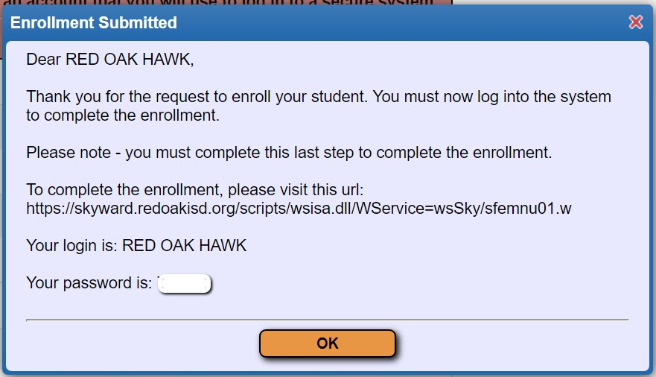

Write down the login and password then click OK. You will be taken directly to the New Student Enrollment Application Form

4. Enters child’s information
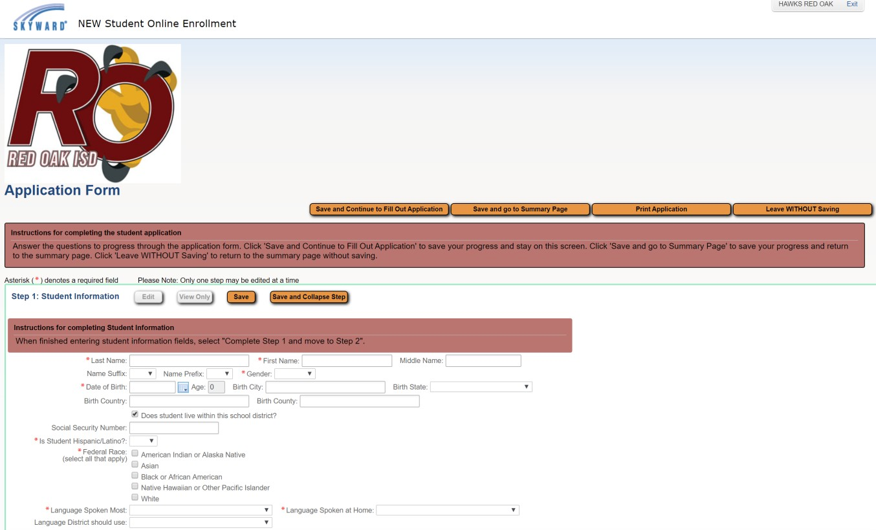
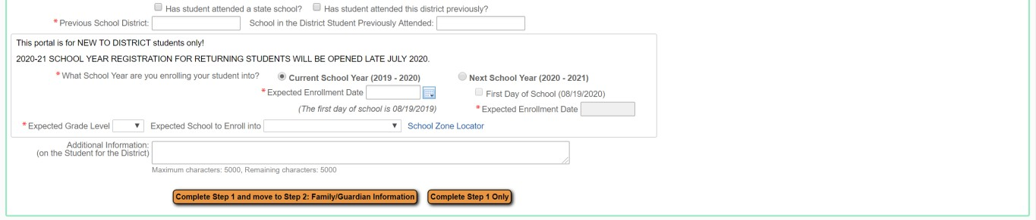

Select to enroll child in Current School Year or Next School Year.

Step 5. Family/Guardian Information  Parent must complete all red * Primary Phone  Family Home Language Home Address  Parent Name Relationship to Child | 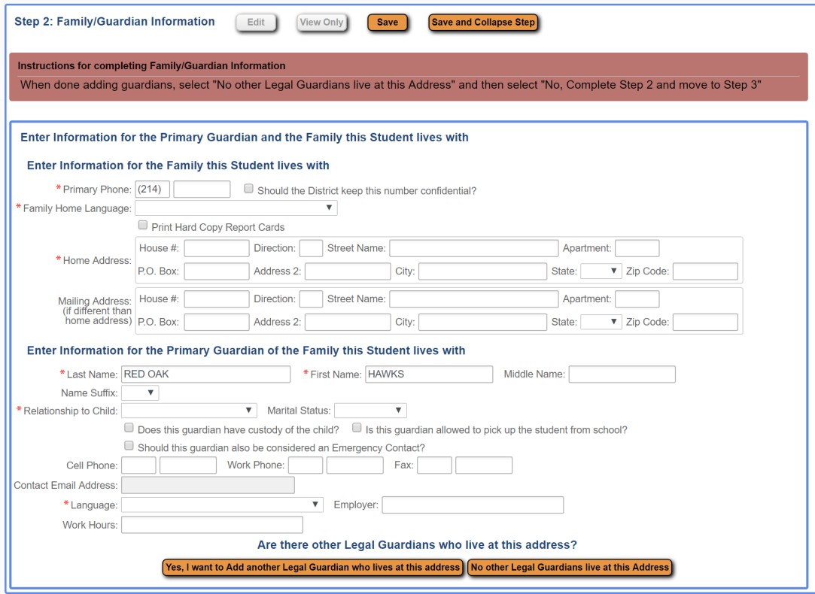
Step 6. Emergency Contact Information
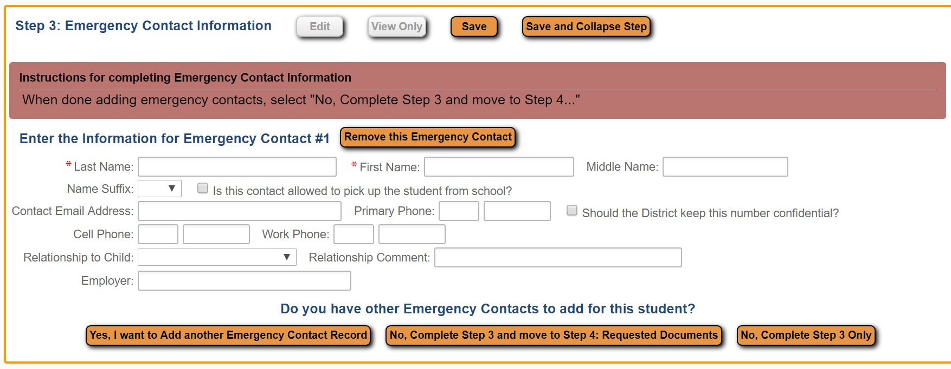

Step 7. Requested Documents
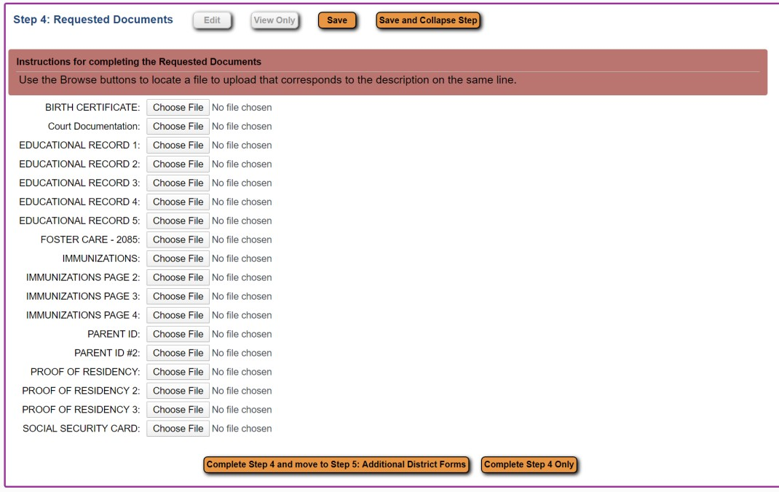
If you do not have access to scan documents, skip this step and bring documents to school office. Parent must click “Complete Step 4 and move to Step 5” or “Complete Step 4 Only”.
Step 8. Additional District Forms – these are required to submit application.
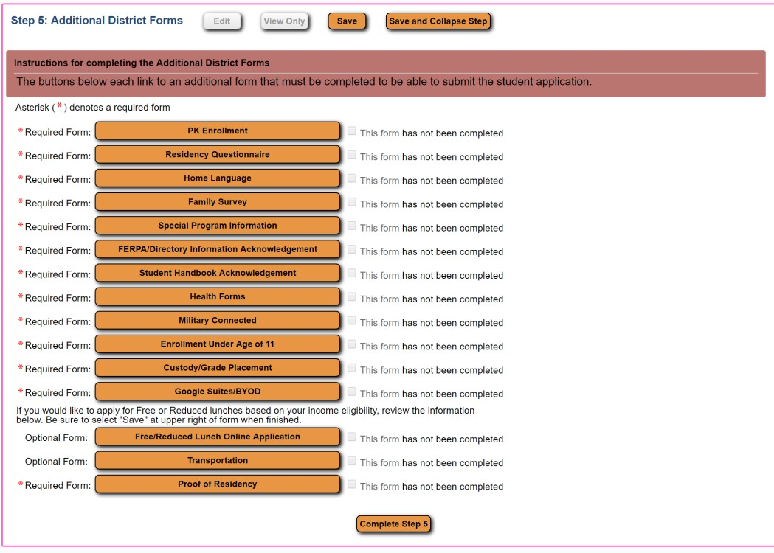

Complete the required forms above and Click Save to continue to next required form.

Step 9. Submit Application to District – All Steps must be completed before an application can be submitted
*****If you do not see the Submit Application button, verify all steps have been completed. (Green checks to right of Steps 1-5)****
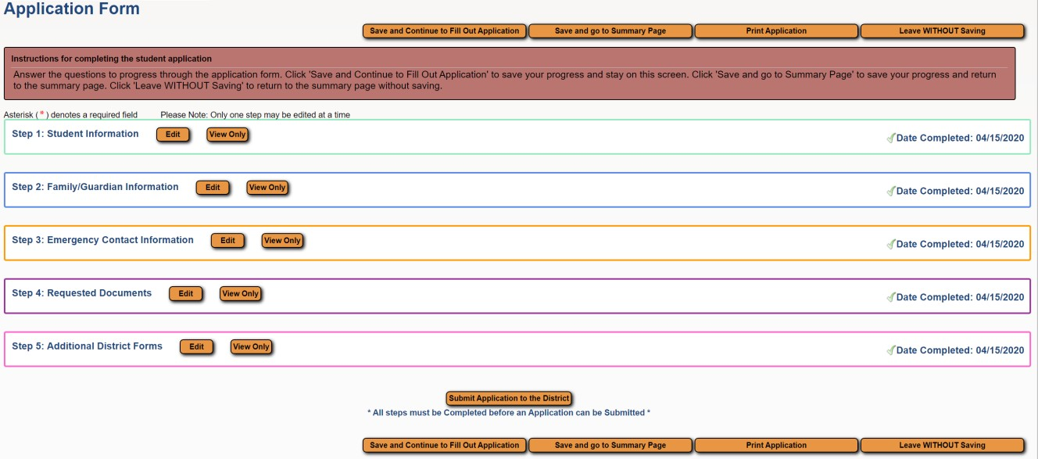

Once everything has been completed, click submit Application to District button

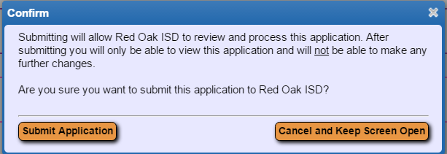

Confirm application and click Submit Application

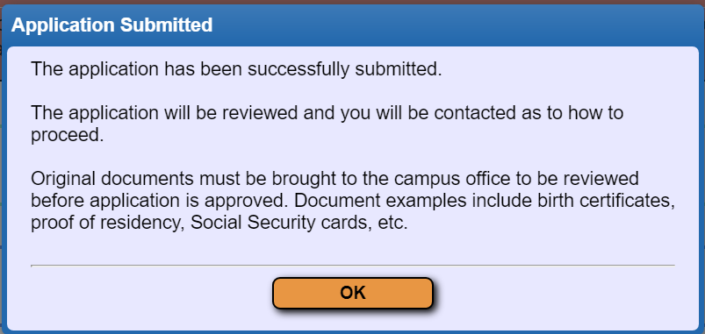

Once an application has been submitted, you will be able to view the application, but will not be able to edit.

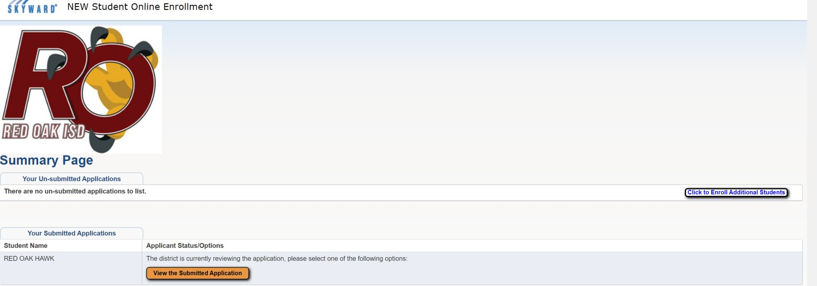

Step 10 Parent can select “Click to Enroll Additional Students” to start an application for more students. Repeated information will be pre-populated for each additional student.

