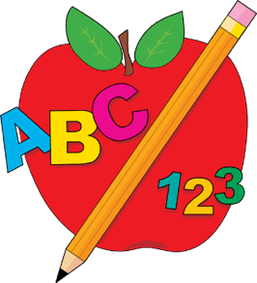18-36 Month Class Supply List

- 1 four-fold rest mat size 48” x 24” x 2”- Kindermat or other brands ok as long as the mat is 4-fold and the correct size, no exceptions
- 1 standard size crib sheet to cover rest mat- Please label with child’s name
- 1 light blanket- Please label with child’s name
- 1 spill proof refillable water bottle (No Owala bottles) - Please label with child’s name
- 1 spill proof milk cup for lunch (if needed)- Please label with child’s name
- 1 sleeve/pack of diapers or pullups- If using pulls ups they must have Velcro sides for potty training
- 1 Clorox Disinfectant wipes pop up canister
- 2 large boxes of tissue
- 1 standard size backpack- Must be large enough for folder, jacket, lunchbox, sheet and blanket, etc. Please label with child’s name
- 12 pack box of baby wipes
- 2 pack roll of paper towels
- 1 pkg Elmer’s Purple Glue Sticks (6 count)
- 1 pkg Crayola Crayons JUMBO (8 count)
- 1 pkg Crayola Crayons Large (8 count)
- 1 pkg Crayola washable markers broad tip (10 count classic colors)
- 2 Crayola Watercolor Paints with brush (8 count)
- 1 box of snack size zip lock bags
- Please send 2 seasonally appropriate complete changes of clothing including: shirt, pants, socks, underwear, and shoes (Does not have to be DCA uniform shirt). Please place all clothing in a large zip-lock bag labeled with your child’s name. ---
- Empty plastic grocery bags would be greatly appreciated
- The children may bring a small stuffed animal to have at rest time, if needed

