Preschool (Age 3+) Class Supply List 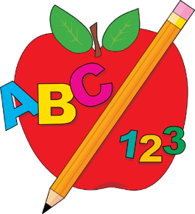

- 1 four-fold rest mat size 48” x 24” x 2”- Kindermat or other brands ok as long as the mat is 4-fold and the correct size, no exceptions
- 1 standard size crib sheet to cover rest mat- Please label with child’s name
- 1 light blanket- Please label with child’s name
- 1 spill proof refillable water bottle- Please label with child’s name
- 1 Clorox Disinfectant wipes pop up canister
- 2 large boxes of tissue
- 1 standard size backpack- Must be large enough for folder, jacket, lunchbox, sheet and blanket, etc. Please label with child’s name
- 3 packs of baby wipes
- 2 rolls of paper towels
- 1 pkg Elmer’s Purple Glue Sticks (12 count)
- 2 pkg Crayola Crayons (16 count)
- 1 pkg Crayola Color Pencils (36 count)
- 2 washable school glue (8 oz bottles)
- 1 pkg Crayola washable markers broad tip (10 count classic colors)
- 2 Crayola Watercolor Paints with brush (8 count)
- 1 pkg white cardstock (Girls) 1 pkg assorted colors cardstock (no neon) (Boys)
- Zip lock bags – (1 of each size) snack, sandwich, and gallon
- Please send a seasonally appropriate complete change of clothing including shirt, pants, socks, underwear, and shoes (Does not have to be DCA uniform shirt). Please place all clothing in a large zip-lock bag labeled with your child’s name.
- The children may bring a small stuffed animal to have at rest time, if needed

