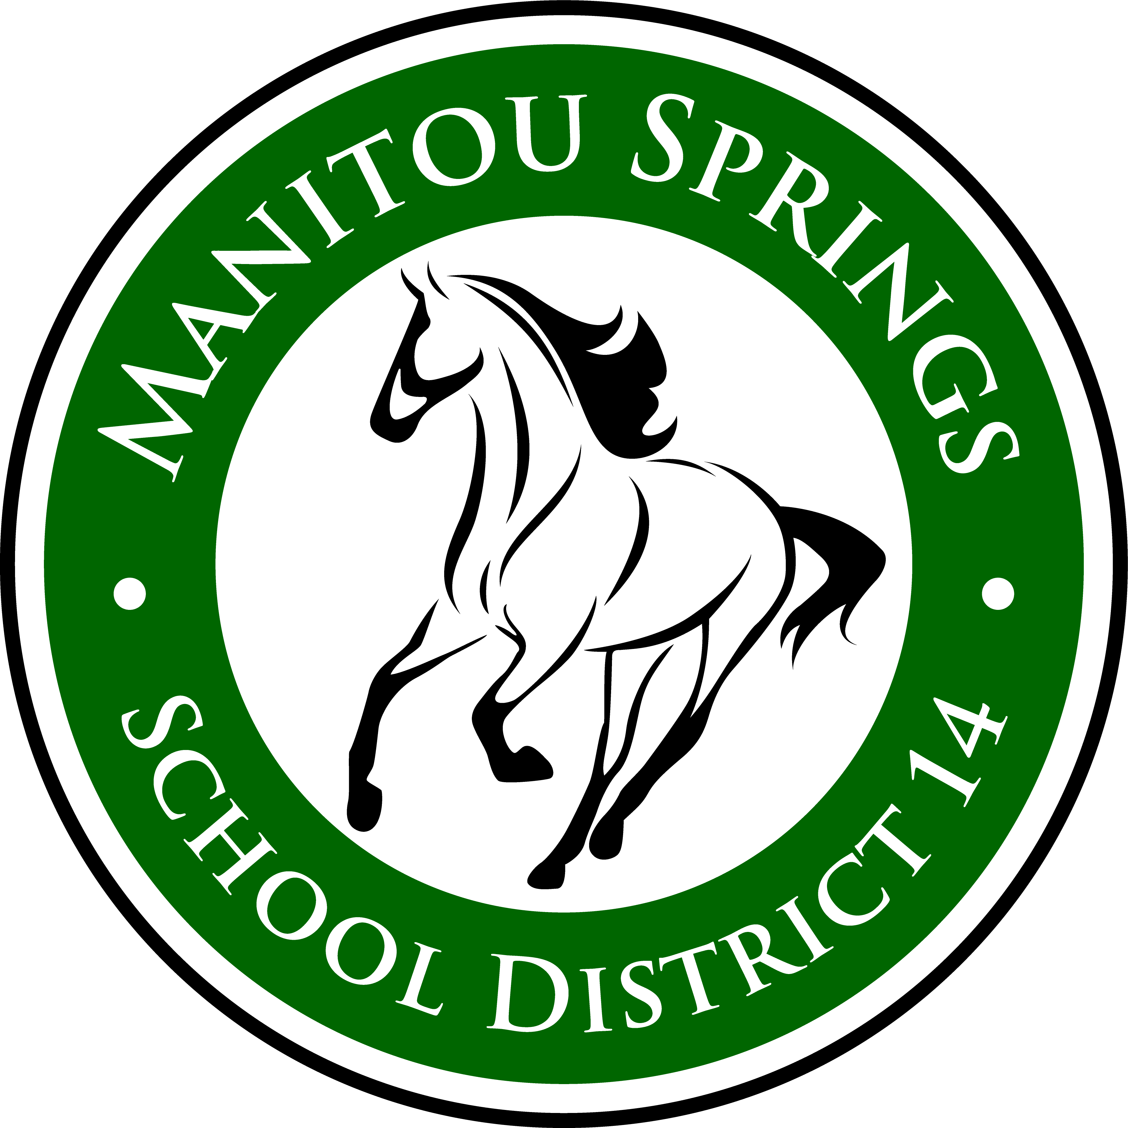
Manitou Springs
School District 14

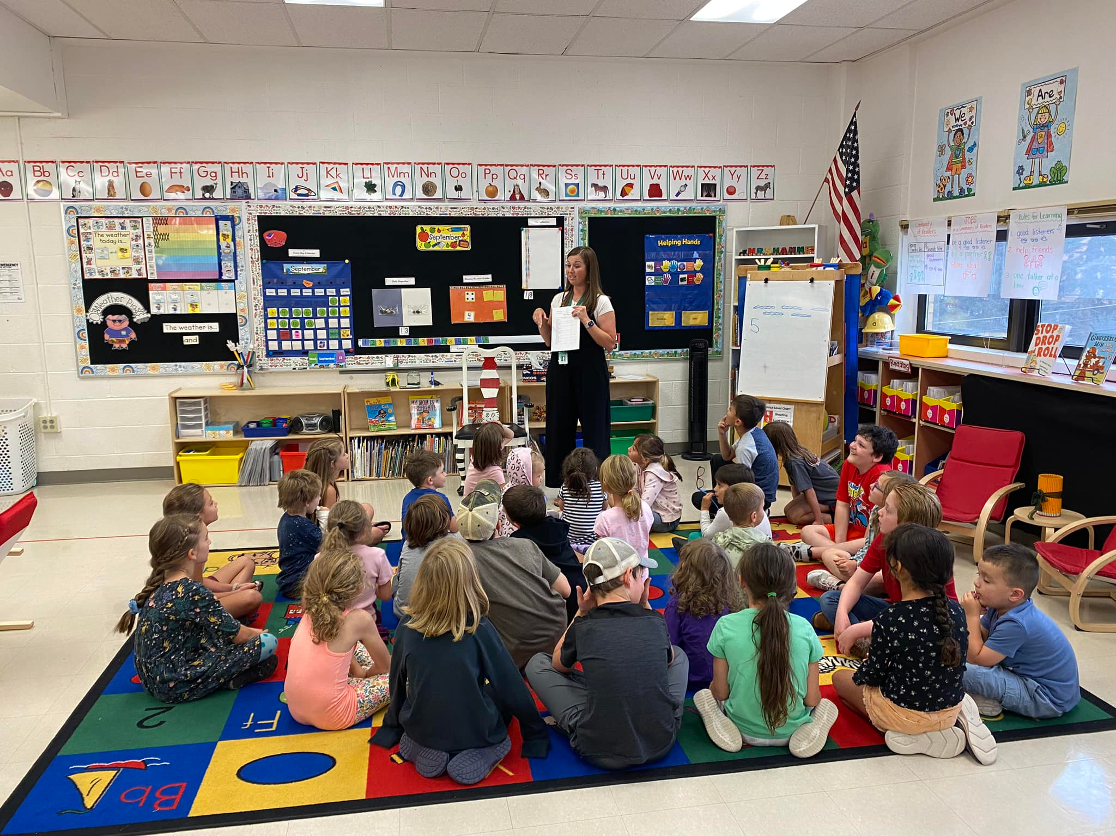

Adopted Budget
2024-2025

Introduction

Manitou Springs is located close to the center of the State of Colorado nestled into the foothills of the Rocky Mountains, on the western end of El Paso County. Founded in 1871, Manitou Springs was established as a scenic town that provided health and wellness opportunities for those seeking cures and treatments for diseases like tuberculosis and other illnesses.

In 2022, Manitou Springs School District 14 celebrated its 150-year anniversary. The history of the school district is rich and has always been supported by the City of Manitou Springs.

The Manitou Springs School District 14 serves approximately 1,325 students from Preschool to 12th Grade who reside in the mountain communities of Manitou Springs, Cascade, Green Mountain Falls, Chipita Park, Crystal Park, and Cedar Heights. Nearly half of the students in the district are “choice” students, residing in other locations in El Paso and Teller Counties.

The district operates 4 schools, a shared integrated learning center for middle and high school students that also houses district administration, and a bus barn.

Organizational Overview

Manitou Springs School District is a local public school district that serves the communities of Manitou Springs, Cascade, Green Mountain Falls, Chipita Park, Crystal Park, and Cedar Heights in El Paso County, Colorado. The district operates within the guidelines and compliance of the Colorado Board of Education and the Colorado Department of Education.

The executive structure of the school district consists of a five-member Board of Education. The policy governance Board of Education sets Board policy and executive limitations, authorizes allocation of district resources, and is available for public comment and inquiry. School Board members are elected at-large to four-year terms.

Manitou Springs School District 14 Board of Education:

President: Tina Vidovich
Vice President: Natalie Johnson
Director: Jill Bishop
Director: Connie Brachtenbach
Director: Maggie Santos


The Board of Education appoints the superintendent. Sean Dorsey serves as the superintendent for Manitou Springs School District. The superintendent manages the daily operations of the school district.



The following organizational chart demonstrates the structure of the school district.

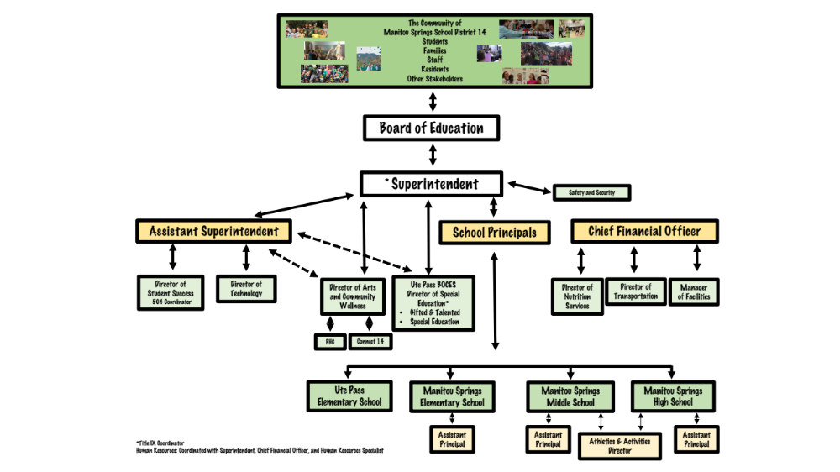

District Core Values, Vision, and Mission

Manitou Springs School District is driven by the core values of Relationships, Deep Learning, and Opportunity as we serve our children and our communities.

Relationships: We value authentic connections grounded in trust and respect between ALL people.
Deep Learning: Our community practices: dynamic, divergent, critical, and global thinking.
We challenge each learner to master, transfer, and apply the knowledge, skills, and abilities needed for success.
Opportunity: We provide accessible and engaging opportunities for purposeful growth and visionary learning.

Manitou Springs School District 14 Vision
Responsible citizens contributing with knowledge and integrity to a dynamic world.

Mission
Manitou Springs School District 14 is dedicated to:
- Providing a safe and caring learning environment
- Encouraging all students to reach their potential
- Preparing responsible citizens

Financials

General Fund

The General Fund is the primary fund used to cover the traditional costs of operating a school district. This fund is used to manage all resources that are not legally required to be managed in another fund.

Revenues

The primary funding source of the General Fund is prescribed through the Colorado School Finance Act. The School Finance Act is determined each year through legislations and details total program funding on a per-pupil based formula. The funding is broken into state and local tax funds. Each year, legislation approves the School Finance Act using inflation and anticipated student growth. Factors (some examples include cost of living, size, at-risk) are used to differentiate per-pupil amounts from district to district based on the needs and demographics of the various school districts across the state. Total Program is the per-pupil amount (after the reduction of the Budget Stabilization Factor) multiplied by the K-12 student count.

For 2024-2025 legislation passed a School Finance Act with inflation of 5.2% and eliminated the Budget Stabilization Factor. Manitou Springs School District’s per-pupil increased from $10,641.63 in 2023-2024 to $11,637.15 in 2024-2025. Unfortunately, along with many districts across the state, Manitou’s student count has continue to decrease each year since October, 2018. K-12 FTE was 1,207 in October, 2023, but the district benefited by the averaging rule for funded count, funding the district at 1,298.8 students. As higher years drop off in the average, our funding continues to decrease. The district is working diligently to bring enrollment numbers back to pre-COVID counts. The 2024-2025 adopted budget assumes an enrollment of 1,234 FTE, which is equivalent to 1,267 funded count. Overall, the revenue from the School Finance Act is budgeted at $14.2 million.

In addition to the School Finance Act, Manitou Springs School District receives a large portion of local property tax revenue due to the passage of Mill Levy Overrides (MLOs). The voters of the school district have generously passed MLOs to generate additional revenue for the district. Each year, the Board of Education certifies the mills, determining how much tax will be collected by the district. Based on the passage of the MLOs, MSSD14 has the opportunity to collect up to 25% of Total Program defined by the School Finance Act. The budgeted revenue from MLOs for 2024-2025 is $4.7 million.

Districts received many grant funds to offset the expenditures of lost learning that would occurred due to the COVID-19 pandemic. These grants supported the district for a number of years, but were spent down in the fall of 2023 and are no longer a revenue source for the district.

In spring of 2022, the district was awarded a Building Excellent Schools Today grant (BEST) from CDE. Manitou Springs School District received $1,115,366 and must match $2,868,086 to replace the roofs and add secure entryways at both Manitou Springs Elementary and Ute Pass Elementary. In order to fund the necessary 72% match, the Board of Education approved $4.0 million in Certificates of Participation (COPs).

Expenditures

Manitou Springs School District’s 2024-2025 adopted budget is over $23.7 million.

After feedback from the District Accountability Committee’s Salary & Compensation Sub-committee, the district moved the certified salary schedule back to a traditional salary schedule. The cost to move certified staff onto a new schedule was over $100,000. Staff wanted a salary schedule that ensures equity and transparency for all. Once on the schedule, all certified staff received a step and a cost of living increase of up to 6%. For those that had a salary higher than the appropriate step amount, the COLA was capped at 3%. Overall, certified staff increases ranged from 3% to 18.7%. the average certified increase was 6.54%. All classified staff, directors and building administrators received a 6% cost of living increase. The cost of the COLA for all staff was over $770K. In addition to the salary schedule and COLA, the district also implemented a longevity bonus to recognize staff that have worked for the district for more than 10 years. In the implementation year, all staff members that have worked for the district for 10 years or more will receive a $1,000 bonus. Beginning in 2025-2026, we will give the bonus to staff at 5 year increments beginning at year 10 (years 10, 15, 20, 25, etc.). While health insurance is offered to all Manitou employees, not every employee chooses to use our health benefit. For 2024-2025, the district’s premiums increased by 10.9%. The district pays the majority of the overall premium, but the 10.9% was added to both the employer and employee. United Healthcare also gave the district a $15K admin credit that will help offset the employer share. Overall, the employee compensation package for 2023-2024 is $1,364,424!

The compensation package is the primary increase of on-going expenditures for the 2024-2025 school year. There is a budgeted reduction of 7.5 FTE across the district. This and salary and benefit savings will be on-going and helps offset the increase in compensation for all employees.

2024-2025 will see a lot of changes to Manitou Springs School District. We will be finalizing capital projects associated with the BEST grant. A small portion of the work was completed in the 2022-2023 school year, but the majority was done and spent in 2023-2024. The contractors will be finalizing Manitou Elementary’s roof, mechanical unit and front office in the summer of 2024.

Reserves

Historically, Manitou Springs School District has maintained a healthy reserve balance in the General Fund. Per Colorado law, the district is required to have a minimum reserve balance of 3 percent under the Taxpayer Bill of Rights (TABOR). Any reserves above the 3 percent minimum are unassigned. The Board appropriates reserves, meaning that the district leadership has the opportunity to spend these reserves if needed during the school year. Due to the COPs received in April, 2022, the district is has carried a larger than normal reserve balance. With the BEST work being finalized in 2024-2025, the reserves will return to a normal level at the end of the fiscal year.

The 2024-2025 adopted budget includes more expenditures than revenue, therefore the reserves will need to be used to balance the budget. In order to balance the budget, the district is planning to spend roughly 2.9 million of the reserve balance. The primary reason for this is the work associated with the BEST grant. In order to match the funds from BEST, the district received a COP. This is currently sitting in our fund balance and will be spent down this fiscal year. If enrollment increases, not as much of the reserves will need to be used because additional revenue will come from the School Finance Act. Spending down the reserves by $2.9 million will still leave an end of year balance of $6.9 million, or roughly 29%. For a district of our size, a range of 15% to 20% is considered a healthy General Fund Reserve.

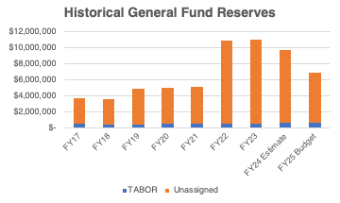
General Fund Revenue Sources

The total General Fund revenue budget for 2024-2025 is $20.9 million. The district receives General Fund revenue from a variety of sources including locally, at the state and federal levels. Local sources are obtained from property taxes and specific ownership taxes. There is property tax authorized from the state through the School Finance Act and from mill levy overrides. The main forms of revenue each year are property taxes, state equalization and specific ownership taxes.

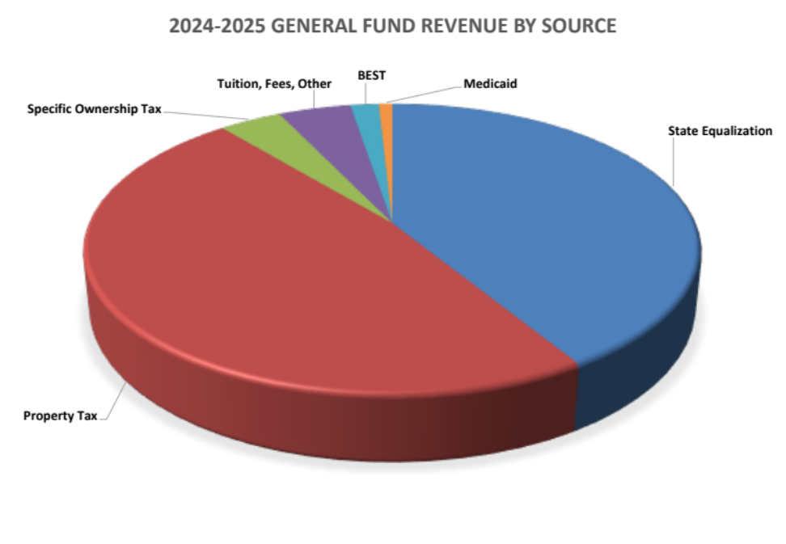

Property Tax

Per the School Finance Act, Colorado school districts are required to levy a property tax to fund the local share of total program. This mill is known as the Operating Levy and currently varies by school district. The current Operating Levy for Manitou is 24.816, but will begin to increase by 1 mill every year until we get to the new required 27 mills. In addition to the Operating Levy, districts can choose to go to tax payers for Mill Levy Overrides. The community of Manitou Springs School District has been very generous and has passed a number of mills. The school district is currently capped at the maximum of 25% of total program, per the School Finance Act. Each December, the School Board certifies the mills. In December, 2022, the Board certified 26.358 mills for the MLO.

The county assessor’s office determines the assessed valuation of all residential and commercial properties located within the district’s boundaries. The assessed valuation is a percentage of the actual market value (currently 29% for commercial and 6.95% for residential). Property taxes are calculated by multiplying the assessed value by the total mills.

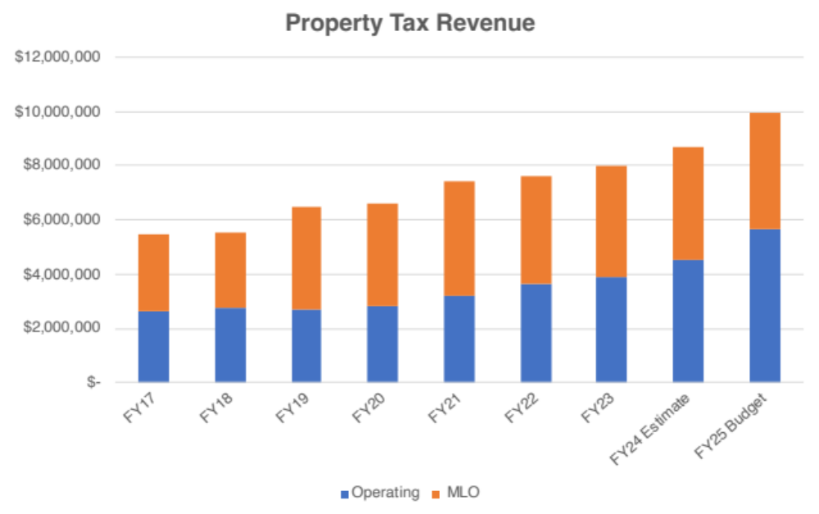

State Equalization

Funding through the School Finance Act is based on student enrollment each year. Once total program is calculated, the state determines how much can be paid for through local property taxes. Whatever is remaining comes from the state in form of state equalization.

Specific Ownership Taxes

Specific Ownership Taxes is the tax collection from vehicle registration. It is collected by the counties and shared with school districts and other taxing entities.

Student Enrollment

Student enrollment is a one of the major factors in funding public schools in Colorado. School districts receive funds based on the funded count determined through October count each year. The process begins with student membership and eventually gets down to funded count. Student membership is the total number of students that are actively enrolled and attending preschool through 12th grade in Manitou Springs School District. Membership is adjusted by removing students that are ineligible for funding (preschool) and adjusting those that are part-time to get to the full time equivalent or FTE. If a school district is in a state of declining enrollment, the state then averages with the previous year’s FTE counts to minimize the fluctuation and keep enrollment as smooth as possible. If a school is increasing in enrollment, averaging is not necessary.

Manitou Springs School District, similar to other districts across the state, saw a significant drop in enrollment in 2020-2021 due to COVID-19. In a typical year, the enrollment increases after the October count, but in 2020-2021, it continued to decline. We have not seen the increase in students after COVID-19 that we were hoping to. The budget for 2023-2024 is conservative and shows a continuation of the declining trend. The district has been working diligently on advertising and public relations to bring students back. There are currently many grade levels at capacity and on waiting lists, but other grades have many openings.

Choice enrollment is a large part of Manitou Springs School District. In 2023-2024, 49.19% of students attending Manitou schools resided outside of our boundaries. This is an important piece of the overall enrollment of our district. The majority of our choice students come to Manitou from District 11 (340 students in 2023-2024) and Woodland Park (173 students in 2023-2024), but students also reside in Cheyenne Mountain, Harrison, Academy D20, Widefield, Falcon, Cripple Creek, Fountain and Fremont County.
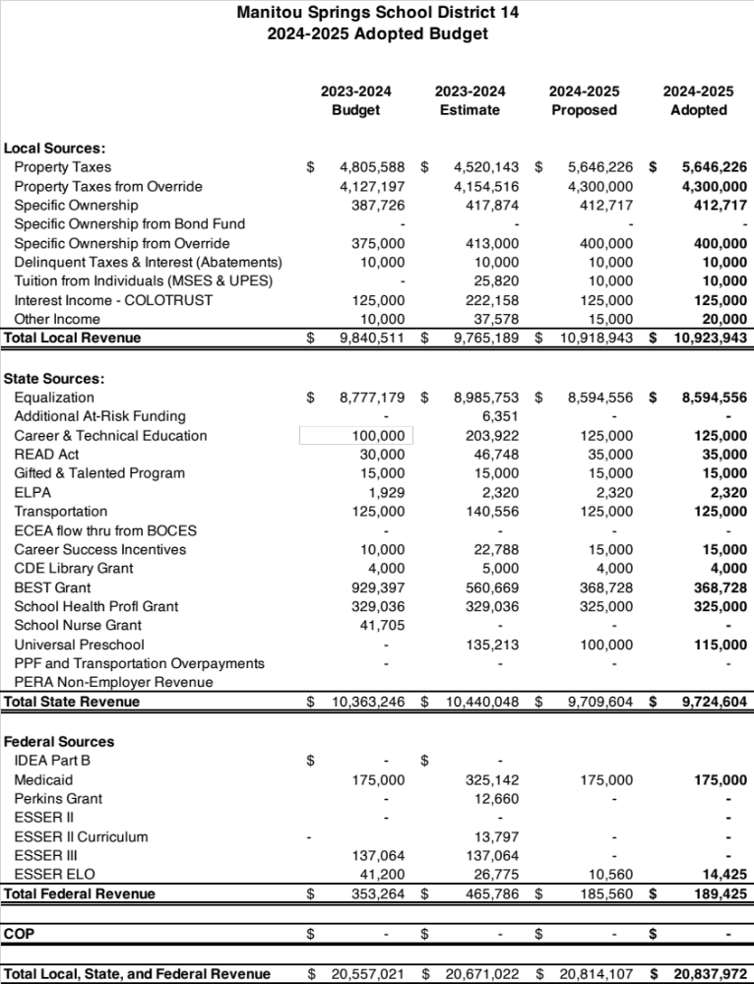

General Fund Expenditure Categories and Classifications

General Fund expenditures are broken into six categories to consolidate reporting. The list below provides examples of some items that fall into each category, but is not an all-inclusive list.

Category | Personnel | Non-Personnel
General Administration | Superintendent, Financial Services, Human Resources, SILC Administrative Assistants | Legal & Audit Fees, Election Expenses, Banking Fees, Technology Services, Advertising
School Administration | Principals, Assistant Principals, Athletic Director, School Secretaries | Office Materials & Supplies
General Instruction | Teachers, Instructional Coaches, Interventionists, Substitute Teachers | Instructional Supplies, Textbooks, Copier Usage, Concurrent Enrollment
Special Education Instruction | Special Education Teachers, Paraprofessionals | Special Education Preschool, Hearing, Vision, Special Education Supplies
Instructional Support | Counselors, Psychologists, School Nurses, Technology | Remote Learning, Instructional Technology, Professional Development, Media Center Supplies, Assessments
Operations & Maintenance | Building Custodians, Grounds, Bus Drivers | Utilities, Custodial Supplies, Grounds Supplies, Bus Equipment

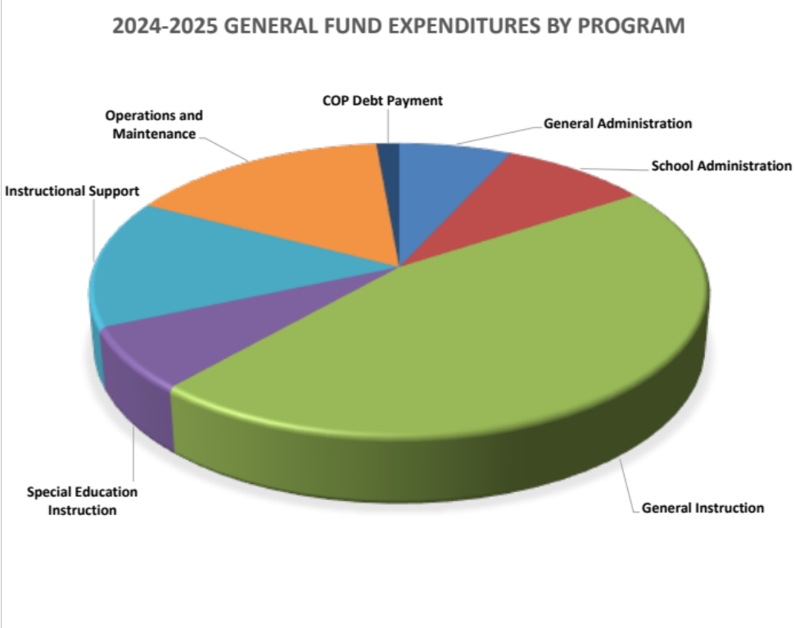
Expenditures are also broken out by classification. The following chart shows the type of expense: Salaries, Benefits, Purchased Services, and Supplies & Equipment. It is typical for school districts to spend roughly 80% - 85% of overall expenditures on compensation. Manitou is in line with the average, as 86% of total expenditures are spent on salary & benefits.

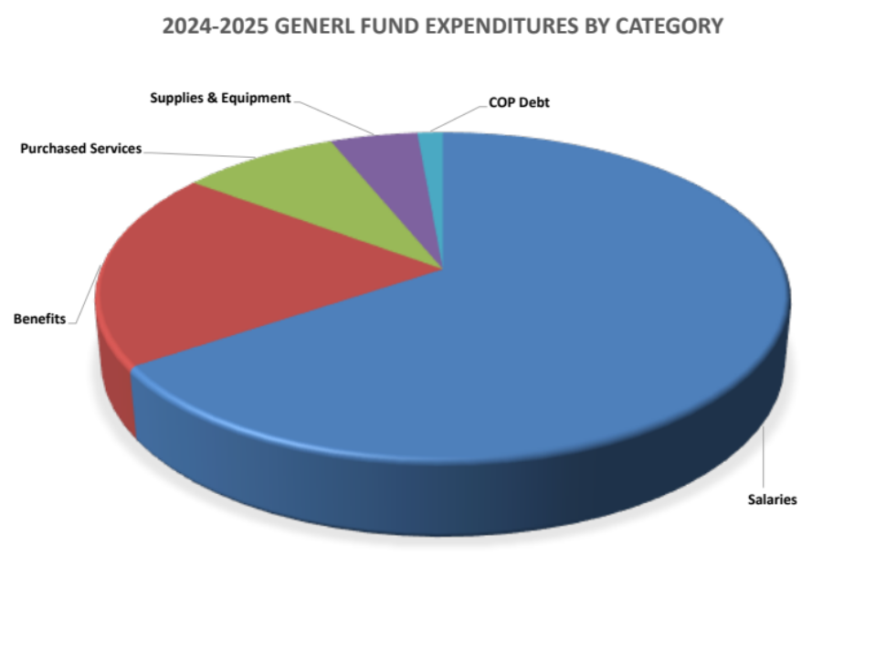
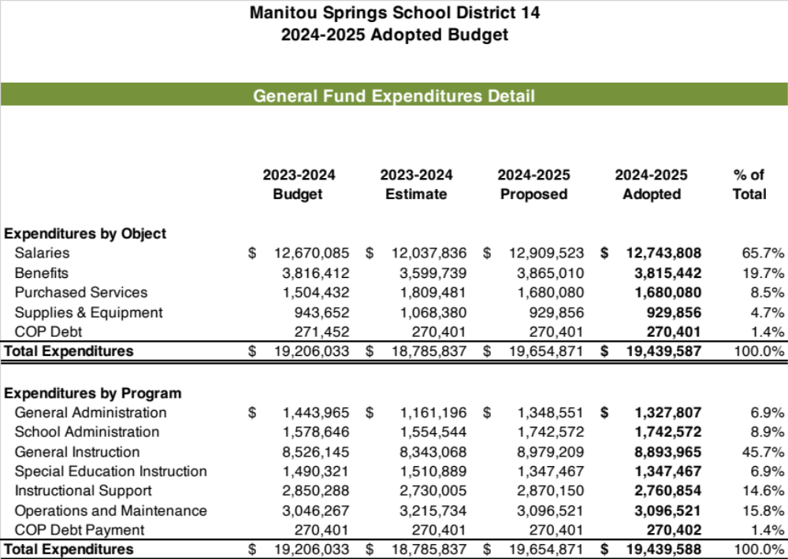

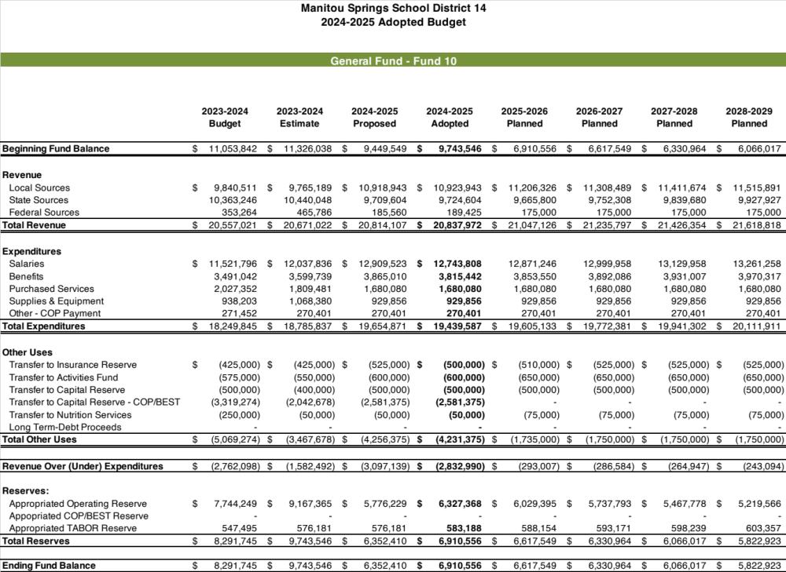

General Fund Detail

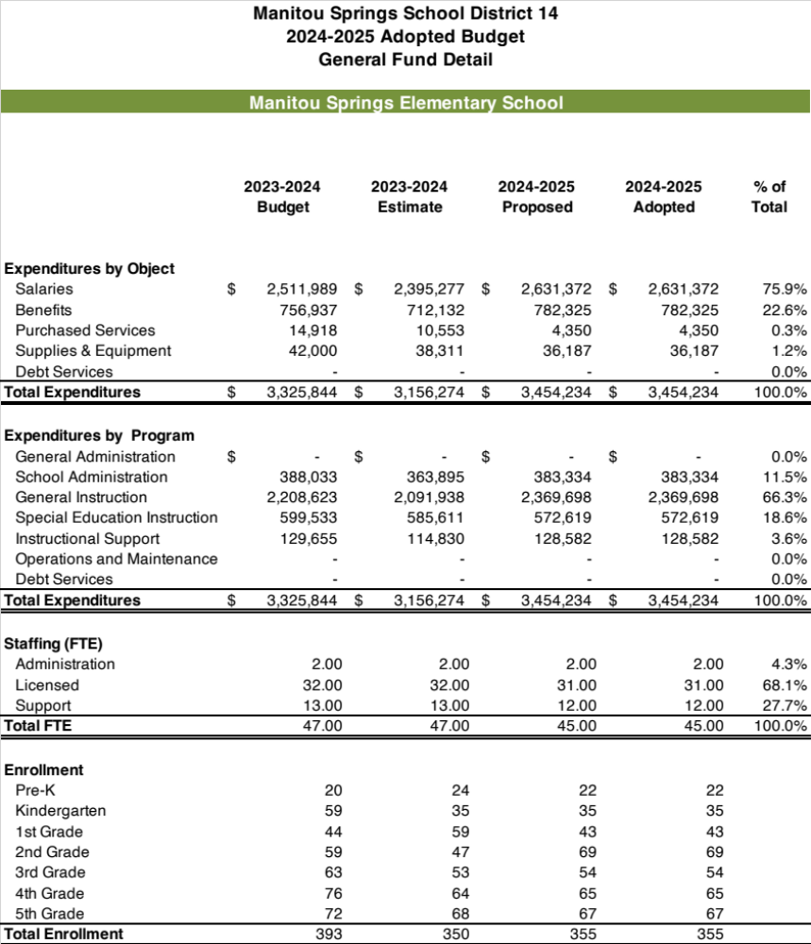

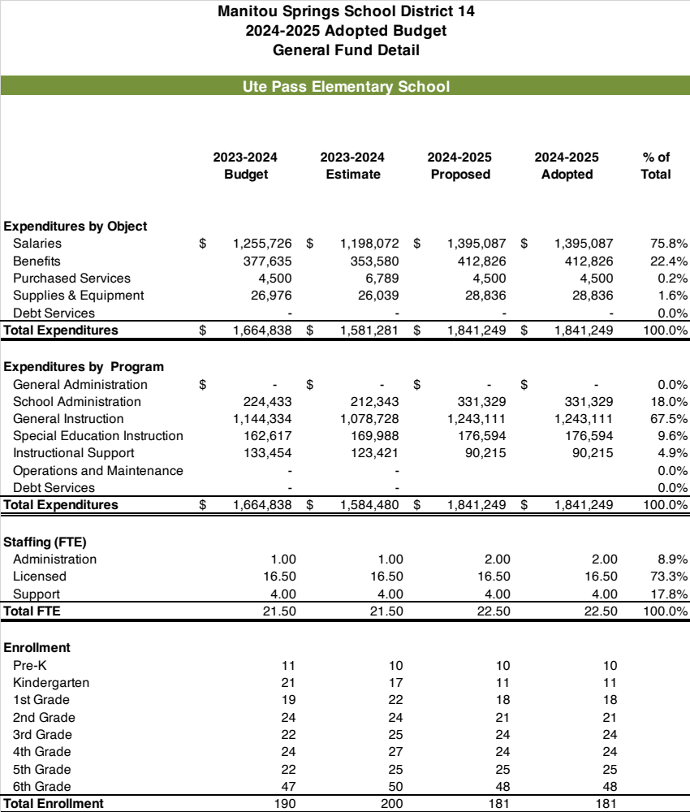

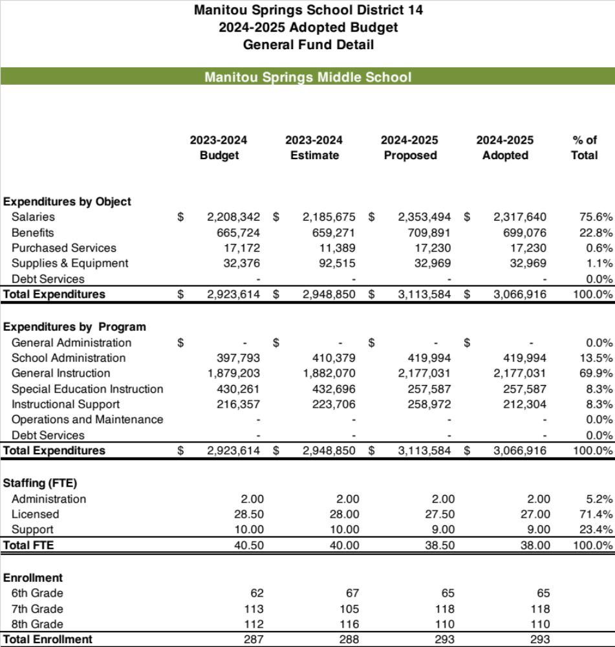

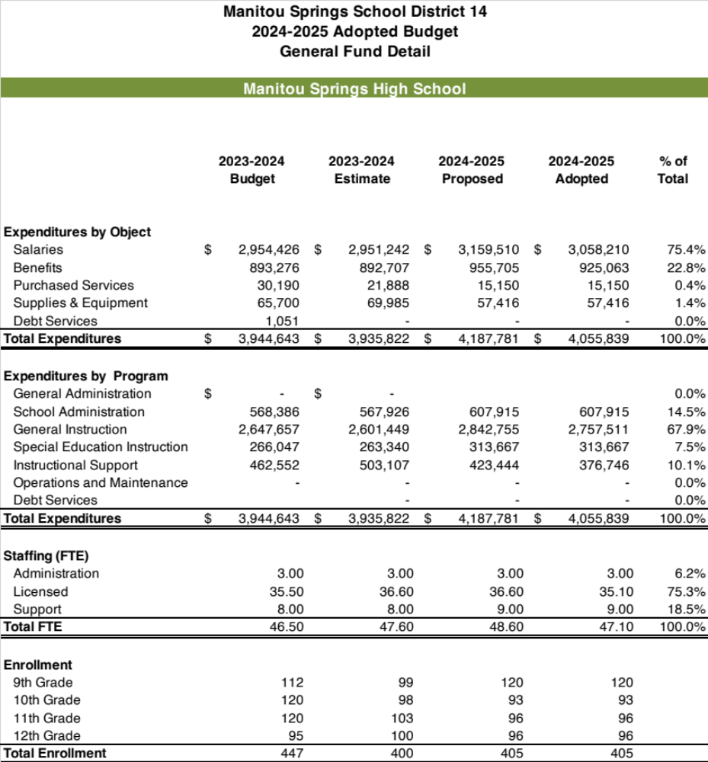

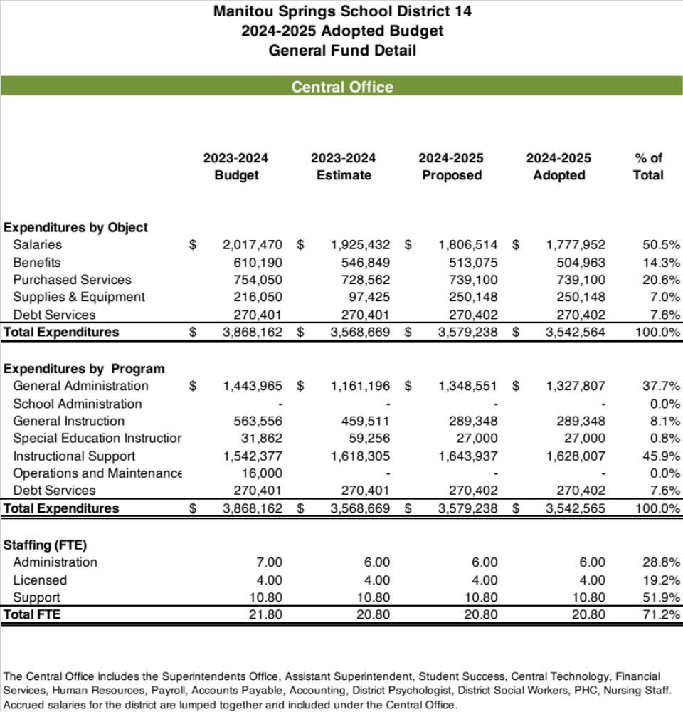
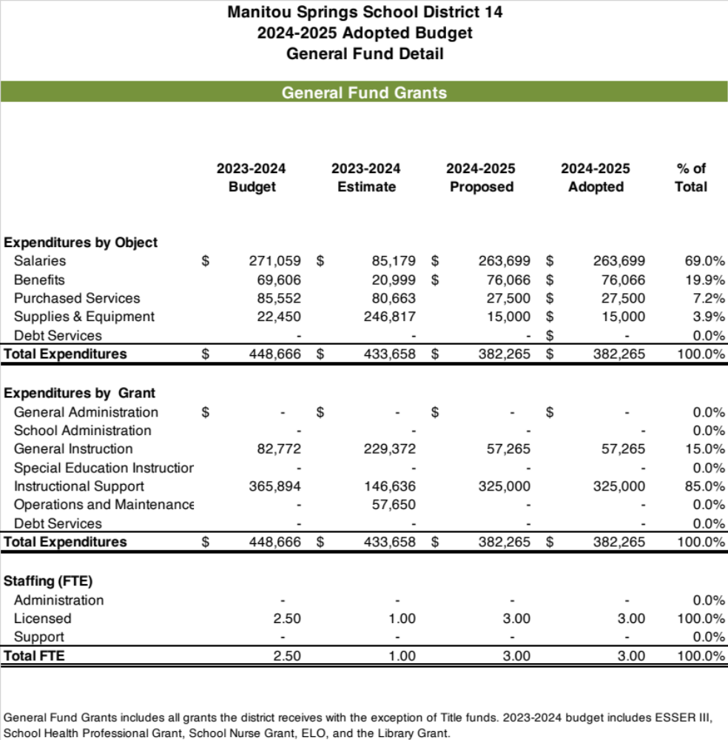

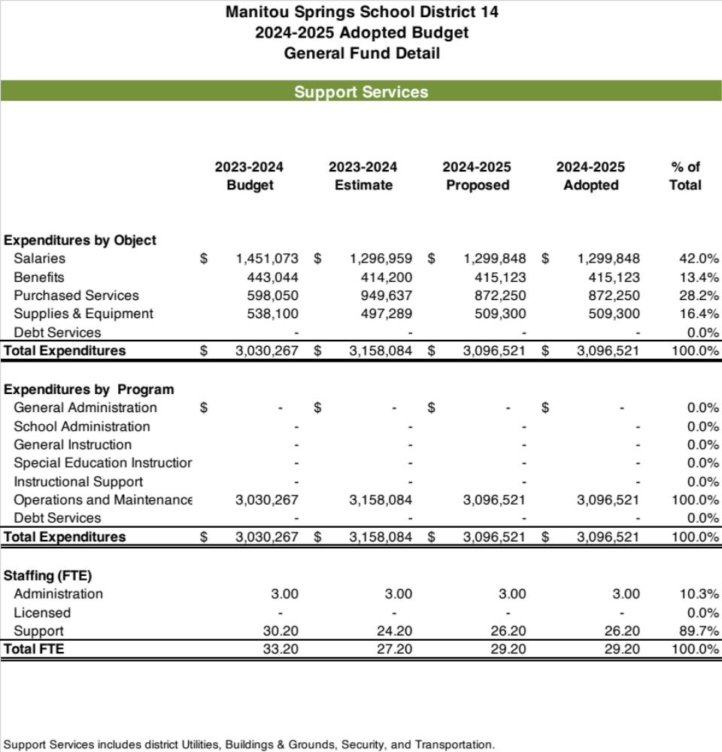

Other Funds

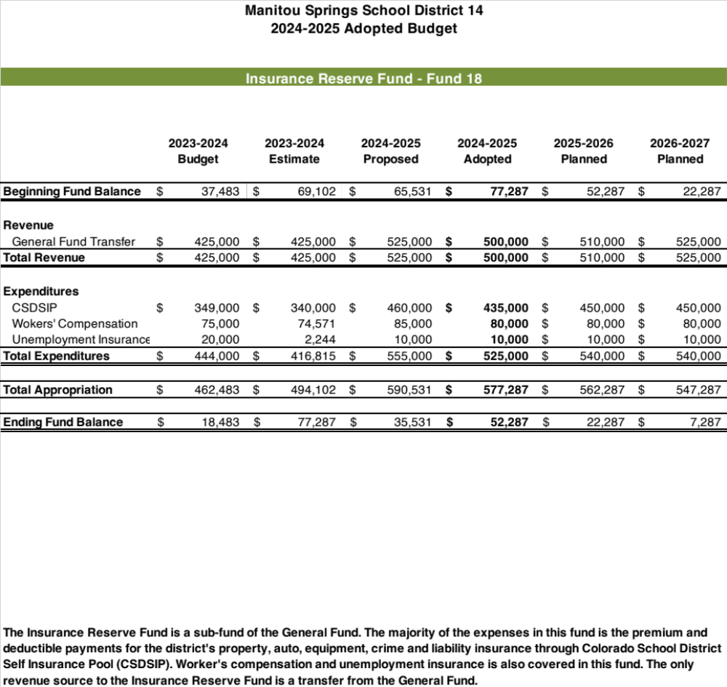

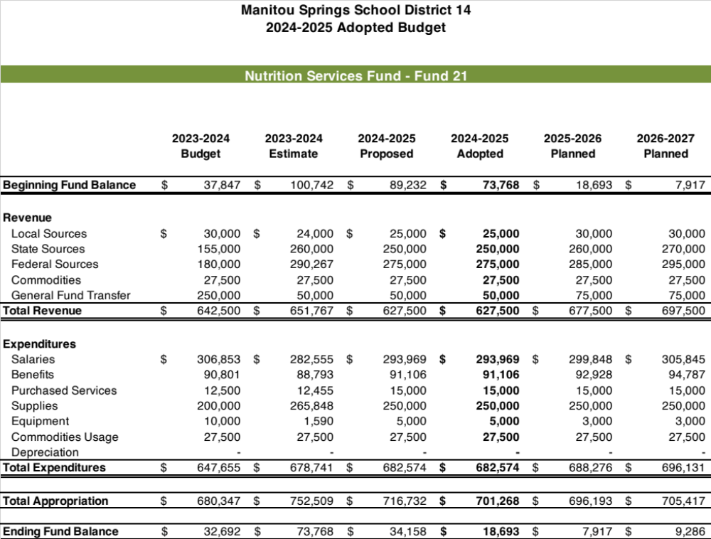

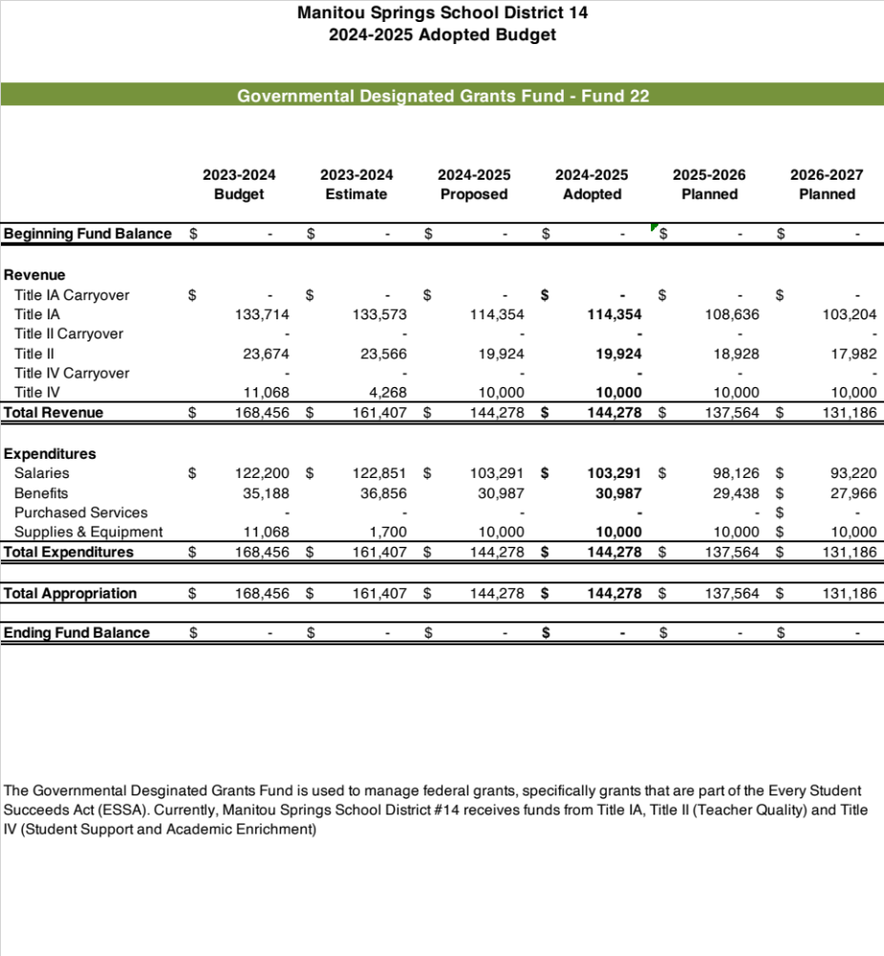

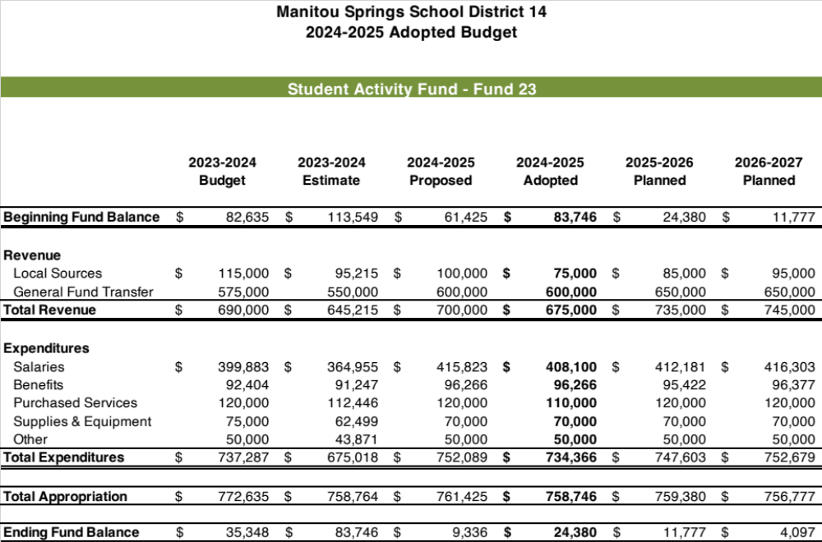

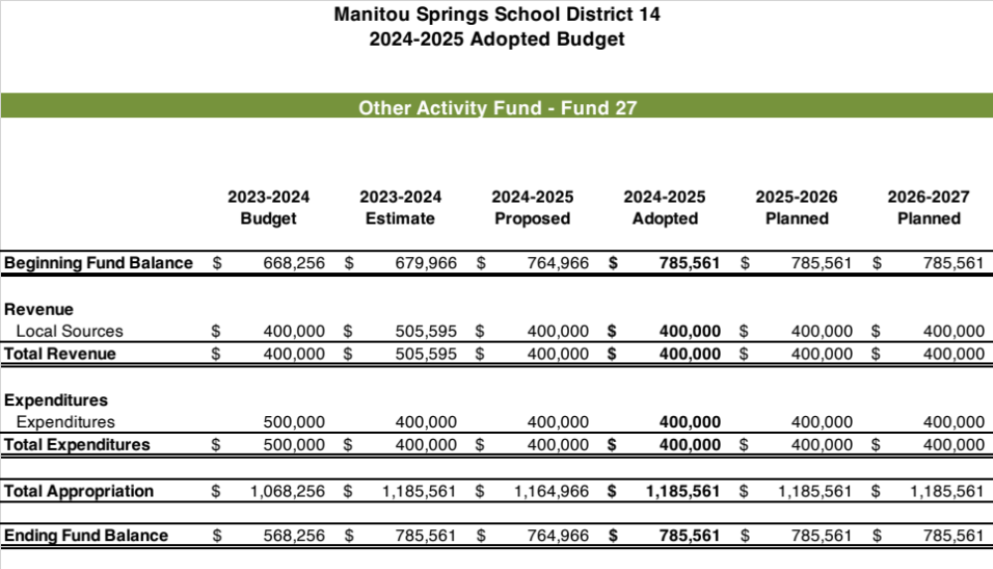

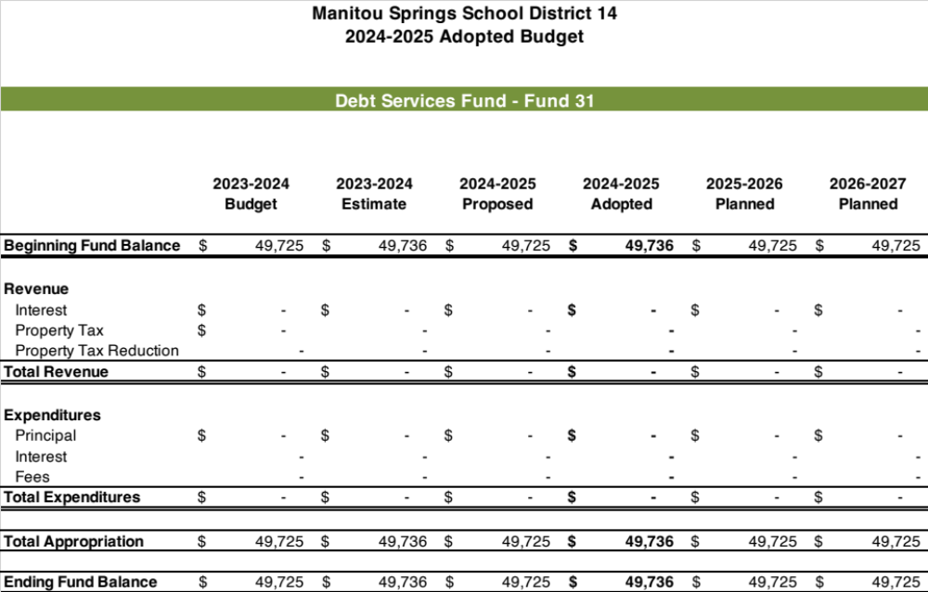

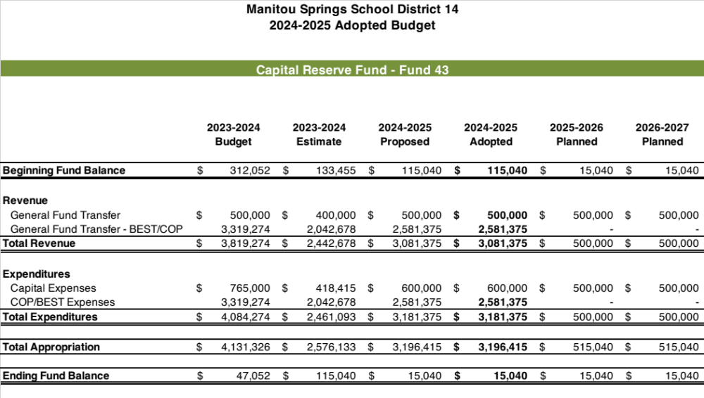

Manitou Springs School District 14
Fiscal Year 2024-2025
Budget Adoption Resolution - Adopted Budget
"BE IT RESOLVED by the Board of Education of School District Number Fourteen in El Paso County that the following revenues and expenditures for each district fund comprising the 2024-2025 Adopted Budget be adopted."
 | Revenue & Beginning Fund Balances | Expenditures & Reserves
General Fund | $ 30,581,518 | $ 30,581,518
Insurance Reserve Fund | $ 577,287 | $ 577,287
Food Service Fund | $ 701,268 | $ 701,268
Governmental Designated Grants Fund | $ 144,278 | $ 144,278
Pupil Activities Fund | $ 758,746 | $ 758,746
Other Activities Fund | $ 1,185,561 | $ 1,185,561
Debt Service Fund | $ 49,736 | $ 49,736
Capital Reserve Fund | $ 3,196,415 | $ 3,196,415
All Fund Total | $ 33,948,657 | $ 33,948,657
Tina Vidovich, Board President |  | Date

Manitou Springs School District 14
Fiscal Year 2024-2025
Budget Appropriation Resolution - Adopted Budget
"BE IT RESOLVED by the Board of Education of School District Number Fourteen in El Paso County that the amounts shown in the following schedule be appropriated to each fund as specified in the Adopted Budget for the fiscal year beginning July 1, 2024 and ending June 30, 2025."
 | Total Appropritation | Expenditures & Reserves
General Fund | $ 30,581,518 | $ 30,581,518
Insurance Reserve Fund | $ 577,287 | $ 577,287
Food Service Fund | $ 701,268 | $ 701,268
Governmental Designated Grants Fund | $ 144,278 | $ 144,278
Pupil Activities Fund | $ 758,746 | $ 758,746
Other Activities Funds | $ 1,185,561 | $ 1,185,561
Debt Services Fund | $ 49,736 | $ 49,736
Capital Reserve Fund | $ 3,196,415 | $ 3,196,415
All Fund Total | $ 33,948,657 | $ 33,948,657
Tina Vidovich, Board President |  | Date

