ROUND LAKE AREA SCHOOLS DISTRICT #116
ROUND LAKE, ILLINOIS
PROJECT: To Furnish and Deliver Physical Education Uniforms to Round Lake Area Schools District #116.

INSTRUCTIONS TO BIDDERS
Sealed proposals will be received in the Business Office for the Round Lake Area Schools District #116 at the place and date as follows:
Round Lake Area Schools District #116
Business Office
1777 N. Cedar Lake Rd. Suite 2
Round Lake Beach, Illinois 60073
Due Date: Wednesday, June 26, 2025, at 9:30 AM CST., at which time the bids will be opened and publicly read.

Any proposals received after the time and date specified may be too late to be considered. Specifications as may be required for these items are enclosed herewith.
Proposals shall be made on the items as listed in the "Schedule of Proposals". Prices quoted shall be guaranteed for a period of ninety (90) days after the date of the proposal. Purchase orders will be awarded based on individual item unit prices.

Proposals shall be submitted on forms to be provided by the Board of Education and completed in full. The sealed envelope containing your bid should be plainly marked: "SEALED BID – Physical Education Uniforms". The Board of Education reserves the right to reject any or all bids, to waive minor informalities in any bid, or to make award in the best interest of Round Lake Area Schools District #116.

Bid Timeline
Date | Task | Notes
June 13, 2025 (Friday) June 14, 2025(Saturday) | Publish legal notice | Starts 10-day required public notice period
June 16 – June 25, 2025 | Bid open period | Vendors review and prep submissions
June 20, 2025 (Friday) | Vendor question deadline | Last day for written questions
June 23, 2025 (Monday) | Issue final addenda (if needed) | All clarifications issued
June 26, 2025 (Wednesday by 9:30 AM) | Bid submission deadline | Sealed bids due at ONB
June 26, 2025 (Wednesday by 10:00 AM) | Public Bid Opening | Sealed bids publicly opened at ONB
July 7, 2025 (Monday) | Board approval | Award contract
July 8, 2025 (Tuesday) | Contract signed and PO issued | Vendor receives official notice to proceed
By August 8, 2025 (Friday) | Full delivery completed | Vendor delivers uniforms

ERRORS AND OMISSIONS
All proposals shall be submitted with each space properly completed. The special attention of Bidders is directed to the policy that no claim for relief because of errors or omissions in bidding will be considered and Bidders will be held strictly to the proposals as submitted.
All bidders must satisfy themselves as to the intent of these specifications. Should a Bidder find any discrepancies in, or omissions from, any of the documents, or be in doubt as to their meaning, he shall advise the Director of Business Services who will issue the necessary clarifications to all prospective Bidders by means of addenda.
Should the bidder find any discrepancies in, or omission from, any of the documents or be in doubt as to their meaning, he shall advise the Board of Education who will issue necessary clarifications to all prospective bidders by means of addenda as may be appropriate.

WITHDRAWAL OF BIDS
All bids shall be deemed final, conclusive and irrevocable, for at least 60 days after the date of the bid opening. Bids may be withdrawn in person, or by letter, facsimile transmission, and electronic mail or similar means, provided that the withdrawal is actually received by the party to whom bids are to be submitted prior to the time for the opening of bids. No bid shall be withdrawn after the scheduled closing time for the submission of bids without the consent of the Board.

INVESTIGATION OF BIDDERS
- The Business Office will make such investigation as is necessary to determine the ability of the Bidder to fulfill bid requirements. The Bidder shall furnish such information as may be requested and shall be prepared to show completed installations of equipment, types of services, or supplies similar to that included in his bid.

- The Board of Education reserves the right to reject any bid if it is determined that the Bidder is not properly qualified to carry out the obligations of the contract.

Any reference to specified manufacturers denotes specific items preferred. However, you may quote on alternate items of equal or better quality. In any case, be certain to include proper description, Brand Name of the item and supporting literature as appropriate. Exception: No alternate material will be accepted where "No Substitute" appears on the proposal sheet.
Quantities shown are reasonable estimates. This Board of Education reserves the right to adjust quantities in its best interest at the time of contract award without a change in unit prices quoted.

Title and Risk of Loss:
Title to the goods herein described shall not pass until said goods have actually been received by the Board of Education or its consignee, notwithstanding any agreement to the contrary, including, but not by way of limitation, any agreement to pay freight, express, or other transportation or insurance charges. Risk of loss prior to such actual receipt by the Board of Education or its consignee shall be borne by the Seller. Nothing herein contained, however, shall be construed to deprive the Board of its interest, or limiting such interest, in the goods herein described prior to such actual receipt.

***** The items on this bid are budgeted for use during the 2025-2026 school year.
Invoices will not be paid until after July 15, 2025. *****
Delivery:
Any deliveries shall be coordinated as follows: Magee Middle School - Jisela Ruiz (224)842-2604, Round Lake Middle School - Yvonne Villalobos (224) 842-2454, and Round Lake High School – Rosy Banuelos 224- 842-2816. Your bid price must be a delivered price, F.O.B. the Board's destination, with all transportation and handling charges paid by the bidder.

RESERVATION OF RIGHTS BY THE BOARD OF EDUCATION

The Board of Education reserves the right to change quantities, reject any or all bids, to waive irregularities, and to accept the bid which in its sole and absolute discretion is considered to be in the best interests of the District. Any such decision shall be considered final.
The Board of Education further reserves the right to adjust quantities in its best interest at the time of contract award without a change in unit prices quoted. Quantities in this bid packet are reasonable estimates only.
The Board of Education further reserves the right to split the award if it is in the best interest of the Board of Education. If a split award is not acceptable to the Bidder, it must be so stated in its bid.

Rejection and Cancellation:

The Board of Education reserves its rights to reject any goods and to cancel all or any part of this sale if the Seller fails to deliver all or any part of the goods described in the invitation to bid in accordance with the terms, conditions, and specifications contained herein. Acceptance of any part of the goods covered by the invitation to bid shall not obligate the Board of Education to accept future shipments nor deprive it of its rights to revoke any acceptance theretofore given. If the Seller ceases to conduct its operations in the ordinary course of business (including inability to meet its obligations as they mature), or if any proceeding under bankruptcy or insolvency laws is brought by or against the Seller, or if a receiver for the Seller is appointed or applied for, or if an assignment for the benefit of creditors is made by the Seller, the Board of Education may cancel this order without liability except for deliveries previously made or for goods covered by the invitation to bid then completed and subsequently delivered in accordance with the terms, conditions, and specifications contained herein. All goods shall be new and the best and latest model of their respective kinds, without flaws or defects of any kind and shall carry the manufacturer's guarantee covering any defects of material or workmanship. Rejected goods shall be removed at the expense of the Seller, including transportation both ways, promptly after notification of rejection. As to rejected goods, the Seller shall bear all costs of inspection and all risk of loss. The Board of Education will accept no goods containing asbestos.

Waivers:

The Board of Education's waiver of any breach or failure to enforce any of the terms, conditions, and specifications of the invitation to bid shall not in any way affect, limit, or waive the Board of Education's right thereafter to enforce and compel strict compliance with every term, condition, and specification hereof.

State Tax:

The Board of Education is exempt from paying Illinois Use tax, Illinois Retailer's Occupation tax, Federal Excise taxes, and any federal transportation tax.

Split Awards:
Every attempt will be made to award orders on an overall low bid basis. However, the right is reserved to split the award if it is in the best interest of the Board of Education. If a split award is not acceptable to the Bidder, it must be so stated in the bid.
EXCEPTIONS
Any exceptions to these conditions or deviations from written specifications must be in writing and
attached to the bid form.
SIGNATURE CONSTITUTES ACCEPTANCE
The signing of these bid forms shall be construed as acceptance of all provisions contained herein.

Certification:

  - Each bid must be accompanied by a Certificate of Eligibility to Bid, certifying that the bidder is not barred from bidding on public contracts due to a conviction for the violation of 720 ILCS 5/33E-3 (bid rigging) or 720 ILCS 5/33-E4 (bid rotating) of the Illinois Criminal Code of 1961, as amended, or a conviction or admission of guilt which is a matter of record for bribing or attempting to bribe an officer of the State of Illinois. The certificate of Eligibility to Bid form is included within the bid documents.

Failure to do so shall disqualify your bid.

  - Each bid from a Vendor/Contractor with 25 or more employees must be accompanied by a Certificate of Compliance with the Illinois Drug-Free Workplace Act 30 ILCS 580/1 et. seq., as amended certifying that the bidder shall provide a drug-free workplace for all employees engaged in the performance of work under the contract and that the bidder is not barred from bidding on public contracts due to a violation of the Illinois Drug-Free Workplace Act. Each bid from an Individual must be accompanied by a Certificate of Compliance with the Illinois Drug- Free Workplace Act certifying that (he, she, it) shall not engage in the unlawful manufacture, distribution, dispensation, possession, or use of a controlled substance in the performance of the contract and that (he, she, it) is not barred from bidding on public contracts due to a violation of the Illinois Drug-Free Workplace Act. The Certificates of Compliance with the Illinois Drug-Free Workplace Act forms are included within the bid documents.

Failure to do so shall disqualify your bid.

  - Each bid must be accompanied by a certificate regarding a sexual harassment policy certifying that the bidder has a written sexual harassment policy that includes: information that sexual harassment is illegal; defines sexual harassment under Illinois law; describes sexual harassment using examples; has an internal complaint process including penalties; informs employees of their rights under the Illinois Human Rights Act, 775 ILCS 5/1 et. seq., as amended and the complaint process available through the Department of Human Rights and Illinois Human Rights

Commission; and, states that anyone filing a complaint will be protected against retaliation. The certificate regarding sexual harassment policy form is included with the bid documents.

Failure to do so shall disqualify your bid.

  - Each bid must be accompanied by a Certification Regarding Debarment, Suspension, Ineligibility and Voluntary Exclusion, Lower Tier Covered Transactions, as required by Department of Education regulations implementing Executive Order 12549, Debarment and Suspension, 34 CFR Part 85, for all lower tier transactions meeting the threshold and tier requirements stated at Section 85.110. The certificate regarding debarment, suspension, ineligibility and voluntary exclusion, lower tier covered transactions is included with the bid documents.
Failure to do so shall disqualify your bid.
ROUND LAKE AREA SCHOOLS DISTRICT #116
ROUND LAKE, ILLINOIS

PROJECT: To Furnish and Deliver Physical Education Uniforms to Magee Middle School.
Schedule of Proposals
SECTION I:
All items under Section I are to be delivered to Magee Middle School, 500 N. Cedar Lake Road, Round Lake, Illinois, 60073.

Item #1: Shirts - C2 Sport, Performance T-Shirt 5100, 100% polyester moisture-management/antimicrobial performance fabric, Graphite color.

Magee Wellness Logo
-logo is placed in center of front side of shirt
-logo should be approximately 3 inches down from shirt collar and 11 inches covering the chest

Yellow Rectangular Name Plate Box (2 locations: front and back side of shirt)
-Front Side: below the Magee Wellness logo
-should be approximately 8 inches in width and 3 inches in height
-Back Side: located between the shoulder blades
-should be approximately 7 inches down from the shirt collar; 8 inches in width and 3 inches in height

Qty | Description | Per Cost | Total Cost
120 | YXL/XS Shirts | $ ea | $
420 | Small Shirts | $ ea | $
420 | Medium Shirts | $ ea | $
168 | Large Shirts | $ ea | $
72 | Extra Large Shirts | $ ea | $
36 | 2XL Shirts | $ ea | $
12 | 3XL Shirts | $ ea | $

* NO SUBSTITUTION *

Item #2: Shorts -- C2 Sport, Performance short 5129, 100% polyester moisture-management/antimicrobial performance fabric
1.5" covered elastic waistband, Navy color.

Round Lake logo
-logo is placed on bottom left leg
-logo should be approximately 3 inches in length

Yellow Rectangular Name Plate Box
-location is below the Round Lake logo on the bottom left
-should be approximately 1 inch in length, 5 inches in width and 2 inches up from the bottom of the short

Qty | Description | Per Cost | Total Cost
120 | YXL/XS Shorts | $ ea | $
420 | Small Shorts | $ ea | $
420 | Medium Shorts | $ ea | $
168 | Large Shorts | $ ea | $
72 | Extra Large Shorts | $ ea | $
36 | 2XL Shorts | $ ea | $
12 | 3XL Shorts | $ ea | $

*NO SUBSTITUTION *
ROUND LAKE AREA SCHOOLS DISTRICT #116
ROUND LAKE, ILLINOIS

PROJECT: To Furnish and Deliver Physical Education Uniforms to Round Lake Middle School.

SECTION II:
All items under Section II are to be delivered to Round Lake Middle School, 200 N. Lotus Drive, Round Lake Heights, Illinois, 60073.

Item #1: Shirts -- C2 Sport, Performance T-Shirt 5100, 100% polyester moisture-management/antimicrobial performance fabric, Graphite color.

RLMS Wellness Logo
-logo is placed in center of front side of shirt
-logo should be approximately 3 inches down from shirt collar and 11 inches covering the chest

Yellow Rectangular Name Plate Box (2 locations: front and back side of shirt)
-Front Side: below the RLMS Wellness logo
-should be approximately 8 inches in width and 3 inches in height
-Back Side: located between the shoulder blades
-should be approximately 7 inches down from the shirt collar; 8 inches in width and 3 inches in height

Qty | Description | Per Cost | Total Cost
120 | YXL/XS Shirts | $ ea | $
312 | Small Shirts | $ ea | $
276 | Medium Shirts | $ ea | $
120 | Large Shirts | $ ea | $
36 | Extra Large Shirts | $ ea | $
0 | 2XL Shirts | $ ea | $
12 | 3XL Shirts | $ ea | $

* NO SUBSTITUTION *

Item #2: Shorts -- C2 Sport, Performance short 5129, 100% polyester moisture-management/antimicrobial performance fabric
1.5" covered elastic waistband, Navy color.

Round Lake logo
-logo is placed on bottom left leg
-logo should be approximately 3 inches in length

Yellow Rectangluar Name Plate Box
-location is below the Round Lake logo on the bottom left
-should be approximately 1 inch in length, 5 inches in width and 2 inches up from the bottom of the short

Qty | Description | Per Cost | Total Cost
72 | YXL/XS Shorts | $ ea | $
420 | Small Shorts | $ ea | $
420 | Medium Shorts | $ ea | $
84 | Large Shorts | $ ea | $
0 | Extra Large Shorts | $ ea | $
0 | 2XL Shorts | $ ea | $
0 | 3XL Shorts | $ ea | $

* NO SUBSTITUTION *

ROUND LAKE AREA SCHOOLS DISTRICT #116
ROUND LAKE, ILLINOIS

PROJECT: PROJECT: To Furnish and Deliver Physical Education Uniforms to Round Lake High School.

SECTION III:
All items under Section III are to be delivered to Round Lake High School, 800 High School Drive, Round Lake, Illinois, 60073.

Item #1: Shirts - C2 Sport, Performance T-Shirt 5100, 100% polyester moisture-management/antimicrobial performance fabric, Graphite color.

Active Bodies Create Active Minds (cicular logo)
-logo is placed in center of front side of shirt
-logo should be approximately 3 inches down from shirt collar and 11 inches covering the chest
Note-the gray is the t-shirt color, not part of the logo.

Yellow Rectangluar Name Plate Box (2 locations: front and back side of shirt)
-Front Side: below the Active Body logo
-should be approximately 8 inches in width and 3 inches in height
-Back Side: located between the shoulder blades
-should be approximately 7 inches down from the shirt collar; 8 inches in width and 3 inches in height

Qty | Description | Per Cost | Total Cost
0 | YXL/XS Shirts | $ ea | $
384 | Small Shirts | $ ea | $
612 | Medium Shirts | $ ea | $
504 | Large Shirts | $ ea | $
360 | Extra Large Shirts | $ ea | $
12 | 2XL Shirts | $ ea | $
12 | 3XL Shirts | $ ea | $

* NO SUBSTITUTION *

Item #2: Shorts - C2 Sport, Performance short 5129, 100% polyester moisture-management/antimicrobial performance fabric
1.5" covered elastic waistband, Navy color.

Round Lake logo
-logo is placed on bottom left leg
-logo should be approximately 3 inches in length

Yellow Rectangluar Name Plate Box
-location is below the Round Lake logo on the bottom left
-should be approximately 1 inch in length, 5 inches in width and 2 inches up from the bottom of the short

Qty | Description | Per Cost | Total Cost
0 | YXL/XS Shorts | $ ea | $
252 | Small Shorts | $ ea | $
312 | Medium Shorts | $ ea | $
252 | Large Shorts | $ ea | $
120 | XL Shorts | $ ea | $
60 | 2XL Shorts | $ ea | $
12 | 3XL Shorts | $ ea | $

* NO SUBSTITUTION *

*Lead Time for Delivery Days
*Number of days required for replacement shorts or shirts to be delivered for orders placed during 2025-26 school year Days

*Prices guaranteed to remain same for replacement orders during 2025-26 school year: YES NO

Proposal submission due on or before June 26, 2025 at 9:30 AM CST
*****Please Note: Payment will be made after July 15, 2025*****

Date: Name of Company:

Phone:
By: (Print or Type) (Title)

Fax:
(Signature)

Email Address: Address:
□ For purposes of state reporting only, checking this box certifies that this business is minority owned, female owned, owned by person with disabilities or locally owned.

Note – Modified Schedule of Proposals may be accepted if the information provided is sufficient

ROUND LAKE AREA SCHOOLS DISTRICT #116
ROUND LAKE, ILLINOIS

CERTIFICATION I - CERTIFICATE OF ELIGIBILITY TO BID
PROJECT: To Furnish and Deliver Physical Education Uniforms to Round Lake Area Schools District #116.

Pursuant to Section 33E-11 of the Illinois Criminal Code of 1961 as amended (720ILCS 5/33E-11), hereby certifies that neither (he, she, it) nor any of (his, her, its) partners, officers, or owners of (his, her, its) business has been convicted in the past five (5) years of the offense of bid-rigging under Section 33E-3 of the Illinois Criminal Code of 1961 as amended (720ILCS 5/33E-3) and that neither (he, she, it) nor any of (his, her, its) partners, officers, or owners of (his, her, its) business has ever been convicted of the offense of bid-rotating under section 33E-4 of the Illinois Criminal Code of 1961, as amended (720ILCS 5/33E-4).
Company Name:
Address:

By: (Print or Type) (Title)

Signature:

Phone:
Date:

Subscribed and sworn to before me this day of , 20 .

Notary Public
SEAL

NOTE: This form must be returned with your proposal. Failure to do so shall disqualify your proposal.

ROUND LAKE AREA SCHOOLS DISTRICT #116
ROUND LAKE, ILLINOIS

CERTIFICATION II
CERTIFICATE OF COMPLIANCE WITH ILLINOIS DRUG-FREE WORKPLACE ACT

PROJECT: To Furnish and Deliver Physical Education Uniforms to Round Lake Area Schools District #116. [Vendors with 25 or More Employees]
□ This certifies that we have less than 25 employees.
□ This certifies that we have 25 or more employees and does hereby certify pursuant to section 3 of the Illinois Drug-Free Workplace Act that [he,she,it] shall provide a drug-free workplace for all employees engaged in the performance of work under the contract by complying with the requirements of the Illinois Drug-Free Workplace Act and, further certifies, that [he, she, it] is not ineligible for award of this contract by reason of debarment for a violation of the Illinois Drug-Free Workplace Act.

[Vendor]

By Authorized Agent of Vendor

Title:

Date:

Subscribed and sworn to before me this day of , 20 .

Notary Public

SEAL

NOTE: This form must be returned with your proposal. Failure to do so shall disqualify your proposal.

ROUND LAKE AREA SCHOOLS DISTRICT #116
ROUND LAKE, ILLINOIS

CERTIFICATION III
CERTIFICATE OF COMPLIANCE WITH SEXUAL HARASSMENT POLICY

PROJECT: To Furnish and Deliver Physical Education Uniforms to Round Lake Area Schools District #116.

I hereby certify pursuant to Section 2-105 of the Illinois Human Rights Act, as amended (775 ILCS 5/2- 105) that (he, she, it) has a written sexual harassment policy that includes, at the minimum, the following information: (1) the illegality of sexual harassment; (2) the definition of sexual harassment under State law; (3) a description of sexual harassment, utilizing examples; (4) an internal complaint process including penalties; (5) the legal recourse, investigative and complaint process available through the Department of Human Rights and Human Rights Commission; (6) directions on how to contact the Department of Human Rights and Human Rights Commission; and (7) protection against retaliation.
[Vendor]

By Authorized Agent of Vendor

Title:

Date:

Subscribed and sworn to before me this day of , 20 .

Notary Public

SEAL

NOTE: This form must be returned with your proposal. Failure to do so shall disqualify your proposal.

MAGEE MIDDLE SCHOOL T-SHIRT FRONT LOGO

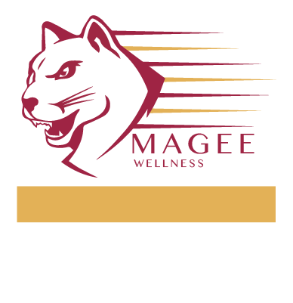

ROUND LAKE MIDDLE SCHOOL T-SHIRT FRONT LOGO



ROUND LAKE HIGH SCHOOL T-SHIRT FRONT LOGO



BACK OF EACH SHIRT

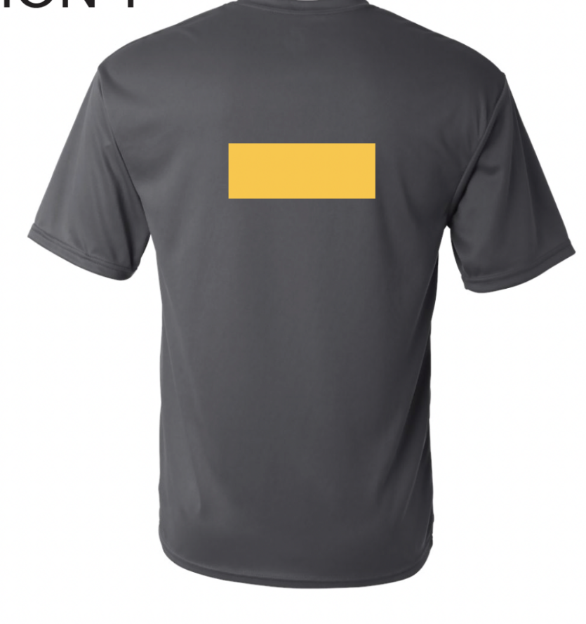

SHORTS



