How To Use DCLS’s All Ready Access Program

STEP 1: Go to https://dcls.org/

STEP 2: Click on “Library Account Login.” Do not use the catalog search box before logging in!
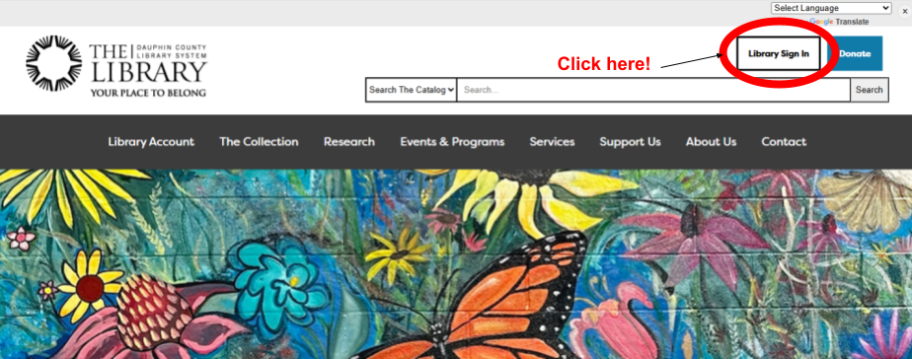

STEP 3: Enter your barcode and pin. Your barcode is CD and then your student ID number. Your pin is the last four digits of your student ID. If you already have a library card, your PIN has not changed, and both your
student ID number and your library card number are attached to your account.

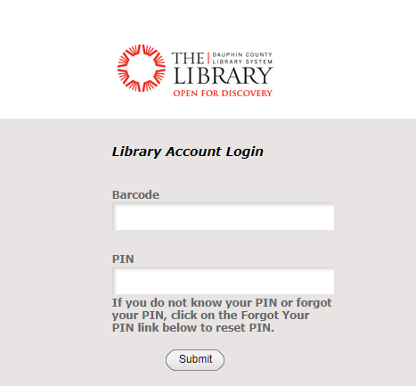
CD10012345
2345

If you get an error message, click the “Forgot Your Pin” link and follow the instructions. You will get a link to reset your pin in your school email.

Hoopla: On Demand Audiobooks & eBooks

Create an account with Hoopla. To find Hoopla, click on the DCLS icon in the upper right hand corner of the search screen you’re taken to after you log in.

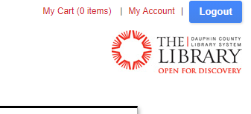

Once you’re back on the home page, click on “The Collection.” Then click on “eBooks, Audiobooks, Magazines, & Music.”

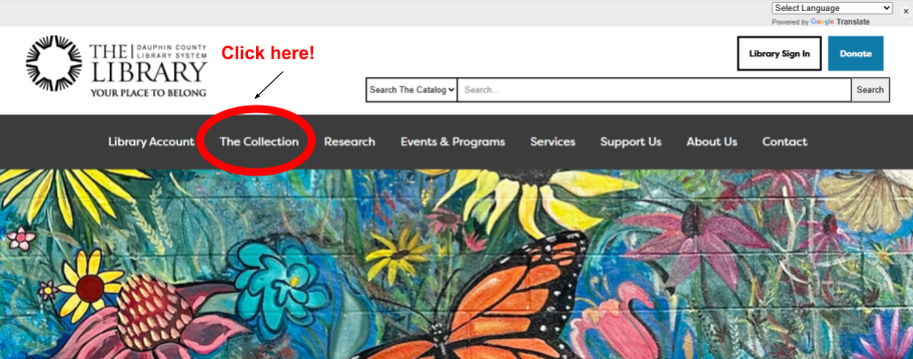

Then click on “eBooks & eAudiobooks.”
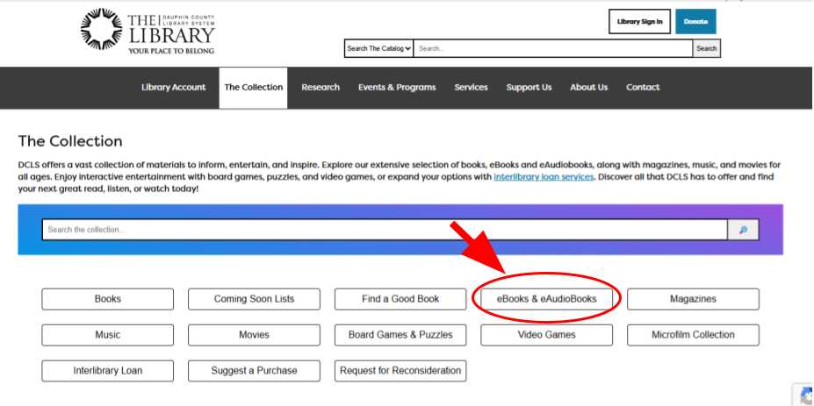

Find the link to Hoopla.
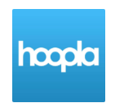

Click “Get started today” and create an account with whichever email address you prefer to use. Your school email will work.

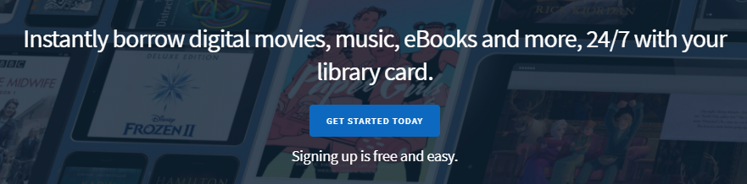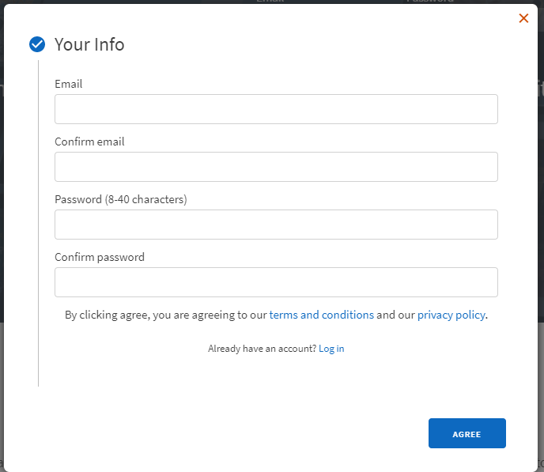

There is a Hoopla app you can download as well.

Libby by Overdrive: Audiobooks & eBooks

To use Libby to check out eBooks, you will not need to create a separate account, but you can use the Libby app to read the books.

Go back to the eBooks & eAudiobooks page.

Go to Libby by Overdrive.



Log in using your barcode and pin. To use Libby, you will have to download the app. Instructions for different devices are on the eBooks & eAudiobooks page.

All the other resources should allow you to log in using your barcode and pin without any extra steps for accessing materials.

