You will receive an email from SchoolCare around July 17. You should complete the enrollment using the following directions.

Click here

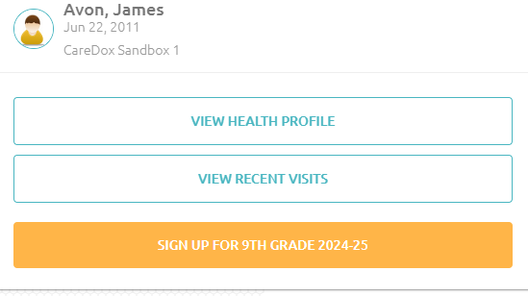
Click here

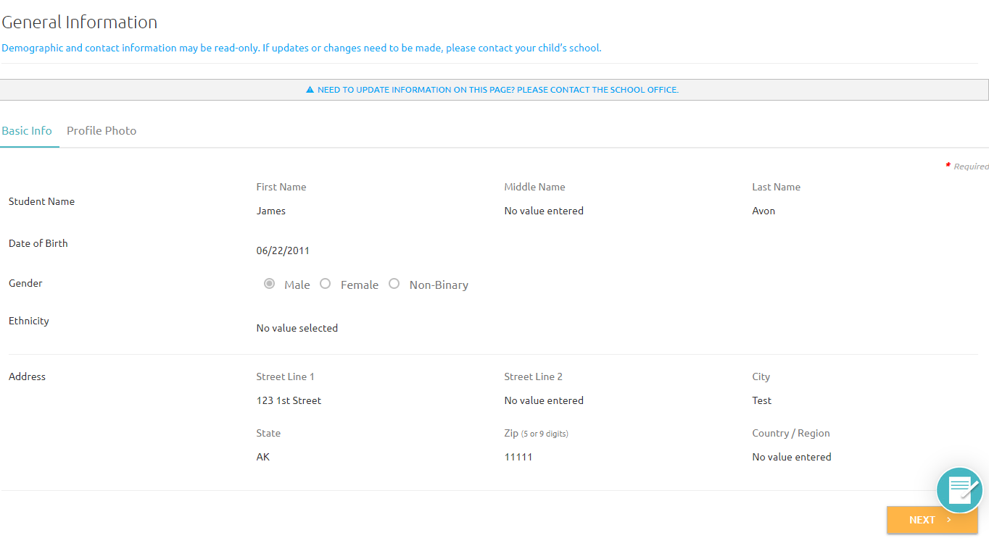
If no allergies click
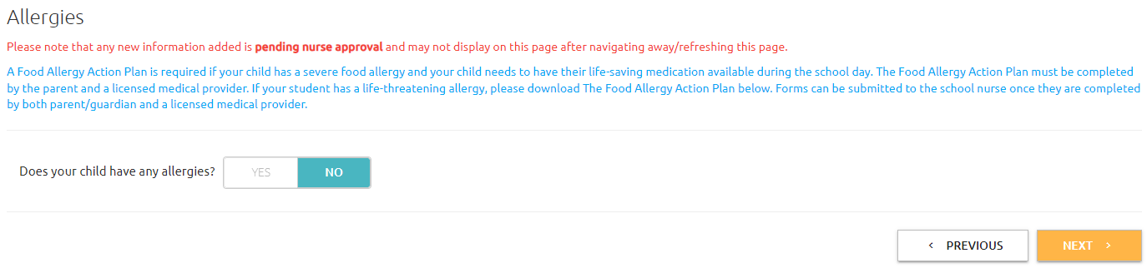

If your child does have allergies click “Yes” and complete the information on this page. You do not have to add a care plan or dates if you do not know them. Once you complete allergy information, click

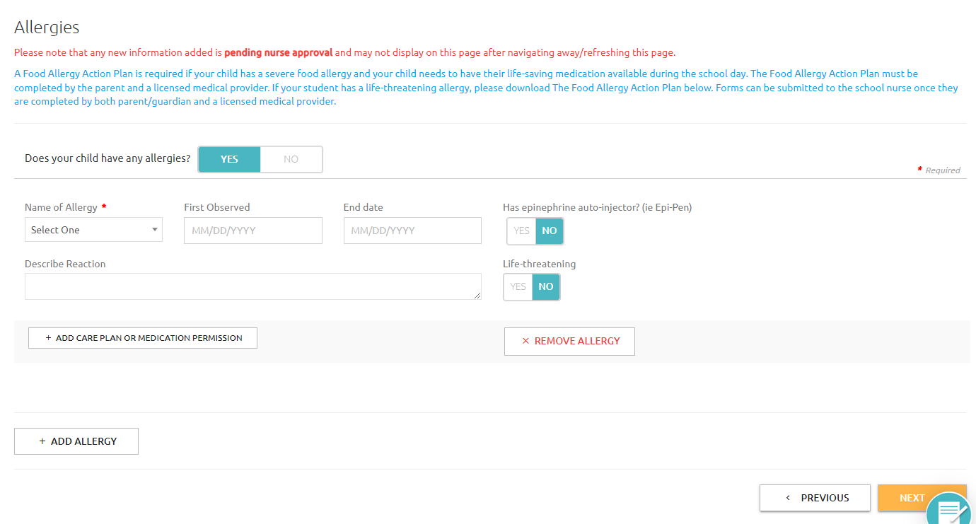

If your child does not have a medical condition, click
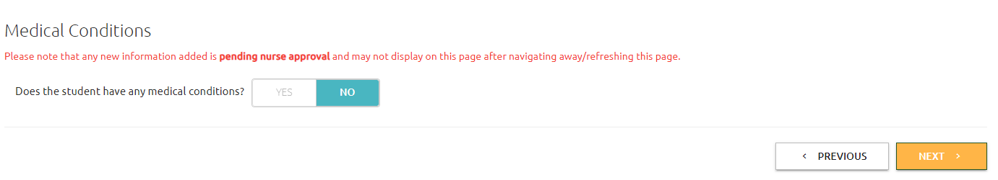
If your child does have a medical condition click “Yes” and complete the information on this page. You do not have to add a care plan or medication permission. If you do not know the onset date, you do not have to add it. Once you have completed the information, click
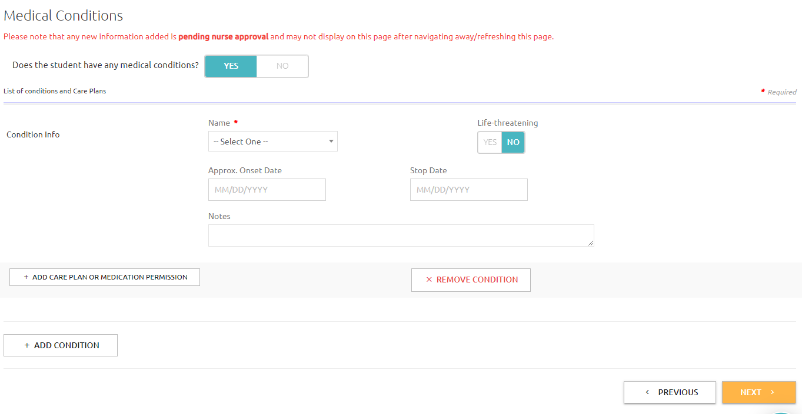

You do not need to upload an immunization card to this page. If you do not have an immunization record, you do not need to upload it. You can click
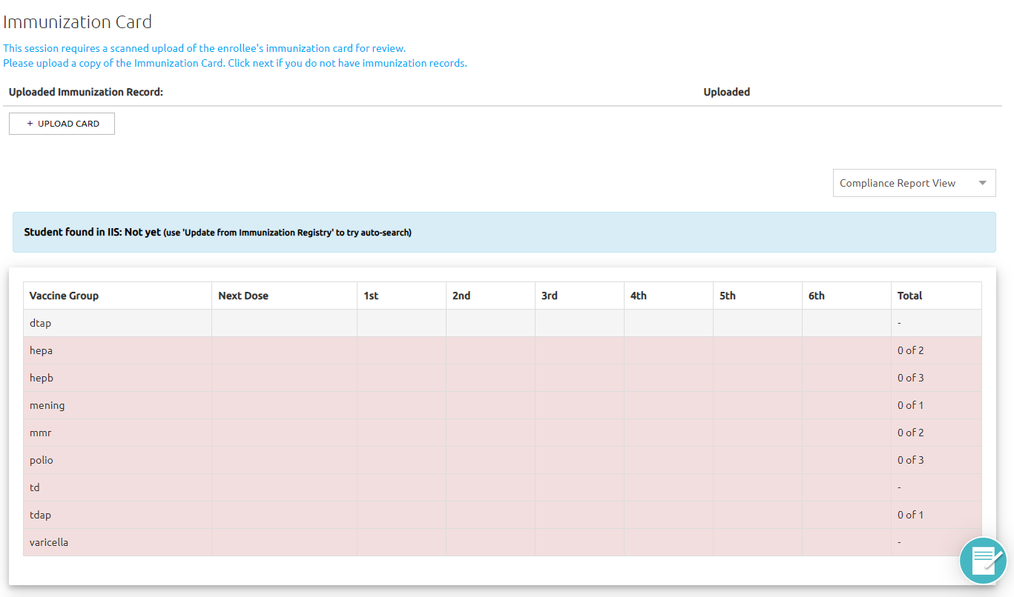
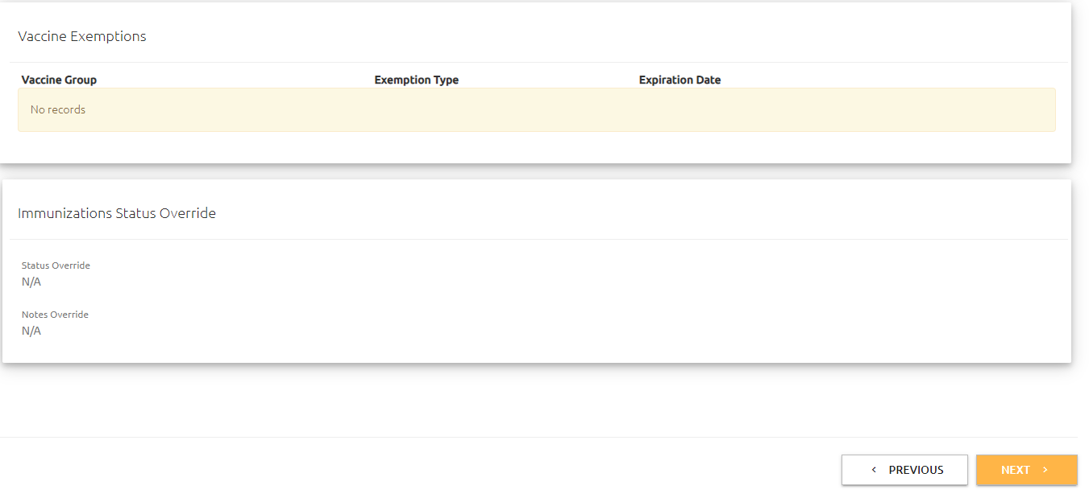

If you child has medication that needs to be administered at school, click
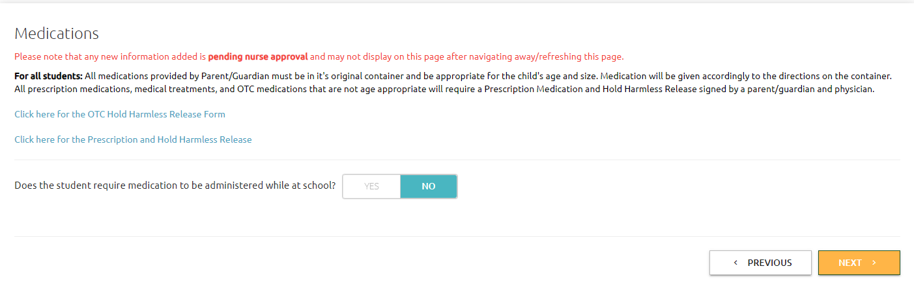
If your child needs to have medication administered at school, click “Yes”. You can download the OTC form if the medication is over the counter or download the Prescription form if your child needs a prescription medication. If you are unable to download or print these forms, the nurse has paper copies in the clinic where she can also add the medication to this record. Click

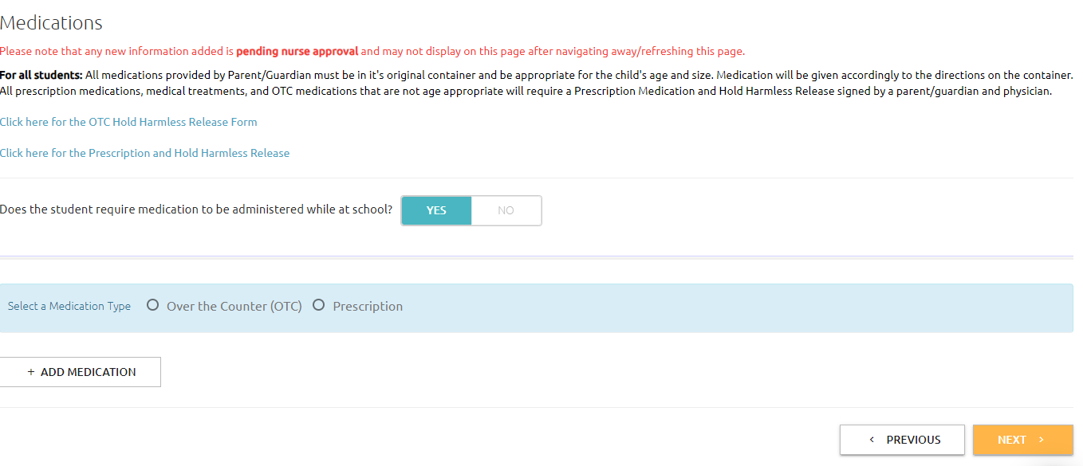

Avon Schools stocks acetaminophen (Tylenol), ibuprofen (Motrin), and Tums in the school clinics. If you want to allow your student to take the medications at school, click “Yes”. If you do not want to allow your student to take these medications at school, the nurse will call to get your verbal permission to administer the medication to your child. Once you have answered these questions, click
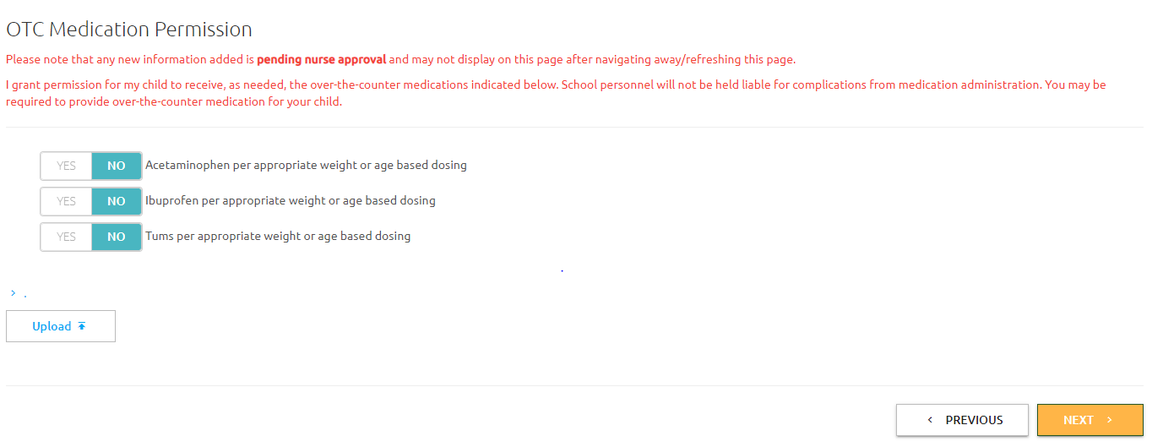

Check this if you will allow the nurse to provide emergency medical services to your child.
Check this box to electronically sign the consent.
Type our relationship too your child here then click here to submit your enrollment.

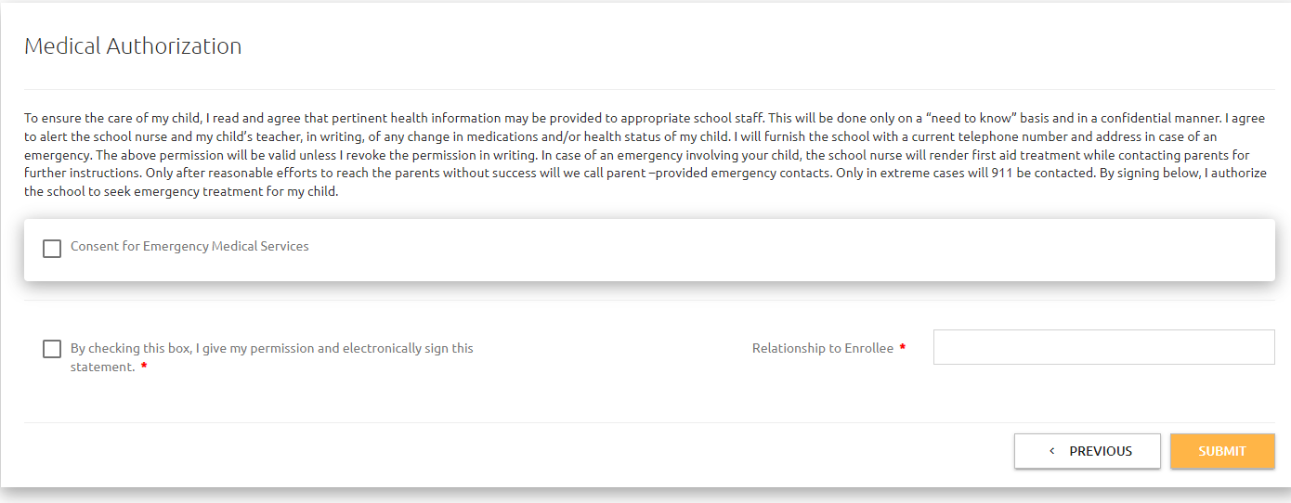

This box will open when you submit your form. Click to complete enrollment.
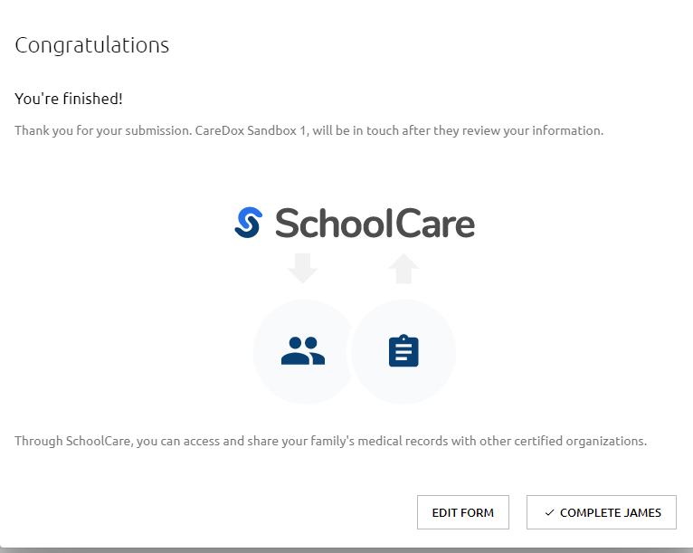

This will take you back to your SchoolCare account page where you can submit enrollment forms for other children in your family.

