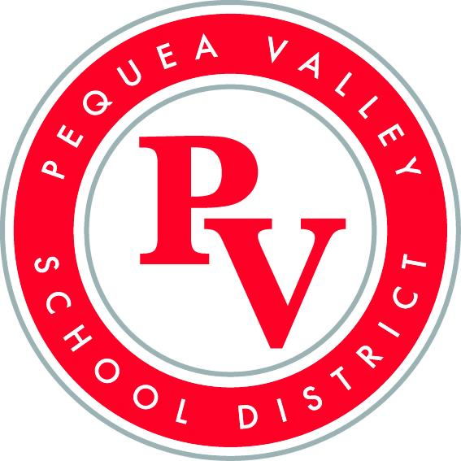

First Choice Update
6/12/2025

Year in Review
- Special thanks to the PV School Board for supporting the First Choice vision of our school. A total of 48 pages of first choice successes were shared this year! These experiences are life-changing to so many learners. Thank you!
- Links to monthly board reports
  - September
  - October
  - November
  - December
  - January
  - February
  - March
  - April
  - May

FIRST CHOICE UPDATE PRESENTATION

First Choice Discovery Mentor Program Website: Looking forward to kicking off a new year of our 11th Grade PV Mentor Program.

