STUDENTS

As a student, I will:

- Remember that I am a KEY scholar and perform accordingly by adhering to the
COUGAR CREED.

- Be receptive of help from my teachers and staff

- Make good choices like paying attention in class, staying on task, doing my best, and working hard at my schoolwork

- Be a leader, make good decisions, and always do my best.

AT HOME

As a parent, I will:

- Support my child’s learning by ensuring that he/she has proper rest and nutrition and attends school on time and on a regular basis

- Support my child’s learning by reading with him/her

- Help set a positive tone for learning with my child


- Participate in decisions relating to the education of my child through a mutually respectful relationship with school staff


- Provide a mutually respectful relationship between all parties (students, parents, teachers, and volunteers
fine arts magnet

4000 Kelley Street Houston TX 77026
Erika Carter, Principal
IN THE CLASSROOM

As a school, we will:

- Provide a high-quality effective learning environment that is safe

- Provide students will rigorous learning opportunities and engaging lessons

- Provide ongoing two-way communication between teachers and parents through parent-teacher-student conferences and frequent reports to parents

- Provide reasonable access to staff through an “open door” policy

- Provide opportunities for parents to volunteer and participate in their child’s class and observe classroom activities

- Provide a mutually respectful relationship between all parties (students, parents, teachers, and volunteers)

OUR GOALS FOR STUDENT ACHIEVEMENT

Our mission is to offer, provide, and equip scholars with the knowledge and tools that will allow each of them to experience success everyday.

100% of our students will be equipped with the academic, social, and emotional tools to ensure each shows growth and is prepared for promotion and/or exit to 9th grade.

DISTRICT GOALS

Houston ISD will provide a package of essential leadership, instructional, social and emotional, and community supports for our school communities, then our schools will be equipped to accelerate preparation of our students to fulfill the qualities and characteristics of the HISD Global Graduate profile.

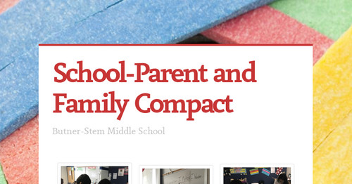

2020-2021

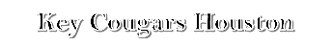
WHAT IS A SCHOOL-PARENT COMPACT?

At Key Middle School, our parents and community are important to us and the growth of our students. The school and parents of the students participating in activities, services, and programs funded by Title I, Part A of the Elementary and Secondary Education Act (ESEA), agree that this compact outlines how the parents, the entire school, and the students will share the responsibility for the improving student academic achievement and the importance of the partnership between the school-parent that will help children achieve this mission.

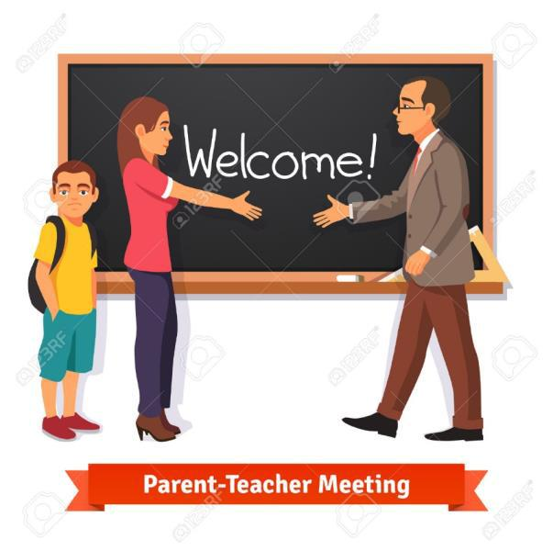
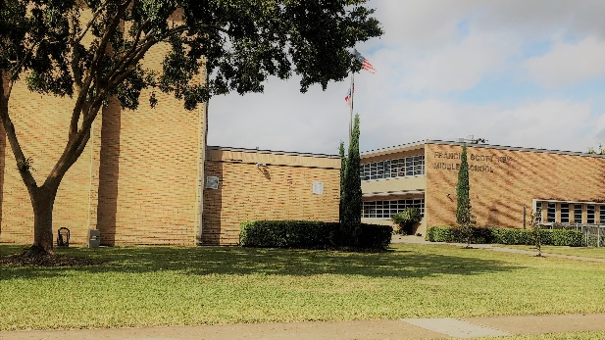
Francis Scott Key Middle School
4000 Kelley Street
Houston TX 77026
713.636.6000
ACTIVITIES TO BUILD

PARTNERSHIPS

- Open House

- Coffee Chats with the Principal

- Academic Night

- Family and Community Engagement Events

- Field Trips/Volunteering

- Career Day

- Sporting Events

COMMUNICATION ABOUT LEARNING

You are always welcome to visit by simply giving the main office prior notice. We would love for you to come and volunteer, but more importantly reinforce our work here at Key by supporting us with the following:

- Ensure your child has good attendance.

- Ensure he or she is well behaved at all times.

- Ensure that your child works hard and
- completes all work.

keymscougars
KEY MIDDLE SCHOOLWILL:

- Provide high-quality curriculum

- Supportive and Effective Learning Environment

- Hold Parent-Teacher Conferences

- Provide parents with reports on students’ progress.

- Provide parents reasonable access to staff

- Provide parent opportunities to volunteer and participate in their child’s class

School Year: 2020-2021

www.houstonisd.org/key


Key Cougars Houston


KeyMS_Cougars

