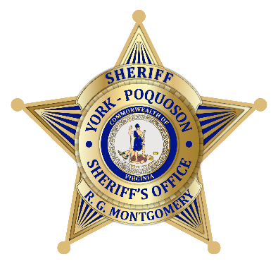
The York-Poquoson Sheriff’s Office is Now Accepting Applications for the York-Poquoson Sheriff’s Office Citizens Academy for Youth (SCA for Youth)

The Sheriff’s Citizens Academy for Youth (SCA for Youth) is a weeklong class that provides insight into the operations of the York-Poquoson Sheriff’s Office.
During this week, students will participate in a variety of law enforcement related activities such as How to Become a Deputy Sheriff, Youth Mental Health, Traffic Laws, Agency Tours, Demonstrations, and Practical Exercises that include Crime Scene Investigations, DUI and Radar Procedures, and Distracted Driving.
This academy is designed for youth between the ages of 14 – 17 years of age (high school aged) who wish to learn more about law enforcement in York County.
Participation in the academy requires a commitment of one week, Monday through Friday, from 9:00 a.m. to 4:00 p.m. The academy dates for this year are August 11 – 15, 2025.

How do I apply?
- Applications can be found online at https://www.yorkcounty.gov/3816/Sheriffs-Citizen-Academy-for-Youth

- The York-Poquoson Sheriff’s Office selects Sheriff’s Office Citizens Academy for Youth participants based on a first come – first serve process. Each applicant is required to pass a criminal background check conducted by the York-Poquoson Sheriff’s Office.

- The York-Poquoson Sheriff’s Office will notify applicants or parents by email of their acceptance into the academy. Class is limited to 12 students.

- For more information contact Crime Prevention Specialist Kevin Taylor (757) 890-3639 or email kevin.taylor@yorkcounty.gov

