June Updates

Dear AP Families and Providers,
The new school year is around the corner and SBCEO: Early Care and Education Program Alternative Payment Program is looking forward to our continued partnerships. To do so please update the following information as it applies to your business or child.
Families:

To ensure your child transitions seamlessly for the new school year. Our program asks to report any school changes that may apply.
- Child will begin Preschool/HeadStart
- Child will begin TK or Kinder (AM, PM or All Day)
- Child will transition to 1st Grade
- Child will transition to Junior High.
To report these changes please contact your Case Worker by July 31st, 2025.

Licensed Providers/Centers:
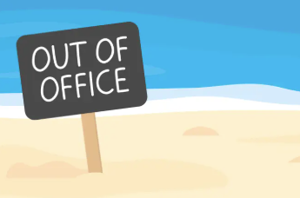
Our new fiscal year is around the corner. Please update 25-26 Non-Operational Days and contact your Provider Specialist or print the following page and submit it to your local Early Care and Education office.

10 Non-Operational day form

Attention:
SBCEO is now offering the option of
digital submission. If you are interested, please contact
our office and we will help you set up your portal.

