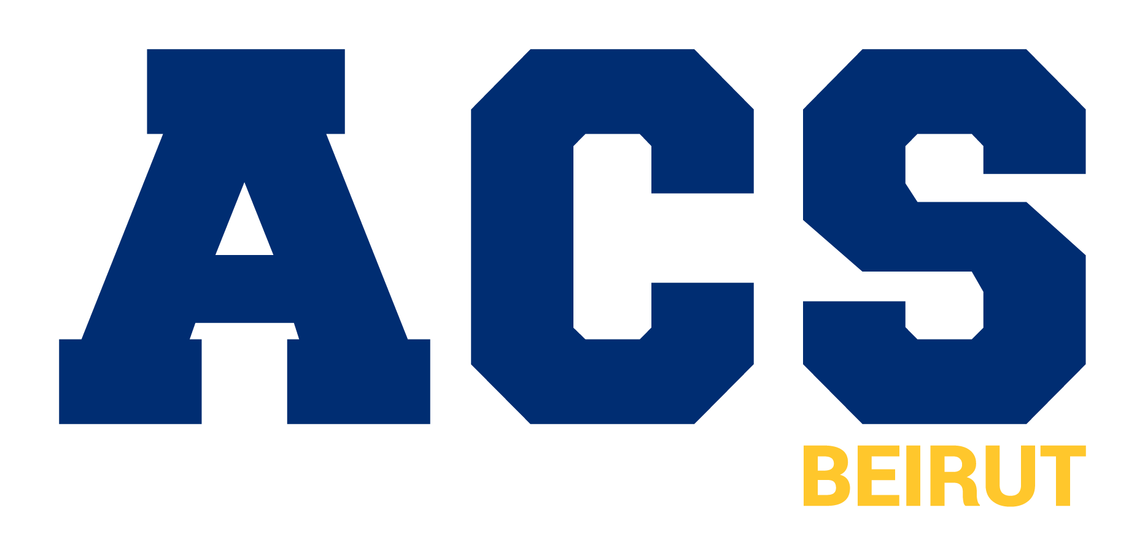

Gifts of Securities

Please complete this form and send a copy to the American Community School Beirut (ACS) – NY Office (A. C. S. 305 E. 47th Street, 8th Floor New York, NY 10017 - 2303 USA) or an email to business@acs.edu.lb ensuring ACS Beirut receives proper notification and that your instructions are carried out in a timely manner.

Please note that shares transferred electronically that do not include the donor’s name will be recorded as ‘Anonymous’ without this form.

For questions or concerns, contact the ACS Development Office at the following email: fhayeck@acs.edu.lb

Please use a separate form for each share transfer.

Donor Name:
Gift Purpose (Check / Highlight all that Apply):

- Annual Fund - Unrestricted
- Financial Aid Fund
- Facilities and Capital Projects
- Academic Programs
- Faculty and Staff
- Sustainability
- General Endowed Funds

Please list this gift as anonymous in publication materials.
( ) Yes ( ) No

Notes - Please note specific Area of Impact here, or leave blank to apply your gift to the Area of Greatest Need:

Details of Shares Transferred:

Company Name:
Company Ticker:
Number of Shares:

ACS Brokerage Account Details:

Charles Schwab
DTC Clearing # 0164 Code 40

Charles Schwab & Co., Inc.
El Paso Operations Center
1945 Northwestern Drive
El Paso, TX 79912-1108

For credit to the American Community School at Beirut
Account Number: 9931-2468

I/We do hereby certify that the above transfer constitutes a gift to the American Community School Beirut, and I/we relinquish all further interest in this instrument.

Sign and Print Name:

Date:
Please note that you may be required to file IRS Form 8283 for gifts of securities or property made to ACS. Please check with your tax advisor.

