FEDERAL PROGRAMS
Principal’s Handbook
John Spikes, Federal Programs Director

Calcasieu Parish
Public Schools

Building Foundations for the Future

Revised May 2025

TABLE of CONTENT

CONTENTS | PAGES
CPSB Federal Programs Checklist | 3
CPSB Federal Programs Staff | 4
Title I Guidelines | 5 - 31
Title I Family Engagement Information and Forms | 32 - 52
Title I Procedures and Forms | 53 – 100
Required Parental Information for Student Code of Conduct | 101 - 113
Title I Job Descriptions | 114 - 119
Certification | 120 - 122
Title III Information and Forms | 123 - 127
Safe & Drug Free Schools Information and Forms | 128 - 132
McKinney-Vento Homeless, Foster Care, Migrant Info. & Forms | 133 - 149

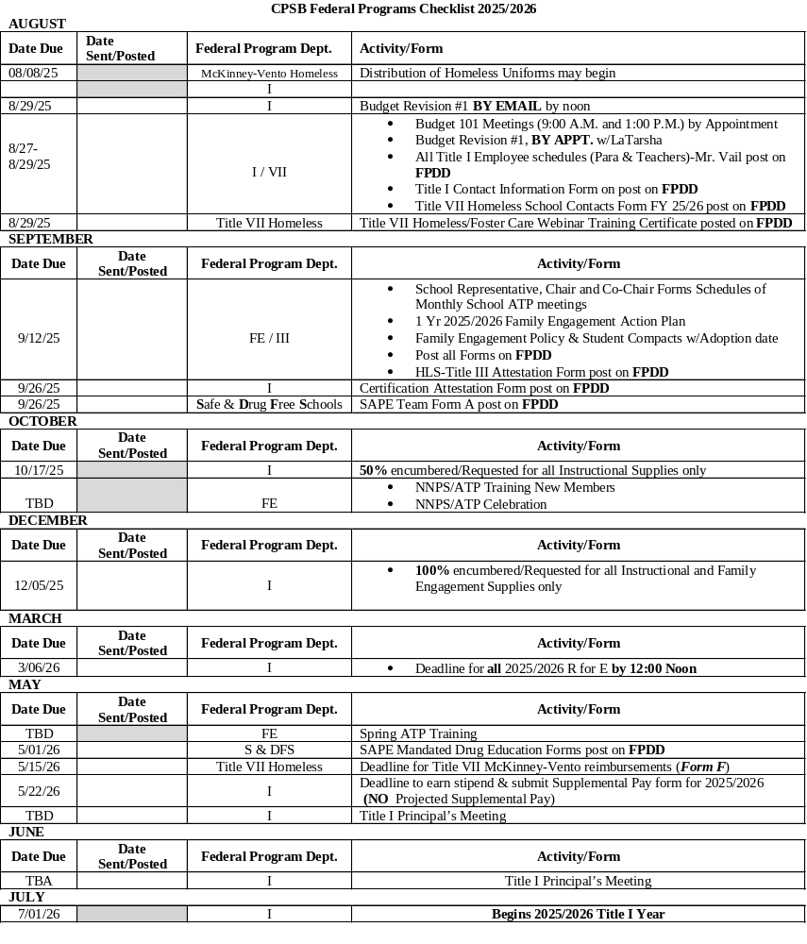

FEDERAL PROGRAMS TEAM 
*3310 Broad Street
John Spikes, Director of Federal Programs
Phone: (337) 217-4170 Ext. 2401 Fax: (337) 217-4171
Email: johnw.spikes@cpsb.org

Richard Vail, Title I Supervisor/CAI Labs
Phone: (337) 217-4170 Ext. 2405 Fax: (337) 217-4171
Email: richard.vail@cpsb.org

LaTarsha Theard, Federal Programs Funds Coordinator
Phone: (337) 217-4170 Ext. 2404 Fax: (337) 217-4171
Email: latarsha.theard@cpsb.org
Courtney Leonard, Federal Programs Funds Coordinator
Phone: (337) 217-4170 Ext. 2411 Fax: (337) 217-4171
Email: julia.bourgeois@cpsb.org
Melonie Wallace, Title I Computer Network Technician
Phone: (337) 217-4170 Ext. 2414 Fax: (337) 217-4171
Email: melonie.wallace@cpsb.org
Crystal Ann Fleming, Federal Programs Secretary
Phone: (337) 217-4170 Ext. 2409 Fax: (337) 217-4171
Email: courtney.leonard@cpsb.org
Della Bell, Federal Programs Secretary
Phone: (337) 217-4170 Ext. 2403 Fax: (337) 217-4171
Email: della.bell @cpsb.org
*2423 6th Street (Rosteet Annex)
Loree L. Smith, Federal Programs Coordinator Title I Family Involvement & Title III
Phone: (337) 217-4170 Ext. 2406 Fax: (337) 217-4173
Email: loree.smith@cpsb.org
Johnethia Bellard, Federal Programs Coordinator Title I & Title VII Homeless Liaison
Phone: (337) 217-4170 Ext. 2408 Fax: (337) 217-4173
Email: carolyn.toups@cpsb.org
Anita Falcon, Title I Non-Public Schools Teacher
Phone: (337) 217-4170 Ext. 2402 Fax: (337) 217-4173
Email: jane.lanza@cpsb.org
Lisa Chaumont, Title I Non-Public Schools Teacher
Phone: (337) 217-4170 Ext. 2402 Fax: (337) 217-4173
Email: lisa.delaney@cpsb.org
Natasha Walker, Title VII Child Advocate
Phone: (337) 217-4170 Ext. 2416 Fax: (337) 217-4173
Email: dianna.thompson@cpsb.org
Lacitta Lavergne, FE & NP Schools Secretary
Phone: (337) 217-4170 Ext. 2402 Fax: (337) 217-4173
Email: joanna.petry@cpsb.org

Kendria Guice, Federal Programs Secretary
Phone: (337) 217-4170 Ext. 2407 Fax: (337) 217-4173
Email: janet.leveque@cpsb.org

Title I
Guidelines and Forms

Title I Guidelines

Purpose of Funding
Funding is to enable children who are most at risk to meet the state’s challenging student academic achievement standards. The schoolwide program is to improve academic achievement throughout a school so that all students, particularly the lowest achieving students, demonstrate proficiency related to the state’s academic standards. Federal Programs is a support to instructional achievement and in no way will be used to circumvent CPSB Policies and/ or Procedures.

Schoolwide Program
A Schoolwide Program permits a school to use funds under Part A of Title I and other federal education program funds and resources to upgrade the entire educational program of the school and to raise academic achievement for all students. Calcasieu Parish School System Federal Programs Department serves all schools having a poverty level of 60% and above for students grades K - 12. Elementary and elementary grade span schools below 60% but greater than 40% poverty level are also served. The date to determine Title I eligibility (ED %) is set by the LDOE. Title I schools are served with a uniform per pupil amount. Schoolwide Programs have great latitude in determining how to spend their Title I, Part A and other program funds as long as they engage in schoolwide reform strategies that increase the amount and quality of learning time and help provide a high-quality curriculum for all children according to a comprehensive plan to help children meet the state academic achievement standards. The expanded opportunity in Title I for schoolwide programs is designed to significantly increase the opportunities of schools, districts, and states to raise the achievement of all children, but particularly those who have always been the intended beneficiaries of Title I: economically disadvantage children, low-achieving children, migrant children, children who are neglected or at risk of dropping out, and Limited English Proficient children. Core elements of a schoolwide program are: a comprehensive needs assessment; a comprehensive plan based on the results of the assessment; and annual evaluation of the plan.

School Wide Program Plan
Federal Guidelines refer to this as a School Wide Program Plan. In Louisiana it has been referred to as the School Wide Plan (SWP).

Any eligible school that desires to operate a schoolwide program shall first develop or amend a comprehensive plan for reforming the total instructional program in the school that:
- Describes how the school will implement the required components listed below.
- Describes how the school will use resources under this part and from other sources to implement those components.
- Includes a list of state, local, and federal programs that will be consolidated in the schoolwide program.
- Describes how the school will provide individual student academic assessment results in a language the parents can understand, including an interpretation of those results, to the parents of a child who participates in the state assessments.

SWP Reminders
- Focus should be on student improvement. Each initiative / strategy should be linked to student achievement.
- Strategies must be Scientific & Research Based and/or Evidenced Based
- Title I Request for Expenditures must be supported by SWP.
- Must be available to the LDOE, District, parents and the public.
- Each School Wide Plan must include ten components in the plan.
- School Wide Components ESSA
- School Wide Plan ESSA
- See following 4 pages for SWP Info:
- LDOE Focus Areas

School Wide Plan Committee
The School Wide Plan Committee according to the LDOE, is a school’s internal assistive team responsible for planning, implementing, and evaluating the school’s improvement process. Typically, the principal or another instructional leader establishes this core planning team. The SWP must be developed with the involvement of parents and other members of the community to be served and individuals who will carry out the plan, including teacher, principals and administrators. If appropriate, the plan developers may also include pupil service personnel, technical assistance providers, school staff and, if the plan relates to a secondary school, students from that school. In addition to possessing diverse skills and experience, the team should be knowledgeable about Title I programs and their regulatory requirements. Use of an existing school leadership group may avoid duplication of effort and capitalize on the collective experience and expertise in the school as long as all the appropriate participants are represented. CPSB recommends that the SWP Committee be diversified and representative of the school and community for which it serves.
SWP Committee Meeting Reminders:
- Documentation must include purpose of meeting, date and signatures of those in attendance. (Agenda & Sign In)
- As per the Superintendent, a copy of the documentation in bullet 1 above MUST be sent to the Federal Programs Director, given to all in attendance, as well as kept on file at school.
- It is recommended to have 4-6 SWP Committee meetings per year. SWP Committee meetings can include: working on SWP, review of data, collaboration for Schoolwide Title I Budget, Family Involvement Action Plan and / or Family Engagement Budget.
- SWP Committee meetings are not staff PD.

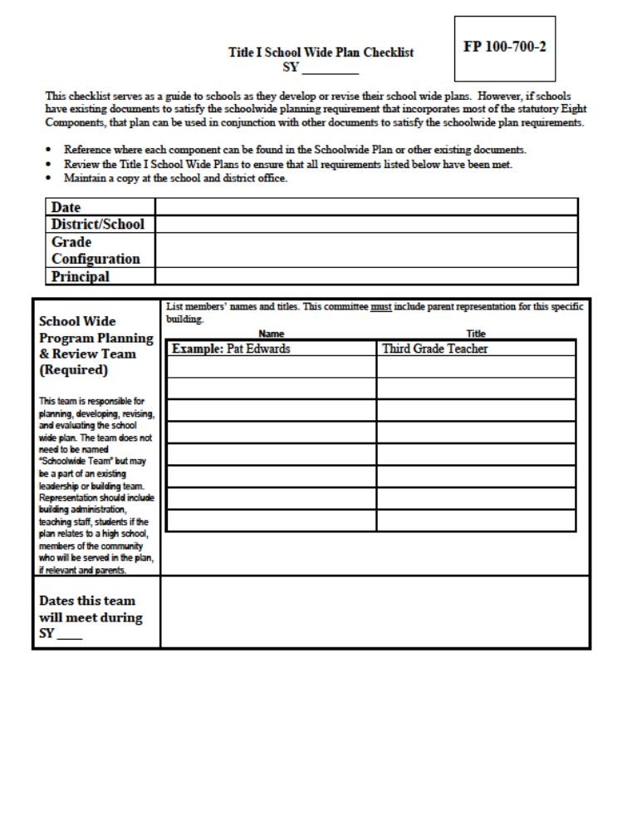

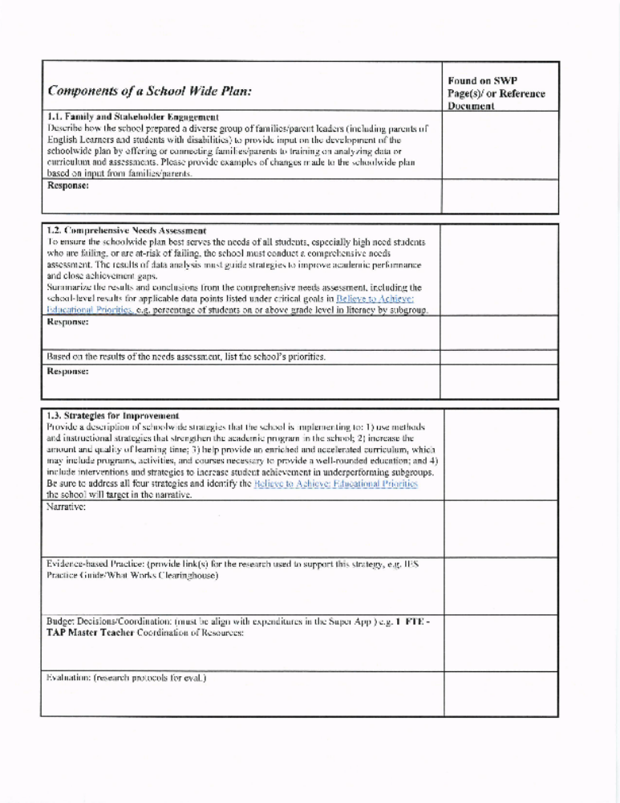

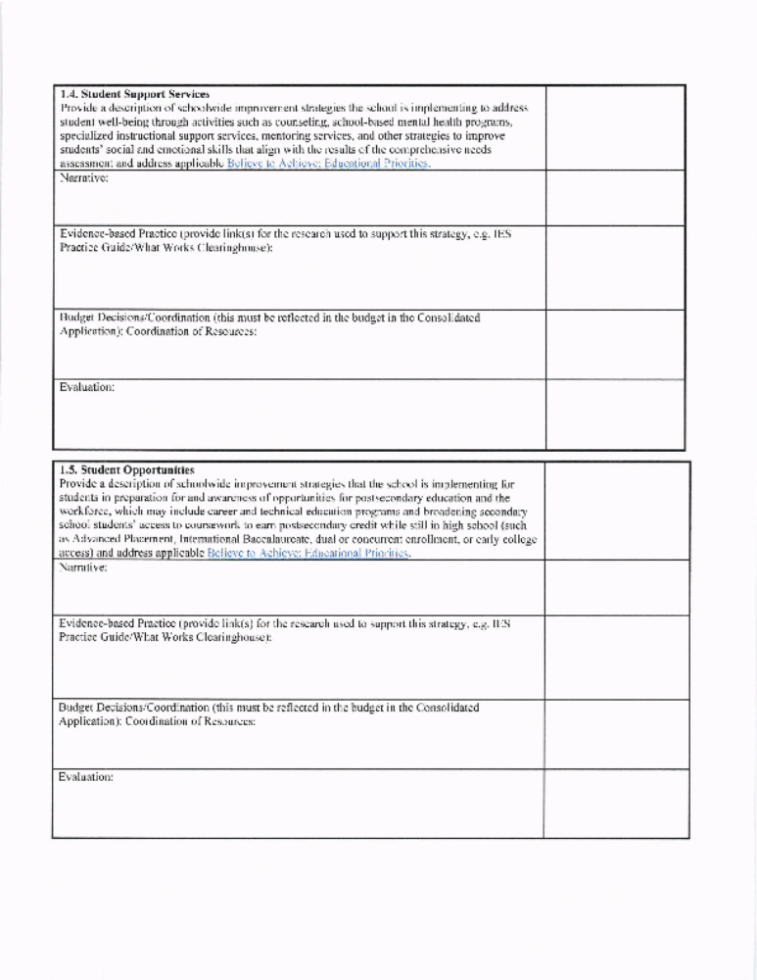

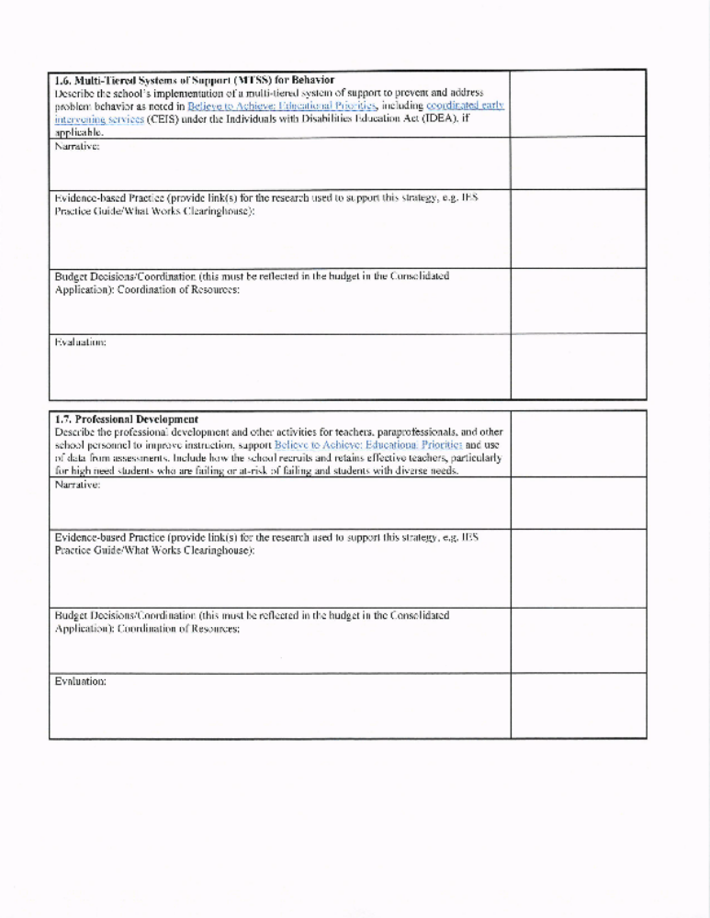

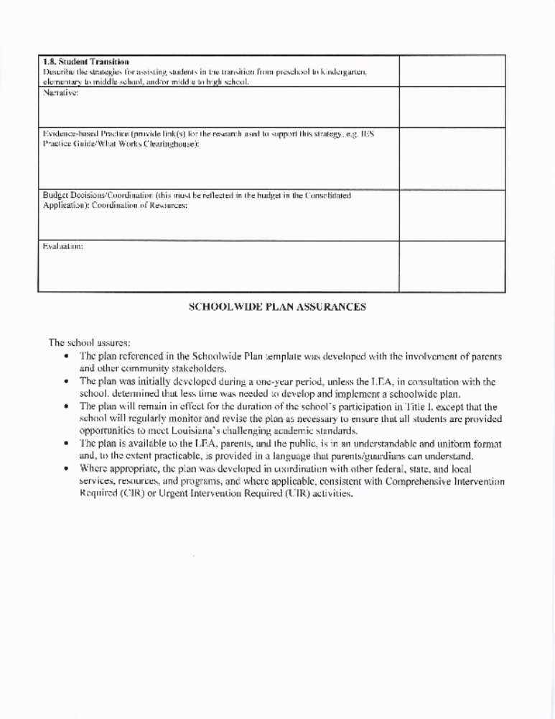

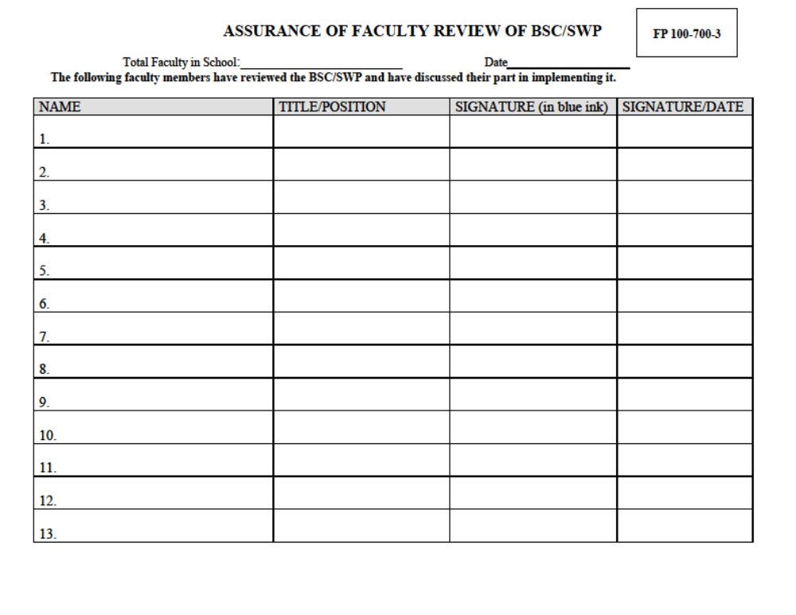

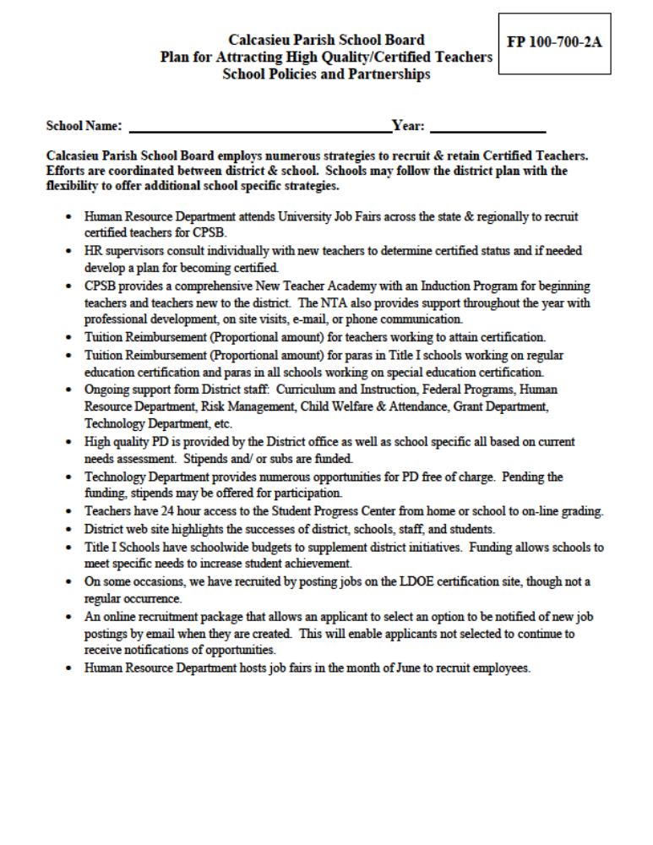
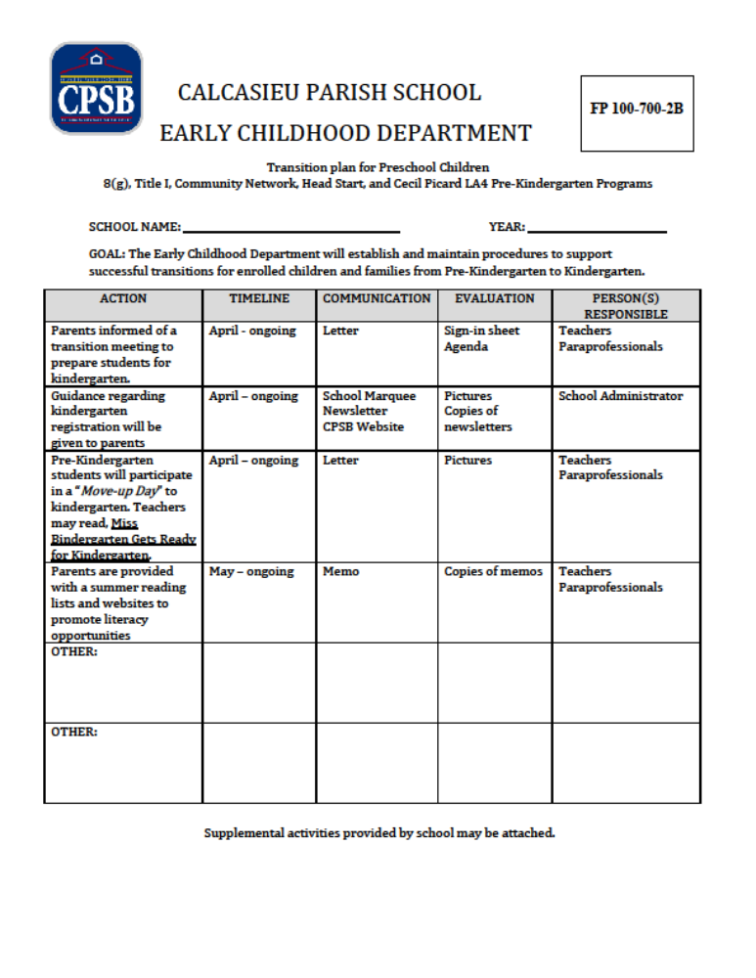

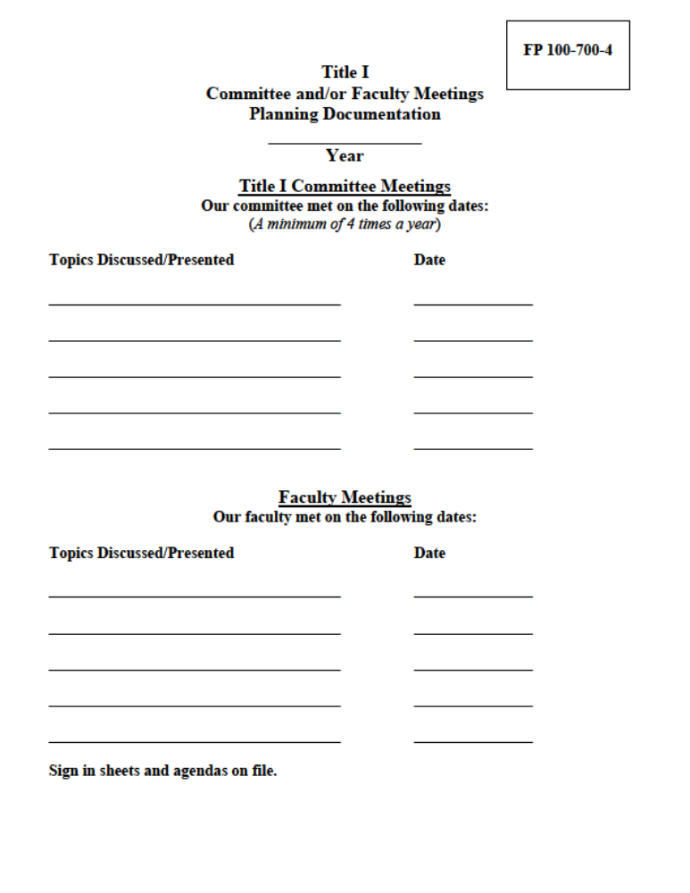

Title I Documentation (5 years)
Title I Schoolwide Program documentation will be maintained according to the LDOE Title I School Checklist. A Title I Documentation Box will be provided to each school to maintain the required documentation. Documentation must be ongoing throughout the school year. Documentation will be checked during each school year by district Federal Program Staff. Title I Schoolwide documentation must be maintained and kept on file for a minimum of 5 years.

Title I School Electronic Documentation (Documentation is NOT an Option!) The Federal Programs documentation box will assist Title I schools with the necessary documentation of the Title I Schoolwide Program. Listed below are the Topics included in the Group Discussion Board and suggested items for evidence of compliance.
- LDE Info: School Monitoring Checklist, info received from LDE
- (1) SWP: SWP, School Budget Justification
- (2) Budget & Related Information: Budget Sheet w/ updates & notifications, budget communications (e-mails, memos, etc.), calendar w/ dates
- (3) Purchasing Procedures: Principal meeting agendas, memos, FP Handbook, meetings w/ FP Office
- (4) Technical Assistance: Agendas, sign ins, FP technical assistance forms, FP Handbook & Website, memos, e-mails, FP forms, date checklist
- (5) (13) Highly Qualified/Teaching Certification: Para Pro test info & form, para tuition reimbursement, FP Handbook & Website, HR info for teacher tuition reimbursement, New Teacher Academy info
- (6) Professional Development: All documentation of PD, FP Handbook & Website PD info
- (7) (16) Coordination of Services: Examples of other services / programs supporting school, Title III, X, S&DFS folders in “Doc Box”
- (8) Supplies support SWP: Documentation of R for E w/ SWP (PD, FI, Instructional)
- (9) Fixed Assets: FA Inventory, FA Disposal Form, memos, e-mails
- (10) (11) Title I Funded Staff & Support SWP: List of Title I found staff, job descriptions, budgets, PARs, copies of SWP pages(s) identifying positions
- (12) Funds address needs: SWP portion indicating spending aligns w/needs, data sources / documentation
- (14) Principal Certification Attestation Form: Attestation form w/ Certification documentation for all staff
- (15) Family Engagement: FE Action Plan, all FE documentation
- Technology Integration: Alignment w/SIP, documentation for software selection, teacher accompanying students to lab, lab manager responsibilities / job description, lab reports generated & to teacher, equipment tagged & in FA inventory.
- Paraprofessional Documentation: Job description, daily schedule, PD, HQ qualifications
- Title III EL-Home Language Survey Attestation Form
- S & DF Schools
- Title VII McKinney-Vento Homeless

Allowable Cost Must Meet the Following Criteria
Necessary & Reasonable, Allocable
- A cost is reasonable if it does not exceed that which would be incurred by a prudent person under similar circumstances.
Allocable to the Federal Grant /Adequately documented
- If the goods or services involved benefit the program
Authorized or Not Prohibited by State or Local Law
Supplement not Supplant
- An LEA may use program funds only to supplement and, to the extent practical, increase the level of funds that would, in the absence of the Federal funds, be made available from Non-Federal sources for the education of participating students. In no case may an LEA use Federal Programs to supplant funds from Non-Federal Sources.

Non-Allowable Expenditures (Not All-Inclusive List)
Subs for testing
Split funding of staff
Furniture, Staff, Student ID badges, Clocks
Incentives, gifts, door prizes
Student Refreshments, Meals (Pizza, Any Size Sandwiches, Condiments, etc.)
Any item/staff used non instructionally
Excessive amounts of supplies (especially purchased end of year)
Any item for teacher/administrative use: Teacher’s Personal/Desk Supplies, stapler, staples, tape
Reimbursements to schools’ w/ exception of Field Trips.

Red Flag Expenditures (burden of proof on school, individual)
Large amounts of stipend pay per CPSB individual
Items that appear to be used administratively / non instructionally / personally
Paraprofessional that appears to being used other than by guidelines
Large quantities of supplies, Restocking of Teacher / Office Supplies

Budget
Title I funding is based on a formula grant. Schools are given a Title I Schoolwide budget according to the number of students qualifying for F/R and/or ED lunch. An electronic budget spreadsheet is available for each school. One-on-one assistance will be given to schools as needed to plan their schoolwide budget. Purchasing procedures and guidelines are included in a separate tabbed section. All orders must be handled through the Title I office. Accuracy is necessary
Electronic Request for Expenditure
- The first step for spending any Federal Program funds
- Completed in detail w/ accurate, current info, including shipping
- Must attach to R for E email quote from the vendor (email 6wks prior to activity)
- Must include the SWP page w/activity identified that supports request for funding.
- Must be approved prior to spending

See Quick Reference Guide for Forms

2025-2026 Public Title I Budget
School Name:
ALLOCATION SUMMARY
Allocation Details | Issued Date / Description |  | Authorized Budget
Tentative Allocation |  | Original | $0.00
Allocation Change: |  |  | 0.00
Allocation Change: |  | Prior Year | 0.00
Allocation Change: |  | Final | 0.00
Total Approved Allocation |  |  | $0.00
Budget Details | Description of Activity |  | Cost of Activity
100 Salaries
Salaries | Curriculum Coordinator |  | $0.00
 | Curriculum Coordinator |  | 0.00
 | Lead Teacher |  | 0.00
 | Lead Teacher |  | 0.00
 | Instructional Teacher |  | 0.00
 | Instructional Teacher |  | 0.00
 | Paraprofessional |  | 0.00
 | Paraprofessional |  | 0.00
 | Lab Technician |  | 0.00
 | Lab Technician |  | 0.00
Total Salaries |  |  | $0.00
Stipends - Professional Development | Activity 1: |  | $0.00
 | Activity 2: |  | 0.00
 | Activity 3: |  | 0.00
 | Activity 4: |  | 0.00
Total Stipends - Professional Development |  |  | $0.00
Stipends - Tutorial Programs | Activity 1: |  | $0.00
 | Activity 2: |  | 0.00
 | Activity 3: |  | 0.00
 | Activity 4: |  | 0.00
Total Stipends - Tutorial Programs |  |  | $0.00
Substitutes - Professional Development | Activity 1: |  | $0.00
 | Activity 2: |  | 0.00
 | Activity 3: |  | 0.00
 | Activity 4: |  | 0.00
Total Substitutes - Professional Development |  |  | $0.00
Bus Drivers - Tutorial Programs | Activity 1: |  | $0.00
 | Activity 2: |  | 0.00
 | Activity 3: |  | 0.00
 | Activity 4: |  | 0.00
Total Bus Drivers - Tutorial Programs |  |  | $0.00
Bus Drivers - Field Trip | Activity 1: |  | $0.00
 | Activity 2: |  | 0.00

 | Activity 3: |  | 0.00
 | Activity 4: |  | 0.00
Total Bus Drivers - Field Trip |  |  | $0.00
200 Benefits
Benefits | Salaries | (Automatically populates) | $0.00
Benefits | Stipends | (Automatically populates) | 0.00
Benefits | Substitutes | (Automatically populates) | 0.00
Benefits | Bus Drivers | (Automatically populates) | 0.00
Total Benefits |  |  | $0.00
300 Professional Services
Contract Speaker | Name of Spkr |  | $0.00
Contract Speaker | Name of Spkr |  | 0.00
Contract Speaker | Name of Spkr |  | 0.00
Contract Speaker | Name of Spkr |  | 0.00
Total Contract Speaker |  |  | $0.00
Purchased Services | Name of Vendor |  | $0.00
Purchased Services | Name of Vendor |  | 0.00
Purchased Services | Name of Vendor |  | 0.00
Purchased Services | Name of Vendor |  | 0.00
Total Purchased Services |  |  | $0.00
400 Property Services
Copier Rental | Vendor/Lease Term |  | $0.00
Copier Rental | Vendor/Lease  Term |  | 0.00
Copier Rental | Vendor/Lease  Term |  | 0.00
Copier Rental | Vendor/Lease  Term |  | 0.00
Total Copier Rental |  |  | $0.00
Maintenance/Repair Agreement | Vendor/Lease Term |  | $0.00
Maintenance/Repair Agreement | Vendor/Lease  Term |  | 0.00
Maintenance/Repair Agreement | Vendor/Lease  Term |  | 0.00
Maintenance/Repair Agreement | Vendor/Lease  Term |  | 0.00
Total Maintenance/Repair Agreement |  |  | $0.00
Equipment Wiring/Installation | Vendor/Item |  | $0.00
Equipment Wiring/Installation | Vendor/Item |  | 0.00
Equipment Wiring/Installation | Vendor/Item |  | 0.00
Equipment Wiring/Installation | Vendor/Item |  | 0.00
Total Equipment Wiring/Installation |  |  | $0.00
500 Other Purchase Services
Charter Bus | Vendor |  | $0.00
Charter Bus | Vendor |  | 0.00
Charter Bus | Vendor |  | 0.00
Charter Bus | Vendor |  | 0.00
Total Charter Bus |  |  | $0.00
Field Trip/Admission Tickets | Vendor |  | $0.00
Field Trip/Admission Tickets | Vendor |  | 0.00
Field Trip/Admission Tickets | Vendor |  | 0.00
Field Trip/Admission Tickets | Vendor |  | 0.00

Total Field/Trip Admission Tickets | $0.00
Printing & Binding | Vendor | $0.00
Printing & Binding | Vendor | 0.00
Printing & Binding | Vendor | 0.00
Printing & Binding | Vendor | 0.00
Total Printing & Binding |  | $0.00
Site License / Online Subscriptions | Vendor | $0.00
Site License / Online Subscriptions | Vendor | 0.00
Site License / Online Subscriptions | Vendor | 0.00
Site License / Online Subscriptions | Vendor | 0.00
Total Site License / Online Subscriptions |  | $0.00
Testing Fees | Vendor/# of Recipients | $0.00
Testing Fees | Vendor/# of Recipients | 0.00
Testing Fees | Vendor/# of Recipients | 0.00
Testing Fees | Vendor/# of Recipients | 0.00
Total Testing Fees |  | $0.00
Travel - Professional Development | Conference | $0.00
Travel - Professional Development | Conference | 0.00
Travel - Professional Development | Conference | 0.00
Travel - Professional Development | Conference | 0.00
Travel - Professional Development | Conference | 0.00
Travel - Professional Development | Conference | 0.00
Travel - Professional Development | Conference | 0.00
Total Travel - Professional Development |  | $0.00
600 Supplies
Instructional Supplies | Vendor | $0.00
Instructional Supplies | Vendor | 0.00
Instructional Supplies | Vendor | 0.00
Instructional Supplies | Vendor | 0.00
Instructional Supplies | Vendor | 0.00
Instructional Supplies | Vendor | 0.00
Instructional Supplies | Vendor | 0.00
Total Instructional Supplies |  | $0.00
Professional Development Supplies | Vendor | $0.00
Professional Development Supplies | Vendor | 0.00
Professional Development Supplies | Vendor | 0.00
Professional Development Supplies | Vendor | 0.00
Total Professional Development Supplies |  | $0.00
700 Equipment
Equipment* ($5,000+ per item) | Vendor/Item | $0.00
* Requires formal justification | Vendor/Item | 0.00
 | Vendor/Item | 0.00
Total Equipment |  | $0.00
TOTAL ALLOCATED AUTHORIZED BUDGET |  | $0.00
Budget Discrepancy (Over)/Under** |  | $0.00
** If there is a balance greater than $0.00 in line identified as "Budget Discrepancy", this amount indicates that the authorized budget allocation

is either over allocated or under allocated. An amount in "RED ($)" indicates that the budget allocation is over allocated and needs to be
decreased to meet authorized budget. An amount in "BLACK $" indicates that budget allocation is under allocated and needs to be
increased to meet authorized budget.
Comments or Notes:
Principal's Signature |  | Date

2025-2026 Public Family Engagement Title I Budget
School Name:
ALLOCATION SUMMARY
Allocation Details | Issued Date / Description |  | Authorized Budget
Tentative Allocation | 01/00/00 | Original | $0.00
Allocation Change: |  | District | 0.00
Allocation Change: | 01/00/00 | Prior Year | 0.00
Allocation Change: | 01/00/00 | Final | 0.00
Total Approved Allocation |  |  | $0.00
Budget Details | Description of Activity |  | Cost of Activity
100 Salaries
Stipends - Family Engagement | Activity 1: |  | $0.00
 | Activity 2: |  | 0.00
 | Activity 3: |  | 0.00
 | Activity 4: |  | 0.00
Total Stipends - Family Engagement |  |  | $0.00
Substitutes - Family Engagement | Activity 1: |  | $0.00
 | Activity 2: |  | 0.00
 | Activity 3: |  | 0.00
 | Activity 4: |  | 0.00
Total Substitutes - Family Engagement |  |  | $0.00
Bus Drivers - Family Engagement | Activity 1: |  | $0.00
 | Activity 2: |  | 0.00
 | Activity 3: |  | 0.00
 | Activity 4: |  | 0.00
Total Bus Drivers - Family Engagement |  |  | $0.00
200 Benefits
Benefits | Stipends | (Automatically populates) | $0.00
 | Substitutes | (Automatically populates) | 0.00
 | Bus Drivers | (Automatically populates) | 0.00
Total Benefits - Family Engagement |  |  | $0.00
300 Professional Services
Contract Speaker | Name of Spkr |  | $0.00
 | Name of Spkr |  | 0.00
 | Name of Spkr |  | 0.00
 | Name of Spkr |  | 0.00
Total Contract Speaker - Family Engagement |  |  | $0.00
500 Other Purchase Services
Postage - Family Engagement | Vendor |  | $0.00
 | Vendor |  | 0.00
 | Vendor |  | 0.00
 | Vendor |  | 0.00
Total Postage - Family Engagement |  |  | $0.00
Site License - Family Engagement | Vendor |  | $0.00
 | Vendor |  | 0.00
 | Vendor |  | 0.00
 | Vendor |  | 0.00
Total Site License - Family Engagement |  |  | $0.00
Travel - Family Engagement | Conference |  | $0.00
 | Conference |  | 0.00
 | Conference |  | 0.00
 | Conference |  | 0.00
Total Travel - Family Engagement |  |  | $0.00
600 Supplies - Family Engagement
Supplies - Family Engagement | Activity 1: |  | $0.00
 | Activity 2: |  | 0.00
 | Activity 3: |  | 0.00
 | Activity 4: |  | 0.00
 | Activity 5: |  | 0.00
 | Activity 6: |  | 0.00
Total Supplies - Family Engagement |  |  | $0.00
Refreshments - Family Engagement | Activity 1: |  | $299.00
 | Activity 2: |  | 0.00
 | Activity 3: |  | 0.00
 | Activity 4: |  | 0.00
 | Activity 5: |  | 0.00
 | Activity 6: |  | 0.00
Total Refreshments - Family Engagement |  |  | $299.00
800 Other Objects - Family Engagement
Membership Dues & Fees | Vendor | Johns Hopkins University - NNPS | $0.00
 | Vendor |  | 0.00
Total Membership Dues & Fees |  |  | $0.00
TOTAL ALLOCATED AUTHORIZED BUDGET |  |  | $299.00
Budget Discrepancy (Over)/Under* |  |  | ($299.00)
* If there is a balance greater than $0.00 in line identified as "Budget Discrepancy", this amount indicates that the authorized budget allocation
is either over allocated or under allocated. An amount in "RED ($)" indicates that the budget allocation is over allocated and needs to be
decreased to meet authorized budget. An amount in "BLACK $" indicates that budget allocation is under allocated and needs to be
increased to meet authorized budget.
Comments or Notes:
Principal's Signature |  |  | Date

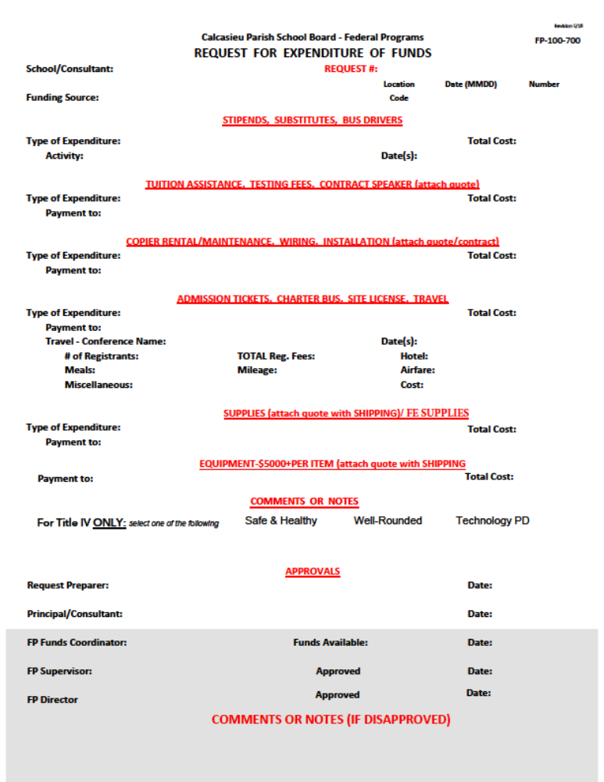

Fixed Assets
CPSB policy states that Equipment is property at the threshold of $5000. Supplies are considered below the $5000 threshold. Computers will be tagged as a Fixed Asset (items of street value). Red flags are items bought in large quantities and items that are more expensive but less than $5000. Examples are copiers, tv’s, printers, ActivBoards, electronic carts, etc. Title I items under $5000 must be labeled with permanent marker as “Title I”. For Title I purposes, schools are held accountable for all items purchased with Federal Funds. Schools must be able to locate all items purchased with Federal Funds. Title I Dept. will make random
Fixed Asset checks.
- Items purchased with Title I $ must be instructional in purpose and may NOT be used in an administrative nature.
- All Title I Fixed Assets must be located and assigned to a specific location (instructional in nature). “Cannot be located” is not an allowable response.
- Contact Federal Programs prior to discarding OLD Title I Fixed Assets, so that she can advise you on the proper procedure.
- It is the school’s responsibility to replace items that cannot be located unless deemed old enough to be discarded at $0. (Contact Federal Programs)
- A Police Report is required for any item purchased with Federal Funds that has been stolen. A Police Report is required for the stolen item to be removed from the FA List. Federal Programs will not replace stolen items.
Auditors have found issues with fixed assets in the following areas:
- Schools purchasing items with school activity funds and never recording those items as fixed asset or requesting tags.
- Items discarded at schools but never reported to the fixed asset department as discarded.
- Items reported as stolen with no police report
- Items listed in the wrong room or location
- Items listed in non-instructional locations
- Items not assigned to teacher

Technical Assistance
CPSB Federal Programs Department will hold an annual meeting for Title I principals and/or Title I school budget coordinator. The Federal Programs Department will have a current Federal Programs Handbook and website. A Federal Programs Doc Box/Electronic Documentation will be used for Title I Program documentation as required for LDE school monitoring. Each school will have access to their school allocations and balances. Federal Programs Department Staff will complete a Technical Assistance Form for documentation of technical assistance as assistance is given. A signed copy of the form will be given to the school principal / designee and/or the person for whom assistance was provided.

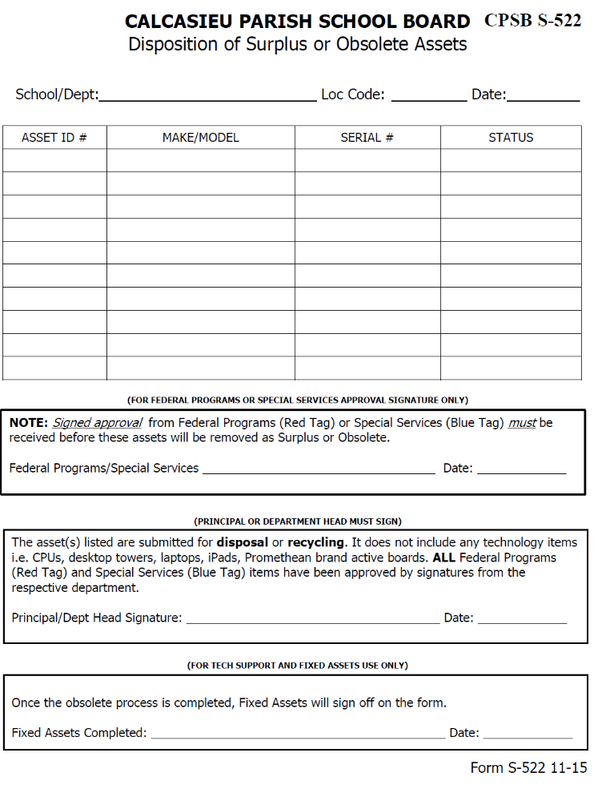

Professional Development
A schoolwide program must provide ongoing and high quality professional development aligned with the state academic standards for principals, teachers, and paraprofessionals to enable all children in the school to meet the state’s student academic achievement standards. Teachers should also be included in professional development activities regarding assessments, so they can provide information on, and improve the achievement of individual students and the overall instructional program. The school will devote sufficient resources to effectively carry out professional development activities. Once a school is identified for improvement, the school must commit to spending at least 10% of its Title I funds (or an amount equal to 10% of Title I funds) to provide high quality professional development. Stipend pay is NOT allowable for Professional Development Travel. PD stipend pay is not allowable for subs. It is not allowable to hire a sub for a sub to attend PD.

Professional Development includes activities that:
- Improve and increase teachers’ academic knowledge;
- Are an integral part of board schoolwide and district wide educational improvement plans;
- Give teachers, principals, and administrators the knowledge and skills to provide students with the opportunity to meet challenging state academic content standards and student academic achievement standards;
- Improve classroom management skills;
- Are high quality, sustained, intensive and classroom-focused in order to have a positive and lasting impact on classroom instruction and the teacher’s performance in the classroom; and are not 1-day or short-term workshops or conferences;
- Support the recruiting, hiring and training of certified teachers, including teachers who became certified through state and local alternative routes to certification;
- Advance teacher understanding of effective instructional strategies that –
    - are based on scientifically based research/evidence based and strategies for improving student academic achievement or substantially increasing the knowledge and teaching skills of teachers; and
    - are aligned with directly related to state academic content standards, student academic achievement standards and assessments, and the curricula and programs tied to the standards;
- Are developed with extensive participation of teachers, principals, parents and administrators of schools to be served under ESSA;
- Are designed to give teachers of limited English proficient children, and other teachers and instructional staff, the knowledge and skills to provide instruction and appropriate language and academic support services to those children, including the appropriate use of curriculum and assessments;
- To the extent appropriate, provide training for teachers and principals in how to use technology in the classroom to improve teaching;
- As a whole, are regularly evaluated for their impact on increased teacher effectiveness and improved student academic achievement, with the findings used to improve the quality of professional development;
- Provide instruction in methods of teaching special needs children;
- Include instruction in the use of data and assessments to inform and instruct classroom practice; and
- Include instruction in how school staff can work more effectively with parents.

Certification
Just as all children in a School Wide Program are considered Title I students, all staff in a Title I school is considered Title I staff. Title I Principals must work toward a goal of 100% of core academic subjects being taught by certified teachers. All Title I funded staff MUST be certified. ESSA specifies that all teachers in core subjects are to be certified. Core academic subjects are: (These are umbrellas for related subjects)
- English
- Reading
- Language Arts
- Math
- Science
- Foreign Languages
- Civics & Government
- Economics
- Arts
- History
- Geography
ESSA Parental Notification Requirements specify that an LEA must notify parents of Title I students that parents may request certain information on the professional qualifications of the student’s classroom teacher and paraprofessionals providing services to the child. CPSB procedure for compliance with this requirement is fulfilled by all parents receiving notification at the beginning of the school year through the district Student Code of Conduct or another method of the school’s choosing. This information is available for all stakeholders on the district Federal Programs Website and Brochure.

Parental Notification Requirements also include that schools provide to each individual parent timely notice that the parent’s child has been assigned to, or taught for 4 or more consecutive weeks by a teacher who is not certified. CPSB procedure for notifying parents is by use of a district form letter for parents. This form letter accompanied by an assurance letter and a copy of the class roster will be sent to the appropriate school level personnel supervisor. All parent notification procedures are on the Federal Programs website as well as the Federal Programs Handbook. The “Parents Right to Know” information is available for all stakeholders on the Federal Programs Website.

Title I Principals are required to work with the CPSB Personnel Department to determine each teacher’s and paraprofessional’s Certification status. The district form for Certification status and attached documentation must be kept on file at the school. CPSB Certification Status form is on the Federal Programs Website and in the Federal Programs Handbook. A Certification Attestation Form will be signed by the principal of each Title I school and submitted annually to the Director of Federal Programs. Attestation form is available on the FP Website.

Paraprofessionals
All paraprofessionals (regular & special ed) hired to work in Title I schools in CPSB will be HQ prior to being hired. All paras with instructional duties and working in a program supported by Title I funds must hold a high school diploma or its recognized equivalent AND 48 hours from an accredited college, or associate’s degree, or pass the Para Pro Test. Paraprofessionals needing to take the Para Pro test to become HQ must be recommended by the school principal using the CPSB Federal Programs Para Pro Testing Recommendation Form (Website & Handbook). The principal or designee will fax the Para Pro Testing Recommendation Form to the Federal Department at 337-217-4171Ext. 2403 or Ext. 2411.The Federal Programs Office will call the recommended para to set up a testing date prior to taking the test. Once the test is completed the recommended para will receive a copy of PP scores to bring to the school principal.

HQ Paraprofessionals may perform the following instructional support duties:
- One on one tutoring for eligible students, if tutoring is scheduled at a time when a student would not otherwise receive instruction from a teacher;
- Assisting with classroom management, such as organizing instructional and other materials;
- Assisting in computer instruction;
- Conducting parental involvement activities;
- Providing instructional support in a library or media center;
- Acting as a translator; and
- Providing instructional support services.
Paraprofessionals cannot assume any duties that are inconsistent with this list. A prerequisite to providing any instructional services (including the services identified above) is that the paraprofessional must work under the direct supervision of a highly qualified teacher. Direct supervision means, first, the teacher must plan the instructional activities that the paraprofessional carries out. Second, the teacher must evaluate the achievement of the students with whom the paraprofessional is working. Finally the paraprofessional must work in “close and frequent physical proximity” to the teacher. A program where a teacher visits a site once or twice a week but otherwise is not in the classroom, or a program where a para works with a group of students in another location while the teacher provides instruction to the rest of the class, would not meet the proximity requirement. A paraprofessional may assume limited duties that are assigned to similar personnel who are not working in a Title I Program, as long as the amount of time spent on such duties is the same proportion of total work as the time spent by the similar personnel. These limited duties may include non-instructional duties, such as recess or other duties that do not benefit Title I participating students.
Title I Paraprofessional Tuition Exemption
Paraprofessionals working at a Title I School may be eligible for college tuition exemption. The paraprofessional must be HQ and pursuing a teaching certification every semester in the core content area (see list under HQ). The application for Title I Paraprofessional College Tuition Reimbursement (Handbook and Website) must be completed and approved prior to reimbursement. Complete fulfillment of requirements with documentation as listed on the application must be attained for reimbursement. Reimbursement amounts may vary by year according to District Title I budget. Funds are limited. More information is available in the Federal Programs Office.

Personnel Staffing
All staffing must support implementation and continuation of school Title I program as outlined in your SWP. Schools must have sufficient funds to pay salaries including pay raises, cost of subs, benefits, insurance and pay supplements during the year. All personnel hired with Title I funding must be recommended using the Title I Recommendation Form (on website and in Federal Programs Handbook). The form will be sent to the appropriate Administrative Director first. It will then be routed to Federal Programs Department. All Title I funded employees must be Certified. Every Title I funded employee must have a daily instructional schedule which will be kept on file at the district office.

Salaries
All salaries must support implementation and continuation of school Title I program as outlined in your SWP. Title I teachers working or attending professional development that is outside the normal CPSB dates/time of pay may receive a stipend as long as the PD is held on a CPSB site and is in support of the SWP. Stipend Pay is allowable only for support of instruction and increasing student achievement. Stipend pay is not allowable for administrative duties or teacher management tasks. Examples are planning or creating schedules, daily lesson plans, and the normal expectation of a job requirement as Open House & Parent Conferences. Stipend pay is not allowable for Professional Development travel. Stipend Pay is not allowable for subs. Stipend pay for tutoring is relative to the number of students in attendance. Maximum amount allowable for specific activities may be determined by Federal Programs Department. The stipend must be requested on a R for E prior to work / PD being done. Supplemental Pay forms must match sign in sheet(s) and agenda.
Stipend Pay
- Degreed staff - $35 per hour
- Paraprofessional - Hourly rate up to 40 hours per week then 1.5 hourly rate
Subs needed for Title I teachers (not paras) to attend training or for other school needs must be requested on a R for E. The recommended average sub pay is on the school budget sheet. The actual cost of the sub will be according to the CPSB sub pay schedule and may vary from the average sub rate suggested on the school budget sheet. (See procedures)

Title I Summer Activities / Programs
Any school planning a Title I funded summer activities and / or program for students must submit a written plan to the Director of Federal Programs for approval prior to completing a R for E. The summer activity / program must be captured in the current SWP. The plan must include a narrative and justification of the program. The plan will also detail the exact location, summer activity / program dates / hours, daily instructional schedule, staffing needed, funding required, number of students per class, instructional program to be used and an ending evaluation for each student. Staffing for summer student programs must be reasonable and necessary for the actual number of students attending (not the number registered).

TITLE I
FAMILY ENGAGEMENT INFORMATION AND FORMS

.
FEDERAL PROGRAMS

Families may access information about Federal Programs and State Accountability by visiting the CPSB website. http://www.cpsb.org Under the Parent/Student tab, information may be found under Resources by going to Accountability and/or ESSA Parent Notification. Also under the Parent/Student tab, information may be found under Departments by going to Federal Programs.

ESSA PARENT NOTIFICATION

Families are to be given timely information about Title I programs and their children’s progress, and be involved in their children’s education. There are numerous opportunities for family engagement provided through the Title I program through structured activities, volunteering or serving on committees, or just receiving information, resources, or assistance with a specific problem.

Parents may find additional information regarding Federal Programs and the State Accountability Program on the Louisiana State Department website at https://www.louisianabelieves.com/

Parents are encouraged to be actively involved in all aspects of their child’s education and have a right to know about their child’s school performance and the qualifications of their child’s teacher or paraprofessional. Parents may access their child’s teacher qualifications through a new Teach Louisiana link https://www.louisianabelieves.com/ on the Louisiana State Department of Education website or contact their child’s school.

Parents will be notified if their child is placed in a program for English Language (EL) students, or if they will be taught for four or more consecutive weeks by a teacher not meeting the ESSA definition of certified.

TITLE I
DISTRICT PARENT/FAMILY ENGAGEMENT POLICY
CALCASIEU PARISH SCHOOL BOARD (CPSB)
2025/2026

BE ENGAGED. Louisiana believes that children are our highest priority; families are our partners; educators are valued professionals; graduates must be ready; equity matters; choice expands opportunities; schools are invaluable to communities; and our future is bright!

The Calcasieu Parish School Board recognizes the importance of the school and home working together as
partners in the education of each child. The Calcasieu Parish Title I Parent/Family Policy encourages the engagement of all families. The district Title I Parent/Family Policy as well as each school’s Parent/Family Policy are jointly developed, written and annually reviewed by school staff and parent/family members in order to improve and promote student academic success. These policies incorporate the requirements under the Every Student Succeeds Act (ESSA) of 2015.

Title I is a major provision of the Every Student Succeeds Act (ESSA) of 2015. Title I, Part A –Improving the Academic Achievement of the Disadvantaged provides assistance for students in high-poverty schools.

In order to accomplish our mission, the following policies have been developed to ensure
parental/family engagement in the CPSB Title I Schools.

PART 1. Division Practices and Expectations

CPSB will put into operation programs, activities and procedures for the engagement of
parents/families to support the success of ALL students.

CPSB families of participating children will give input for developing programs and activities that are planned and operated with meaningful consultation through our District ATP (Action Team Partnerships).

CPSB Title I Coordinators will work with the served schools to ensure that the required school-level family engagement policies meet the requirements of the law and that each policy will include a school-family compact.

CPSB will provide full opportunities, to the extent practicable, for the participation of family members with limited English proficiency, family members with disabilities, and family members of migratory children to receive, information and school reports in an understandable format and language family members can understand.

CPSB will submit all comments from family members, with the plan, to the Louisiana Department of Education if any family members are not satisfied with the district policy.

CPSB will engage the Title I families in decisions about how the one percent of Title I, Part A funds reserved for family engagement, will be spent.

CPSB supports and agrees with the statutory definition of parent/family engagement, and
expects that its Title I schools will carry out programs, activities and procedures in accordance with this definition:

CPSB family engagement is an empowering partnership among families, educators, practitioners and the community with shared responsibility for the personal success of children and youth.
- An Empowering Partnership means that families, educators, practitioners, and the community cultivate and sustain relationships that are active, equitable and respectful to support the learning and social-emotional growth of children and youth.
- Shared Responsibility means that families, educators, practitioners, and the community collaborate and communicate to promote positive educational outcomes for children and youth.
- The Personal Success of children and youth means the accomplishment of their desired visions and goals.

PART 2. Implementation of CPSB Title I Family Engagement Components

CPSB will engage family members in the joint development, implementation and evaluation of the district-wide policy by serving on our district ATP. The results of the evaluation will be used to identify barriers and better design strategies for increased family engagement.

CPSB Title I specialists will provide technical assistance and other necessary support to assist the schools in developing and implementing effective family engagement policies and activities by participating in the development of the One Year Action Plan as a component of the school wide plan (Balance Score Card), and other events at the served schools in order to improve academic achievement.

CPSB Title I programs at the district and school levels will coordinate and integrate, as necessary, family engagement activities, workshops and meetings with the following programs: Head Start, Pre-K, World Languages, PIE (Partners in Education), Special Education, and Adult Education.

CPSB Title I schools will provide multiple opportunities/activities for family members of participating students.

- Family/Community events/activities can be offered in a virtual and/or drive thru format. This could include School Messenger, Remind, Facebook, “X” (formally Twitter), ZOOM and Microsoft TEAMS.

Title I schools will:
- jointly develop school family policies through participation on the Action Team for Partnerships (ATP) and annually review the policy and activities during a Spring ATP meeting, in order to identify barriers and better design strategies to increase family engagement.

- begin cultivating relationships by hosting an annual meeting(s) at the beginning of the school year at each Title I school, at a convenient time, to which all families of participating children shall be invited to attend. Curriculum information will be shared and made available to all families at this time as well as information regarding the Title I program, its policies and requirements.

- share power and decision making by including a parent(s)/family member(s) on the core “school wide team” to provide input into the various activities/decisions made at the school and to assist in the writing, implementation and evaluation of the One Year Action plan and family policy.

- jointly develop a school-family Learning Compact and distribute to all families of participating students that outlines how the family members, the school staff, and the students will share in the responsibility for improved student achievement.

- to support families as advocates and build capacity for engagement by providing workshops and trainings at a variety of times along with multimedia communications sent home, etc., throughout the year educating families on ways to support their child’s education through a better understanding of:
  - the importance of ongoing communication with the school staff
  - understanding the curriculum for core subjects of reading and mathematics
  - assisting with homework
  - monitoring their child’s school progress
  - understanding assessments, both local and state, that are used to measure student progress, as well as proficiency levels students are expected to meet
  - scheduling and participating in effective annual parent/teacher conferences
  - understanding the Every Student Succeeds Act (ESSA) of 2015

- hold library and/or computer lab, math, reading, science or social studies family nights

- continue cultivating relationships by scheduling activities/workshops such as: Title I Days, Drive thru Literacy, Principal Pals, March Mathness, Lunch and Learn, Student led Conferences, Zearnathon, volunteer programs, classroom observations etc.

- make home visits as necessary to further assist/communicate with families.

- collaborating with community partners to provide families with helpful community resources as needed, and

- provide funding under this part for childcare and transportation as necessary for families to attend school activities, conferences, workshops, meetings, etc.

CPSB Title I schools will ensure that information related to the school and family programs, meetings, and other activities, is sent to the families of participating children in a format/language (upon request) and, to the extent practicable, for parents to understand. Such items may include, meeting/workshop notices, newsletters, phone calls, notes home from the teacher(s), community resources, parent brochures, spring survey, etc. Interpreters and Translators will be used to assist family members at various parent/school activities as needed.

CPSB Title I schools will notify families of children attending Title I schools identified for school improvement by sending a letter to the families stating the reason for the identification and how parents can become engaged.

CPSB Title I schools will notify families when students are taught by a teacher who is not fully certified under ESSA for four or more consecutive weeks by sending a letter to the families.

Family members may reference, for further information, the entire law in Section 1118 of the Every Student Succeeds Act (ESSA), Title I, Part, Improving the Academic Achievement of the Disadvantage at www.ed.gov/programs/titleiparta/parentinvguid.doc.

PART 3. ADOPTION

This District-wide Family Engagement Policy has been developed jointly with, and agreed on with, family members of children participating in the Title I, Part A programs, as evidenced by meeting agendas emails at the district and school level.

This policy was adopted by Calcasieu Parish School Board Title I ATP on March 25, 2025.
and will be in effect for the period of one year. CPSB will distribute this policy to all families of participating Title I, Part A, children upon adoption.


March 25, 2025
Loree L. Smith, Coordinator Family Engagement Date

EXAMPLES OF ALLOWABLE
TITLE I FAMILY ENGAGEMENT EXPENDITURES

The focus of expenditures for Title I Family Engagement funds is on building the capacity of families of Title I participating children to be able to join in an effective partnership with schools to support high student achievement. Expenditures should be planned in accordance with goals, objectives, and activities detailed in the district or school’s One-Year-Action Plan. Families of Title I participating children must be consulted regarding Title I expenditures. Such consultation must take place before any expenditures are made, be ongoing, and continue throughout the fiscal year.
**Expenditures should be reasonable and be made in accordance with the CPSB Title I policies and procedures as detailed in the Federal Programs Handbook for Principals. Materials and supplies should be ordered prior to FE activities. These materials may not be for restocking office supplies or school materials.**

Examples of allowable Family Engagement expenditures with Title I funds include:
Title I Family Engagement Supplies and Instructional Supplies:
- Family literacy training
- Parenting skills building
- Meetings to engage families in planning, development, and evaluation of Title I programs (ATP)
- Professional development for families to enable all children in the school to meet District and State performance standards, during the regular school year and the summer
- Per session costs of hiring teachers to provide classes or workshops for parents
- EL’s and GED preparation courses for adults
- Evening classes that develop practical skills, such as computer proficiency for families
- Instructional supplies and materials for family workshops and trainings
- Books to create a lending library collection for families
- Supplies for a family resource room to be used for family workshops and other training sessions
- Contracts with community-based organizations to provide family engagement services more appropriately provided by an external agency
- Distribution of home-based educational activities
- Activities for non-English speaking families
Title I Family Engagement Refreshments:
- Family engagement activities only -- no student activities. School and individual reimbursements are allowed. Refreshments are coffee, water, and lite snacks (NO MEAT)
- Refreshments requests are limited to $299 or less. The quantity purchased must be proportionate to the number of attendees.
*Note: This is a list of examples of allowable expenditures
CPSB Title I Guidelines
For Family Engagement

Each Title I School is required to develop and have the following:

- An Action Team for Partnerships (ATP) consisting of faculty, staff & families. In MS/HS could include students.

- Family Engagement Policy reviewed annually with ATP.

- School-Family Learning Compact reviewed annually with ATP.

- One-Year Action Plan, to be included in the SWP or Balance Score Card and developed with the ATP. This should include at least 2 Academic goals, 1 Behavioral goal and 1 Climate of Partnership goal.

- The ATP must meet monthly or every six weeks (agendas, sign-in sheets and minutes should be kept). This schedule should be sent to Loree L. Smith, Family Engagement Coordinator by early September.

- ALL family engagement activities should be documented with flyers, agendas, sign-in sheets, evaluations, photos, videos, etc…

- Each Title I school should host at least 2 large family events during the school year.

- Each Title I school shall have a minimum of 2 faculty/staff members and 2 parents/guardians on the District ATP.

- Attendance at District ATP meetings is required by each Title I schools’ ATP.

- Each Title I school shall complete annual UPDATE for National Network of Partnership Schools, to remain members of the NNPS.

THE KEYS TO SUCCESSFUL
SCHOOL, FAMILY, AND COMMUNITY PARTNERSHIPS
EPSTEIN’S SIX TYPES OF ENGAGEMENT

PARENTING: Assist families with parenting and childrearing skills understanding child and adolescent development, and setting home conditions that support children as students at each age and grade level. Assist schools in understanding families.
Type 1


COMMUNICATION: Communicate with families about school programs and student progress through effective school-to-home and home-to-school communication.
Type 2

VOLUNTEERING: Improve recruitment, training, work, and schedules to involve families as volunteers and audience at the school or in other locations to support students and school programs.

Type 3

LEARNING AT HOME: Involve families with their children in learning activities at home, including homework and other curriculum-related activities and decisions.
Type 4

DECISION MAKING: Include families as participants in school decisions, governance, and advocacy through PTA/PTO, school councils, committees, action teams, and other parent organizations.
Type 5

COLLABORATING WITH THE COMMUNITY: Coordinate community resources and services for students, families, and the school with business, agencies, and other groups, and provide services to the community.
Type 6

FP 600-1

WHOLE GROUP DISCUSSION

HOW MIGHT YOUR SCHOOL(s) ORGANIZE AN
ACTION TEAM FOR PARTNERSHIPS (ATP)?

Think about the following decisions to organize a school’s ATP.

1. Who should be the members and leaders of your school’s ATP?

Remember: There should be at least 6-12 members of the ATP, including 2-3 teachers,
2-3 parents, principal, and others from the community or from the school.
- If there is a PTA or parent organization at the school, it must have a representative on the ATP.
- If there is a Parent Liaison at the school, s/he must be on the ATP.
- If there is an After-School Program at the school, it should have a representative on the ATP.

Are there other representatives at your school(s) who MUST be on the ATP?
_______________________________________________________________

- When could the whole Action Team for Partnerships (ATP) meet?
Remember: The ATP must meet at least monthly. Committees (e.g., those responsible for family and community involvement linked to reading or other goals in the One-Year Action Plan) meet as needed

to plan and conduct activities.

How often? _______________________________________________
What day? _______________________________________________
What place? ______________________________________________
What time? ______________________________________________

How might the ATP get information from the meeting to those who could not attend?
_______________________________________________________________

3. Which groups at your school should hear from the Action Team for
Partnerships about its plans and progress on family and community engagement? Be realistic about how frequently reports should be made.

Which Groups? How Often? What Form? Who will present?

School Council _________________ _________________ ________________________
PTA/PTO _________________ _________________ ________________________
ALL Parents _________________ _________________ ________________________
ALL Faculty _________________ _________________ ________________________
Local Media _________________ _________________ ________________________
OTHERS (please list)
_______________________ _________________ _________________ ________________________

WHAT OTHER QUESTIONS DO YOU HAVE ABOUT THE ATP

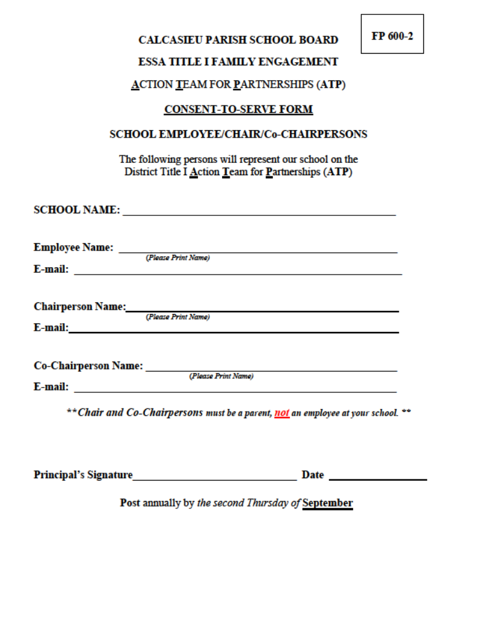
FP-600-3
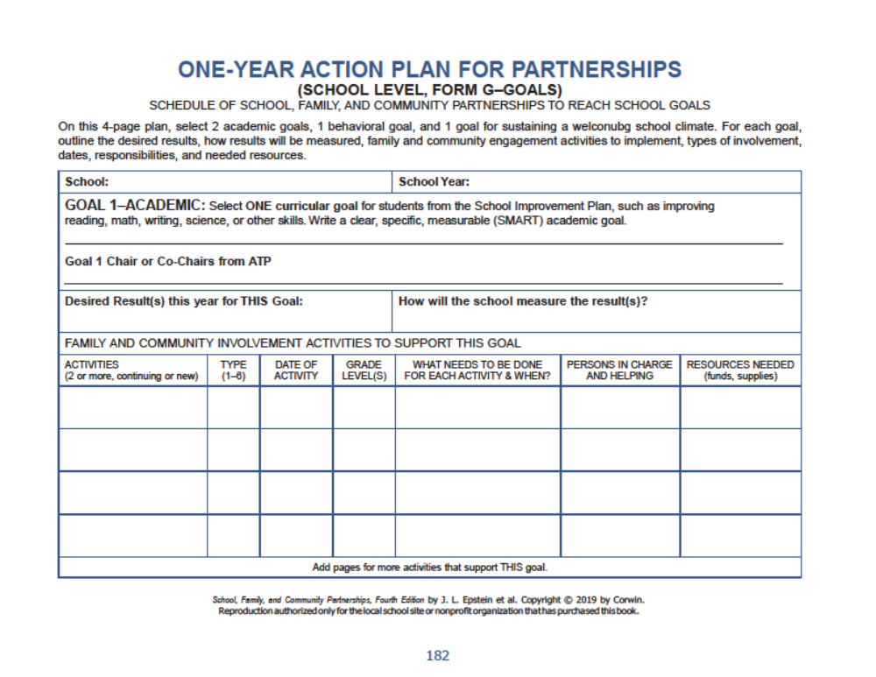
FP 600-3

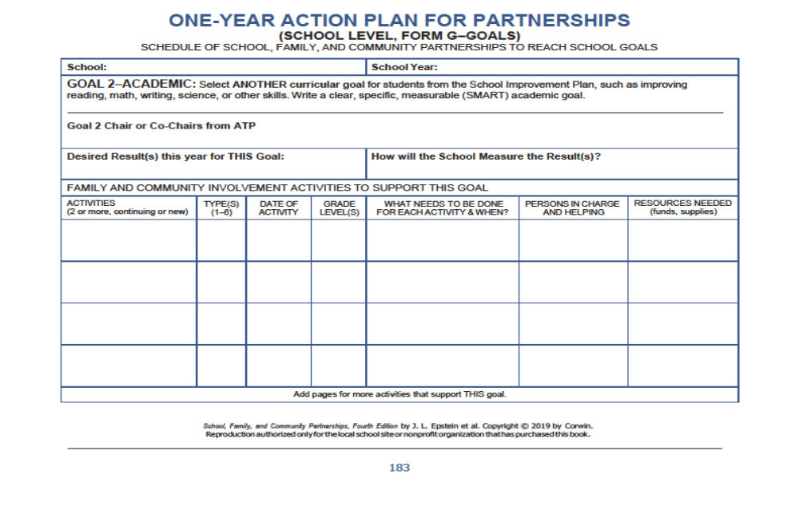
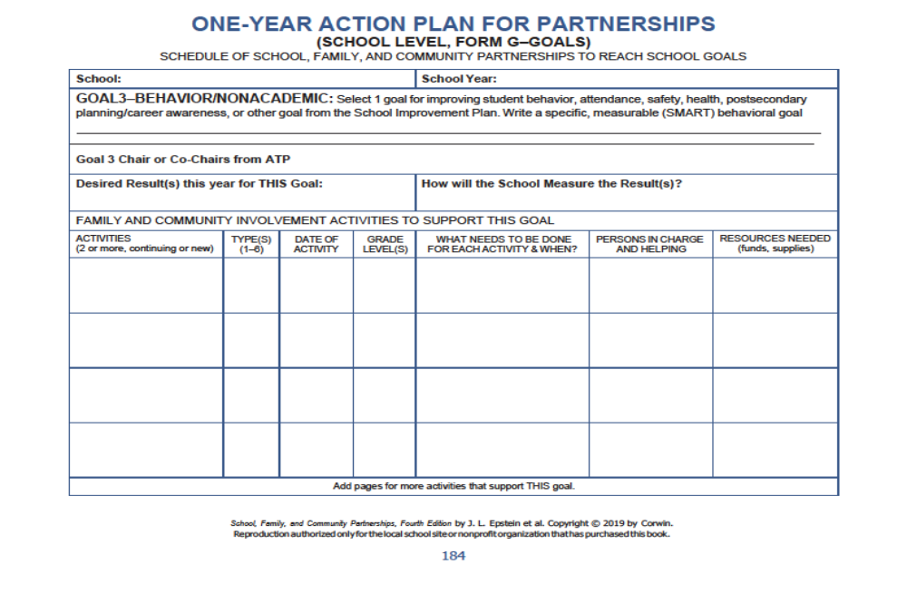

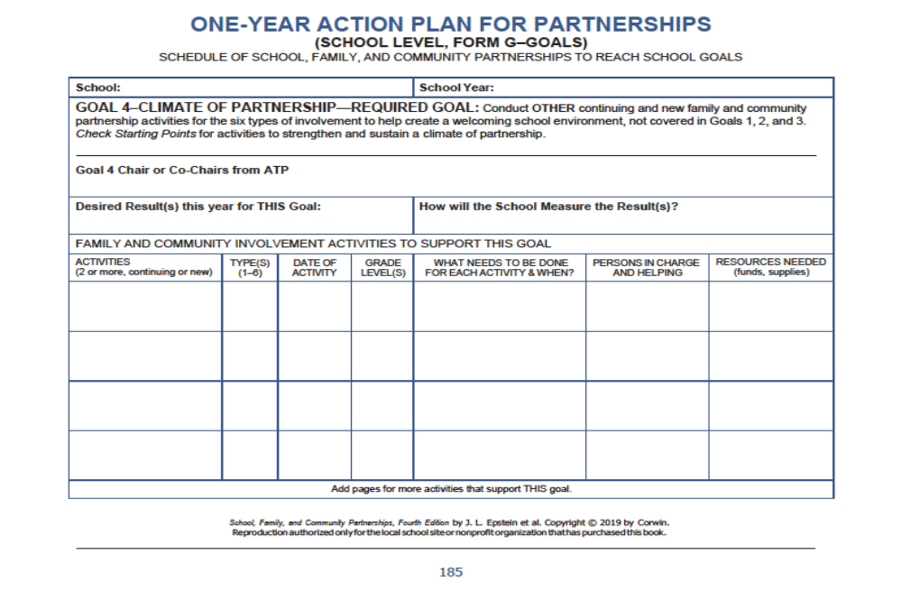

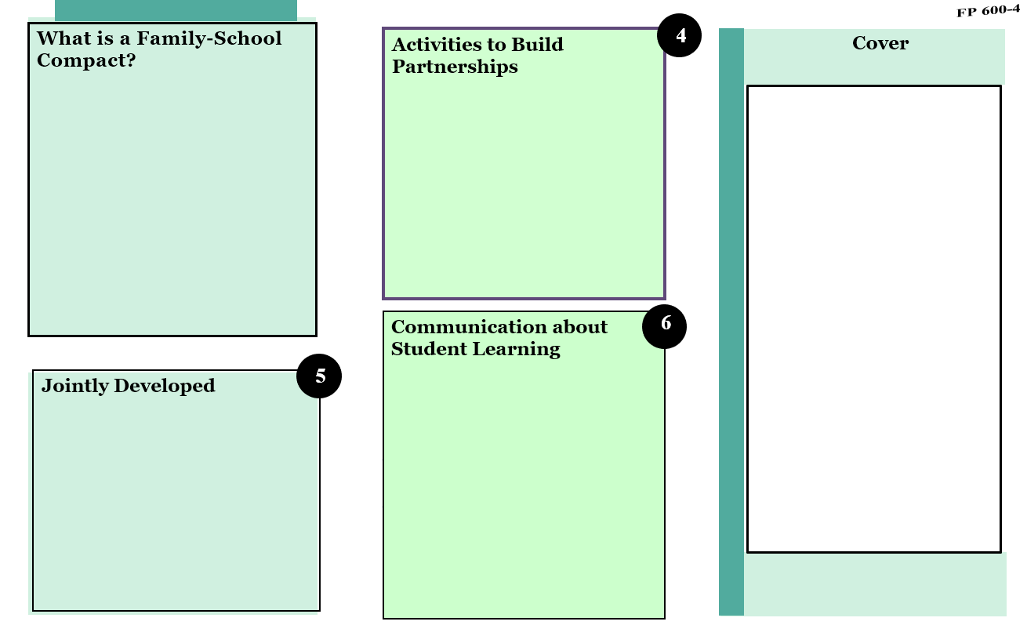

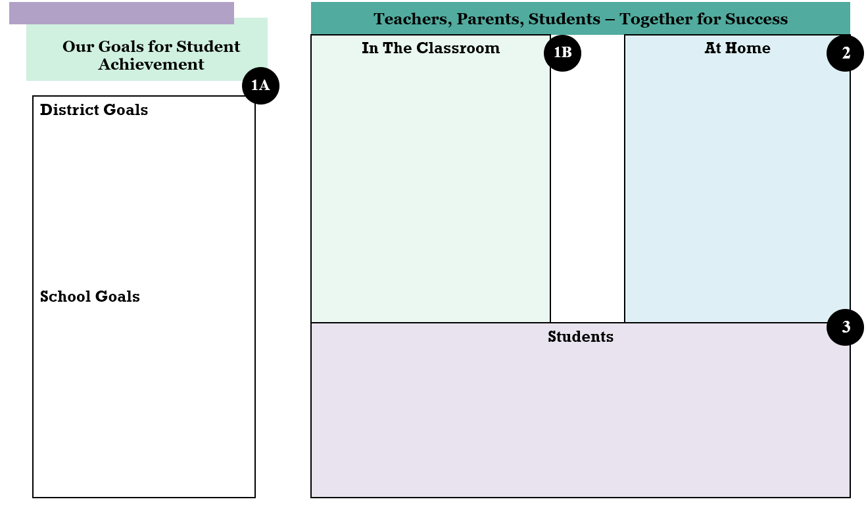

Developing Meaningful Parent/Family Engagement Tips and Tools

Checklist: Demonstrating Parent/Family Engagement Compliance

Collect and keep on file the following documents to demonstrate compliance with ESSA parental involvement requirements. Include any additional documents that demonstrate your district’s efforts to involve parents in district programs. Also include any translated versions of these documents.

Notices to parents regarding the parental involvement Policy __________

Copy of parent/family engagement policy __________

Notices regarding school improvement, correction action or restructuring __________

Printed copy of the school Web page providing parents/families
with information about parental engagement plans __________

Invitations to parent/family meetings __________

Copies of agendas from parent/family meetings __________

Copies of attendance sheets from meetings __________

Copies of notices, surveys or other documentation soliciting parent
input on use of funds reserved for parent/family engagement activities __________

Copies of other documents demonstrating efforts to engage parent/family __________

Developing Meaningful Parent/Family Engagement -Continued Tips and Tools

A Checklist for Schools: Making Parent/Family Engagement Work

Use this as an internal school or school district checklist to determine strengths in parental involvement activities, as well as areas that might need improvement.

Parenting and Family Skills

1. _____ We sponsor parent education and family learning workshops.

2. _____ We ask families the types of workshops or informational events they would be interested in, and what session times would be most convenient.

3. _____ We provide families with information about child development.

4. _____ We lend families books, tapes, and CDs on parenting and parenting workshops.

5. _____ We provide families with information about developing home conditions that support school learning.

6. _____ We survey parents to determine their needs, assign staff members to help address those needs, and work
with parents to link community resources.

7. _____ We have a family resource center or we help parents access other resource centers in the community.

8. _____ We have support groups for families with special needs and interests.

9. _____ We train staff members and support them in reaching out to all families.

Communication

1. _____ We have parent-teacher conferences to establish student learning goals for the year.

2. _____ We listen to parents tell us about their children’s strengths and how they learn.

3. _____ Teachers have ready access to school telephones to communicate with parents during or after the school
day.

4. _____ Staff members send home positive messages about students.

5. _____ We make efforts to communicate with fathers.

6. _____ Parents know the school telephone numbers of staff members and the times available to take phone calls
from parents.

7. _____ We involve families in student award and recognition events.

8. _____ We encourage and make provisions for staff members to talk with parents several times each semester.

9. _____ We communicate the school’s mission and expectations for students to parents.

10. _____ The school has a homework hotline or other kind of telephone system.

Developing Meaningful Parent/Family Engagement -Continued Tips and Tools

11. _____ We provide parents with structured ways to comment on the school’s communications:
Example: mailed, phone, or take-home surveys.

12. _____ We have staff members available to assist and support parents in their interactions with the school (i.e.,
home-school liaisons).

13. _____ We send home communications about:

• Student academic progress.

• Meetings at school.

• How parents can be involved in student activities.

• Student discipline.

• Child development.

• PTA/PTO.

• Curriculum.

• How parents can be involved as volunteers.

• How parents can be involved in school governance.

• How parents can help with homework and encourage learning at home.

• Community resources available to families.

• The school’s philosophy of learning.

14. _____ Staff members make home visits.

15. _____ Before a crisis occurs, we speak directly to parents in a way that does not include leaving messages on
answering machines if students are having academic or behavioral difficulties.

Learning at Home

1. _____ We have structured program to help parents assist their children with homework.

2. _____ We offer learning events and activities for the whole family.

3. _____ We invite families to borrow resources from school libraries.

4. _____ We link parents with resources and activities in the community that promote learning.
5. _____ We give parents questionnaires they can use to evaluate their child’s progress and provide feedback to
teachers.
6. _____ Schools staff and school communications help parents link home learning activities to learning in the
classroom.

Developing Meaningful Parent/Family Engagement -Continued Tips and Tools

Volunteering

1. _____ We encourage families and other community members to attend school events.

2. _____ We offer youth service learning opportunities for students who want to volunteer in the community.

3. _____ We help school staff learn how to work with parent and community volunteers.

4. _____ We ask family members how they would like to participate as volunteers at their child’s school or
community.

5. _____ We encourage family and community members to become involved as:

• Participants in site-based management councils.

• Presenters to students on careers and other topics.

• Assistants with art shows, read-aloud events, theater workshops, book swaps and other activities.

• Tutors/mentors.

• Chaperones on field trips and other class outings.

• Instructional assistants in classrooms, libraries and computer laboratories.

• Non-instructional assistants.

• From-the-home contributors of baked goods, assembled materials, typing, etc.

6. _____ We have a program to recognize school volunteers.

7. _____ We offer volunteer opportunities for working and single parents.

8. _____ We gather information about the level and frequency of family and community participation.

Governance and Advocacy

1. _____ We encourage parents to attend school board meetings.

2. _____ We assign staff members to help address concerns or complaints.

3. _____ We invite staff and parents to meet collaboratively.
4. _____ We assign staff members to help address concerns or complaints.

5. _____ We involve parents in:

• Revising school and district curricula.

• Planning orientation programs for new parents.

• Developing parental skills programs.

• Establishing membership for site-based management councils.

Developing Meaningful Parent/Family Engagement -Continued Tips and Tools

Community Outreach

1. _____ We act as a source of information and referral about services available in the community for families.

2. _____ We use a variety of strategies to reach out to adults, families and children of all ages, races and
socioeconomic backgrounds in the community.

3. _____ We encourage local civic and service groups to become involved in schools in a variety of ways, such as
mentoring students, volunteering, speaking to classes and helping with fundraising events.

4. _____ We encourage staff and students to participate in youth service learning opportunities.

5. _____ We work with local chamber of commerce or business partnership council and public library to promote
literacy.

6. _____ We widely publish and disseminate school board meeting notices, summaries and board policies and
agendas and encourage the feedback and participation of community members.

TITLE I
PROCEDURES AND FORMS

Procedures for Personnel Recommendation & Withdrawal

Personnel Recommendation

Degreed Positions:

Applicant must be certified in the area he/she is teaching.
Complete Federal Programs Permission to Hire Form (FP 100-1)
Attach copy of transcript or degree.
Obtain Administrative Director’s approval
Submit to the Title I Department

Paraprofessional Positions:

Applicant must have high school diploma or GED.
Associates degree or 48 hours from an accredited college and university or passed the Para Pro test (score 450)
Complete Federal Programs Permission to Hire Form (FP 100-1)
Attach college transcript or Para Pro test scores.
Obtain Administrative Director’s approval
Submit to the Title I Department

The Para Pro test is available through the Title I Department. Complete the Para Pro Testing Recommendation Form (FP 100-2) and fax to 217-4171.

Withdrawal of Positions:

Complete the Federal Programs Withdrawal Packet (FP 100-3A/3B) and submit to the Title I Department

Refer to Quick Reference Guide

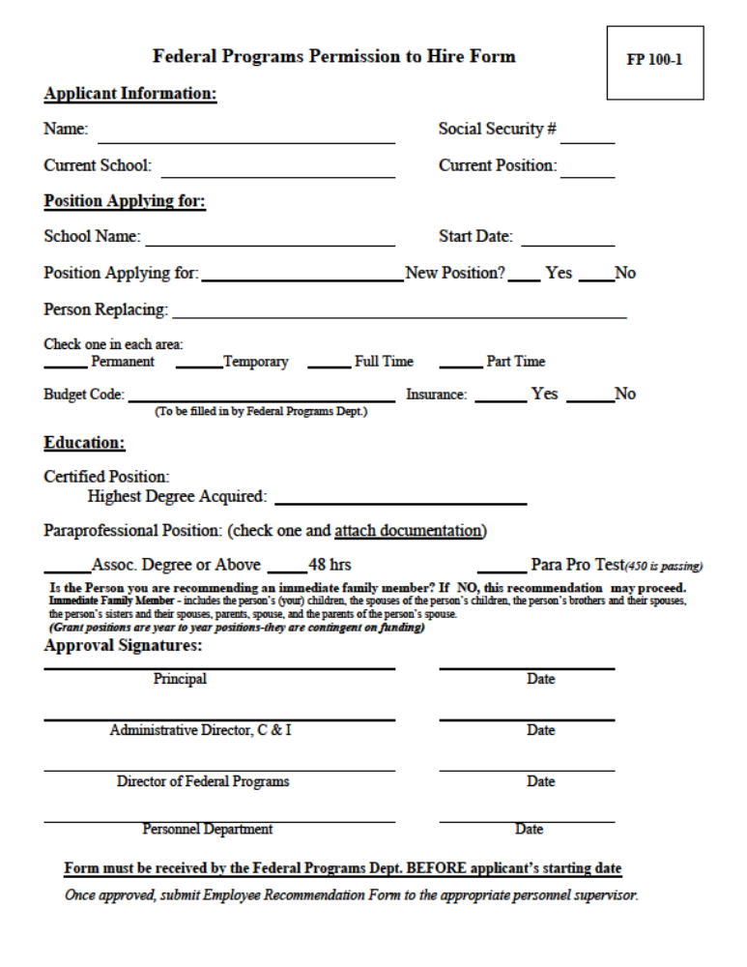

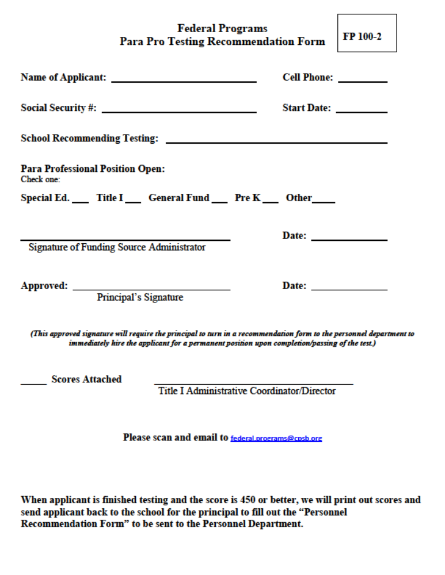

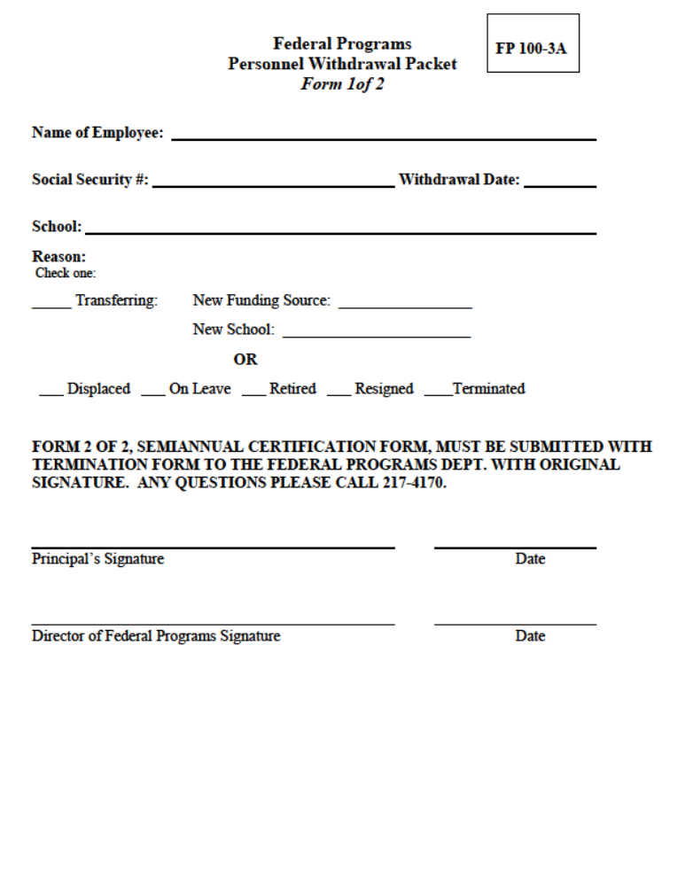

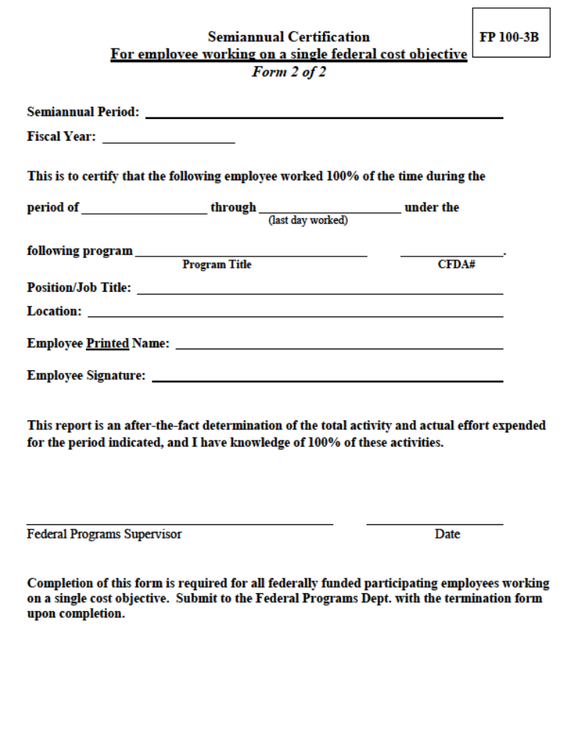

Procedures for Supplemental Salaries
**Due to Federal Programs 2 days prior to Payroll Due Dates**

Supplemental pay forms must be received by Title I by the 1st day of each month to receive pay that month. Employee name and Employee I.D.# must match the CPSB system or the entire supplemental will be returned for corrections. The Title I Department will stamp the budget code on the supplemental pay forms. Scratch outs/changes on sign in sheets are audit exceptions.

TITLE I SIGN IN SHEETS MUST BE USED
A “Personnel Activity Report” must be completed for any person receiving supplemental pay from Title I. To adhere to this USDOE requirement a statement has been added to the Federal Programs sign in sheets. Sign in sheets without the statement will NOT be accepted.

Title I CPSB School Bus

6 weeks Prior to Activity:
Request for Expenditure (FP 100/700) – one per activity
Activity, date, estimated cost
Page from SWP

Upon Completion:
Supplemental Pay Forms (S 507) (must have dates, times, # of hours)
Field Trip - Completed form from Transportation Dept.
- Tutorial Program – Federal Programs Sign in sheets (FP 100-4A) (signed in and out daily) R/E # on all reimbursement documentation.

Title I Stipends

Reminder: Paraprofessionals earn their hourly rate and overtime rate after 40 hours. Please contact the Payroll Dept. with any questions. Overtime log must be completed by all paraprofessionals (S 534), refer to Circular No.:14-106.

6 weeks Prior to Activity:
Request for Expenditure (FP 100/700) – one per activity
Activity, date, estimated cost
Page from SWP

Title I Stipends-Continued

Upon Completion:
Supplemental Pay Forms (S-507) (must have dates, times, # of hours and R for E #)
Agenda
Federal Programs in sheets (FP 100-4A) (signed in and out daily)
Early Arrival Verification Form (FP 100-8) when applicable
R/E # on all reimbursement documentation

Title I Substitutes

Substitutes used during testing is not an allowable Title I expense.

6 weeks Prior to Activity:
Request for Expenditure (FP 100/700) – one per activity
Activity, date, estimated cost
Page from SWP

Upon Completion:
Teacher left school – Sub signs teacher’s payroll and Sub Hired Form (FP 100-5) is submitted to the Title I Dept.
Teacher remained in school – Supplemental pay form submitted to the
Title I Dept. (S-507) with the agenda & Federal Programs sign in sheets (FP 100-4D) attached. R/E # on all reimbursement documentation

Tuition Reimbursement

Title I school paraprofessional - teacher certification only in regular education core content areas.

6 weeks Prior to Semester: (Approval before attending)
Request for Expenditure (FP 100/700)
Application for Paraprofessionals Tuition Assistance Form (FP 100-6)

Upon Completion:
Expense Voucher (S 536)
Itemized Tuition Receipt
Transcript R/E # on all reimbursement documentation

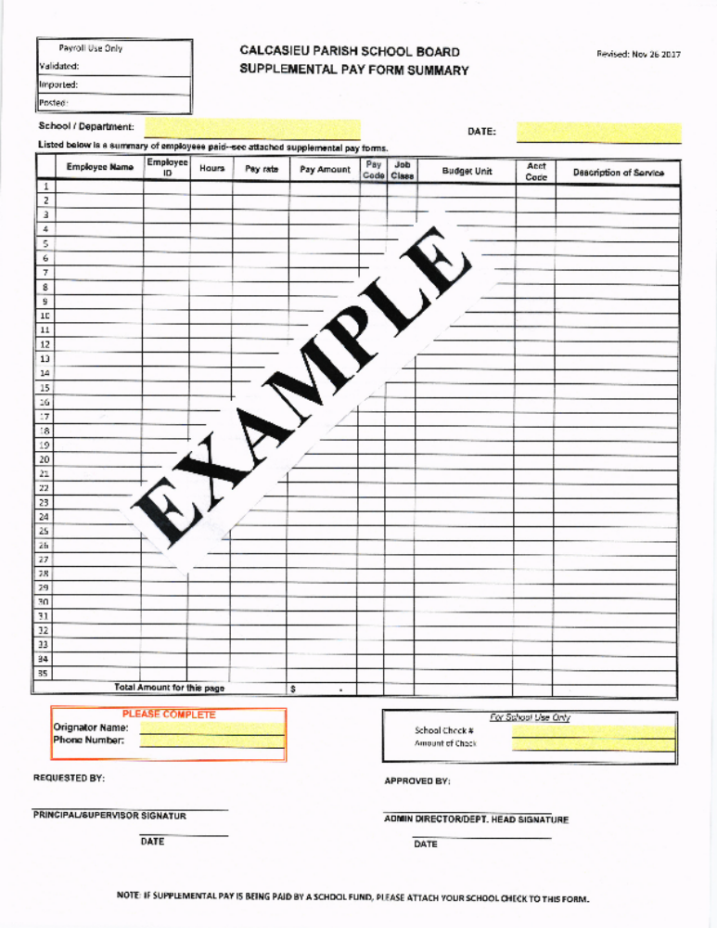
CPSB S-507

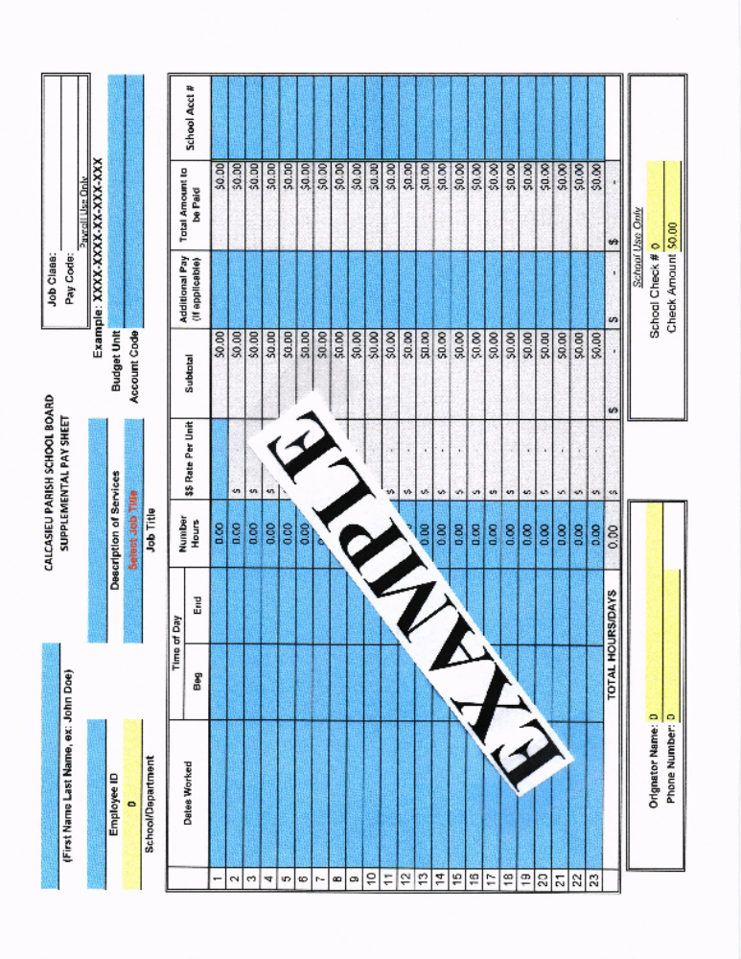

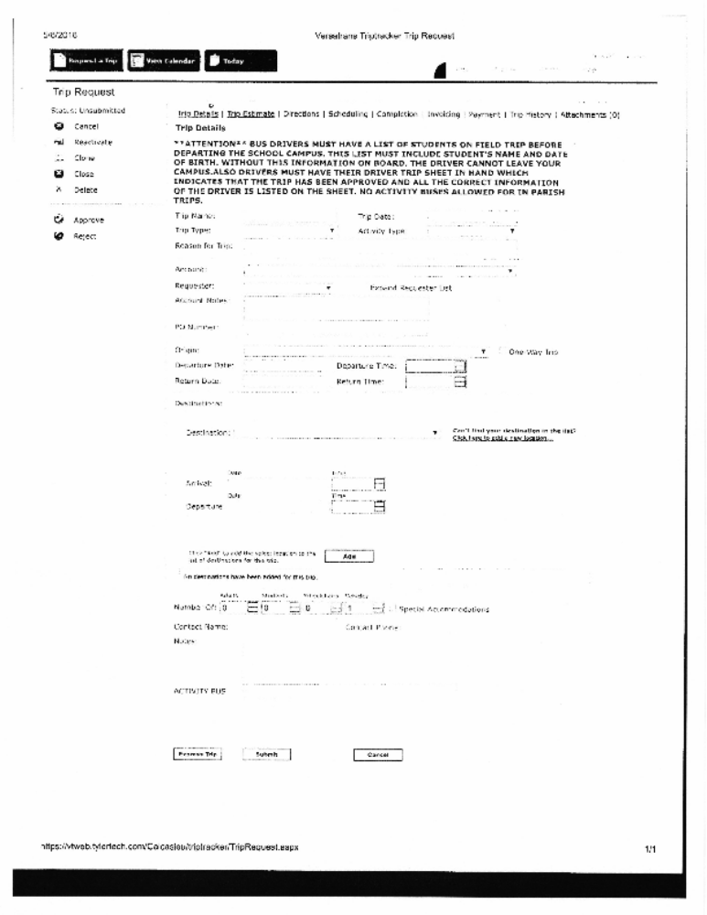

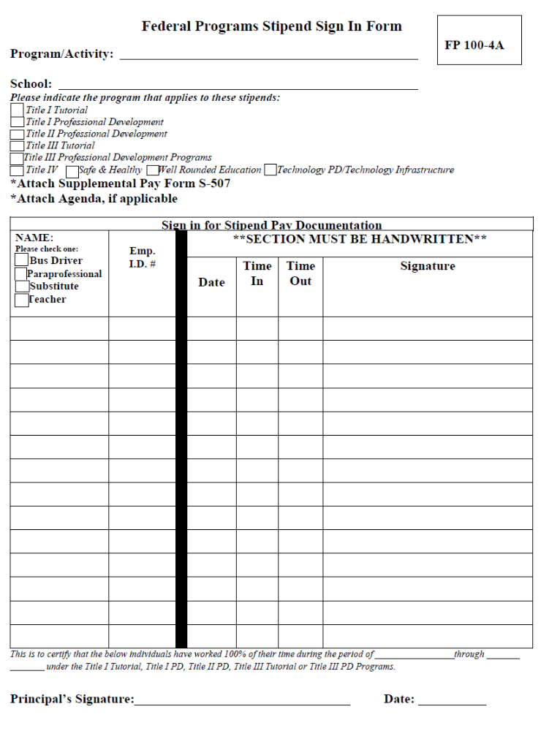
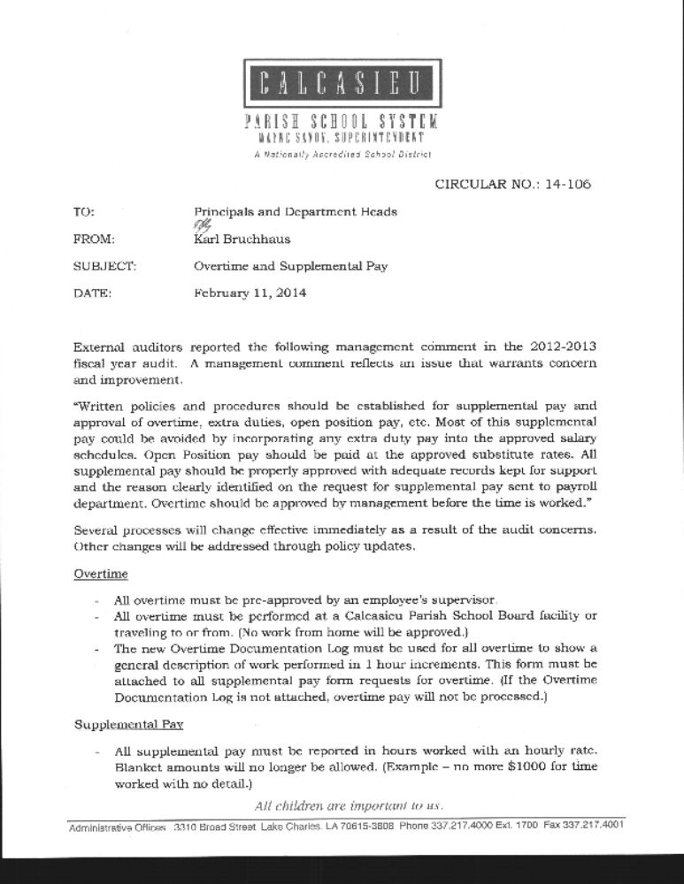

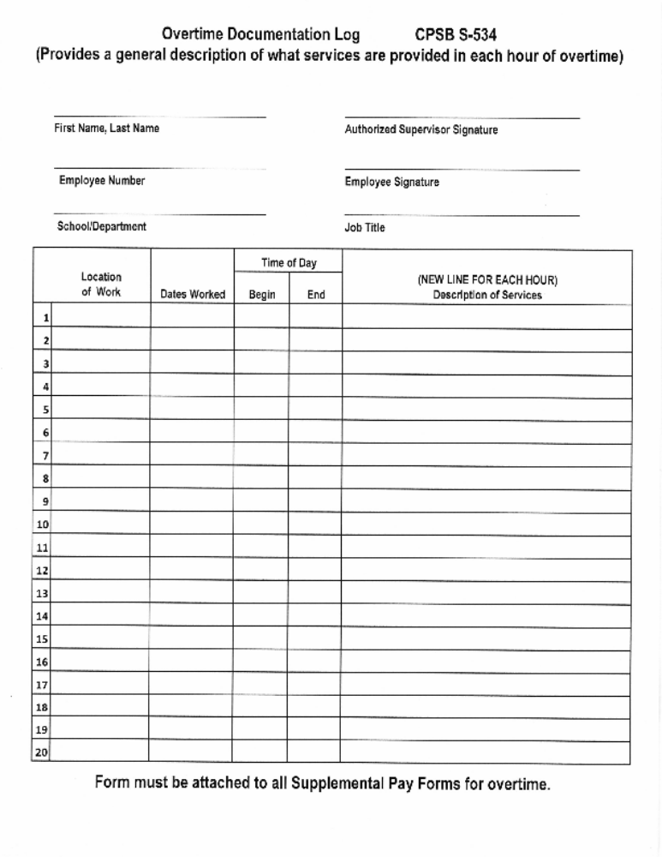

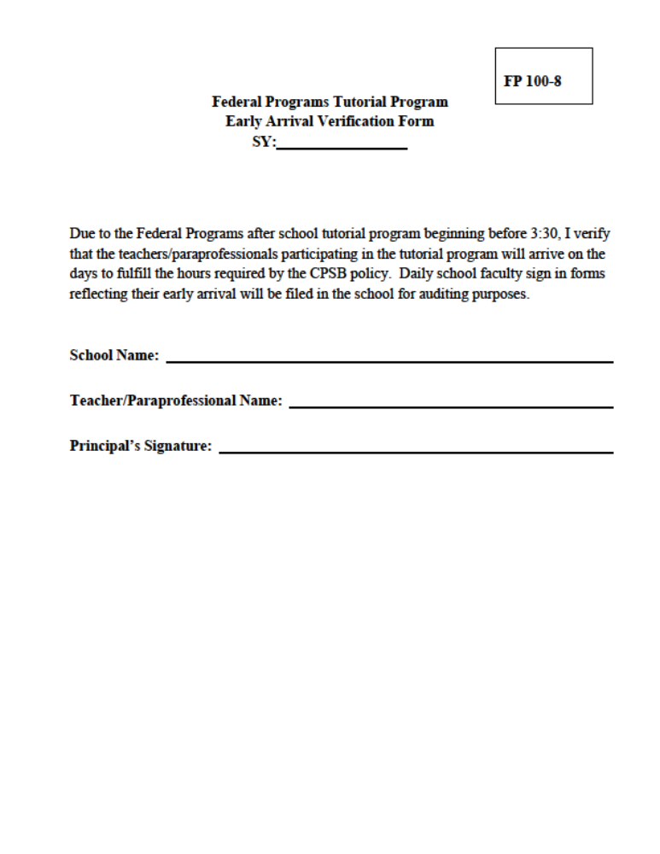

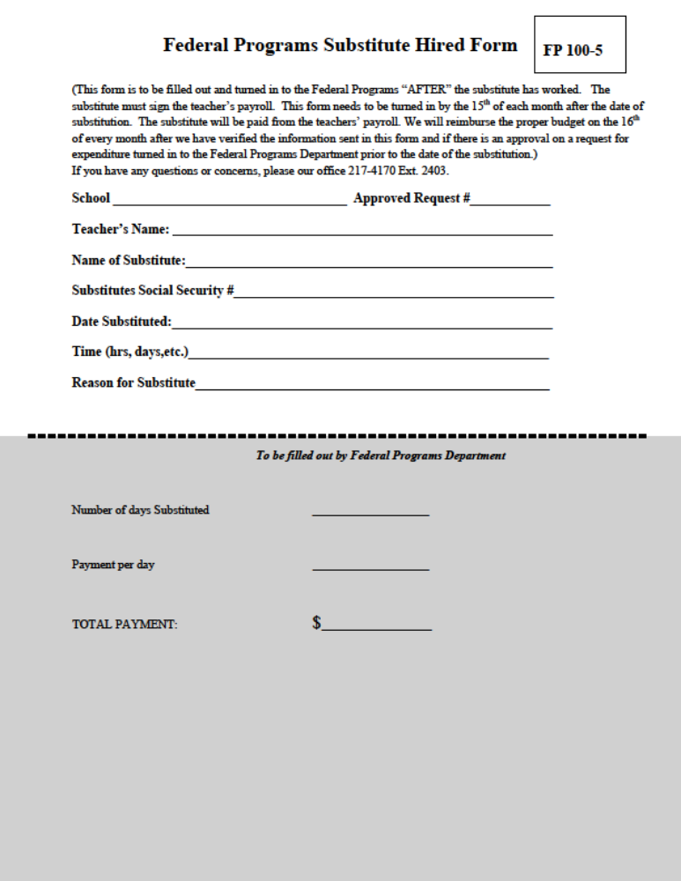

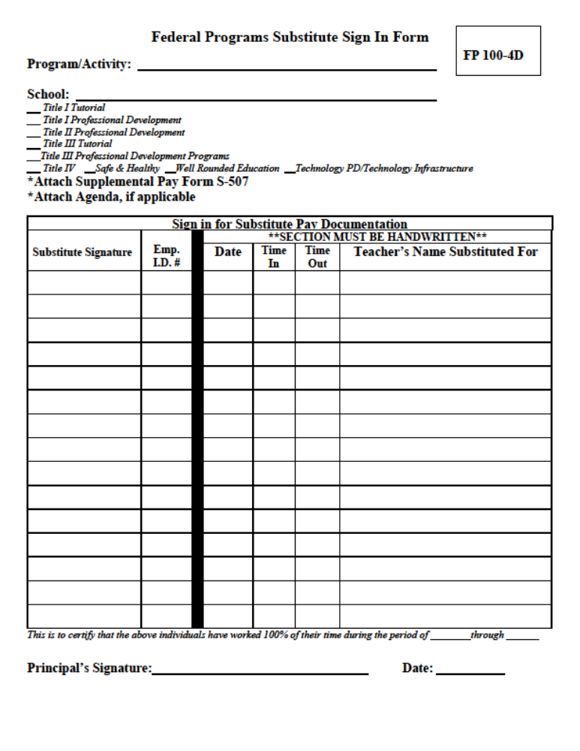

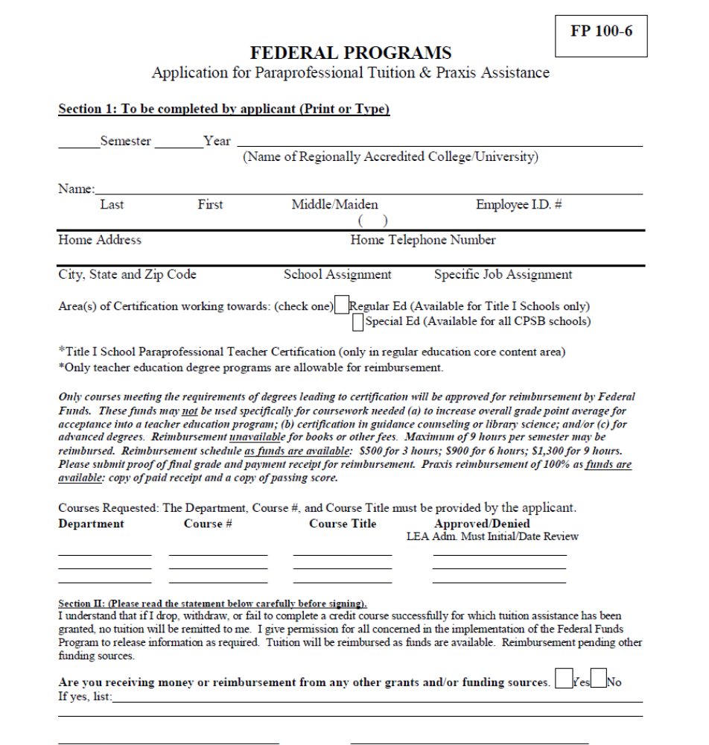

CPSB S-536

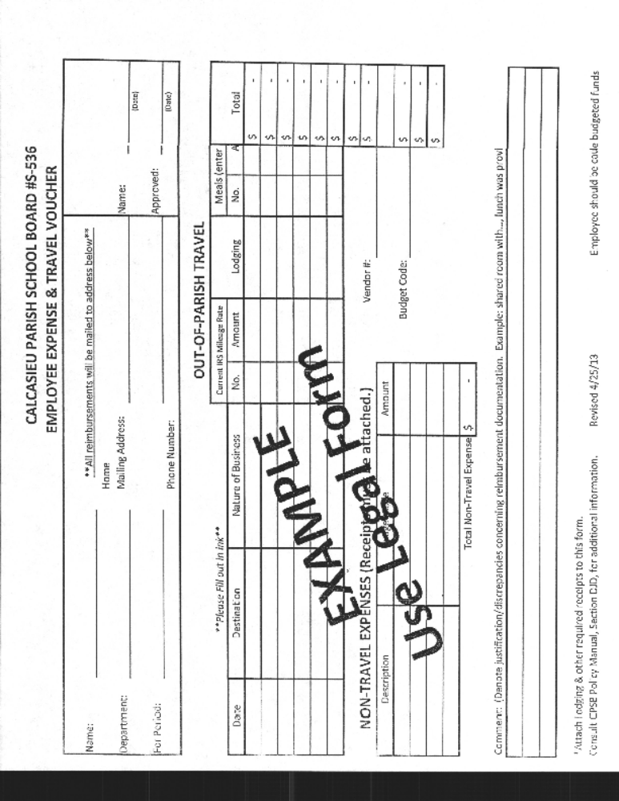

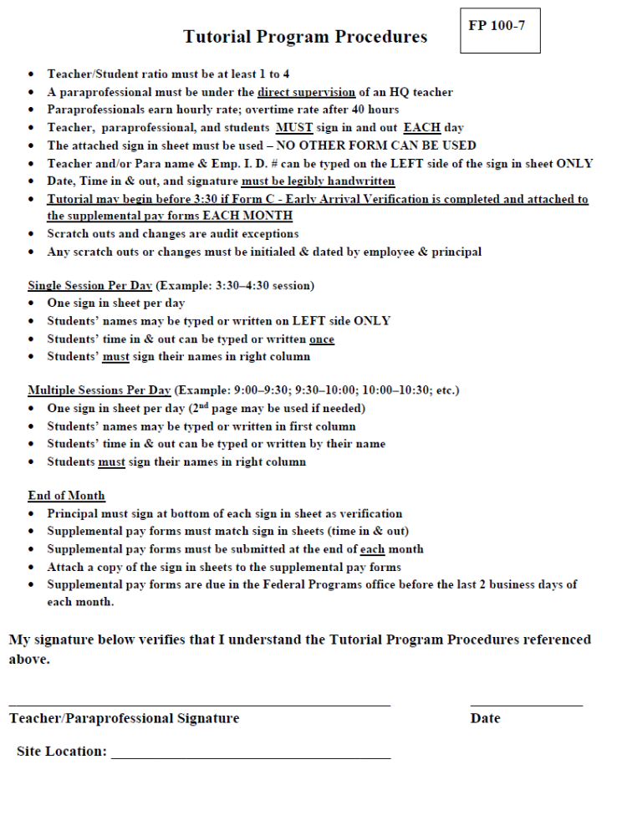

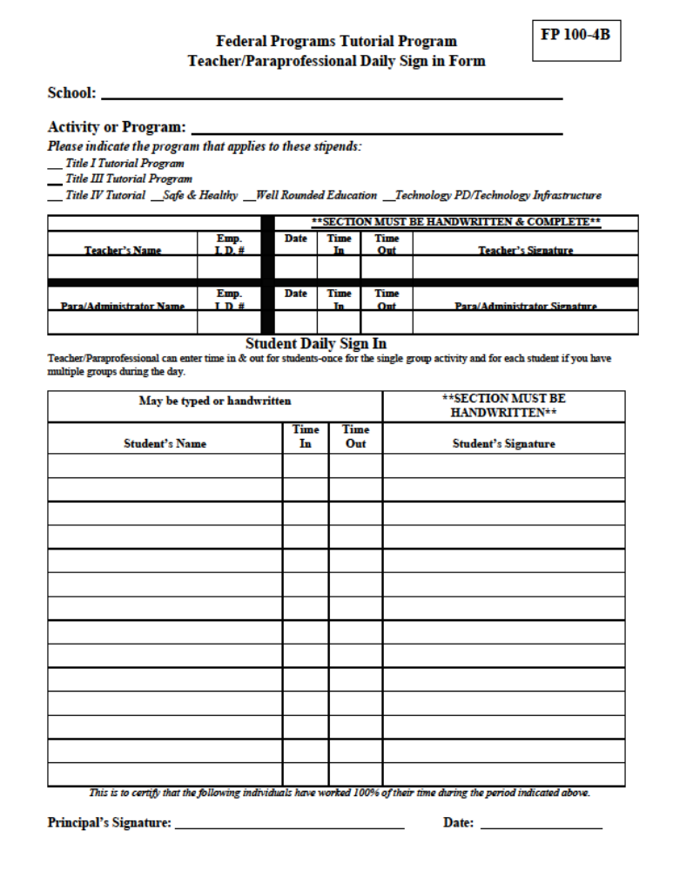

Procedures for Professional Services

Purchase Educational Services – Contract Speaker

6 weeks Prior to Activity:
Request for expenditure (FP 100/700) – one per activity
Contract Packet (FP 300-1 and S 514) completed and approved by Adm. Director & Superintendent
Page from SWP (must be instructional)

Upon Completion:
Invoice signed & dated by school principal.
Agenda
Federal Programs Sign in Form (FP 100-4A) (Stipends sign in and out) or
Federal Programs Sign in Form (FP 100-4E) Attendance Only
R/E # on all reimbursement documentation

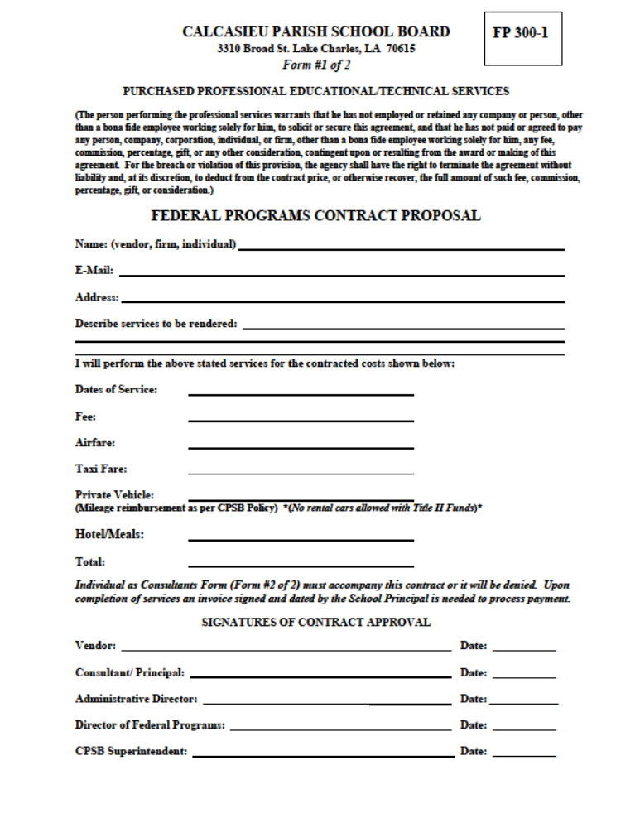

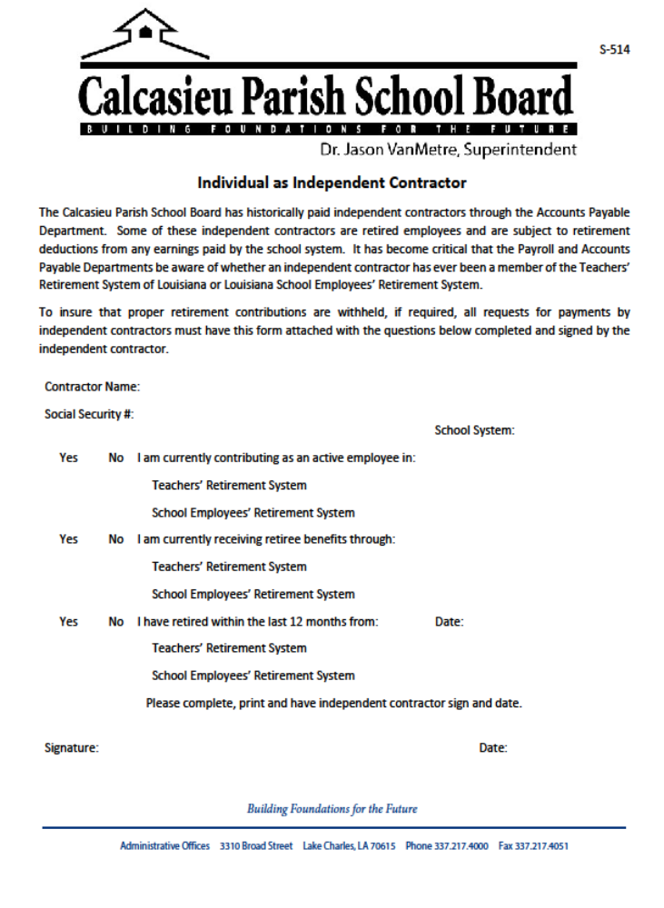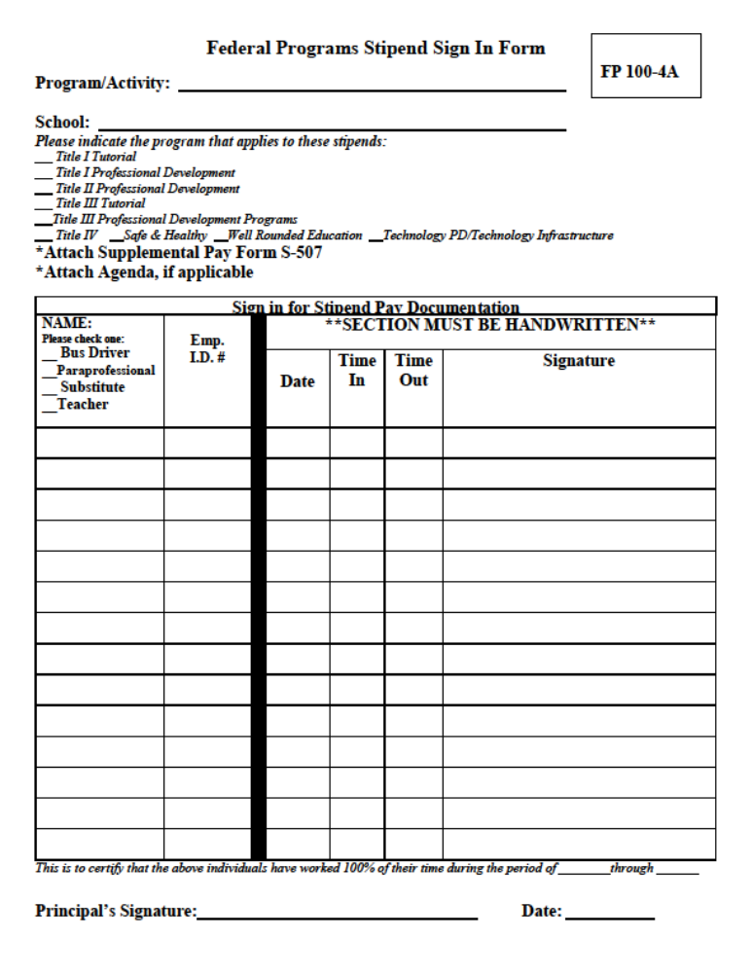

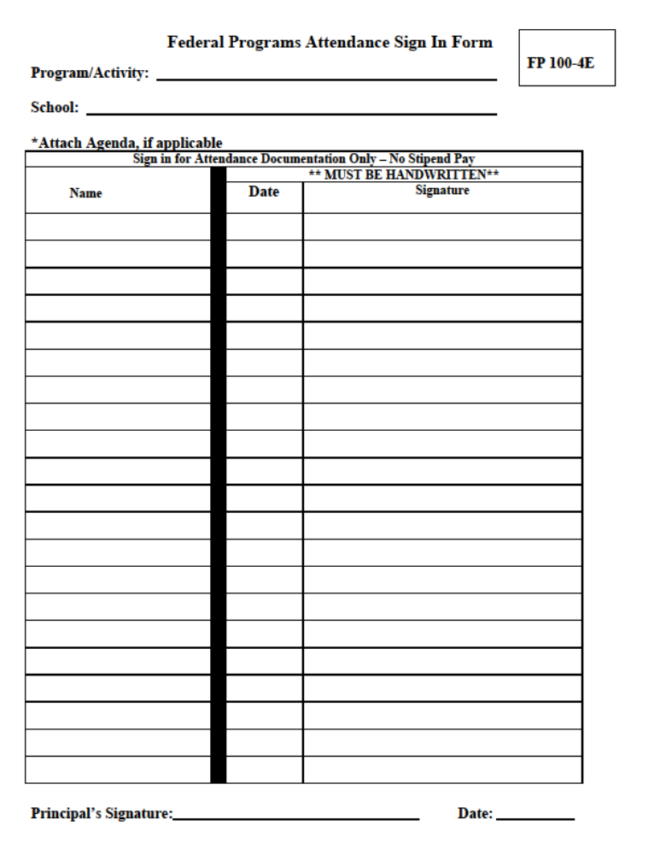

Procedures for Property Services

Copier Rental & Maintenance Contracts

New contracts must follow procedures below. POs will be generated for existing contracts on July 1. Email any changes to federal.programs@cpsb.org

Do not accept machines delivered on a “trial basis”. School will be responsible for contract payments.

Copiers rented with Title I funds must be located in teacher workrooms. Title I equipment shall not be located in administrative offices.
DO NOT ACCEPT A NEW MACHINE WITHOUT A TITLE I PURCHASE ORDER.

Invoice directly to: Calcasieu Parish School Board
Federal Programs - School Name
3310 Broad Street
Lake Charles, LA 70615

New Copier Rental Agreement

Prior to Delivery: Before R/E Federal Programs shall review contract.
Request for Expenditure (FP 100/700)
Contract approved by CPSB Purchasing Agent
Contract signed by principal and salesman reflecting number of years, yearly charge, documentation fee, property tax.
Page from SWP
PO must be received BEFORE delivery of machines.

Upon Delivery:
Sign & date invoice
Submit to the Federal Programs Department
R/E # on all reimbursement documentation

New and Existing Copier Maintenance Agreement

6 weeks Prior to Invoice:
Request for Expenditure (FP 100/700)
Contract approved by CPSB Purchasing Agent
Contract signed by principal and salesman reflecting number of years, yearly charge
Page from SWP

Upon Receipt of Invoice:
Sign & date invoice
Submit to the Federal Programs Department
R/E # on all reimbursement documentation

Wiring / Installation

6 weeks Prior to Work Date:
Request for Expenditure (FP 100/700)
Quote
Page from SWP

Upon Completion:
Sign & date invoice
Submit to the Federal Programs Department
R/E # on all reimbursement documentation

Procedures for Other Purchase Services

Charter Bus Company
See Memo from Risk Management

6 weeks Prior to Activity:
Request for expenditure (FP 100/700) one month prior to activity
Contract with Principal’s signature (No Deposits)
Page from SWP

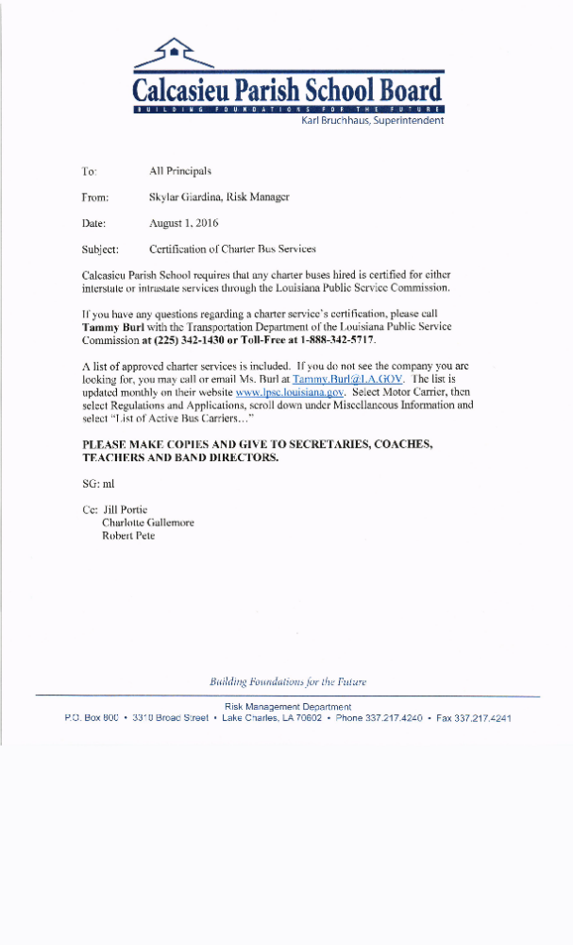
Admission Tickets

6 weeks Prior to Activity:
Request for expenditure (FP 100/700)
Activity, date, estimated cost (no meals or t-shirts allowed)
Page from SWP (must be instructional)

Upon Completion:
Title I will reimburse the school
Itemized receipt for admission tickets, signed & dated by vendor, and copy of school canceled check
List of students that attended the field trip
R/E # on all reimbursement documentation

Site License

6 weeks Prior to Activation:
Request for Expenditure (FP 100/700)
Pending Tech Approval (Addendum)
Quote
Page from SWP

Upon Activation:
Sign, date, and submit invoice to Federal Programs Dept.
R/E # on all reimbursement documentation

Testing Fees

6 weeks Prior to Activity:
Request for Expenditure (FP 100/700)
Fee documentation
Names of students testing
Page from SWP

Upon Completion:
Check needed before testing:
Date of testing
Receipt of payment
Check needed after testing:
Sign, date and submit invoice to Federal Programs Dept.
Names of students that actually tested
R/E # on all reimbursement documentation

Teacher Travel

Important travel reimbursement information:
- No school reimbursements allowed.
- Reimbursements made to individuals.
- An individual can only be reimbursed for one room and/or one airline ticket.
- Do not reserve or pay for multiple hotel rooms or airline tickets.
- Credit card must be in employee’s name.
- Registration fees and/or travel advances must be reimbursed to Federal Programs Department if individual does not attend the conference.
- no exceptions

6 weeks Prior to Activity: **{See Pre/Post Travel Check List (FP 500-1)}**

Request for expenditure (FP 100/700)
Activity, dates, number of participants & estimated cost
Approved AESOP
Pre-Conference Travel Form (FP 500-2) for each person attending conference
Page from SWP
Registration Forms/Conference information complete with names & cost at least 3 weeks before the early bird deadline and/or registration deadline

Upon return: (See Travel Check List FP 500-1) Paperwork is due within 10 school days
Travel Expense Voucher (S 536)
Copy of AESOP Approved Permission to travel
Agenda
Name badge or certificate of completion, if available
Itemized hotel bill, $0 balance, conference hotel rate documentation
Airline ticket/e-ticket that shows name & cost OR Out-of-State Mileage Reimbursement Form
Shuttle/Taxi receipts signed by driver
Meal reimbursement Form (S 504)
***Please tape receipts & name badges to a sheet of paper**
R/E # on all reimbursement documentation

FP 500-1
Pre-Travel Checklist
Checklist for Pre-Travel | Yes | No
Request for Expenditure Form FP 100/700
Page from SWP
Pre-Conference Travel Form FP 500-2
Activity, dates, number of participants & estimated cost
Submit registration forms complete with names, cost and Principals signature at least 3 weeks (15 schools days) before the early bird deadline and/or registration deadline
Approved permission to travel – Entered into Aesop (include all travel dates; number and answer all “7” questions) (1) Name of Event (2) Destination – hotel, city, state (3) Date (s) of Trip – Abbreviate months, example – Mar, Nov, Dec (4) Indicate Fund that is paying for trip (5) Sub Needed – Yes or No (6) If sub is needed – who is paying for the sub, example – School or CPSB or Grant (7) Benefit to School System (see Updated Travel Approval Procedures)
Out-of-state Travel: The mileage reimbursement form must be completed by registrants choosing NOT to fly. Submit Form S-505 along with approved travel (AESOP) to Wayne Foster, Director of Internal Auditing.
Federal Programs Travel Advance Request Form FP 500-4 (airfare & hotel only) Submit no later than one month (30 school days) before trip
Use Governmental Emp. Hotel Lodging Sales/Use Tax Exemption Form S-518 when checking into hotel.
- Registration fees and/or travel advances must be reimbursed to Title 1 if individual does not attend the conference.
I understand that there are no exceptions.
Post-Travel Checklist
Checklist for Post-Travel | Yes | No
Paperwork is due within 10 school days
Expense Voucher Form S-536 – completed, signed, and dated (Home Address Must be Included)
Approved permission to travel – Entered into Aesop (include all travel dates; number and answer all “7” questions) (1) Name of Event (2) Destination – hotel, city, state (3) Date (s) of Trip – Abbreviate months, example – Mar, Nov, Dec (4) Indicate Fund that is paying for trip (5) Sub Needed – Yes or No (6) If sub is needed – who is paying for the sub, example – School or CPSB or Grant (7) Benefit to School System
Agenda
Name badge or certificate of completion
Itemized hotel bill with employee name, $0 balance, conference hotel rate documentation (list occupants & attach their approved permission to travel forms)
Airline ticket/e-ticket that shows name & proof of payment or Out-of-State Mileage
Reimbursement Form S-505 with Mr. Foster’s signature
Shuttle/Taxi receipts with driver’s signature (if applicable)
Enter travel advance amount (if applicable)
Partial Reimbursement Agreement Form FP 500-3 (if applicable)
Meal Reimbursement Form S-504
If registration is paid by individual, a copy of registration form, itemized receipt showing form of payment (statement or canceled check)
Please tape receipts & name badges to a sheet of paper
- No school reimbursement allowed. Reimbursements made to individuals. An individual can only be reimbursed
for one room and/or one airline ticket. Do not reserve or pay for multiple hotel rooms or airline tickets. Credit card
must be in employee’s name.
- Registration fees and/or travel advances must be reimbursed to Title 1 if individual does not attend the conference.
I understand that there are no exceptions.
- Out-of-state Travel: The Mileage Reimbursement Form S-505 must be completed by all registrants choosing NOT
to fly. Submit all forms in one packet to Wayne Foster, Director of Internal Auditing.
**Give this sheet to teacher before travel**

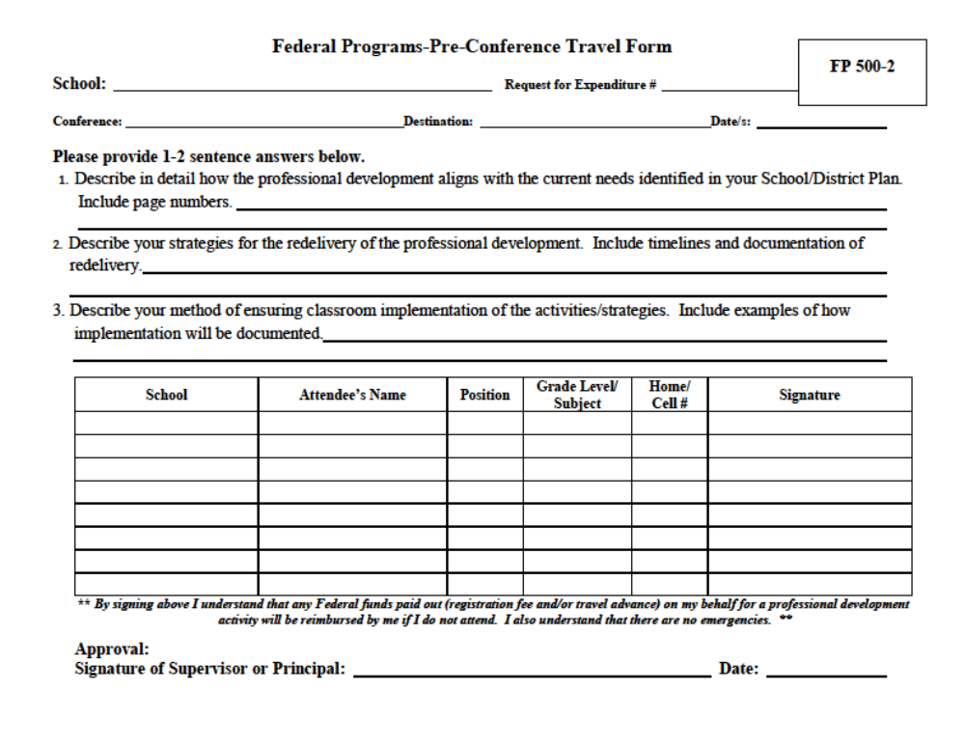

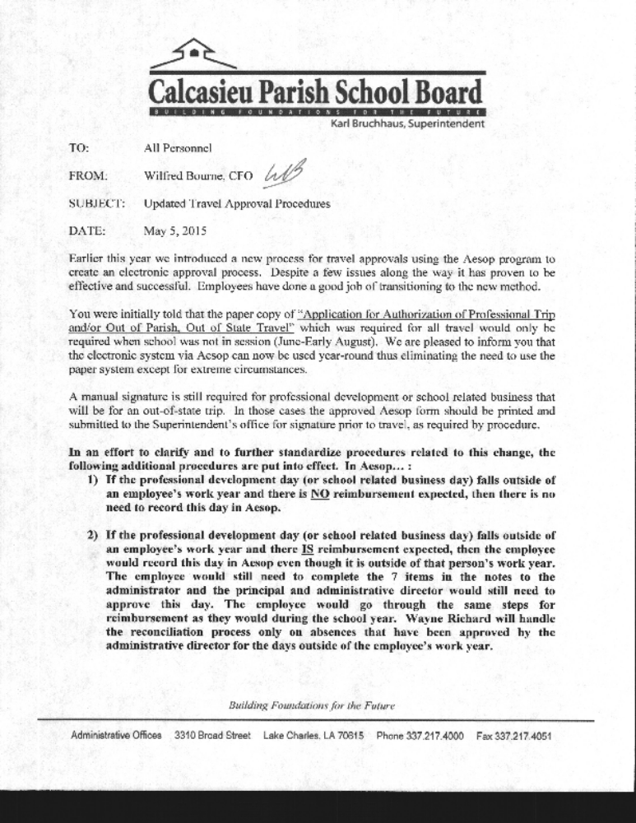
S 505
FP 500-2
CALCASIEU PARISH SCHOOL BOARD
Application for Mileage Reimbursement for Driving Out-of-State
Submit this form to the Internal Auditing Department at (337) 217-4191.

School or Department: ________________________________ Fax #:
Employee Name:
Number of Employees traveling from your site:
Names of Employees riding in your vehicle:

Destination:
Conference Name:
Conference Address:

Date(s) of trip
- Employees are paid the lower of mileage or air fare
- Employees are to carpool. If employees do not carpool, the rate is split between those driving.
- Employees are not paid extra days for meals or lodging because they choose to drive.

For Internal Auditing Use:
Reimbursable Amount: $

Date:

Internal Auditor

A COPY OF THIS FORM MUST BE ATTACHED TO THE TRAVEL REIMBURSEMENT FORM

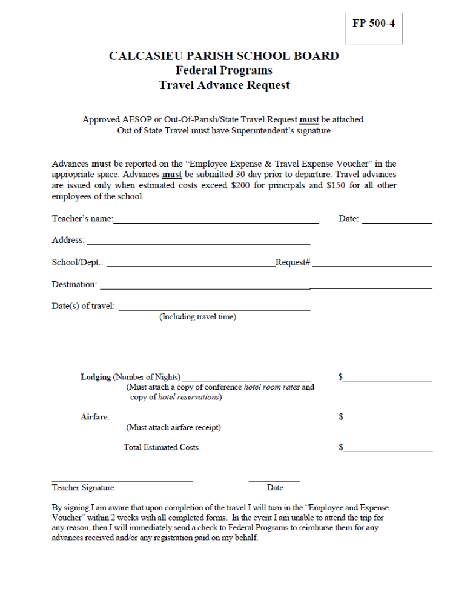

CPSB S-518
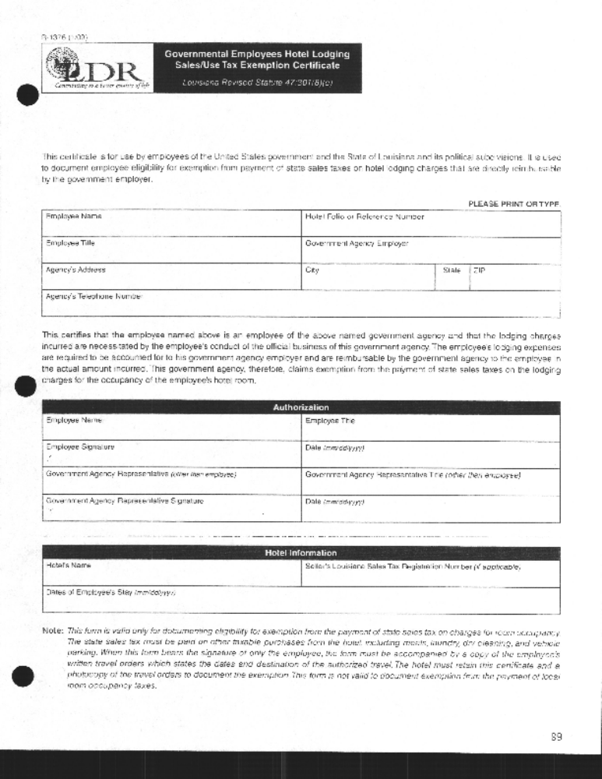

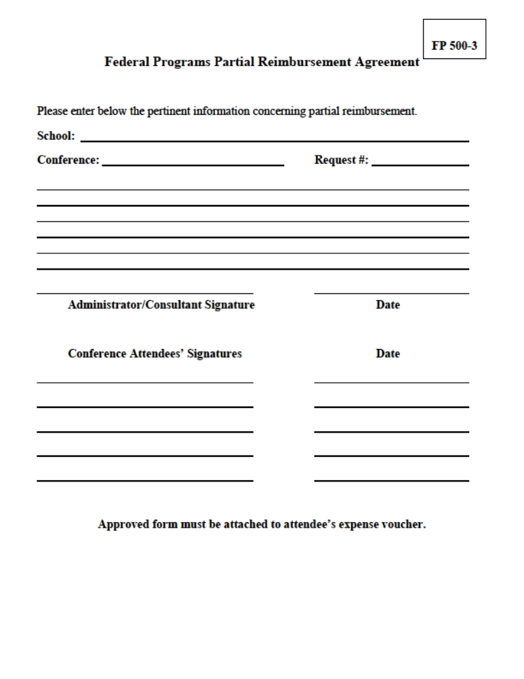

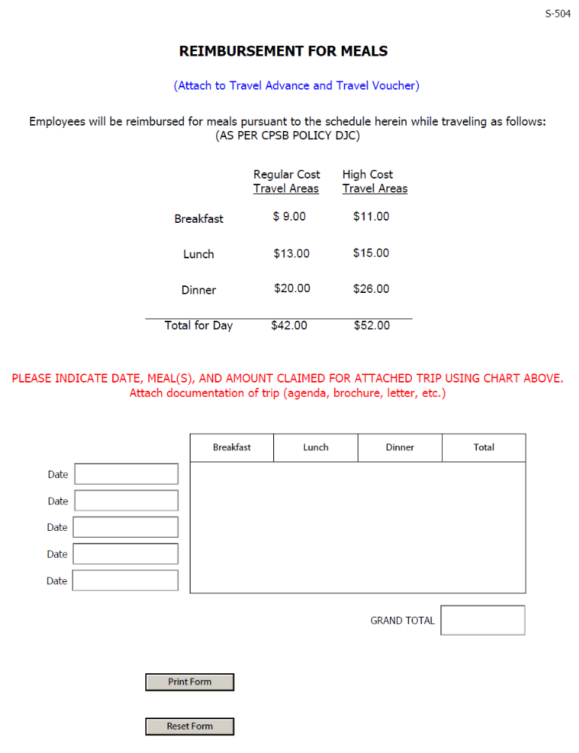
FILE: DJD
Cf: EGD

EXPENSE REIMBURSEMENT

The Calcasieu Parish School Board shall reimburse employees and School Board members for expenses incurred while on official Board business within budgetary and policy limitations. Such reimbursement shall be in accordance with the following guidelines:

- Definitions:

  - Official Domicile - The official domicile for employees shall be the person's work place. For employees who work in more than one location, the official domicile shall be determined by the Superintendent or his/her designee. Every employee will be assigned an official domicile, and no travel or subsistence expenses shall be allowed at the place of official domicile except as authorized in section 5, Reimbursement for Transportation, Subsistence, and Other Expenses, below.
  - Travel Period - The travel period shall be a period of time between the time of departure and the time of return.
  - In-Parish Travel - In-parish travel is all travel within the borders of Calcasieu Parish or travel through adjacent parishes between points within Calcasieu Parish when such is the most efficient route.
  - Out-of-Parish Travel - Out-of-parish travel is all travel outside of Calcasieu Parish.
  - Special Meals - Special meals are meals for persons who are considered guests of the Calcasieu Parish School system and for employees who are on official business with said guests. In parish meals are also considered special meals and must be authorized and include receipts as listed herein. All requests for reimbursement for special meals must be accompanied by a receipt as authorized by section 5, Reimbursement for Transportation, Subsistence, and Other Expenses, and must be approved by the superintendent or his/her designee.

- Eligibility for Reimbursement of Travel Expenses:

  - Employees shall be eligible to receive reimbursement for travel when away from the official domicile or in accordance with section 5, Reimbursement for Transportation, Subsistence, and Other Expenses.
  - Employees shall be reimbursed on an actual expense basis for all reasonable travel expenses as outlined herein. The request for reimbursement (travel voucher) must be accompanied by a receipt or other supporting documentation for each item claimed, except for:

  - taxicab or local public transportation of $10.00 or less.
  - tips for baggage handling, $1.00 per bag in and $1.00 per bag out of airport and hotel - 3 bag maximum.
  - parking at self-service lots when $5.00 OR less per day.
  - meals as per section 5, Reimbursement for Transportation, Subsistence, and Other Expenses.

  - No employee shall request travel reimbursement on behalf of any other employee. Only the traveling employee will be entitled to reimbursement so that travel of each employee can be tracked for auditing purposes.

- Authority to Incur Traveling Expenses:

  - All travel shall be authorized and approved by the appropriate department head. Such approval authority may be delegated as deemed appropriate by each department head.
  - In-parish travel shall be limited to necessary trips, and requests for reimbursement for in-parish travel shall denote the date, destination, and mileage.
  - Out-of-parish, but within the state, travel shall be electronically approved by the department head after creation of an absence in the Aesop online absence management system that includes answers to the following 7 questions in the “Notes to administrator” section: (1.Name of event, 2.Destination, 3.Date(s) of travel, 4.Fund to be charged, 5.Is sub needed, 6.If so, who’s paying for that, 7.Benefit to school system).
  - All out-of-state travel shall have prior approval of the Superintendent, and in the absence of the Superintendent, the Chief Academic Officer, Chief Operating Officer or the Chief Financial Officer shall render the decision. The creation of an absence in the Aesop online absence management system that includes answers to the following 7 questions in the “Notes to administrator” section: (1.Name of event, 2.Destination, 3.Date(s) of travel, 4.Fund to be charged, 5.Is sub needed, 6.If so, who’s paying for that, 7.Benefit to school system) shall be completed and submitted prior to the date of the requested trip. Emergency situations may be approved by the Superintendent or his/her designee. Meeting/conference agendas shall be attached to request.
  - Travel dates should encompass all dates that an employee will be traveling, including dates to and from, and not strictly conference dates listed on a brochure. Return from travel will be on last day of reason for travel unless prior approved via initial travel request by the appropriate department head.

- Transportation:

  - Travel routes should be the most direct and usually traveled route. All mileage shall be computed on the basis of odometer readings or from point of origin to point of return as computed on an online mapping program such as “google maps or mapquest” showing the shortest distance between the two locations. Any mileage reimbursement claimed must begin at an employee’s official domicile for work purposes. (An employee’s official domicile is not an employee’s home.)
  - Out-of-state travel shall be approved by the Superintendent considering the purpose of the travel, benefit to the System, number of personnel involved, and the frequency of travel. Among the factors to be considered should be the length of travel time, cost of operation of a vehicle, cost and availability of common carrier services, etc. In the event that an employee chooses to drive instead of traveling by air, the amount reimbursed should be approved by the system’s Internal Auditing department.
  - Calcasieu Parish School Board System-owned vehicles must comply with the following regulations:

  - All purchases made on Calcasieu Parish School Board gasoline credit cards must be signed for by the employee making the purchase, and the license number, the unit price, and the quantity of the commodity purchases must be noted on the delivery ticket by the vendor. Items incidental to the operation of the vehicle may be purchased via Calcasieu Parish School Board gasoline credit cards only when away from official domicile on travel status. In all instances where a credit card is used to purchase items or services which are incidental to the operation of a vehicle, a receipt along with a written explanation of the reason for the purchase shall be attached to the travel voucher.
  - No employee shall carry unauthorized passengers in Calcasieu Parish School Board owned automobiles unless their presence is for purposes relating to official Calcasieu Parish School Board business.
  - Any personal use of vehicles owned by the Calcasieu Parish School Board is strictly prohibited. If the School Board allows an employee to take a vehicle home, the personal usage allowed is only to commute to and/or from work in the vehicle.
  - Each Department Head which authorizes Calcasieu Parish School vehicles to employees, shall notify the Payroll Supervisor of any changes in the status of miles driven per year, the type of vehicle driven, or a different employee who drives the vehicle as soon as the change is initiated.
  - Any employee who uses vehicles owned by the Calcasieu Parish School Board in a reckless or careless manner or for unauthorized personal use will be subject to disciplinary action.

  - Personally owned vehicles shall be subject to the following:

  - When two (2) or more persons travel in the same personally-owned vehicle, only the owner of the vehicle shall be reimbursed the expenses for use of the vehicle.
  - Employees with the rank of principal and above, as well as other designated employees, shall maintain vehicles for the purpose of conducting Calcasieu Parish School Board business pursuant to the job assignment.

  - Rented motor vehicles shall be subject to the following:

  - Written approval of the Superintendent or his designee prior to departure shall be required for rental of vehicles.
  - Only the cost of rental of subcompact or compact cars (models) shall be reimbursable, unless non-availability is documented, or the vehicle will be used to transport more than two (2) persons or excessive amounts of baggage and equipment.
  - The rental cost of buses or other commercial carriers shall be reimbursable pursuant to the leasing agreement approved by the department head but should not include any ordinary passenger van with more than 10 seating positions as dictated by safety standards.
  - Physical damage and liability insurance are required and reimbursable when renting a vehicle.

- Reimbursement for Transportation, Subsistence and Other Expenses:

  - Transportation:

  - Mileage driven by an employee in a privately-owned vehicle while in the conduct of official Calcasieu Parish School Board business shall be reimbursed on a per mile basis in accordance with the standard mileage rate as established by the Internal Revenue Service. When more than one employee is attending an out-of-parish meeting or function, the department head will make every effort to assure that the employees carpool to the greatest extent practical. Reasons for not doing so must be documented in writing to the department head 20 days prior to the trip. If reasons for not carpooling are inadequate or disapproved, the employee will be reimbursed ½ of the normal calculated mileage reimbursement.
  - Employees using motor vehicles on official Calcasieu Parish School Board business shall be reimbursed for storage and parking fees, ferry fares, road fares, and bridge tolls.
  - Calcasieu Parish School Board owned credit cards shall not be issued to employees for use in the operation of privately-owned vehicles.
  - The School Board is always interested in the lowest fare available for airfare travel.
Employees should make every effort to purchase the lowest priced ticket through on-line resources or a School Board authorized travel agent.
Proof of trip taken at quoted airfare price will be required for reimbursement of airfare. Attachment of such proof should include a ticket receipt showing destination of trip.
  - When out-of-state travel is required, air travel will be the normal mode of transportation. However, occasions may arise where it is more economical or desirable to travel by motor vehicle. In such cases, the mileage reimbursement shall not exceed the cost of air travel which would have otherwise been incurred based on the lowest quoted airfare rates by airlines or travel agents based on coach class rates booked twenty (20) days in advance for flights between the hours of 6:00 a.m. and 6:00 p.m. The amount reimbursed must be pre-approved by the system’s Internal Auditing Department to verify reasonableness. Additional meals/lodging costs incurred as a result of driving rather than flying shall not be reimbursed. If an employee uses a personal automobile to transport other employees to an out-of-state function, the employee should be eligible for reimbursement at the higher of airfare rate or actual mileage.

  - Meals:

  - Employees will be reimbursed for meals pursuant to the schedule herein, while traveling, as follows:

 | Regular Cost  Travel Areas  Including Baton Rouge | High Cost  Travel Areas*
Breakfast  (if travel begins before 6:00 a.m.) | $9.00 | $11.00
Lunch | $13.00 | $15.00
Dinner  (If travel extends beyond 6:00 p.m.) | $20.00 | $26.00
Total per day | $42.00 | $52.00

* High Cost Travel Areas: New Orleans, Dallas/Fort Worth, Austin, Houston, San Antonio, Little Rock, Pensacola. High cost areas other than those listed will be determined by the Superintendent or Chief Financial Officer using the per diem rate on the U.S. General Services Administration website as a guide.

  - Employees will be reimbursed for special meals. Documentation must be provided on the travel voucher indicating the purpose of the special meal and why it is in the interest of the Calcasieu Parish School Board. Additionally, the names of all persons attending for which reimbursement is requested must be provided on the travel voucher.
  - Meals with set prices determined by approved conference, seminar, or other function registration brochures are reimbursable at the level identified in the brochure if approved by the appropriate administrator.
  - Employees will not be reimbursed for a meal if it has already been included in a conference registration fee as listed on the conference brochure.

  - Lodging:

  - Employees who have obtained prior approval to attend a convention or conference will be reimbursed for lodging expense at the single room convention or conference site rate provided that upon request for reimbursement the original hotel/motel receipts and convention or conference site verification are attached to the travel voucher. Documentation should be attached showing the conference approved single room rate. If the conference rate is no longer available at the time reservations are made, alternate accommodations or rates may be obtained but will be reimbursed a maximum of 105% of the conference rate.
  - Employees will be reimbursed, based upon original hotel/motel receipts (single room rate), for lodging cost while traveling not to exceed the limits presented herein, plus taxes.

Regular Cost  Travel Areas | Baton Rouge  Travel Area | High Cost*  Travel Areas
$100.00 | $130.00 | $160.00

* High Cost Travel Areas: As listed and updated from time to time on the U.S. General Services Administration website at www.GSA.gov. High cost areas will be extended to include surrounding suburban areas associated with high cost metropolitan areas as listed by the GSA.

If reasonable lodging cannot be obtained for these amounts, the Superintendent may authorize appropriate amounts after being provided adequate documentation of efforts to secure lodging within the stated amounts.

  - Other Expenses:
The following expenses incidental to travel may be reimbursed with required receipts attached:

  - communication expenses relative to official Calcasieu Parish School Board business
  - registration fees at conferences
  - charges for storage and handling
  - taxi or local public transportation fares - more than $10.00
  - tips for baggage handling - more than $6.00
  - limousine services to and from terminals or stations
  - vehicle parking cost – more than $5.00
  - vehicle rental, when documented and approved as required in Section 4, Transportation
  - no mileage on a vehicle rented for official Calcasieu Parish School Board business is reimbursable

- Requests for Reimbursement:

  - All requests for reimbursement shall be submitted on the approved travel voucher form. A request for reimbursement must be completed for all travel for which any payment has been made or is due.

  - All travel vouchers shall be completed in full, signed by the person requesting reimbursement, approved and signed by the appropriate officer(s), and submitted to appropriate personnel prior to reimbursement. Travel reimbursement requests are to be submitted to the Accounts Payable Department by the end of the month following the month of travel (e.g., February travel submitted by March 31). Otherwise, late submissions must be approved by the C.F.O.
  - Reimbursement for submitted expenses shall be made within 10 working days after the travel voucher has been appropriately approved and submitted to the Accounts Payable Department.
  - Documentation including invoices for registration fees, airline tickets, hotel receipts, etc., must be attached to travel reimbursement request when submitted.

  - Direct billing to the Calcasieu Parish School Board shall be approved by the Superintendent or his/her designee prior to the occurrence of the activity. When direct billing has been approved, the person receiving said approval shall complete a travel voucher noting the direct billing status and attach to the voucher copies pertinent thereto, such as airline tickets, hotel receipts, conference registration, etc.
  - Out-of-parish travel, involving a significant amount, may be submitted anytime during the month; however, the person so requesting reimbursement should not expect reimbursement prior to ten (10) working days after receipt of the request by the accounts payable department.
  - All requests for travel advances for out-of-parish travel shall be submitted on the appropriate form to the Superintendent or his designee for approval not less than ten (10) working days in advance. Only airfare and hotel are allowable advance items with appropriate documentation. Mileage and meals will not be advanced. A travel reimbursement form must be completed after every trip in which a travel advance was obtained even if no money is owed an employee. This request should have all required receipts attached.
  - Under extraordinary circumstances where the best interest of the Calcasieu Parish School Board requires that travel be undertaken not in compliance with this policy, approval after-the-fact may be given by the Superintendent if appropriate documentation is presented promptly.

Revised: October, 1996 | Revised: June, 2007
Revised: July, 1998 | Revised: August, 2008
Revised: January, 2000 | Revised: July 10, 2018
Revised: February, 2000
Ref: La. Rev. Stat. Ann. §§17:56, 32:861, 32:862, 32:863, 32:863.1, 32:900
Board minutes, 5-7-85, 1-19-88, 5-1-90, 5-21-96, 6-2-98, 12-7-99, 2-1-00, 6-5-07, 8-5-08, 7-10-18
Calcasieu Parish School Board

Procedures for Family Engagement Supplies, Instructional Supplies and Equipment

Instructional Supplies

Check item number and description for accuracy within 24 hours – No returns will be allowed unless the vendor has made an error.
6 weeks Prior to Activity:
Request for Expenditure (FP 100/700)
Itemized quote WITH shipping with vendor contact info
Fixed Assets info – names & room numbers (iPads, laptop, desktop, Promethean board, camera, etc.)
Page from SWP

Orders
A PO will be sent to the vendor. The CPSB warehouse will receive, check in, and forward proof of delivery to account payable. The warehouse will deliver the order to the school and accounts payable will pay the invoice.

Check # of boxes within 24 Hours of delivery and contact the Federal Programs if there is damage and/or discrepancy in the order.

Sign, date, and forward invoices to the Federal Programs Dept. if order is correct and payment is approved.

Upon Completion of FE Supplies:
Email a copy of the following documents within 10 days.
- Agenda of activity serving refreshment.
- Sign in Sheet with FI activity, dated, printed participant’s names and signatures
R/E # on all reimbursement documentation.

Equipment
6 weeks prior Request for Expenditure ($5000+ per item)
Written justification
Attach quote
Fixed Assets info – teachers’ names & room numbers
Page from SWP

Warehouse will receive, tag, and deliver equipment to the school.

REQUIRED PARENTAL INFORMATION
FOR
STUDENT CODE OF CONDUCT

Parental Information
Federal Programs Information
For Parents of
Calcasieu Parish Students

Information also available at: http://www.cpsb.org

Click: Parents/Students
Click: Student Code of Conduct

FEDERAL PROGRAMS

Parents and Guardians may access information about Federal Programs and State Accountability by visiting the CPSB website. http://www.cpsb.org Under the Parent/Student tab, information may be found under Resources by going to Accountability and/or ESSA. Also, under the Parent/Student tab, information may be found under Departments by going to Federal Programs

ESSA PARENT NOTIFICATION

Parents are to be given timely information about Title I programs and their children’s progress and be involved in their children’s education. There are numerous opportunities for family involvement provided through the Title I program through structured activities, volunteering or serving on committees, or just receiving information, resources, or assistance with a specific problem.

Parents may find additional information regarding Federal Programs and the State Accountability Program on the Louisiana State Department website at http://www.louisianabelieves.com

Parents are encouraged to be actively involved in all aspects of their child’s education and have a right to know about their child’s school performance and the qualifications of their child’s teacher or paraprofessional. Parents may access their child’s teacher qualifications through a new Teach Louisiana link teachlouisiana.net on the Louisiana State Department of Education website. Click verify a Louisiana Certificate (may have to click more than once), type in teacher’s name.

Parents will be notified if their child is placed in a program for English Learners (EL) students, or if they will be taught for four or more consecutive weeks by a teacher who has not yet met requirements for a standard certificate as defined by ESSA.

Louisiana Department of Education Complaint Procedures for The Elementary and Secondary Education Act of 1965

If the Calcasieu Parish School Board Title I Program is not providing services in accordance with state and federal regulations, a parent may file a complaint in accordance with the The Louisiana Handbook for School Administrators, Bulletin 741, Section 349, which is available online at the following website address: bese.louisiana.gov/policy Parents may also request a copy of this bulletin by calling the Department’s toll-free number 1.877.453.2721. This bulletin contains detailed procedures established for resolving complaints filed against the Department of Education or a local education agency pursuant to provisions of the Elementary and Secondary Education Act of 1965, 20 U.S.C. §6301, et. seq.(ESEA).

Summarized from the above handbook, complaints to the Louisiana Department of Education must (1) be in writing and (2) describe a violation of the law or a violation of federal statutes or regulations.

The written complaint must include:
- A statement of the violation of requirement of pertinent federal statue or regulation.
- The facts on which the statement is based, including the name of the local education agency;
- A proposed solution for the problem;
- The parent’s signature and contact information;
- Only violations occurring within the past year.

A parent is notified when a complaint has been received by the Department, and complaints will be resolved within 60 days of receiving the complaint, unless the timeline has been extended.
The parent will receive a written decision addressing each violation and will also be informed of the right to request that the Secretary of the United States Department of Education review the decision made by the Louisiana Department of Education

TITLE I
DISTRICT PARENT/FAMILY ENGAGEMENT POLICY CALCASIEU PARISH SCHOOL BOARD (CPSB) 2025/2026

BE ENGAGED. Louisiana believes that children are our highest priority; families are our partners; educators are valued professionals; graduates must be ready; equity matters; choice expands opportunities; schools are invaluable to communities; and our future is bright!

The Calcasieu Parish School Board recognizes the importance of the school and home working together as
partners in the education of each child. The Calcasieu Parish Title I Parent/Family Policy encourages the engagement of all families. The district Title I Parent/Family Policy as well as each school’s Parent/Family Policy are jointly developed, written and annually reviewed by school staff and parent/family members in order to improve and promote student academic success. These policies incorporate the requirements under the Every Student Succeeds Act (ESSA) of 2015.

Title I is a major provision of the Every Student Succeeds Act (ESSA) of 2015. Title I, Part A – Improving the Academic Achievement of the Disadvantaged provides assistance for students in high-poverty schools.

In order to accomplish our mission, the following policies have been developed to ensure parental/family engagement in the CPSB Title I Schools.

PART 1. Division Practices and Expectations

CPSB will put into operation programs, activities and procedures for the engagement of parents/families to support the success of ALL students.

CPSB families of participating children will give input for developing programs and activities that are planned and operated with meaningful consultation through our District ATP (Action Team Partnerships).

CPSB Title I Coordinators will work with the served schools to ensure that the required school- level family engagement policies meet the requirements of the law and that each policy will include a school-family compact.

CPSB will provide full opportunities, to the extent practicable, for the participation of family members with limited English proficiency, family members with disabilities, and family members of migratory children to receive, information and school reports in an understandable format and language family members can understand.

CPSB will submit all comments from family members, with the plan, to the Louisiana Department of Education if any family members are not satisfied with the district policy.

CPSB will engage the Title I families in decisions about how the one percent of Title I, Part A funds reserved for family engagement, will be spent.

CPSB supports and agrees with the statutory definition of parent/family engagement, and
expects that its Title I schools will carry out programs, activities and procedures in accordance with this definition:

CPSB family engagement is an empowering partnership among families, educators, practitioners and the community with shared responsibility for the personal success of children and youth.
- An Empowering Partnership means that families, educators, practitioners, and the community cultivate and sustain relationships that are active, equitable and respectful to support the learning and social-emotional growth of children and youth.
- Shared Responsibility means that families, educators, practitioners, and the community collaborate and communicate to promote positive educational outcomes for children and youth.
- The Personal Success of children and youth means the accomplishment of their desired visions and goals.
PART 2. Implementation of CPSB Title I Family Engagement Components

CPSB will engage family members in the joint development, implementation and evaluation of the district-wide policy by serving on our district ATP. The results of the evaluation will be used to identify barriers and better design strategies for increased family engagement.

CPSB Title I specialists will provide technical assistance and other necessary support to assist the schools in developing and implementing effective family engagement policies and activities by participating in the development of the One Year Action Plan as a component of the school wide plan (Balance Score Card), and other events at the served schools in order to improve academic achievement.

CPSB Title I program at the district and school levels will coordinate and integrate, as necessary, family engagement activities, workshops and meetings with the following programs:

Head Start, Pre-K, World Languages, PIE (Partners in Education), Special Education, and Adult Education.

CPSB Title I schools will provide multiple opportunities/activities for family members of participating students.

- Family/Community events/activities can be offered in a virtual and/or drive through format. This could include School Messenger, Remind, Facebook, “X” (formally Twitter), ZOOM and Microsoft TEAMS.

CPSB Title I schools will ensure that information related to the school and family programs, meetings, and other activities, is sent to the families of participating children in a format/language (upon request) and, to the extent practicable, for parents to understand. Such items may include, meeting/workshop notices, newsletters, phone calls, notes home from the teacher(s), community resources, parent brochures, spring survey, etc. Interpreters and Translators will be used to assist family members at various parent/school activities as needed.

CPSB Title I schools will notify families of children attending Title I schools identified for school improvement by sending a letter to the families stating the reason for the identification and how parents can become engaged.

CPSB Title I schools will notify families when students are taught by a teacher who is not fully certified under ESSA for four or more consecutive weeks by sending a letter to the families.

Family members may reference, for further information, the entire law in Section 1118 of the Every Student Succeeds Act (ESSA), Title I, Part, Improving the Academic Achievement of the Disadvantage at www.ed.gov/programs/titleiparta/parentinvguid.doc.

PART 3. ADOPTION

This District-wide Family Engagement Policy has been developed jointly with, and agreed on with, family members of children participating in the Title I, Part A programs, as evidenced by meeting agendas emails at the district and school level.

This policy was adopted by Calcasieu Parish School Board Title I ATP on March 25, 2025.
and will be in effect for the period of one year. CPSB will distribute this policy to all families of participating Title I, Part A, children upon adoption.

Loree L. Smith March 25, 2025
Loree L. Smith, Coordinator Family Engagement Date

Safe and Drug Free School & Communities
NOTICE TO PARENTS AND STUDENTS OF CALCASIEU PARISH

The Calcasieu Parish School Board and the Louisiana State Department of Education have directed that each student and his parents/guardians be told that, without exception, a student shall not be under the influence of, bring on, consume or have in his/her possession on a school bus, on school premises, or at a school function away from school, any narcotic drugs or controlled dangerous substance as defined by State law, unless dispensed by a licensed physician as allowed by law. Any student of the Calcasieu Parish School Board found to be in violation of this policy will be subject to expulsion as provided in the Drug-Free Schools and Communities Act Amendments of 1989, Public Law 101-226. Terms of the law are mandatory and include a statement that referral sources are available to parents/guardians.

Act 909—1990 Louisiana Legislative Action
- Mandates that any student, sixteen (16) years or older, found guilty of knowledge of and intentional distribution of or possession with intent to distribute any controlled dangerous substance on school property, on a school bus, or at a school event shall be expelled from school for a minimum of twenty-four calendar months.
- Mandates that any student who is under sixteen (16) years of age and in grades 6-12 and who are found guilty as in (1.) above shall be expelled from school for a minimum period of twelve (12) calendar months.
- Mandates that any student who is kindergarten through grade five and who is found guilty as in (1.) above shall be referred to the local school board through a recommendation for action from the superintendent.
- Specifies procedures for review or appeal as follows:
  - The parent or tutor of the pupil may within five days after the decision is rendered, request the school board to review the findings of the superintendent or his designee.
  - The parent or tutor of the pupil may, within ten days, appeal to the district court for an adverse ruling of the school board/superintendent.
- Requires that upon recommendation by a principal for the expulsion of any student referred to above, a hearing shall be conducted by the superintendent or his designee to determine whether the student shall be expelled or if other corrective or disciplinary action shall be taken. Until such hearing, the student shall remain suspended from school.
- Mandates that no student expelled pursuant to this act shall be readmitted to any public school in the State except upon the approval of the school board system to which he seeks admittance.

Title IX
Title IX of the Education Amendments of 1972 prohibits discrimination on the basis of sex in education programs or activities which receive Federal financial assistance.
It is the policy of the Calcasieu Parish School Board, in compliance with the requirements of Title IX, to maintain a learning environment that is free from prohibited sexual discrimination or sexual harassment. CPSB does not discriminate on the basis of sex in its educational programs or activities. Title IX additionally prohibits such discrimination in admission and employment. All forms of unlawful sex discrimination on the part of an employee-to-employee, employee-to-student, student-to-student, or any person to another person or any combination of these relationships are prohibited. Inquiries about or complaints of violation of this policy or of Title IX of the Education Amendments of 1972 may be directed to the Title IX Coordinator, Dr. Felicia Coleman, 600 S. Shattuck St., Lake Charles, LA 70601, Ph: 337-217-4150, Ext 1503 email: felicia.coleman@cpsb.org or the Assistant Secretary for Civil Rights of the U.S. Department of Education, Office for Civil Rights, Department of Education, 400 Maryland Ave., SW, Washington, DC 20202-1100, Email: ocr@ed.gov, 1-800-421-3481.

McKinney-Vento Homeless
Education of Children and Youth in Homeless Situations

The CPSB Policy supports the McKinney-Vento Homeless Act by removing barriers to enable students to enroll in school. The McKinney-Vento Act applies to a student who does not have a fixed regular and/or adequate residence. This would include a family/student that is doubled up due to economic hardship, forced eviction, living in emergency/transitional shelter, campground, trailer park, a car, or a public area (bus/train station), an unaccompanied youth, and Migrant children living in “Homeless” situations. All school fees are waived. Each school has a person who is trained to assist a family/student throughout the school year. A Dispute Resolution Form and procedures are available by contacting the Homeless Liaison Office.

DCFS Foster Care
Foster Care Parents will provide DCFS Foster Care Placement Forms to the assigned schools.

Migrant Education:

Please complete the Louisiana Migrant Education Family Search Form and return it to your school. You can obtain the form in English, Spanish, or Vietnamese at the following links listed below:
English Migrant Family Search Form: https://forms.office.com/r/FYjqWxZDwb Spanish Migrant Family Search Form: https://forms.office.com/r/hAG0xuytq4

Vietnamese Migrant Family Search Form: https://forms.office.com/r/LayUHV7WCi

Johnethia Bellard, District McKinney-Vento Homeless Liaison, Point of Contact DCFS and Migrant Education
2423 6th Street Lake Charles, LA
Phone: 337.217.4170 Ext. 2408 Fax: 337.217.4173 Email: johnethia.bellard@cpsb.org Email: federalprogramsrosteet@cpsb.org

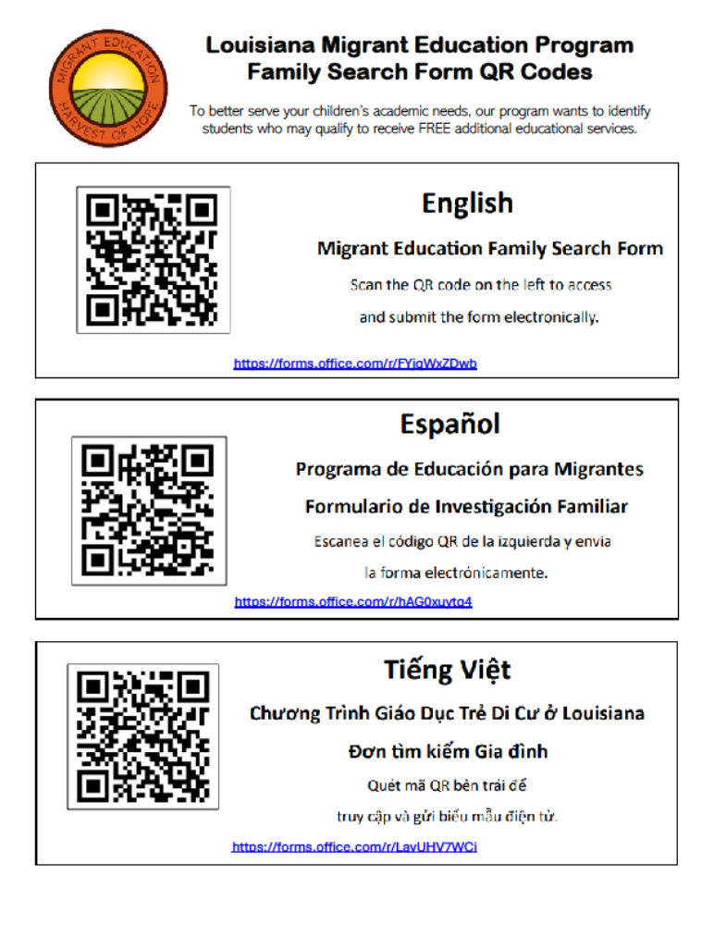

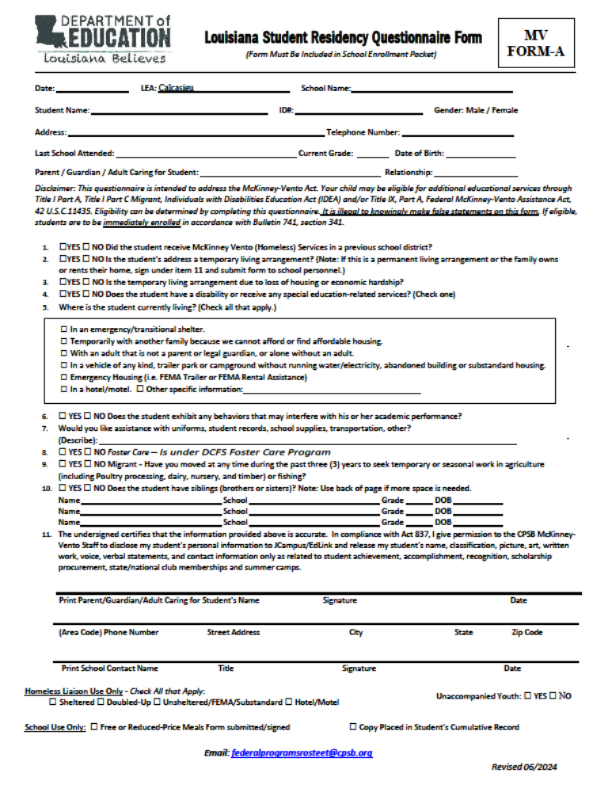

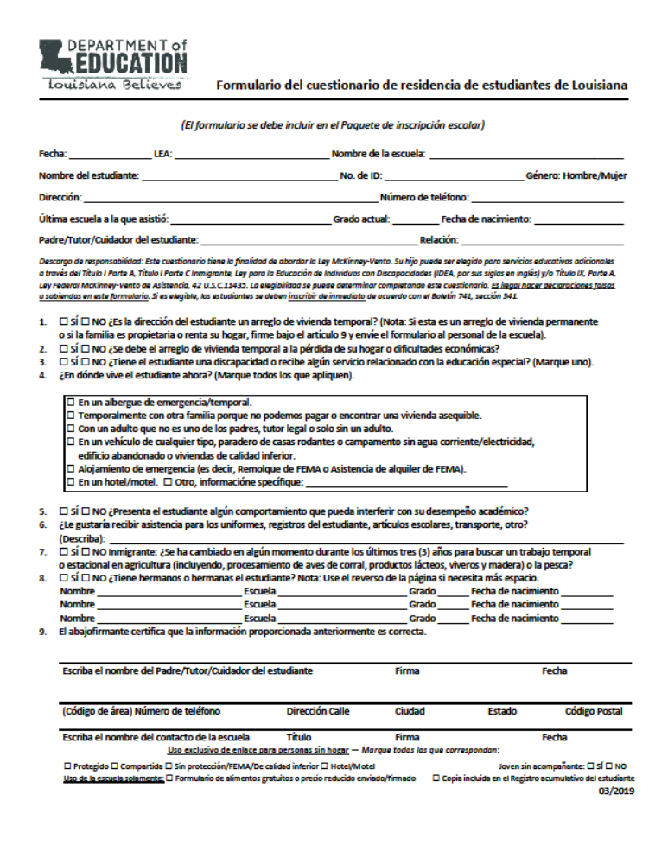

FEDERAL PROGRAMS REQUIRED PARENTAL INFORMATION

I have read and understand the documents listed below in the student’s CPSB Code of Conduct Handbook regarding Federal Programs. My signature on the CPSB Student Code of Conduct Acknowledgement Page indicates that I have reviewed on these documents:
- Federal Programs Information
- Parent Notification Information
- LA Dept. of Education Complaint Procedures for The Elementary and Secondary Education Act of 1965
- District Family Engagement Policy
- Act 909
- Title IX Information
- McKinney-Vento Homeless Information
- DCFS Foster Care Contact
- Migrant Education
- McKinney-Vento Louisiana Student Residency Questionnaire Form

TITLE I
JOB DESCRIPTIONS

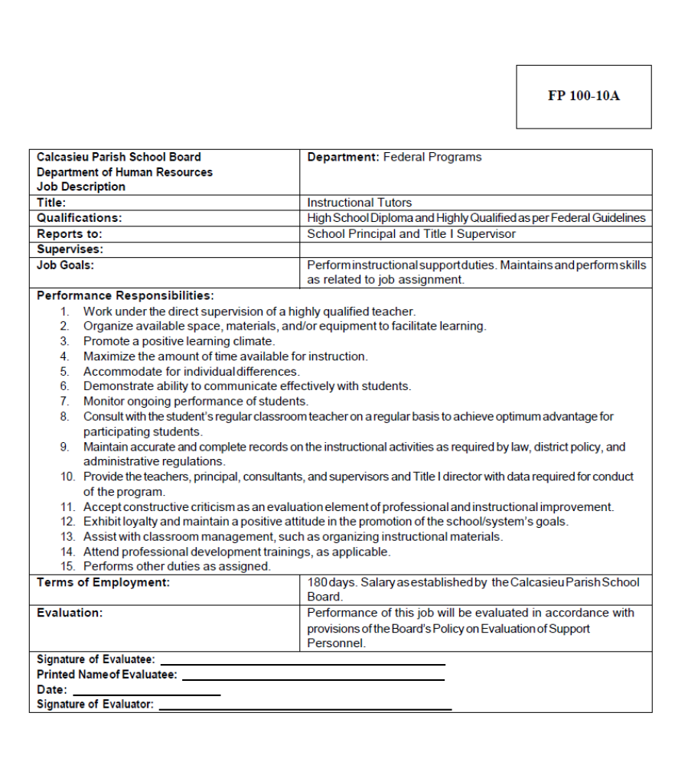

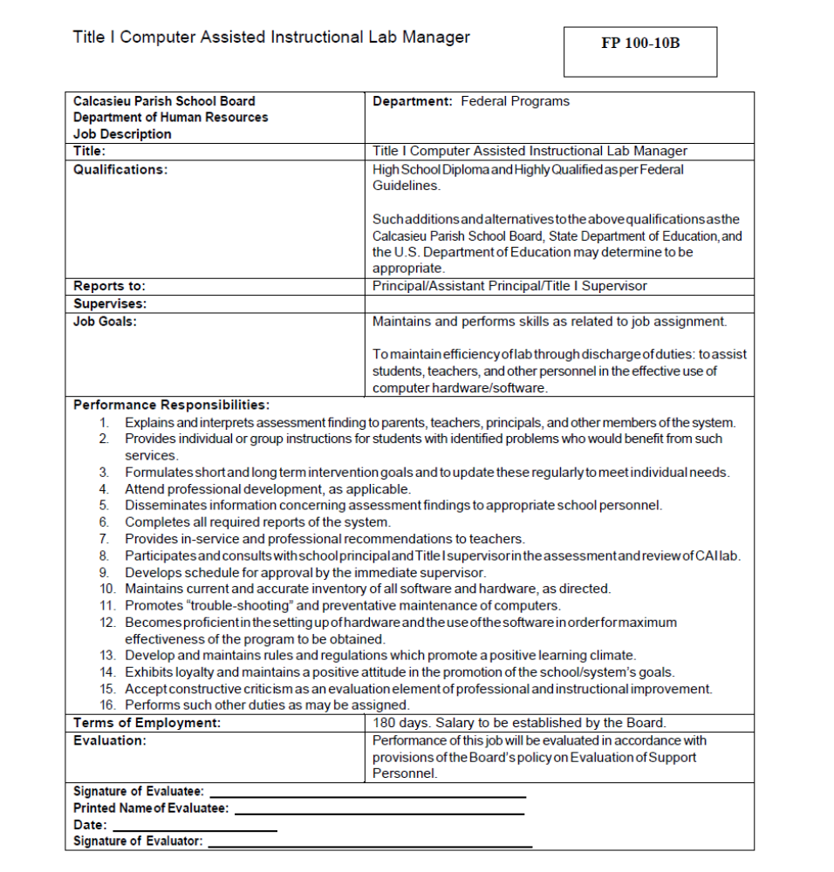

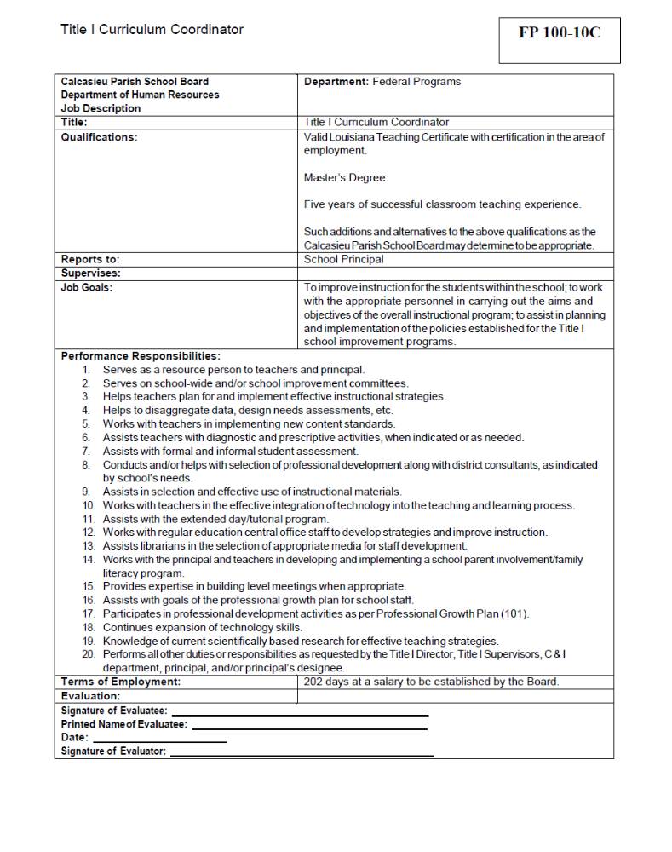

Certification

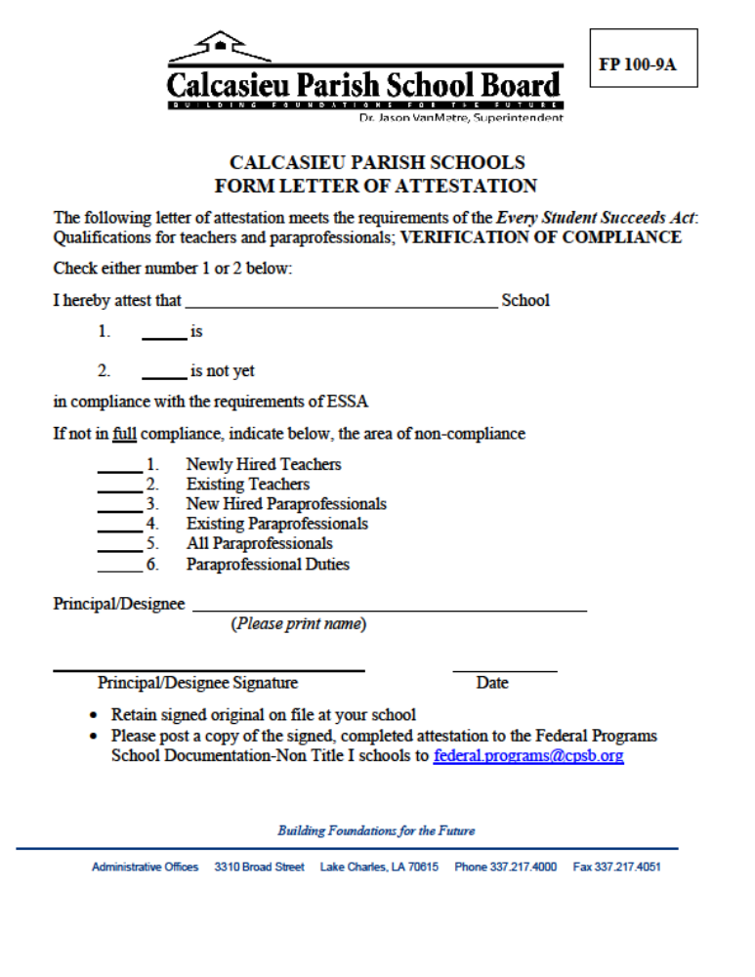

TITLE III
INFORMATION AND FORMS

Title III
Loree L. Smith, Supervisor
Federal Programs Calcasieu Parish Schools
2423 6th Street (Rosteet Annex)
Lake Charles, LA 70601
Phone: 337.217.4170 Ext. 2406
Fax: 337.217.4173

TBD Consultant, World Languages EL/ PK-12
Cindy Dore’, Lead EL Teacher, Calcasieu Parish
600 S. Shattuck Street
Lake Charles, LA 70601
Phone: 337.217.4150 Ext. 1516
Fax: 337.217.4152

https://www.cpsb.org/curriculum/english-learners-esl/home

SAPE
(Substance Abuse Prevention Education)
INFORMATION AND FORMS

NOTICE TO PARENTS AND STUDENTS OF CALCASIEU PARISH

The Calcasieu Parish School Board and the Louisiana State Department of Education have directed that each student and his parents/guardians be told that, without exception, a student shall not be under the influence of, bring on, consume or have in his/her possession on a school bus, on school premises, or at a school function away from school, any narcotic drugs or controlled dangerous substance as defined by State law, unless dispensed by a licensed physician as allowed by law. Any student of the Calcasieu Parish School Board found to be in violation of this policy will be subject to expulsion as provided in the Drug-Free Schools and Communities Act Amendments of 1989, Public Law 101-226. Terms of the law are mandatory and include a statement that referral sources are available to parents/guardians.

Act 909—1990 Louisiana Legislative Action
- Mandates that any student, sixteen (16) years or older, found guilty of knowledge of and intentional distribution of or possession with intent to distribute any controlled dangerous substance on school property, on a school bus, or at a school event shall be expelled from school for a minimum of twenty-four calendar months.
- Mandates that any student who is under sixteen (16) years of age and in grades 6-12 and who are found guilty as in (1.) above shall be expelled from school for a minimum period of twelve (12) calendar months.
- Mandates that any student who is kindergarten through grade five and who is found guilty as in (1.) above shall be referred to the local school board through a recommendation for action from the superintendent.
- Specifies procedures for review or appeal as follows:
  - The parent or tutor of the pupil may within five days after the decision is rendered, request the school board to review the findings of the superintendent or his designee.
  - The parent or tutor of the pupil may, within ten days, appeal to the district court for an adverse ruling of the school board/superintendent.
- Requires that upon recommendation by a principal for the expulsion of any student referred to above, a hearing shall be conducted by the superintendent or his designee to determine whether the student shall be expelled or if other corrective or disciplinary action shall be taken. Until such hearing, the student shall remain suspended from school.
- Mandates that no student expelled pursuant to this act shall be readmitted to any public school in the State except upon the approval of the school board system to which he seeks admittance.

McKINNEY-VENTO HOMELESS, Foster Care, Migrant
INFORMATION AND FORMS

McKinney-Vento Homeless, Foster Care and Migrant Programs
Goals, Procedures and Services
Focus:
- Awareness, Identification and Access
- School enrollment and stability
- Support academic success
- Student centered decisions based on the best interest of the student

Who qualifies for McKinney-Vento Homeless Act?
- Children living in shelters, including domestic violence shelters
- Children living in hotels/motels
- Children living on the streets or in cars, abandoned buildings, campgrounds, etc.
- Children living in substandard conditions – not fit for human habitant (i.e. no electricity, no heat, no running water, no windows/doors, holes in the roof/floor)
- Abandoned and/or runaway children and youth (Unaccompanied Youth)
- Two or more families living together in crowded or undesirable living conditions, (doubling/tripling up) because they have no place of their own to live where they can safely and healthfully meet their basic needs in privacy and with dignity. (Extreme poverty)
The Rights of Homeless Students
(Federal Law: McKinney-Vento Homeless Act)
- McKinney-Vento Homeless students stay in their school throughout the school year even if their residence has changed (school of origin). This decision is always made in the best interest of the children.
- MV students will receive a permit from CWA (when required).
- MV students have immediate access to school enrollment without proof of residency, birth certificate, immunizations, school records or other required documents.
- MV students are provided transportation to school of origin.
- MV students can enroll in a pre-school program.
- MV students are provided appropriate school services that are provided by CPSB.
- If there is a Dispute Resolution Request, the MV student is to attend school while the issue is being resolved.
- CPSB Homeless and Foster Care Policy is located on District Website (File: JBCBB, Cf: JBC)
Procedures:
- Families and/or students must apply each school year for McKinney-Vento Homeless services.
- Each school will provide a primary and secondary McKinney-Vento and Foster Care Contact Person who will be trained by completing the 2021/2022 MV and FC Training Webinar “Certificate of Completion” and email: federalprogramsrosteet@cpsb.org or Fax 217-4173 to my office.
- School contacts or administrators will provide McKinney-Vento information at the beginning of the year school staff in-service.
- Title I Administrators will post Agenda and Sign in Sheets to Federal Programs Blackboard.
- Non-Title I Administrators will email: federalprogramsrosteet@cpsb.org or fax (217-4173) Agenda and Sign in Sheets to my office
- Each student’s Enrollment packet/Code of Conduct will have a Louisiana Questionnaire Form or Migrant Form for parents to complete and return to their child’s school.
- When the Louisiana Questionnaire Form (A) is returned to the School Contact person with questions #1 and/or #2 checked yes, that student may meet the qualification for the MV Program. The School Contact person will interview the family/student to assess their needs and provide further information of services provided by the MV program and other resources/agencies. The family/student will receive a MV pamphlet (purple).
- If a school contact receives the La. Questionnaire from a student and Foster Care question is checked YES, please email: federalprogramsrosteet@cpsb.org or fax (217-4173) the application to Federal Programs office along with the FC Referral Form and the DCFS child’s placement Forms.
- If a school contact receives the Migrant Form from a student and the Migrant question is checked YES, please email: federalprogramsrosteet@cpsb.org or fax (217-4173) the application to Federal Programs office.
- The school’s contact person will email: federalprogramsrosteet@cpsb.org or fax (217-4173) the completed Louisiana Questionnaire Form (A), Title VII McKinney-Vento Homeless Confidential Referral Form (B) (with the Principal’s signature) per student, Title VII McKinney-Vento Homeless Student Needs Assessment Form (C) (if applies), if in need of an Out of Zone bus transportation a McKinney-Vento Transportation Request Form (D) {Out of Zone Form D requires Principal signature} (email: federalprogramsrosteet@cpsb.org or fax (217-4173).
- The Liaison’s signature (Carolyn Toups) indicates that the student qualifies for MV Homeless services. The approved MV Homeless Confidential Referral Form (B) will be emailed to the school contact person. A copy of the approved MV Homeless Confidential Referral Form (B) is to be kept in the school contact person’s MV files and a copy of Forms A & B are placed in each MV student’s cum-folder. This will ensure that “homeless” documentation travels with the student’s school information.
- The McKinney-Vento Homeless Student Needs Assessment Form (C) will provide the necessary information for the MV staff to bundle the school uniform and basic school supplies. The school contact person will notify the parent or guardian that the uniform and school supplies bundles are ready to be picked up at the school.
- MV Homeless student’s information is to be handled with complete confidentiality and utmost discretion. I suggest you advise classroom teacher(s) of their “homeless” students, because all school fees are waived, and no pressure should be placed on “homeless” students for payment. (CPSB Registration Hardship Waiver Request)
- Each family is required to follow schools’ guidelines and procedures regarding the Food Services Department. The MV office will email Food Services and JCampus daily, with a list of approved homeless students’ names. All MV students and Foster Care students qualify for Free School Meals but is required to complete application if not a CEP school.
- The MV office will email a request the McKinney-Vento Transportation Request Form (D) {requires Principal signature} for Out of Zone. The MV students can remain in their school of origin for the remainder of the school year. The MV office must have Form D for any MV student riding a CPSB bus requesting an Out of Zone bus. If a student’s address changes during a school year, then a new Form D with “change of address” must be email: federalprogramsrosteet@cpsb.org or fax (217-4173) to the MV office.
- Once the student has been qualified for the MV Homeless Program, the student remains under this MV Homeless Program for the remainder of the school year.
- If a student’s living situation changes and/or becomes unstable at any time during the school year, they may be eligible for the MV Homeless Program.
- Schools are to display a MV Homeless poster in a public area of their school.
- All MV Homeless information is posted on CPSB Federal Programs McKinney-Vento Blackboard.
- Families are notified by the Dianna Thompson, Child Advocate, of agencies/resources available.
- Any student who qualifies for MV Homeless services is provided a MV Homeless pamphlet.
- Contact the District’s Homeless Liaison (Carolyn Toups) regarding a Dispute Resolution Form.
- Families who do not meet the qualifications for McKinney-Vento Homeless under the new ESSA law, will receive a notification letter.
- Family or students must apply every year.
Federal Monitoring Requirements:
- The schools Administrator allows time for MV Professional Development/Training by the MV School contact person to inform staff of MV information. Documentation of training at your school will need to be documented (on beginning of the school year Agenda) for Federal monitoring requirements. Email: federalprogramsrosteet@cpsb.org or fax (217-4173) documentation (copy of Agenda and MV Webinar Certificate of Completion) to the Federal Programs office. MV poster is to be displayed in a public area of the school. Schools are required to keep Federal Programs Documents on file for 5 years.
McKinney-Vento Homeless Educational School Reimbursement Guidelines:
Step #1. Email: federalprogramsrosteet@cpsb.org or fax (217-4173) the VII McKinney-Vento Pre-Approval
for Educational School Reimbursement Form (E) with the school principal’s signature, a copy of the
Letter to Parents and copy of Transportation “Trip Tracker” Approved Form (when applicable).
Step #2. BEFORE spending any money, the McKinney-Vento Pre-Approval for Educational
Reimbursement Form (E) must be approved by Carolyn Toups and emailed back to your school
contact person with approved signature. (REVISED-2019)
Step #3. The McKinney-Vento Request for Educational Reimbursement Form (F), with the
Principal’s signature can be faxed for reimbursement along with proof of payment (copy of canceled
check from school); CPSB Federal Programs will reimburse the school. Reimbursement Forms (F)
are due the second Friday of May annually. (REVISED-2019)
**All schools are to waive school fees for all McKinney-Vento Homeless students. Under the
McKinney-Vento Homeless Program, student’s report cards cannot be held because of unpaid fees.

McKinney-Vento Homeless Forms:
- Form A – Louisiana Student Residency Questionnaire Form, (Spanish version on
Federal Programs Blackboard)
- Form B – McKinney-Vento Homeless Confidential Referral Form (Requires principal’s signature)
- Form C – McKinney-Vento Homeless Student Needs Assessment Form
- Form D – McKinney-Vento Transportation Request Form-Out of Zone (Requires principal’s signature)
- Form E – McKinney-Vento Pre-Approval for Educational Reimbursement
- Form F – McKinney-Vento Request for Educational Reimbursement
- Caregiver Form for Unaccompanied Youth
- CPSB Registration Hardship Waiver Request
- Dispute Resolution Form (Contact District Homeless Liaison)
Services provided by McKinney-Vento Homeless Program:
- Qualifies for Free School Meals
- Basic school supplies and a back pack (if needed)
- Tops, bottoms, 1 belt, and 1 jacket
- 1 P.E. uniform for Middle & High school students
- Specialize school supplies (upon request-Form E)
- According to CPSB policy Bus Transportation is provided for all MV Homeless students
- Pre-Approved Reimbursement Form (E)
Example: Reimburse school for cap, gown, and diploma for graduating seniors
- MV Homeless pamphlet (information for MV students)
- MV Homeless pamphlet (contact information)
- Reimbursement to the school for MV Senior Students Cap & Gown
- Send in Form E for approval for any items the student needs
- iPads, laptops, and Hot Spots
Services provided by the School for the McKinney-Vento Homeless Student:
- Louisiana Student Residency Questionnaire Form is provided in the school’s enrollment packet (Code of Conduct). Forms are to be completed and returned to the school and forms are kept on file at the school for (5) five years. Forms returned with “Yes” on questions #1 and 2 will need to be addressed. Returned Form A if Migrant is checked YES or if Foster Care is check YES. If FC is checked YES, send a copy of a completed Foster Care Form A along with DCFS Placement Forms.
- Enroll students without barriers
- MV family follows school’s procedure for Food Services Department
- Dress code for MV Students will be waived until uniform and school supplies are delivered to the school.
- WAIVE ALL SCHOOL FEES (CPSB Registration Hardship Waiver Request)
- Distribution of uniforms and school supplies to MV students with discretion and confidentiality
- Contact the District Homeless Liaison for the Dispute Resolution Form.
- MV Forms A & B will be placed in each student cum folder and the school will keep all MV Forms on file at your school (5 years). (The MV office can provide you an updated list of your school’s MV students upon request.)
- Provide MV information/training to your school faculty (guidelines and services). Please email: federalprogramsrosteet@cpsb.org or fax (217-4173) documentation (Agenda and sign in sheet) to the MV office.
Services Provided by McKinney-Vento Sub Grant FY 2021-2022:
- Homeless Child Advocate will contact families/Unaccompanied Youth to provide community resources
- Educational Field Trips
- Tuition for Educational Services
- Special Fees for School Tools (ex. Sewing Kit)
- Tutoring
- Transit System bus tickets
- Summer Programs
- iPads, laptops, and Hot Spots
Foster Care Program
- Foster Care students will not qualify for McKinney-Vento Homeless under the new ESSA Law.
- DCFS Foster Care Case Managers will provide a School Counselor Letter/Placement Agreement Form to the school when a child enters Foster Care and when updating any changes regarding previous DCFS Letter sent to the school.
- Adoptive parents will notify the school about the child’s legal name change once adopted.
- Please email: federalprogramsrosteet@cpsb.org or fax (217-4173) a copy of the CPSB Foster Care Confidential Referral Form A and the DCFS Child Placement Forms to Carolyn Toups, POC

Contact information: Johnethia Bellard, District McKinney-Vento Homeless Liaison and
District Foster Care POC (Point of Contact)
2423 6th Street (Rosteet Annex)
Lake Charles, LA 70601
E-mail: federalprogramsrosteet@cpsb.org
Phone: 337.217.4170 Ext. 2408 Fax: 337.217.4173
Natasha Walker, MV Homeless Child Advocate
2423 6th Street (Rosteet Annex)
Lake Charles, LA 70601
Phone: 337.217.4170 Ext. 2416 Fax: 337.217.4173
Kendria Guice, Federal Programs MV Homeless Secretary 2423 6thStreet (Rosteet Annex)
Lake Charles, LA 70601
Phone: 337.217.4170 Ext. 2407 Fax: 337.217.4173

McKINNEY-VENTO HOMELESS DISPUTE RESOLUTION FORM
- McKinney-Vento Homeless Liaison will be charged with providing a written explanation if there is a need for a “Dispute Resolution”.

McKINNEY-VENTO HOMELESS WRITTEN NOTIFICATION OF
ENROLLMENT DECISION FORM
- The McKinney-Vento Homeless Liaison will provide a written explanation to the student or parent/guardian if the District assigns the child or youth to a school other than the “School of Origin” or other than a school requested by the parent/guardian.
Please contact District McKinney-Vento Homeless Liaison
if there is a need for the above forms:
Johnethia Bellard
2423 6th Street (CPSB Rosteet Annex)
Lake Charles, LA 70601
E-mail: Johnethia.Bellard@cpsb.org
Phone: 337-217-4170 Ext. 2408
Fax: 337-217-4173

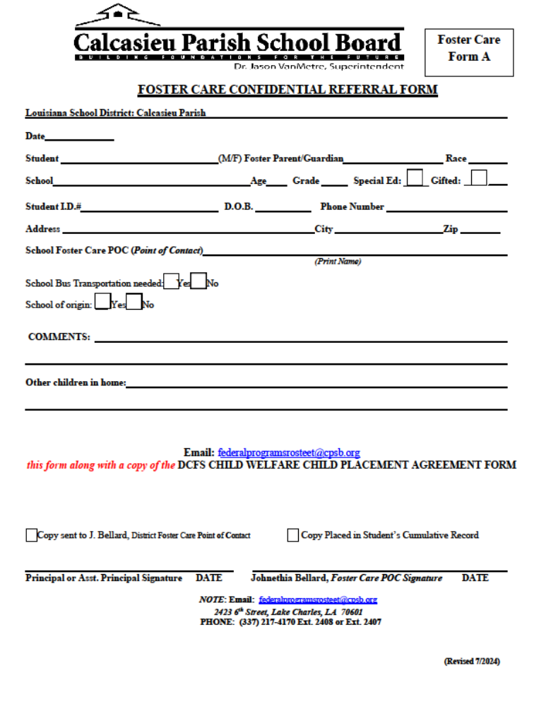


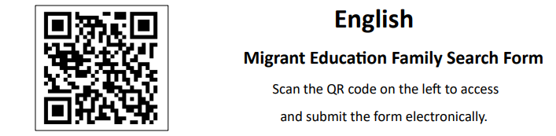
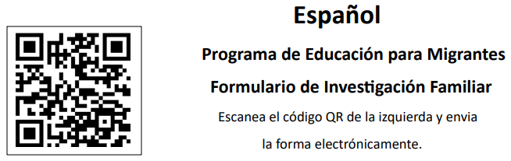


https://forms.office.com/r/FYjqWxZDwb

Louisiana Migrant Education Program
Family Search Form QR Codes

To better serve your children’s academic needs, our program wants to identify students who may qualify to receive FREE additional educational services.
https://forms.office.com/r/hAG0xuytq4
https://forms.office.com/r/LayUHV7WCi

