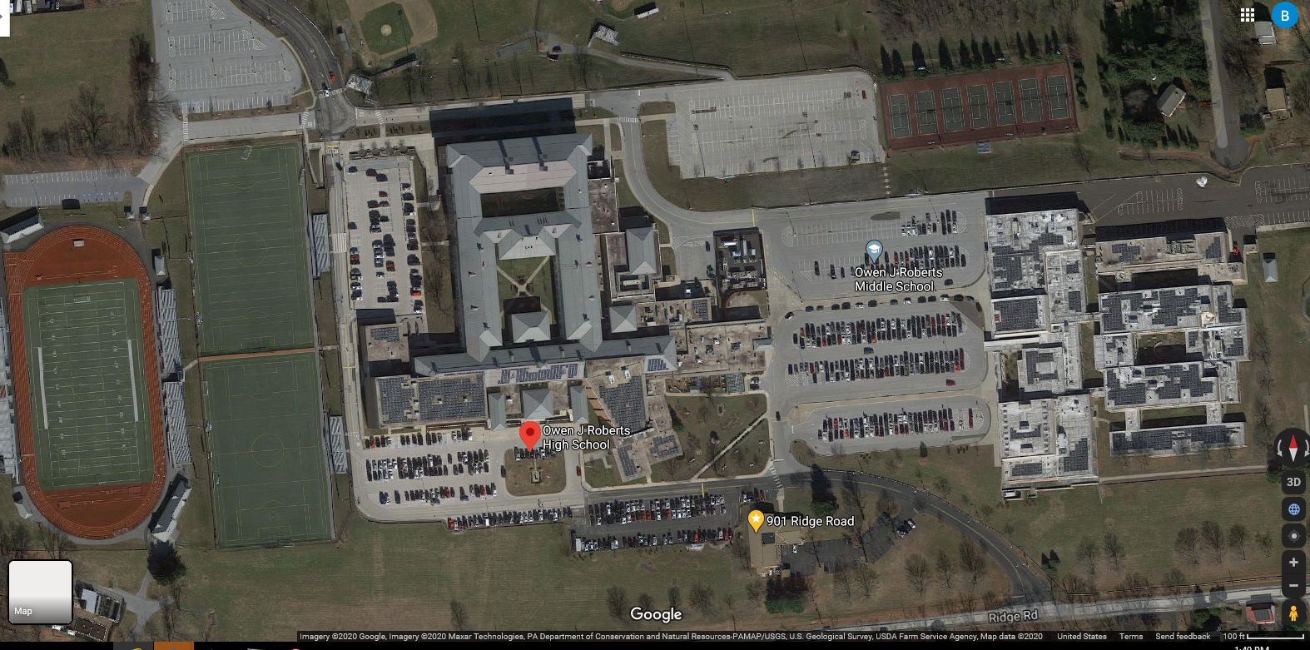
Lot 11
Lot 10
Lot 6
Lot 9
Lot 7
Lot 8
Lot 5
Lot 4
Lot 3
Lot 2
Lot 1

