TO: All New Users/Requestors and Current Requestors

FROM: Rialto USD Maintenance & Operations Services

Clara Romero, Norma Zaragoza

For those of you who have not registered yet, here are a few tips that I have found helpful to common problems:

- Print out the attachment (New User Maintenance Direct Requester Guide) and follow the steps.
- Use this link: https://www.myschoolbuilding.com/myschoolbuilding/mygateway.asp?acctnum=276014080
- Your REGISTRATION is complete – Only AFTER you create your 1st work order.
- Step 10 (very important) gives you your SUBMITTAL PASSWORD (which is different than your user/login password). It is: rialtousd
- Make sure to remember your personal/ individual login password.
- Add the login page to your favorites.
- In the CRAFT section IT – is not for our IT Department. It is for the Maintenance Department (bells, alarms, audio systems). For IT requests, continue using their system – Help Desk to create Incidents.

I hope these tips make it easier for those who have not registered yet. This information has been sent to all directors/administrators and secretaries, if you need to forward this information to a clerk at your site/department, you can do so. If you have any questions or need some help, please do not hesitate to call us or the School Dude customer service department.

If you have any questions, please call us (909) 820-7863 or you can also call the experts at School Dude, (877) 868-3833.

Thank you for your patience – we are still learning every day.


How to Register/Log in
Maintenance Direct Requester Guide
- Open your Internet Browser (Internet Explorer, Firefox, etc). Click on the following link, or copy and paste it into the web browser:
https://www.myschoolbuilding.com/myschoolbuilding/mygateway.asp?acctnum=276014080
- If you are a returning user, enter your Email Address and Password. Click Sign In.
- If you have forgotten your password, click the Forgot Password? Link and enter your email address. We’ll send you instructions for resetting your password.
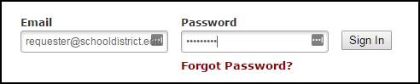
- If you are submitting your first request, you must enter registration information first. *Note: Your registration will be complete after you submit your first work request.
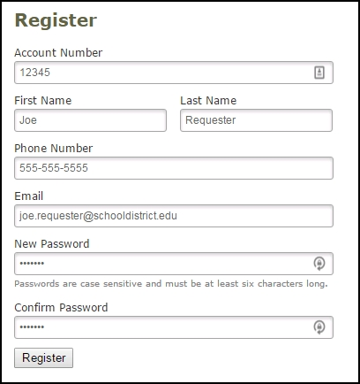
- Enter the Account Number provided by your Administrator.
- Enter your First and Last Name, as well as your Phone Number and Email Address.
- Type the Password you would like to use to log into your SchoolDude account and confirm it. The password you choose must be 6 characters long.
- Click Register to go to the work order request form.

The Dude Says:
To create a shortcut to your desktop, find a blank area on this screen and right click on your mouse. You will have the option to create a shortcut or add to your favorites. Creating a shortcut will add an icon to your desktop. You can double click it the next time you want to sign in.

How to Submit a Request
- Make sure you are on the Maint Request tab at the top of the screen.
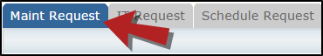
*Note: Any field marked with a red checkmark is a required field.
- Step 1: These fields will already be filled in with your contact information according to how it was entered upon registration.
- Step 2: Click on the drop down arrow and highlight the Location where the work needs to be done. Do the same for Building (if available) and Area. Also, be sure to type in the area description or room number in the Area/Room Number field.
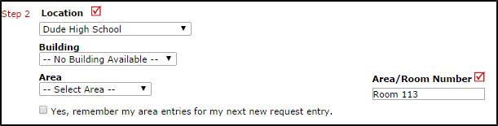
- Step 3: Select the Problem Type that best describes the request/issue you are reporting.
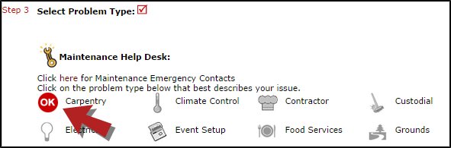
- Step 4: Type in a description of the problem.
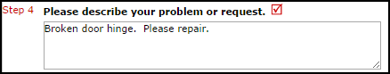
- Step 5: Enter a time that you are available for the maintenance work to come by.
- Step 6: Select a Purpose for the work if necessary. This will default to Reactive Maintenance.
- Step 7: Enter the date you would like to have the work completed by.
- Step 8: Select the Budget that will apply to costs related to this work request.
- Step 9: Attach a file to your request if necessary (i.e. a picture of damage or setup diagram).
- Step 10: Type in the Submittal Password. rialtousd
- Step 11: Click the Submit button.
My Request Tab
You can view any requests that you have entered into the system by clicking on the My Requests tab. Hover your mouse over the Shortcuts link and click on My Maint Requests. You will see a listing of any requests that you have entered into the system. You are also able to print out a listing of your requests by clicking on the printer icon.
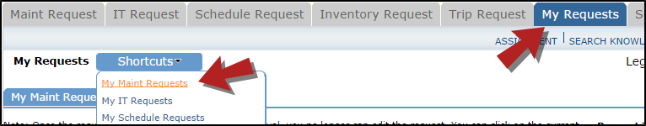
On the My Requests page you will see up-to-date information on your requests including the current status, work order ID number, and Action Taken notes. You can click on the number next to the status description in the Request Totals section to see all of your requests marked with that status. You can also search for any work order request by typing a key work into the Search box and clicking Go.
