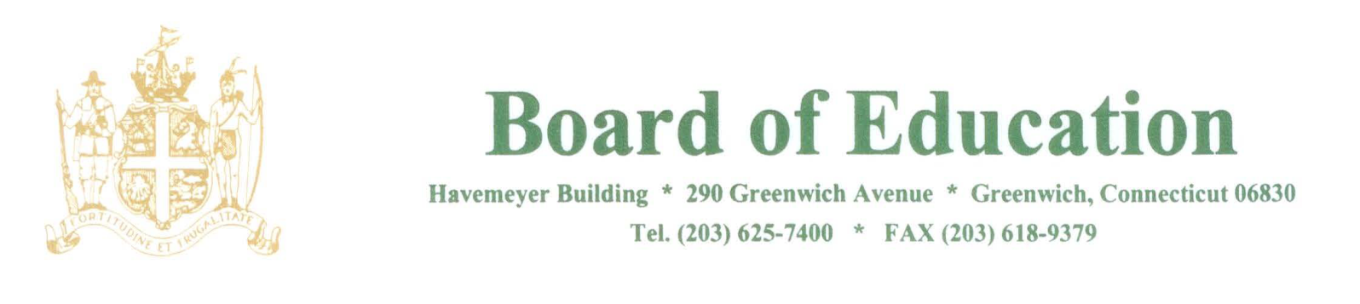

NOTICE OF MEETING

PLEASE POST

Notice is hereby given of the Hybrid Meeting of the Greenwich Board of Education Policy Governance Committee, on Wednesday, May 21, 2025 at 3:30pm in the Havemeyer Boardroom, 290 Greenwich Avenue, Greenwich, CT or virtually.

Join from PC, Mac, iPad, or Android:
https://us02web.zoom.us/j/83384605296
Or Dial 646 558 8656 and use Webinar ID: 833 8460 5296

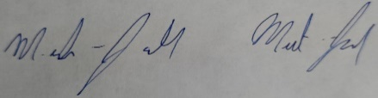
____________________
MJ Mercanti-Anthony
Policy Governance Committee Chair

MJMA/lv 5/19/25

