You are cordially invited to join us for
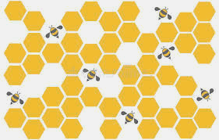

Haviland
Avenue School’s Annual Children’s Night!

---------------------------------------------------------------------------------------------------------------------------------

Haviland is excited to welcome you back to Children’s Night, one of our community’s favorite traditions. Please join us for an evening of celebrating the hard work and achievements of our students. Families are encouraged to stop in at any time to view and participate in a variety of activities planned for the evening. Please see details below, and don’t hesitate to contact us with any questions.

Haviland Avenue School
Wednesday, May 28, 6:30 - 8:00 pm

HAS Preschool Showcase - Fairy Tale Showcase

K - 2 Showcase - Academic Games, Presentations, and Activities

MUSIC - Makey Makey Play Doh Piano

STEAM - Student projects will be on display in room 225.

Art Showcase - will be on display outside the art room and in the halls
outside of the classrooms. Be sure to do the Scavenger Hunt for added fun!

Library Showcase - 4th of July, Summer Activities, Mrs. McCutcheon's SEL topics (celebrating differences), and our new Spanish Language books

Health/Physical Education - American Heart Association Showcase

Math Coach - Stop in the upstairs main hallway for resources, tips, and tricks for
helping your child with math.

PTA Spring Book Fair will be in the library. Stop in to browse our selection of books for
summer reading and end of year teacher gifts!

