

STUDENT & PARENT HANDBOOK
2025-2026



TABLE OF CONTENTS

STUDENT/PARENT LETTER | 2
FORMS USED DURING THE SEMESTER  Required Forms Checklist  Early Release/Late Arrival & Program Consents  Program Student Guidelines  Course Syllabus  WBL Handbook & Syllabus Verification  Educational Training Agreement  Employment Verification & Training Plan Information  Training Plan  Continued Employment Commitment & Hours Requirements  Unpaid Internship Agreement  Student Employability Skills Evaluation  School Calendar 25-26 | 3  4  5  7  8  9  11  12  13  14  15  16
STUDENT EXPECTATIONS  General Expectations  Attendance Policy  Grading Policy  Assignments  Workplace Behavior  Dress Code  Following Instructions  Mentor/Supervisor Role  Additional Tips for Success | 17  17  18  18  19  19  20  20  21

PARENT/STUDENT LETTER

Dear Work-Based Learning Student & Parent(s):
Thank you for your interest in the Work-Based Learning Program! This is going to be a very exciting experience for a student like you who desires a challenging, enriching, and career-based opportunity. This experience will provide you with opportunities for instruction not only in academics but also in occupational skills, career exploration, and guidance in identifying employment and educational goals. You will now have the opportunity to connect what you learn in school with work-site application, enabling a smooth transition into your post-secondary plans beyond high school.

As a reminder, if your student has not already taken a full credit of Career Tech or other courses closely related to his/her career pathway, it is required that these courses be taken while in the WBL program. Ideally, jobs should be in the student’s career area of interest.

All WBL students must have an approved job by the last day of the first week of the semester. Ultimately, it is the student’s responsibility to find a job but check with the WBL Coordinator periodically as employers often contact the school seeking WBL student applicants. The Work-Based Learning Coordinator must approve all jobs or internship placements. The following rules apply for Work-Based Learning jobs and/or internships:
- Jobs cannot be of a dangerous nature (as determined by the WBL Coordinator).
- Employers must operate from a business storefront or office with a business phone line & registered tax ID number (no residences). Additionally, WBL students may never work alone. A supervisor must always be on site.
- The student must be placed on the employer’s payroll with all income reported on a W-2 form and adherence to all federal and state regulations including child labor and minimum wage laws, and income tax and Social Security withholding regulations. Students cannot be paid in cash. A 1099 form is not allowed as students may not work as independent contractors. (If at any point in the year it is found that you are being paid in cash or working as an independent contractor, you will be dropped from the class.)
- All unpaid internships must go through an approval process.
- It is recommended that parents ensure the employer has workers’ compensation insurance. The school is not allowed to ask this question.
- Employment within a family business is usually not allowed. You may not be supervised by a family member.
- Seasonal, weather dependent, delivery, and self-employment jobs are not allowed. Babysitting in someone’s home is not allowed. Driving while on the job is not allowed. NO driving is permissible except from school to work and work to home.
- Jobs must be within a reasonable commuting distance (as determined by the WBL Coordinator). You must have your own transportation to work (either drive yourself or a parent drives you).
- Students may not resign from a job without prior approval from the WBL Coordinator. Students are expected to remain at the same job throughout the school year.
All students accepted to the program must attend a mandatory orientation with the assigned WBL coordinator. At this meeting the coordinator will go over required paperwork and expectations for the WBL program. If a student fails to attend orientation and/or does not return required paperwork in its entirety, the student will be dropped from the program.
Thank you,
Michelle Duren: Cherokee HS
770-721-5355 / Michelle.Duren@cherokeek12.net

Emily Henderson: Cherokee HS
770-721-5380/ Emily.Henderson@cherokeek12.net

Donna Lloyd: Creekview HS
770-704-4408 / Donna.Lloyd@cherokeek12.net

Chris Jeffreys: Creekview HS/ iGrad
770-704-4453 / Chris.Jeffreys@cherokeek12.net

Nichole Gibson: River Ridge HS
770-721-6521 / Nichole.Gibson@cherokeek12.net

Casandra Hembree: Sequoyah HS
770-721-3241 / Casandra.Hembree@cherokeek12.net

Lisa Harrell: Woodstock HS
770-721-3035 /Lisa.Harrell@cherokeek12.net

Robyn Mattson: Etowah HS 770—721-3171 / Robyn.Mattson@cherokeek12.net

REQUIRED FORMS CHECKLIST

Student Name:
ID #:
Current Grade:

Once admitted into the Work-Based Learning Program, the following are required for your file by the first Friday of the semester of your WBL enrollment. If you are MISSING any form or any form is NOT completed, you will be removed from the Work-Based Learning program.

The WBL Program Forms Checklist below applies to both unless specified otherwise. Unpaid interns must also have a signed Unpaid Internship Agreement submitted.

Check  When  Completed | WBL PROGRAM FORMS
 | Online Application
 | Release Approval and Program Consents
 | Program Student Guidelines
 | WBL Handbook & Syllabus Verification
 | Educational Training Agreement
 | Employment Verification and Training Plan
 | Continued Employment Commitment
 | Unpaid Internship Agreement (If Applicable)

EARLY RELEASE/LATE ARRIVAL APPROVAL & PROGRAM CONSENTS

Directions: For a student to be enrolled in the program, the parent/guardian must read the text below and signify understanding and agreement by signing and dating the form at the bottom of the page.
Early Release/Late Arrival
I understand that my child, ____________________________, is enrolled or seeking enrollment in the work-
based learning program at ___________________________ High School and that my child will be dismissed early, before the end of school, or arrive after the beginning of school, for his/her regularly scheduled on-campus classes each day for this purpose.
I assume full responsibility for my child after early dismissal from school, or prior to arriving at school after the start of the school day, including days when my child is not required to be on the job.
Program Consents
- Reliable transportation is a requirement. School-provided transportation is not available for WBL students. I release the WBL site (paid or unpaid internship), all Cherokee County High Schools, and any agents of the employer, unpaid internship or the Cherokee County School District, from any liability that may result from the student’s use of his/her individual transportation.
- I acknowledge that the Cherokee County School District, the Career Pathways Facilitator, and the owner(s)/employees of the unpaid internship or employer site cannot be held responsible for medical/hospital cost resulting from injuries that might occur by participating in the WBL program.
- Permission is granted to photograph my son/daughter/ward for promotional and educational purposes.
- I hereby authorize the school or the WBL worksite or unpaid internship supervisor or mentor to secure emergency medical treatment. I will assume all financial responsibility.
- Some employers or unpaid internship placements require prospective employees or unpaid interns to participate in drug screening procedures. In such cases, this procedure becomes a condition of participation/employment. I consent to my son’s/daughter’s/ward’s participation in drug screening in these situations.
- I consent to the enrollment of my son/daughter/ward in the WBL Program as an employee or unpaid intern during the school year indicated above.

Parent/Guardian Signature |  | Date

Student Signature (if 18 or older) |  | Date

PROGRAM STUDENT GUIDELINES

Cherokee County School District Work-Based Learning
All Placements - Paid Position or Unpaid Internship
PROGRAM GUIDELINES

All Work-Based Learning (WBL) paid employment or unpaid internship placement sites must be approved by the WBL Coordinator in order for the student to receive credit for his/her work experience.

WBL paid employment or unpaid internship placement approval and continuation in the program will be based upon the student’s adherence to the following guidelines.

Approval Process:
The student must ALWAYS receive prior approval from the WBL Coordinator before accepting a job or unpaid internship for the purposes of the WBL program. Retroactive approval of an existing job/unpaid internship for purposes of the WBL program is at the WBL Coordinator’s discretion.

Employment Eligibility and Commitment:
- An unpaid intern and their parent/guardian must sign the Unpaid Internship Agreement. (Does not apply if student is in a paying position)
- The student must work a minimum of 5 hours per week for each class period in which he/she is enrolled in the WBL program and for which the student could earn ½ unit per semester for each class period in which he/she is enrolled in WBL. There will be a penalty on the grading of the Time Wage sheet for any week that the minimum hours are not met.
A student enrolled for 1 period must work/intern for a minimum of 5 hours per week.
A student enrolled for 2 periods must work/intern for a minimum of 10 hours per week.
A student enrolled for 3 periods must work/intern for a minimum of 15 hours per week.

The majority of these hours must be worked from Monday through Friday; students employed only on Saturday and Sunday are not eligible for Work Based Learning.
- The WBL student worker must commit to work through the last day school during the school year. As this is a requirement of the state, there will be consequences for resigning before the official Cherokee County last day of school that will result in a lowering of the student’s grade.
- The student must inform the WBL Coordinator promptly of any problems that arise on the job or unpaid internship placement site that may affect his/her employment or intern status. If the student is terminated from the job or released from the internship for any reason, the student must notify the WBL Coordinator within two school days following the termination/release. Continuation in the WBL program at this time will depend upon the circumstances of the termination and the student’s ability to secure suitable employment or internship. Continuation in WBL is not guaranteed if a student loses employment/intern status.
- The student may NOT resign/quit his/her position and commits to working in the approved location for the duration of the school year.
- Any student who is fired/terminated/released during the semester or resigns/quits his/her job or unpaid internship without prior approvals will receive a failing grade for that portion of the semester.
- Although the student is not required to work during school holidays for the purposes of the WBL program, the employer or unpaid internship site coordinator may require the student to work. If this is the case, the student must abide by the employer/site coordinator’s decision.
- On regular school days when school is dismissed early or all after-school activities are officially cancelled, the WBL student is not required to report to work that day for purposes of the WBL program. The decision to work on these days, if planned or expected, should be made by the student and parent or guardian in conjunction with the employer/internship supervisor.
- The student must, when participating in the medical internship programs, comply with the coordinating healthcare facilities requirements. This includes medical screenings and other guidelines. The student must meet any medical screenings required by potential internship provider/unpaid internship placement or employer at his/her own expense.
- The student must maintain a minimum overall GPA of 2.5. Any student not on track for graduation at the end of the semester will be removed from the WBL program. Any exceptions to this are at the discretion of the WBL Coordinator or school administration.

Eligible Student Work Locations:
- The student, whether in a paid or unpaid internship placement, must be employed by a place of business which keeps regular business hours and operates out of a store front or office. Work in “home offices” is not allowed.
- The students must be employed in approved worksite or, in the case of an unpaid intern, placed in an approved location. Unacceptable worksites or placements may include, but are not limited to, the following: in-home Nanny’s or babysitters (or similar employment), seasonal jobs, weather dependent jobs, delivery jobs and self employment jobs.
- Employment or unpaid internship placement in a student’s family business is strongly discouraged.
- The student must have a supervisor on duty at all times, and the supervisor must be directly responsible for the supervision of the student’s performance on the job or unpaid internship.
- The students must maintain appropriate employment or unpaid intern placement until the end of the school semester to receive credit for WBL. Failure to maintain such employment or placement may result in loss of credit for the WBL program for the semester and the student may be required to report to ISS during their WBL periods unless otherwise approved by the WBL coordinator.
- The student must respond to requests for information relative to education and career progress during the mandatory 2-year period following graduation. The student will provide current contact information during this mandatory reporting time.

School/Work Attendance:
- The student must make every effort to attend school every day. Additionally, a student is not permitted to report to work or placement if he/she misses two or more classes in a school day without approval from the WBL Coordinator. If the student fails to obtain prior approval, the work or internship hours will not be counted toward the minimum number of hours required for the WBL program.
- The student must attend his/her classes on campus according to the daily schedule. The student should notify the employer or unpaid internship placement of any modified work schedule due to testing or change of events.

Student Behavior:
- The student must maintain acceptable discipline records to remain good standing in the WBL program. If a student is in ISS or Alternative School, he/she may be required to stay the entire school day and not permitted to report to work or to participate as an intern that day. A student receiving three or more days of ISS will be removed from or not enrolled in the WBL program the following semester unless approved by the WBL Coordinator and administration.
- The student must leave campus upon, or remain off campus throughout, their release period(s), unless working on campus, and must not return to campus during their work release period(s) without WBL Coordinator or administrative approval. It is the responsibility of the WBL student to communicate to the WBL Coordinator that they are on campus during their work release period(s) when that is the case.
- Students will be dismissed from the Work-Based Learning program for various reasons, including but not limited to falsifying records/documents, job termination, academic integrity violations, inadequate job performance, failure to meet graduation requirements, excessive absences or tardiness (more than 10 unexcused occurrences), and violations of program rules.
I have fully read and agree to abide by the above Work-Based Learning Guidelines.
Student Signature Date

Parent Signature _______ Date _________

COURSE SYLLABUS 2025-2026

The Work-Based Learning Program in Cherokee County allows juniors and seniors who have identified a specific career objective to obtain experience and skills in a workplace setting. It offers students a unique opportunity to prepare for future educational and career goals while in high school.
Requirements:
- Student is engaged in his/her career pathway, supported by a career interest survey or career aptitude test.
- Student must attend school in order to work on any given day. If the student is absent from his/her classes at school for ½ the school day or more, the student will also be counted absent from work-based learning class(es).
- Continuous employment must be maintained throughout the semester to receive course credit.
- Student may not quit/change job unless approved by the Career Pathway Facilitator and professional procedures are followed.
- Student will provide completed documentation for this course. **see below**
- Student will meet at appointed time with Facilitator weekly and other designated times throughout the course. Failure to meet and turn in weekly sheets will result in removal of Work-Release Pass and can result in dismissal from the program.
- Student will complete an Electronic Career Portfolio to proficiency.
- Student will provide proof of time through Weekly Journal Sheets and copy of paystubs.
- Make up work policy (per handbook) is a 10% deduction the first day and an additional 10% deduction for each day after, not to exceed the 3 days.
- Grade recovery is available to any student who scores below a 70 on any major assignment. Students submitting incomplete work or students earning a zero on an assignment may not recover the grade. See student handbook defining cheating/plagiarism.
- Students must complete all documents in professional manner using blue or black Ink.
- Failure to attend class meetings, individual meetings, to sign in daily, and to check email daily will result in loss of work exit pass and can result in dismissal from the program. Students are required to sign in DAILY. Failure to sign in will result in student being marked absent for WBL periods. It is imperative that students check email account DAILY & respond when requested.

Required File Documents:
STUDENT/PARENT FORMS | EMPLOYER FORMS
- Online Application  - Early Release/Late Arrival Approval & Program Consents  - WBL Program Student Guidelines  - Handbook & Syllabus Verification | - Employer/Internship Verification  - Educational Training Agreement  - Employment Training Plan & Initial Rating  - Unpaid Internship Agreement (Unpaid Interns Only)

Student Evaluation:
CATEGORY | PERCENTAGE
Worksite Mentor/Employer Evaluation  **evaluated 4 times per year** | 30%
Portfolio Evaluation & Teacher Evaluation  **assignments will be due throughout the year** AND  **required file documents and assignments, email monitoring  ** attendance at meetings and sessions with Work Based Learning Teacher | 40%
Work/Wage Documentation  **Fulfilling the minimum weekly required hours and submitting documentation of Work Hours (timesheets with copy of paystubs) | 30%

WBL HANDBOOK & SYLLABUS VERIFICATION

My signature denotes that I have read and understand the Work-Based Learning Student Handbook which is located on the WBL Website and the WBL Coordinator’s Canvas page. I have read the handbook and agree to comply with the following:
- Student Expectations
- Attendance Policy
- Grading
- WBL Assignments/Career Portfolio Requirements
- Workplace Behavior
- Workplace Dress Code
- Mentor/Supervisor Role
- Following Instructions
- Additional Tips for Success
- Employment Evaluation Form
- Course Syllabus

___________________________________________________ _____________________
Student Name (Printed) ID #

__________________________________________________ ______________________
Student Signature Date

__________________________________________________ ______________________
Parent Signature Date

All Placements - Paid Positions or Unpaid Internships
EDUCATIONAL TRAINING AGREEMENT
Please Print:
Student Name: |  | Parent/Guardian Name:
Employing Company Name: |  | Employing Company Supervisor’s Name:  Mentor’s Name:
Work-Based Learning Coordinator’s Name: |  | Lisa Harrell & Eva Holston
The Student Agrees:
- To be at least 16 years of age and to have a Social Security number.
- To assist the Work-Based Learning Coordinator in finding an appropriate employment or unpaid internship position related to the career focus area of the program and the career objective of the student.
- To provide transportation to and from work.
- To attend school and work regularly. Failure to adhere to this part of the agreement may result in the student receiving appropriate academic and/or disciplinary action.
- To discuss all aspects of the employment with the Work-Based Learning Coordinator and the worksite or unpaid internship placement supervisor—not with other students, coworkers, etc.
- To represent the school and employer or unpaid internship by demonstrating honesty, punctuality, courtesy, and a willingness to learn. If the student is dismissed from employment due to negligence or misconduct, the student will be dropped from the Work-Based Learning Program and receive academic penalty.
- To work a minimum per week of 5 hours for 1 period release, 10 hours for 2 period release, or 15 hours for 3 period release with the majority of these hours during M-F of the school week.
- To make employment or unpaid internship changes with the approval of the Work-Based Learning Coordinator. The Work-Based Learning Coordinator reserves the right to change the student’s employment or internship situation if necessary.
- To be evaluated by the Work-Based Learning Coordinator and the Work-Based Learning work or internship-site placement supervisor a minimum of twice per semester.
- To submit to the Work-Based Learning (WBL) Coordinator a record indicating activities engaged in at the worksite and total hours and salary earned, if any, in a format determined by the WBL Coordinator.
- To allow the release of student records regarding academic performance, attendance, and discipline for the purpose of employment and program follow-up.
- To follow all the safety rules and regulations of the current employer or unpaid internship placement and understand that failure to comply with these safety procedures may result in personal injury or injury to others and/or dismissal from the Work Based Learning program.
- To keep all placement site operating, planning, product/service and customer/patient/student information confidential as appropriate and according to employer policy. Any concerns should be brought to the attention of the WBL teacher or site supervisor.
- To be responsible for obtaining, understanding and complying with employer or unpaid internship site dress code.
- To participate in video conferences and phone calls as requested and to respond to emails within 48 hours.
- To check CANVAS daily for assignments, announcements and other WBL related items.
The Parents/Guardian of the Student Agree:
- To encourage the student to carry out effectively his/her duties and responsibilities at both the school and place of employment or unpaid internship.
- Although Department of Labor rules allow for minors to move cars under certain conditions as part of their employment, the school does not necessarily feel that this is a good practice. Consequently, the parents and the employer agree to assume all liability if the student is required to move an automobile as part of his or her employment or unpaid internship.
- To make inquiries concerning the student’s training, wages, or working conditions through the Work-Based Learning Coordinator rather than directly to the employer or unpaid internship placement.
- To understand that the student must attend school and work regularly and not go to work or to the unpaid internship without going to school, unless approved by the Work-Based Learning Coordinator.
- To offer assistance to the Work-Based Learning Coordinator, serve as a resource person, and/or aid in other ways that could benefit the school and the student.

- To allow the release of student records regarding academic performance, attendance, and discipline for the purpose of employment and program follow-up.
- To provide transportation to and from work or the unpaid internship for my child. Student must leave campus immediately upon their release time or, for morning placements, not arrive until immediately before their first scheduled on-campus class.
- To assume full responsibility for my child after dismissal from, or before arriving at school, including days when my child is not required to be on the job or unpaid internship.
- To assist and support student in obtaining, understanding and complying with employer/unpaid internship dress code.
The Employer/Worksite/Unpaid Internship Supervisor Agrees:
- The Employee-Student or Unpaid Intern-Student has completed the necessary safety training for the current position of employment or internship and the employer or unpaid internship certifies that the proper procedures related to the job/internship requirements have been shown to the student and that in the case of an emergency, the student has been given instructions on what to do to resolve the situation.
- To agree to follow Georgia Department of Labor guidelines regarding the student driving vehicles as part of his or her employment or unpaid internship. Although Department of Labor rules allow for minors to move cars under certain conditions as part of their employment, the school does not necessarily feel that this is a good practice. Consequently, the parents and the employer agree to assume all liability if the student is required to move an automobile as part of his or her employment or unpaid internship.
- To provide a variety of work experiences for the student that contributes to the attainment of his/her career objective.
- To employ the student for a minimum per week of 5 hours for 1 period release, 10 hours for 2 period release, or 15 hours for 3 period release during the academic year with the majority of those hours occurring during M-F of the school week.
- To adhere to policies and practices which prohibit discrimination on the bases of race, color, national origin, sex, and handicap in recruitment, hiring, placement, assignment to work tasks, hours of employment, levels of responsibility, and pay.
- To provide instructional materials and occupational guidance to the student.
- To evaluate the student, in consultation with the Work-Based Learning Coordinator, a minimum of twice per semester.
- To adhere to all federal and state regulations including child labor laws and minimum wage regulations.
- For paid positions only: To adhere to income tax and Social Security withholding regulations. WBL students may not be considered independent contractors and for IRS purposes cannot be issued an IRS Form 1099.
- To provide time for consultation with the work-based learning coordinator concerning the student and to discuss with the Work-Based Learning Coordinator any difficulties that may arise.
- To inform the Work-Based Learning Coordinator before any disciplinary action is taken in regard to the employment of the student.
- To accept any disciplinary action that may result in the student being detained or absent from reporting to work.
- All sites must have a supervisor on duty at all times, and the supervisor must be directly responsible for the supervision of the student’s performance on the job.
- Employers are expected to follow Governor’s Executive Order, Department of Public Health and CDC guidelines regarding employees’ safety.
The Work-Based Learning Coordinator Agrees:
- To assist in the academic and occupational instruction of the student.
- To conduct site visits to the student’s place of employment. These visits may be conducted by phone and/or video conferences due to the current CDC and the DPH.
- To render assistance with educational and training problems of the student.
- To assist the work-based training supervisor in an evaluation of the student’s performance a minimum of twice per semester.
- To maintain records pertinent to the student, the employer, and the school.
I have read the above agreement and will carry out the responsibilities delegated to the best of my ability.
Student Signature |  | Date |  | Parent/Guardian Signature |  | Date

EMPLOYMENT VERIFICATION & TRAINING PLAN

The Role of the Training Plan in Work-Based Learning (WBL): The primary purpose of the WBL placement is to help students gain the experience they will need in the workplace in order to make a successful transition from school to career. The curriculum for WBL placements is the training plan and is mandatory for every student. A training plan is a written document that defines the foundational skills, workplace transitional skills, and job-specific skills that the WBL student will master. The raining plan should be a guide in which specified duties and tasks are itemized. The listing of duties and tasks represent the learning, which should take place through the workplace experience.

Student Name (Print): _______________________________ Student Pathway: ______________________________

Student Career Goal: _____________________________________________________________________________

Employing Company Name: ___________________________________ Type of Business: ___________________
Business Address: ____________________________________ City: ___________________ Zip: ___________
Business Phone: ________________________________________________________________________________
Work-Site Supervisor: ________________ Work-Site Supervisor E-Mail Address: ___________________________
Work-Site Mentor: __________________ Work-Site Mentor E-Mail Address: ______________________________
Student’s Start Date: ________________ Student’s Job Title: ___________________________________________
Student’s Wage: ___________________ Approximate # of Hours/Week: ________________________________

List any potential health/safety concerns related to this specific work assignment (Indicate NONE if no such conditions have been identified): _____________________________________________________________________________

______________________________________________________________________________________________

Special requirements expected of the student: ___________________________________________________________

Directions: Make a list and complete the chart on the next page of at least 10 specific job duties the student will be expected to learn and perform during this school year. Include at least 1 duty/task that relates to the student’s coursework. This list should be comprehensive and specific to the job – you simply break down the job into specific tasks required to complete as part of the job such as “mop the floor”, “process customer payment on point of sale system”, etc. They should not include assumed responsibilities such as report to work on time.

TRAINING PLAN

Please Print Task
(Be as specific as possible. The first task is preprinted and required for all WBL students)
1. Communicate effectively through writing, speaking, listening, reading, and interpersonal skills.

2. Task related to coursework (REQUIRED):

3.

4.

5.

6.

7.

8.

9.

10.

11.

12.

13.

14.

15.

Provide a copy of the formal job description and an employer business card if available.
Student Signature |  | Date |  | Supervisor Signature |  | Date
WBL Coordinator Signature |  | Date |  | Parent Signature |  | Date

CONTINUED EMPLOYMENT COMMITMENT & HOURS REQUIREMENTS
Please Print:
Student Name: |  | Parent/Guardian Name:
Employing Company Name: |  | Employing Company Supervisor’s Name:  Mentor’s Name:

The Work-Based Learning program has specific state guidelines that must be followed by students. Below are some of the most frequently disregarded policies. It is vital that students and parents understand that the policies listed below are not optional and the WBL Coordinator is required to enforce policies. Students that violate any of the polices listed below may receive a failing grade for the course and may be removed from the program.
Students please initial each blank below:
______I understand that I must not quit my job without prior approval of the WBL Coordinator.
______I understand that when I request time off work it is a request not a guaranteed agreement for time off.
______WBL students are NOT guaranteed to have school holidays off work. If a student wants to be off work during
a school holiday, they must follow their individual workplace policies for requesting time off.

______I further understand that my WBL Coordinator has no control over my employer or my work schedule.
_____The WBL student worker must commit to work through the last day school during the school year. As this is a
requirement of the state, there will be consequences for resigning before the official Cherokee County last
day of school that may result in a lowering of the student’s grade.

_____ I understand that I am required to work an average number of hours per week based on the number of periods
I am enrolled in WBL.

1 Period = an average of 5 hours per week.
2 Periods = an average of 10 hours per week.
3 Periods= an average of 15 hours per week.

______ Vacations should not be planned prior to receiving approved time off from work. Being fired from your job
due to being a no show due to a vacation is not acceptable for WBL students.

I have read the above guidelines and will carry out the policies to the best of my ability.
Student Signature |  | Date |  | Parent/Guardian Signature |  | Date
Employer: By signing this agreement you understand that students are required and expected to work until the last day of school. If students resign or are terminated the WBL Coordinator should be contacted as soon as possible.
Employer Signature |  | Date

UNPAID INTERNSHIP AGREEMENT

Student Name: |  |  | Employer/Work Site:

The above-named student will participate in an Unpaid Internship at the above-named employer/work site this school year.

As the parent/guardian for the above-named student, I agree that this student will not receive any compensation or benefits for his or her work in the internship. I understand that the student is a willing participant in the Cherokee County School District Work-Based Learning program and is receiving course credit for their participation in the internship. As such, I agree that the student must complete the requirements of the internship as set forth by the Work-Based Learning teacher and program and the internship site supervisor without expectation of remuneration or benefits, except for the experience and potential high school course credit.

Parent Signature: |  |  | Date:
Student Signature: |  |  | Date:

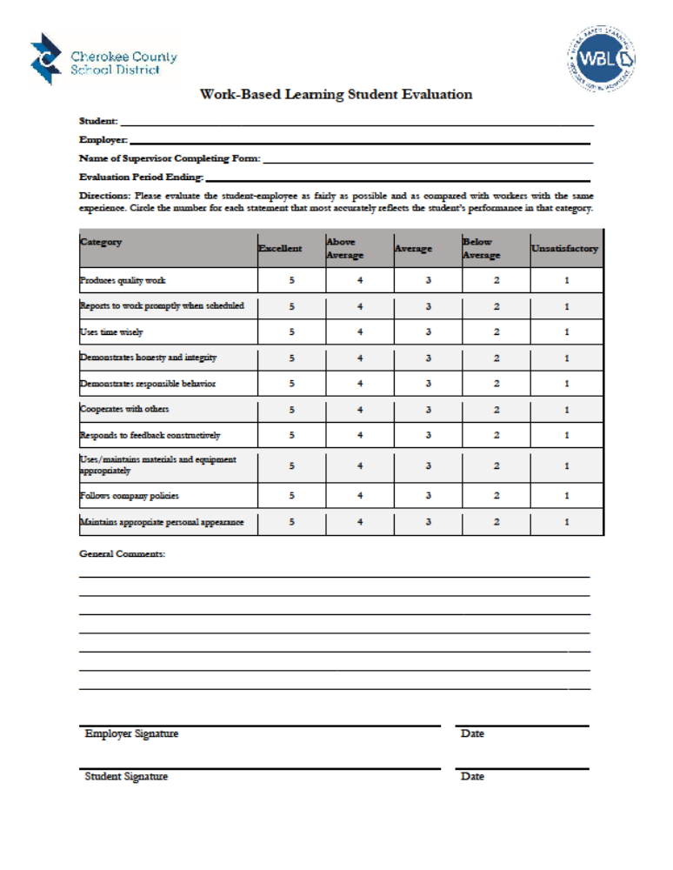
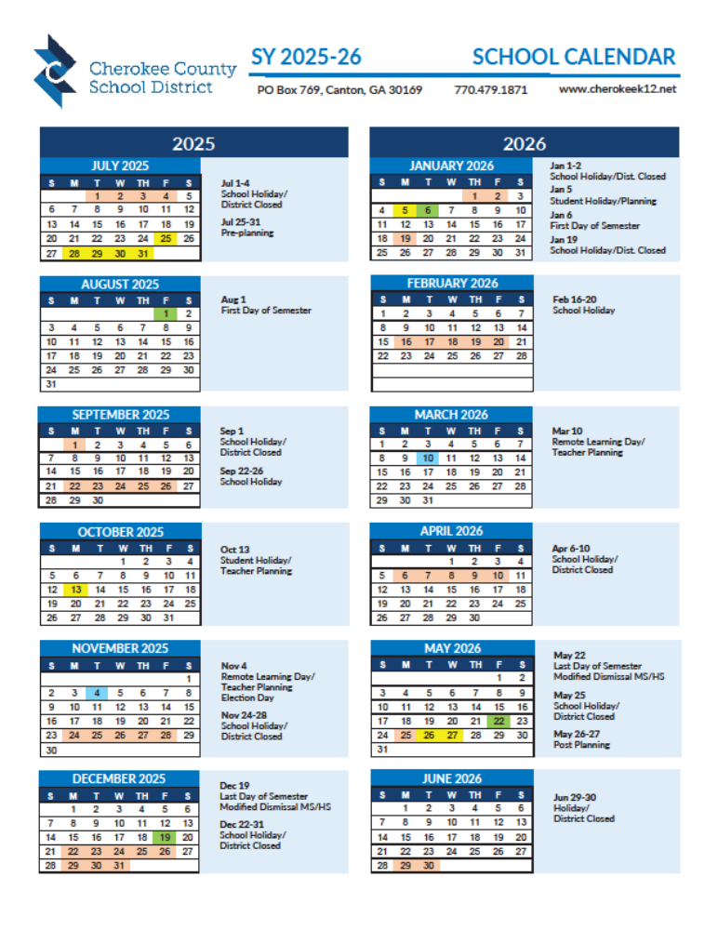

STUDENT EXPECTATIONS

GENERAL EXPECTATIONS
Work-Based Learning (WBL) students are expected to excel in three major areas: Academic performance, school and workplace behavior and job performance.

As a WBL student, you must maintain a 2.5 GPA (C+ average) at in all of your classes and have a 90% attendance record. You may take advantage of many support services to help you achieve these goals, but you have to do the work! Failure to meet either of these goals can result in termination from the program and possible loss of credit.

Furthermore, you must demonstrate acceptable behavior at school and at the worksite. You are expected to meet any additional standards required by your job site. General expectations include:

- Examine self-aptitude, interests and attitudes.
- Establish short- and long-term goals.
- Investigate and evaluate career choices in an academic major.
- Obtain a work permit, if applicable.
- Communicate verbally and in writing using standard English.
- Speak to communicate ideas.
- Complete required forms and records accurately and in a timely manner.
- Follow written and verbal directions.
- Write a resume using standard formats.
- Complete error-free job applications.
- Prepare for the interview process.
- Exhibit professionalism in employability skills such as punctuality and attendance.
- Practice safe working habits including the use of any required or necessary equipment.
- Function in a work environment in accordance with company policies, child labor laws, and employer expectations.
- Perform assigned tasks.
- Dress appropriately for the job setting.
- Acquire job specific content and knowledge.
- Model desirable work traits.
- Model cooperative behavior with coworkers.
- Adapt to the work environment.
- Perform an acceptable volume of work in a job setting.
- Set, pursue, and attain goals in a work setting.
- Perform job duties accurately and professionally.
- Identify and demonstrate appropriate work habits.
- Compute hours and wages and maintain work records accurately and in a timely manner
- Submit paystubs at a minimum of once a month.

ATTENDANCE POLICY
The Work-Based Learning initiative strives to instill the importance of positive work habits and attitudes both on the job and in the classroom. You must assume responsibility for regular attendance at school, and on the job during your scheduled work hours.

If you are absent at school, then you cannot report to the job site except by special permission.

You are an employee of the business and your employer expects you to be at work – on time every day that you are scheduled.
- Excessive absences are grounds for termination from the WBL program.
- Not showing up for work on time, and not calling to notify your employer in a timely manner, with a valid excuse is grounds for termination.

**Your absences will affect your eligibility for credit and continued enrollment in the WBL Program**
- Once you are working for an employer as part of the WBL Program, you cannot change employers without first consulting and obtaining permission from the WBL Coordinator and then following proper, professional procedures. Not following this procedure can be grounds for dismissal from the program.
- If you are sick and cannot go to work, you must contact your mentor/supervisor before you are scheduled to begin work that day. You should always carry your mentor/supervisor’s number with you.
- If you know you will be unable to attend work in advance, such as having to take a test at school, let your supervisor know why you need to be absent and work it out with him or her in advance.
- You are strongly encouraged to schedule all doctor and dentist appointments outside of your work hours; however, should you have an appointment, let your mentor/supervisor know prior to the day of the appointment. The more advance the notice, the better.
- If you are absent due to a death in the family, you must call or have someone else call your employer and the WBL Coordinator.
- School attendance will be checked on a weekly basis by the WBL Coordinator. All students will be issued a WBL pass and will be required to sign out when leaving campus and sign in when arriving on campus. All students must complete this daily.
- Workplace attendance will be noted by your employer on each of your evaluation forms.
- No show to work, and no call =
  - 1st offense – written warning
  - 2nd offense – exit out of the WBL Program

GRADING POLICY
Grades are an important part of the Work-Based Learning program. In order to help students, keep an average that will help them succeed in high school, at work and Post-Secondary the following guidelines have been established:
- At the end of each grading period the WBL Coordinator will check the student’s grades in other classes. It is the STUDENT’S responsibility to alert the WBL Coordinator of failing classes.
- In the event that the student has not maintained a C average or better the student will be placed on probationary status until the next grading period.
- In the event that the student’s grades have not improved by the next grading period (brought up to C average), the student’s grades will be reviewed for possible removal from the program.
- See WBL Syllabus for detailed Work-based Learning Grading Scale.

ASSIGNMENTS
Students are required to use Canvas for WBL assignments which include special announcements, due dates, etc. The following are required file documents and certain assignments that are similar within each of the WBL Programs.

Required File Documents () include:
- Parent/Student Forms
  - Early Release/Insurance Verification Form
  - Program Consents Form
  - Program Guidelines Form
- Employer Forms
  - Employer Verification Form
  - Unpaid Internship Form, if applicable
  - Educational Training Agreement
  - Educational Training Plan & Initial Rating

WBL Assignments include:
- Work Hour & Wage Records (weekly/monthly)
- Employer Evaluations
  - You are required to be evaluated by your employer 4 times a year
- Career Portfolio/ Weekly Assignments

WORKPLACE BEHAVIOR
Workplace behavior involves not only your actions but also your attitude. Employers have stated that an open enthusiasm about being on the job and a willingness to learn are two of the most valued attitudes in the workplace. Attitudes, both negative and positive, are often revealed through facial expressions and body language. Think about what your facial expressions or body language may be saying as you communicate with your mentor or supervisor in the workplace.

Workplace behavior also involves overt actions such as showing up for work when scheduled, being on time, following instructions and dressing accordingly. Most businesses have attendance policies which include limitations on the number of times an employee may be late for work. If you are dismissed from employment because of attendance, your grade will be penalized.

Handling personal relationships on the job takes away from your time at work and is not permitted. Conducting personal telephone calls during work hours is not permitted. Check with your supervisor regarding policy or rules on having or using a cell phone at work. If you need to make an important phone call, you may need to check with your supervisor first. Socializing should be limited to break time and lunch. Visiting fellow students during work hours is not permitted.

DRESS CODE
The following guidelines will assist you in maintaining a professional look at all times while at the workplace:
- If your employer provides you with an Employee Handbook, be sure and read it, especially the information pertaining to dress code.
- If they do not have a handbook, ask your mentor/supervisor about the dress code at your workplace and dress accordingly.
- Keep your hair well-groomed and in an appropriate style.
- If you have a uniform, keep it clean and free of wrinkles.
- Many outdoor or shop oriented workplaces, such as those for electricians, water plant operators, automotive technicians, etc. may permit the wearing of jeans, t-shirts, and caps—but restrict what may be printed or pictured on the t-shirts and caps.

- Keep make-up, perfume, and jewelry to a minimum. Jewelry should include only a watch, class ring, etc. NO “dangling” earrings or piercings!
- In general, do not wear the following items for most worksites: hats, shorts, miniskirts, sandals, sheer or low-cut blouses, tank tops, spandex, and cropped blouses that show your stomach or back.

FOLLOWING INSTRUCTIONS
Performing your duties correctly will help you achieve success on the job. Responsible workers have learned that following all instructions from their mentor or supervisor, completely and accurately, guarantees that the job will be done right. Follow these steps:
- LISTEN
- Look at the person while listening & concentrate on the instructions you are receiving. Pay attention to the details; they will be important when you are completing the task.
- TAKE NOTES
- Bring a notepad and pen with you each time you meet with your mentor/supervisor. You can write down important details and can refer back to your notes if need be when completing the task.
- ASK QUESTIONS
- Be sure that you understand the instructions provided by your mentor/supervisor. If you don’t, ASK! Your mentor/supervisor would rather you ask for clarification versus completing the task incorrectly!
- FOLLOW YOUR INSTRUCTIONS EXACTLY
- Don’t try to create a short-cut by leaving a step out. The task may not make sense to you, but since your mentor or supervisor ultimately has to answer for the work that you do, follow his/her instructions. After you have been on the job for a few weeks, you can suggest or ask about changes in a procedure, but always obtain the approval of your superior before making any change.

MENTOR/SUPERVISOR ROLE
A mentor is a friend, a counselor, a tutor, a coach, a supervisor—someone you can trust.

This may be the first job for many of you and you may be unsure of what is required of you at the worksite. Your mentor (often your supervisor) will be there to answer questions and encourage you so that you can succeed on the job.

Communication is very important. If you do not understand directions or are unclear about certain information, you are encouraged to ask questions. Share information about yourself with your mentor. Your mentor wants to get to know you and your goals for the future. Like a coach, your mentor can train you for success in the world of work.

Questions about your worksite? ASK YOUR MENTOR FIRST. You may then be directed to contact another person in the business. Your mentor will explain rules and safety standards and show you how to operate equipment needed to perform your job duties.

REMEMBER, THE MENTOR IS THERE TO HELP YOU!
- Always treat your mentor with courtesy and respect
- If you need something, ask for it; don’t demand it.
- Accept constructive criticism.

  - Listen to it.
  - Learn from it.
  - Do not feel put down.

Collaboration with Worksite Mentor and/or Supervisor. Each grading period your supervisor will be asked to complete an evaluation. Contact will be made with your employer throughout the semester by phone, email and personal visits. During these times of contact your work performance will be discussed. Information gathered from employer evaluations and employer contact will be used to compile your final grade.

ADDITIONAL TIPS FOR SUCCESS
- Be neat and clean.
- Be friendly and courteous.
- Keep yourself occupied at all times. If you have a job to do—do it. If you don’t have something to do, ask your mentor/supervisor.
- If you have a work-related problem, it is your responsibility to talk with your mentor/supervisor first. If the problems continue consult with your WBL Coordinator.
- If you have a problem with school and assignments, it is your responsibility to talk with your Coordinator immediately!
- Take criticism without resentment and learn from constructive criticism.
- Don’t make excuses. Chronic excuse makers are rarely believed.
- Give your best effort at all times. Remember, your job is important.
- You are entitled to respect on your job. Your mentor/supervisor and your fellow workers are also entitled to respect. Give the same courtesy you expect in return.

