BREAKFAST & LUNCH LINE
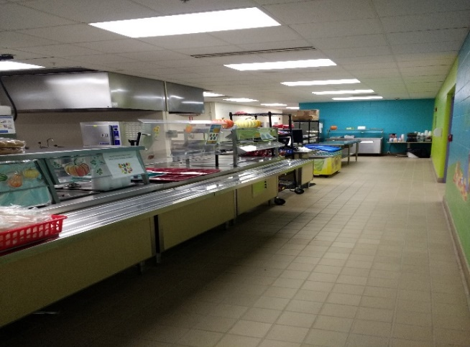
BEHAVIOR EXPECTIONS
Respectful  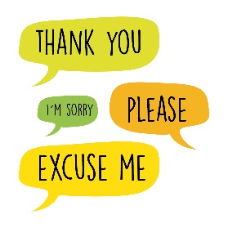 | - Use a 3 Inch voice while waiting in line  - Use a 0 Inch voice when you enter the kitchen door  - Use good manners
Responsible  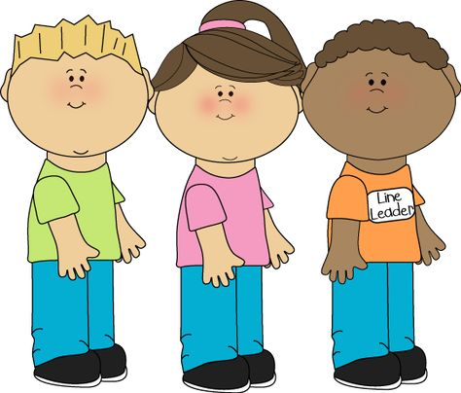 | - Stay in line  - Keep your hands and feet off the art room door
Safe  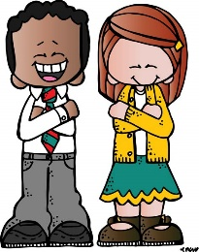 | - Stay standing while in line  - Keep your hands and feet to yourself
BE AN LC PAX LEADER!

