BUS

BEHAVIOR EXPECTIONS
Respectful   | - Follow directions from the driver  - Use a 3 Inch voice  - Use kind words
Responsible  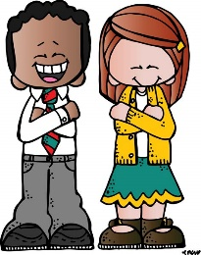 | - Keep your hands, feet and objects to yourself  - Keep the bus clean
Safe  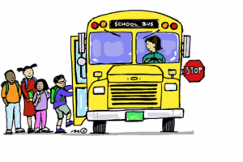 | - Stay in your seat  - Sit properly in your seat  - Keep the aisle clear  - Enter and exit the bus safely
BE AN LC PAX LEADER!

