CAFETERIA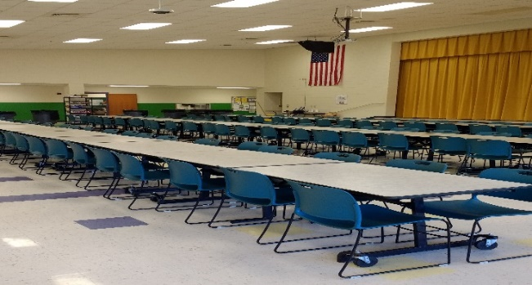
BEHAVIOR EXPECTIONS
Respectful   | - Use a 3 Foot voice while the lights are on  - Use a 0 Inch voice when lights are off  - Use good manners  - Follow directions from all adults
Responsible   | - Clean up your area  - Raise your hand for help  - Stand and walk in a straight line when leaving the cafeteria
Safe  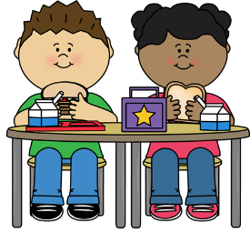 | - Stay in your seat  - Sit properly in your chair  - Always use walking feet
BE AN LC PAX LEADER!

