DIGITAL CITIZENSHIP
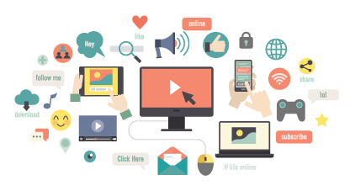
BEHAVIOR EXPECTIONS
Respectful   | - Follow directions from the teacher  - Give proper credit when you use other’s work  - Your digital footprint should not harm others  - Always use kind words
Responsible  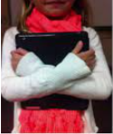 | - Prevent damage and misuse of the device and internet  - Carry the device with two hands  - Put the mouse and headphones away neatly when finished  - Correctly plug the device into its charging station  - Visit appropriate websites that promote learning
Safe   | - Stand up to cyberbullying  - Tell an adult if someone is being unkind or harmful  - Protect your private information and the information of others
BE AN LC PAX LEADER!

