PLAYGROUND
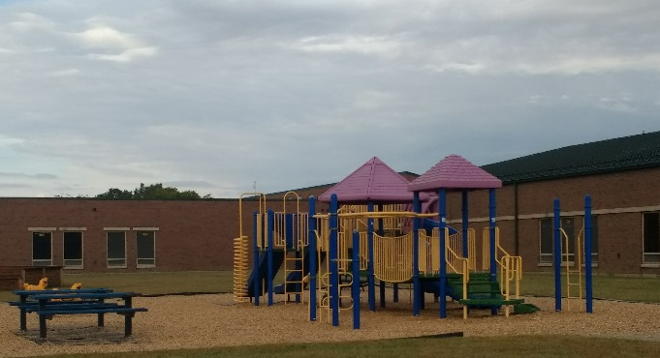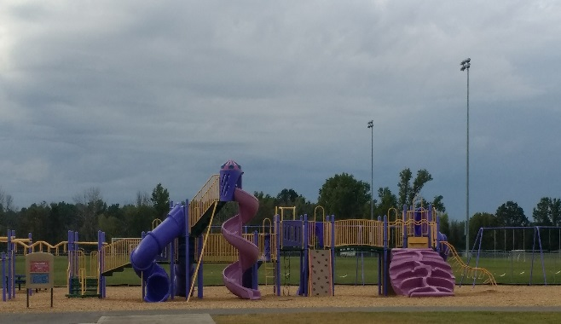
BEHAVIOR EXPECTATIONS
Respectful   | - Follow directions from all adults  - Show good sportsmanship
Responsible   | - Listen for the whistle  - Use playground equipment  properly
Safe  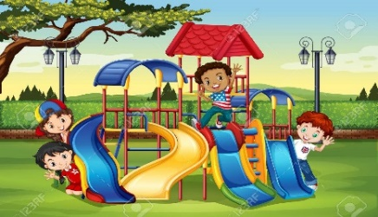 | - Exit the building and enter the playground safely  - Stay in your designated play area  - Avoid trouble situations
BE AN LC PAX LEADER!

