RESTROOM
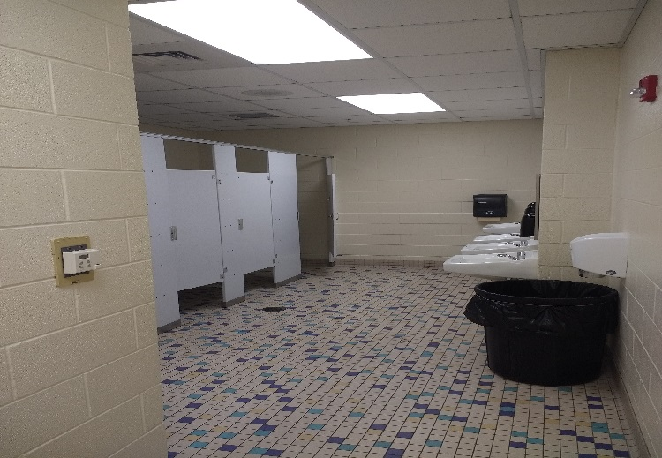
BEHAVIOR EXPECTATIONS
Respectful   | - Use a 0 Inch voice  - Respect the privacy of others
Responsible   | - Keep the restroom clean  - Flush the toilet  - Wash your hands  - Place paper towels in the trash can
Safe   | - Use walking feet  - Use the restroom facility correctly
BE AN LC PAX LEADER!

