WATER FOUNTAIN
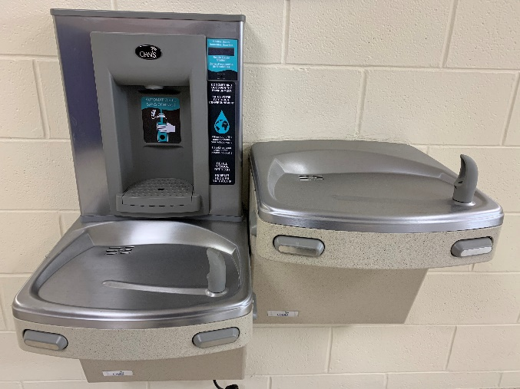
BEHAVIOR EXPECTATIONS
Respectful   | - Use a 0 Inch voice  - Respect the space of others
Responsible  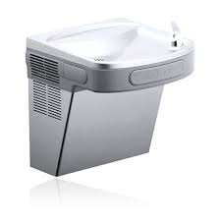 | - Keep your mouth away from the water spout  - Press gently on the push bar  - Keep your hands away from the water spout  - Fill a water bottle appropriately with permission from an adult
Safe  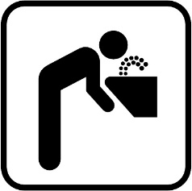 | - Keep the water in the fountain and off the floor  - Use the water fountain correctly
BE AN LC PAX LEADER!

