Information Update/New Student Registration Option(s)
Directions for Those Needing to Do Information Update (Previously Annual Update) or New Student Registration
Parents who do need to update address, child's health information, protective order information, or emergency contacts will proceed with this option.
- Parents can either click on the "More" tab in the menu or the "Information Update" button in the bottom right.
If they click on MORE, they will have to click on Information Update on the next page that appears.
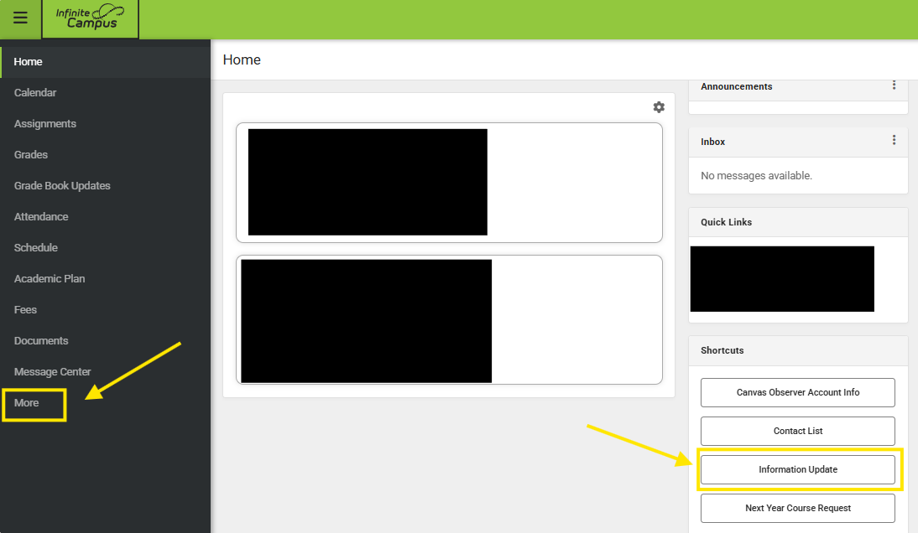
- From there, parents who are only providing updates and not registering a new student will select 25-26 Information Update whereas those registering a new student will pick the appropriate starting school year new registration application.
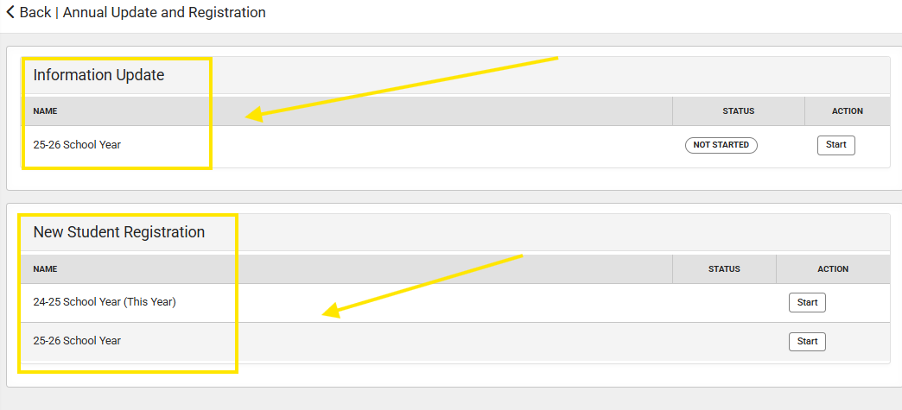

Parents do not have to do both applications. If they complete the information update or the registration application, it will include the annual agreements.

