Annual Agreements Option
Directions for Those Not Needing to Do an Information Update
Parents who do NOT need to update address, child's health information, protective order information, or emergency contacts will proceed with this option.
- When parents first log into Parent portal, there will be a warning icon with "Documents Needing Attention" for each student who has a line of enrollment for next school year.
Personally, I think clicking on the student cards on the home page is the easiest way to navigate to the forms, but they can also click on the "Documents" tab in the menu flyout.
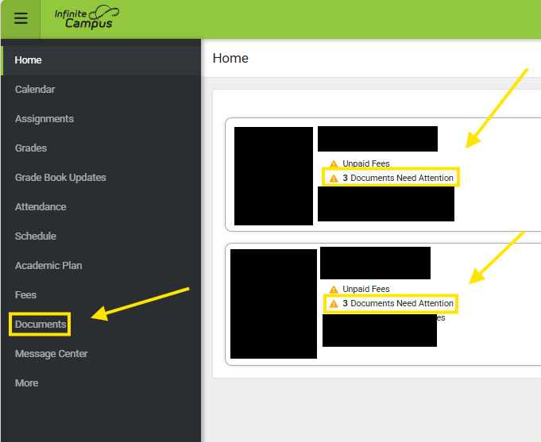

- If they click on documents, they have to select the 25-26 school year to see the documents AND they have to switch between student profiles in the top right corner to complete for each student.
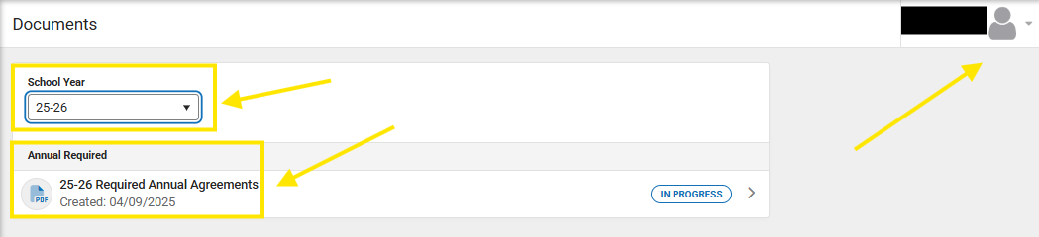
- If they choose to click on the card from the home page, they will scroll down to the "Documents Need Attention" section where they will see the 25-26 Required Annual Agreements. If they have multiple students, they would repeat this process by clicking on "Home" and selecting the next student needing an agreement.
