School Governance Council Meeting 3/26/2025
Attendance:
Dr. Stasaitis
Jessica Gaddis
Isa Alves
Peggy Terhune
Daniel Cocchiola
Joarsis Hernandez-Tapia
Jazmin Alves
Hanalei Cocchiola
Melissa Labbe

Dr. Stasaitis – Welcomed everyone and started our meeting.
Harry Potter performance took place on the Palace stage! Students of all ages and staff participated in the performance. The lobby raised $800 for Key Club.
We had honored guests and schools attend the Harry Potter performance. Honorable Mayor Pernerewski, Board of Education members, WAMS staff, families, community members, and schools (Rotella and Maloney) joined us. Board of Education members reached out and raved about our students’ performance! Consequently, we always hear from parents whose child/children did not get into WAMS. We are always looking for ways for the community to be part of our community through social media and programs, etc.
Mrs. Alves – A special thanks to Mrs. Terhune and the Palace Theater for accepting students throughout the city of Waterbury to be a part of the Palace Theater After-School Program “Being Found: Searching for Connection and Community.” The Palace Theater After-School Program is a six-week after-school workshop series. It is an interactive language arts, music, and theater appreciation program facilitated by professional teaching artists and guests speakers.
Mrs. Terhune – Idea: WAMS students facilitate workshops to other schools. Hall of Fame could be an opportunity to assist with this. Additionally, programs like ENCORE welcome all students from the district. Dr. Schwartz facilitated an event trying to unite the magnet schools.
Dr. Stasaitis – Pippin is coming up on the Apron Stage on April 4th – April 6th. In preparation, the cast worked with the circus!
PSAT/SAT Day on April 8th, 2025
Exchange Club Dinner
Board of Education Awards
Senior Save the Dates:
PROM May 9th ARIA 7-11
College Acceptance Breakfast May 23rd 9AM
Holiday Hill ​June 2nd
Field Day June ​4th
Awards Night June 9th 6PM at the Palace Theater
Graduation ​June 12 9AM at the Palace Theater
Mr. Ferreira is currently heading the 6th, 7th, and 8th grade 21st Century Program.
Ms. Betjemann runs the after-school in CCRC room and it also includes math tutoring for the middle school and high school a couple of times a week.
Next school year: Terryville will not provide transportation. Currently conversations are ongoing to figure this out.
Miss Hernandez-Tapia – updates – Harry Potter was just amazing.
Going to UCONN on a full scholarship!!!!! Majoring in biology.
Miss Cocchiola – Tri-M is so much fun
Key Club sold bracelets
The flying is amazing in Harry Potter! Looking forward to 8th grade formal, Holiday Hill, NYC, and all the events coming up!!
Dr. Stasaitis – attended 23 events this time last year until the last day of school.
Miss Alves – Harry Potter was amazing!
Attended Bingo Night and National Honor Society zoom call.
Palace Theater – started the Palace Theater After-School Program. This was an opportunity to learn about connecting and community through the musicals Come From Away and Dear Evan Hansen. Really enjoyed the voice acting workshop. Had an opportunity to do a voice recording.
Dr. Stasaitis – Julian participated backstage for Harry Potter. The crew behind the scenes is just as important.
Ms. Gaddis - Shakesperience
At WAMS
- High school: Merry Wives performances April 10

- After-school: interest from Harry Potter students. Mondays are presenting a scheduling
- conflict for students. We're talking about doing longer sessions on Fridays only.
At Shakesperience
- Spring Saturday term: March 8-April 26. Middle and high schoolers are doing Hamlet, elementary
- are doing scenes from mythology

- Of Mice and Men workshop

- Give Local April 29-30
Mrs. Terhune - March 2025
WAMS / Palace
Heard Harry Potter was beautiful.
Jazmin Alves and Mrs. Alves were ambassadors for the Palace Theater After-School Program 2025. They encouraged a number of students to join the WAMS community and participate in this program from other high schools throughout Waterbury.
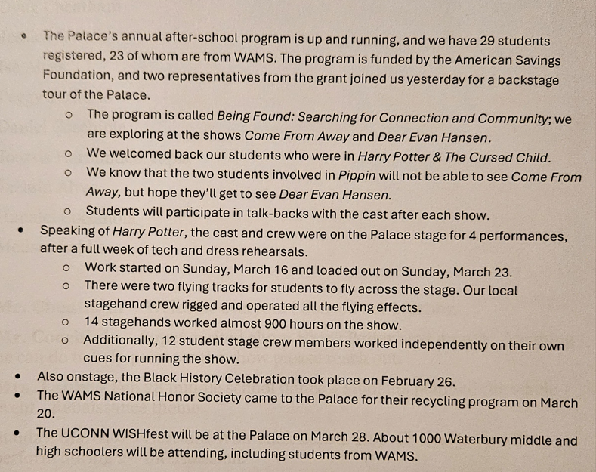
Mrs. Labbe – PTSO BINGO Night –March 13, 2025, 32 people attended and the winners received all types of prizes.
Spirit Night – Urban Air “from WAMS for Special Pricing” and percentage of Sales.
Saturday, March 29,2025 - Spring Quarter Auction 75 baskets. Raised money for 2 scholarships so far $2300.
Teacher Appreciation Day have a coffee truck and smoothies scheduled
This is the Month of the Military Child - Raised money for kids who have joined the Military. We want to honor parents whose children are serving in the military.
Miss Alves – do siblings count? Yes, just note it on the form.
Mr. Cocchiola – Schulte created a space for all of the students to be themselves and participate!!!!! So proud of Hanalei and sister. Took a picture near sound booth and used AI approximately 600 in attendance. Willy Wonka currently holds the record for WAMS. Would like to know the box office final numbers.

Mrs. Labbe – attended all the shows – saw it on the news, and heard it on the radio. “Be a part of the WAMS community”
Mr. Cocchiola – audience all dressed up. This was all new to them. We offered a show that the community wanted.
There are partial day magnet programs. For example, Trumbull has one. Could possibly do something similar, if the interest it there.
Idea - have another school visit/participate in Arts Only!!!!!!
Question: In our program of studies, how do you access the needs? Or does it happen haphazardly?
Dr. Stasaitis – The process starts with Pathways. For example, the UCONN ear training process starts and is added into the Program of Studies. Another key component has to do with what the teacher can offer. There are some prerequisites and student attendance is a must have.
Mr. Cocchiola – Question: can we and/or teachers obtain the curriculum and run a program?
Dr. Stasaitis – Currently there is no district art person. Many things are on hold. Let’s revisit this and have another conversation.
Hall of Fame update, so far, 2500 in donations!
Need coach buses for upcoming trip.
The money raised for the Hall of Fame for the students. Every dollar helps. Items for the Hall of Fame have been ordered.
Mrs. Alves: Thanked Mr. Schulte for allowing Julian to advocate for himself and volunteer to help out back stage for the Harry Potter show. Had a chance to attend Back to the Future in concert with the Waterbury Symphony Orchestra.
Coming up:
WishFest will be held at the Palace Theater and UCONN Waterbury.
4th Annual Autism Event
Summer Youth Employment
Camp Justice for incoming 9th graders – Statewide opportunity
Next meeting April 30, 2025 @ 9:00 am
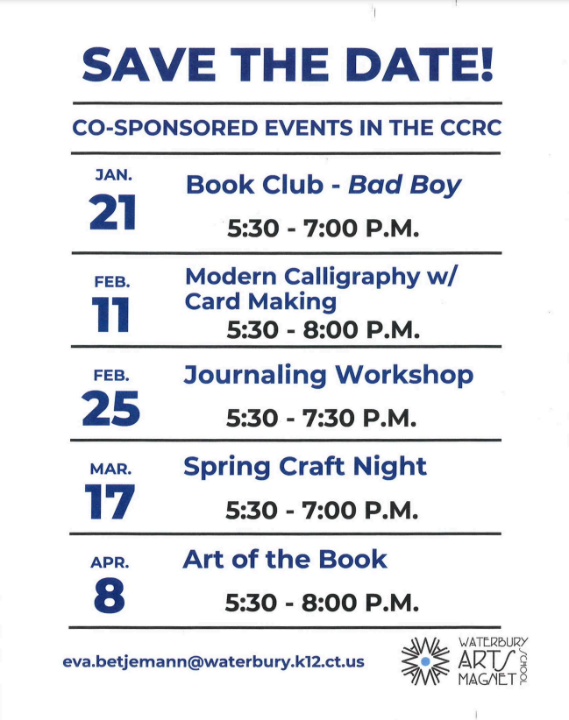

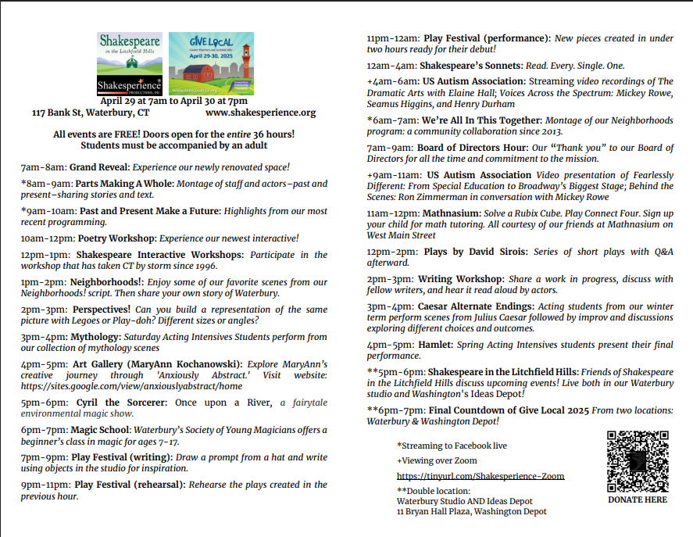

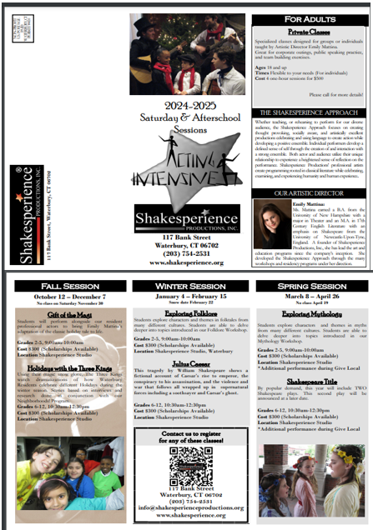

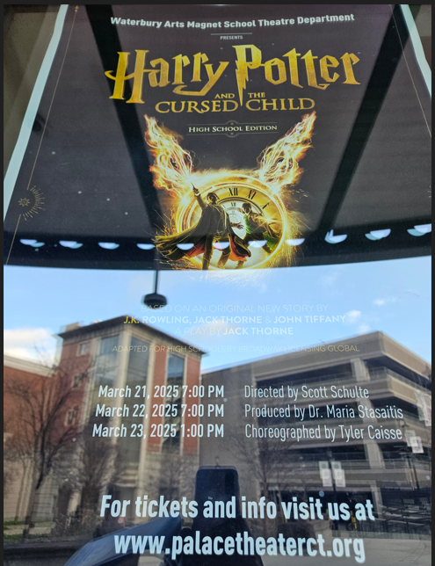

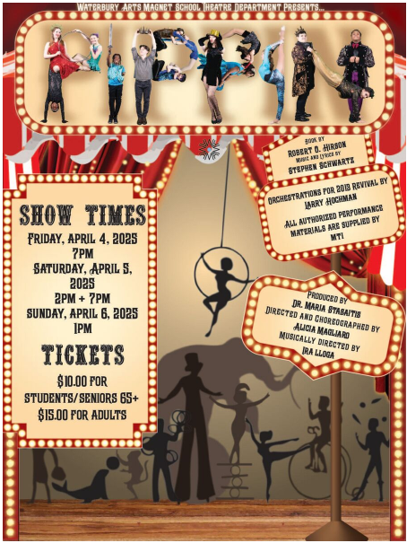
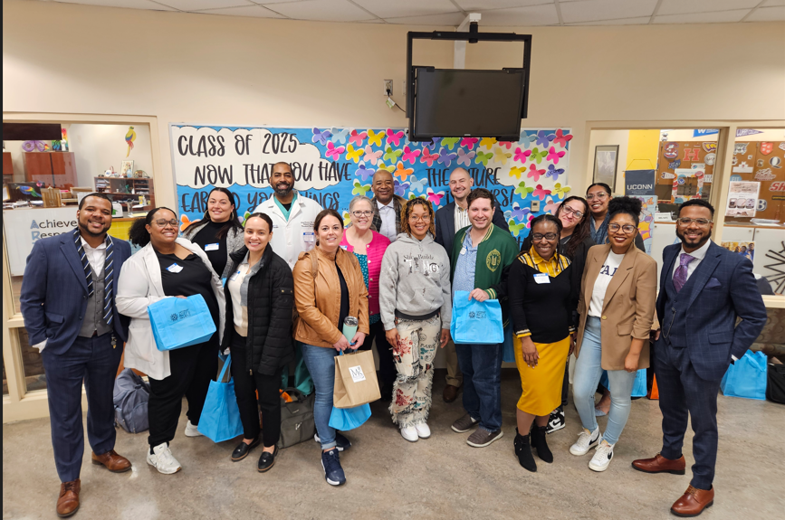
Middle School Guest Speakers!!!
