Old Adobe School
May PTO Meeting Agenda
Monday, May 5, 2025 6:30-7:30pm on Google Meet
Video call link: https://meet.google.com/afr-shui-wmo
Or dial: ‪(US) +1 414-439-0916‬ PIN: ‪131 398 550‬#

- Approval of Meeting Minutes April 14, 2025 PTO Meeting notes
- Ms. Vogel’s Updates
- Treasurer’s Report - Marsha Treasurer Report
- Grants-
Discussion Topics-
- Vote New Board in for 25-26 school year
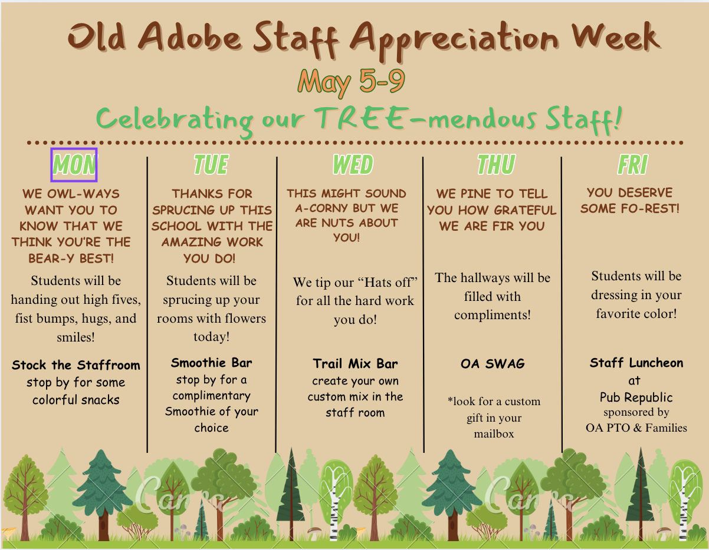
- Staff Appreciation- kicked off SAW with daily activities done by students and the PTO in Staff Room. PTO purchased Staff shirts and will be hosting a luncheon on May 9th for staff. If families would like to contribute please do so by using this link. my.cheddarup.com/c/stock-the-staffroom-with-snacks

- Field Day- sign up will be shared to help run a station
- Promotion- we will be needing volunteers to help clean up multi after promotion ceremony so 6th graders and their families can enjoy celebrating together. SIGN UP
- Suggestions for next year planning- PTO board will be meeting to outline next year's PTO calendar and budget. Please share if there are things youd like to see added, changed, ect to next year's school year!

Recap/Updates/Follow Up:
- Spring Gala
- New Spirit Wear - feed back was passed onalong to Chick City. Still waiting on updated images
- Bingo Night- yummy concession and great prizes, but very low attendance.Next year suggestion to only keep the 1 bingo night in November.
- Stage was ordered and will be here in time to use for promotion
- Socks were ordered for Eastside Relay participants and came under approved amount.

Upcoming Events- (Looking for volunteersfor all upcoming events)
- Kinder Graduation- June 2nd https://www.signupgenius.com/go/10C0D4AADAB2BA0F5CF8-56487557-kinder

- 6th grade Promotion- June 3rd https://www.signupgenius.com/go/10C0D4AADAB2BA0F5CF8-56460532-6thgrade

- Field Day/Last Day of School- June 4th

Next Meeting: PTO Board Planning meeting of 25-26 Calendar/Budget- June 13th

