School Health Advisory Board Minutes 1/22/2025
Present: Rebecca Abernathy, Lori Balaban, Erin Callas, Connie Clark, Kristy Davis, Christine Eagleson, Eileen Gomez, Lila Gerow, Kevin Kirst, Mark Niehaus, Emily Pelliccia, Chris Siebert, Diana Webb
Cell Phone Use in Children and Adolescents
Mark lead a robust discussion on this issue with the goal of coming to a SHAB resolution in support of the cell phone policy -- to help bolster the SB’s confidence on their stance/policy and encourage consistent enforcement
- Governor Youngkin’s Executive Order on Cell Phone Use in Schools
- Dr. Haas’s message to families
- ACPS’s current cell phone policy

Mark explained that his interest in this project is both personal as a father and professional as a physician. He reported that an analysis of the topic indicates five main points in support of restricting cell phone use for students:
- Impact on academic performance
- Impact on mental health and well-being
- Anxiety
- Sleep patterns
- Correlations with depression and suicidality, particularly among girls at night
- Cyberbullying prevention
- Social and physical development
- Face to face interaction
- Promote physical activity
- Safety and security

Times when cell phone use at school may be appropriate:
- Students with diabetes
- Students with adaptive technology
- EL students who use translation services

Mark recommended the book The Anxious Generation by Dr. Jonathan Haidt at NYU as well as resources from:
- Protect Young Eyes
- American Academy of Pediatrics

Rebecca pointed out that cell phones can be used to lure teens into sex trafficking or related exploitation.

Lila shared the student perspective acknowledging that cell phone restrictions are not popular with students, but she sees the benefits to some degree. She explained the enforcement mechanisms at her school. She also recommended educating students about the deleterious impact of teen cell phone use.

Other points in the discussion include:
- Cell phone restrictions should be consistent across grade levels K – 12
- Should students be permitted phone access between classes or at lunch? Should there be any time during the school day when cell phones can be allowed?

Mark will work on a proposed resolution in support of cell phone restrictions.

UVA Cancer Center Grant Proposal to the National Institute on Drug Abuse
Kara Wiseman, Assistant Professor of Public Health Sciences at the University of Virginia, described her grant application for a tobacco use prevention and cessation research project involving 9th and 10th grade students with the goal of SHAB submitting a non-binding letter of support to be used in the grant application as evidence that schools support efforts to address teen tobacco use.

The program involves a didactic portion that provides education about tobacco products and a text message-based program to support cessation.

This program would need to be in addition to the already established health curriculum since the evidence for its effectiveness is still under study.

Mark proposed a SHAB resolution in support of ACPS submitting a nonbinding letter of support, which passed unanimously.

Cannabis Use in Adolescents
Eileen and Connie reported on a community information session in which they participated in the fall in response to an occurrence at one of the high schools where several students became were sent to the ER after consuming cannabis in a device they purchased in a local vape shop. The in-person attendance was not high, but 140 peopled viewed the live-stream. You can see the recording here.

Connie shared the slides she presented. She discussed Delta 8 & Delta 9 products, the various devices used to consume these products, how they are formulated to smell desirable, edibles, as well as the wide-spread availability of various unregulated products. She also mentioned Xylazine and THCA.

She explained that the cannabis available today in very high concentrations frequently causes unpleasant effects such as anxiety, paranoia, nausea, muscle spasms, hallucinations and may unmask conditions like schizophrenia.

Connie explained that Xylazine is now being used as a filler in order to prolong the high of opioids, but since it is not an opioid, it cannot be reversed with naloxone.

A suggestion was made to continue scheduling community conversations to help educate parents, students, staff and community members about the existence and dangers of these substances.

School Attendance: Absences Due to Illness and Doctors’ Notes
Eileen explained that student attendance are automtically flagged when a student reaches the ten day absence mark, and at that point families are asked to provide supporting documentation. If a family does not have a PCP, schools ask the parents to work with their nurse to figure out if the child is well enough to attend school.

The physicians report that it is difficult for them to write exclusion-due-to-illness notes upon request based on parent report of illness symptoms or for illnesses that extend beyond the date of their medical appointment.

Future Meeting Formats Kevin reported that ACPS rules about advisory committee meetings has been updated: The committee can meet up to two times virtually or 25% of the scheduled annual meetings, whichever is greater. Public notification must indicate virtual or in-person meeting format.

Cold Weather and Recess
Eileen reported that formal guidelines for elementary school recess in cold weather are contradictory as evidenced by the two sources posted on the website:
- The VA School Board Association Wind chill under 32° precludes outdoor recess
- Childcare Weather Watch Advises no outdoor recess when wind chill is below 40°

Windchill is a larger determining factor than temperature. Administrators should consider duration of outdoor activity and whether students have appropriate cold-weather clothing. Active time outdoors should be encouraged when possible. During colder days the length of time outdoors may need to be shortened. Students can safely play outdoors at a windchill of 25° if dressed appropriately. The athletic cold weather guidance is not really applicable to elementary school recess.

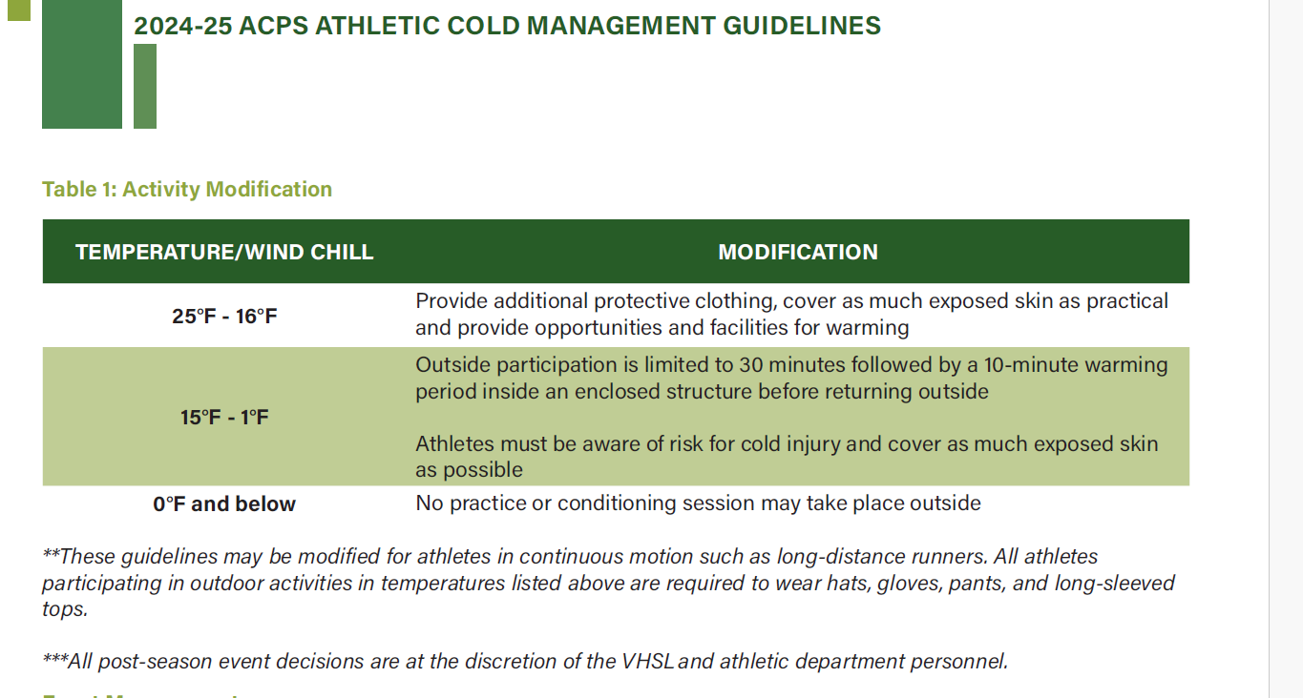

Next Meetings
2/12/25 6:30 to 8:30 PM in room 320
5/14/25 6:30 to 8:30PM in room 320

