Learning Stream Professional Learning Account Instructions

Updated May 2025 (for certified staff only) These instructions are also located on our JCS Professional Learning web page.

1. To login to your PD account, go to the SSO Portal on the district website.
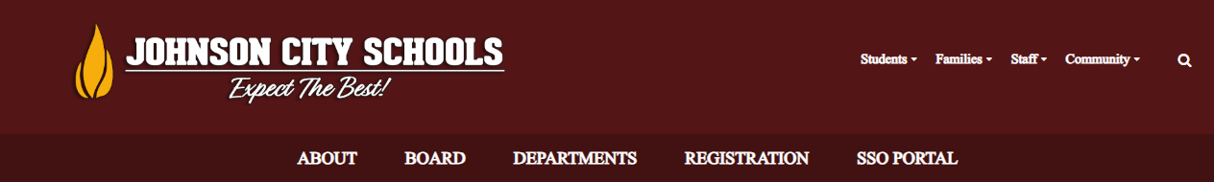
2. Enter your username and click “Go”. Complete the authentication process.
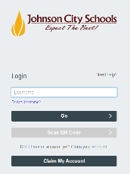

3. Click on the Learning Stream “Training Registration” icon.



4. Click the “Staff Login” link on the Canvas Login Options web page that opens.

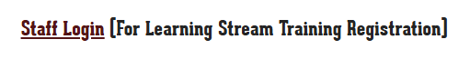

5. Click "Authorize".

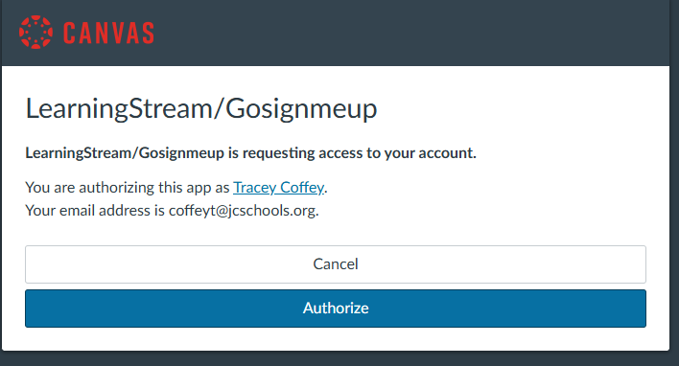

6. Click on the event category you would like view in the top, brown navigation bar.

7. To view details of a session, click the blue button labeled “Learn More and Register”.

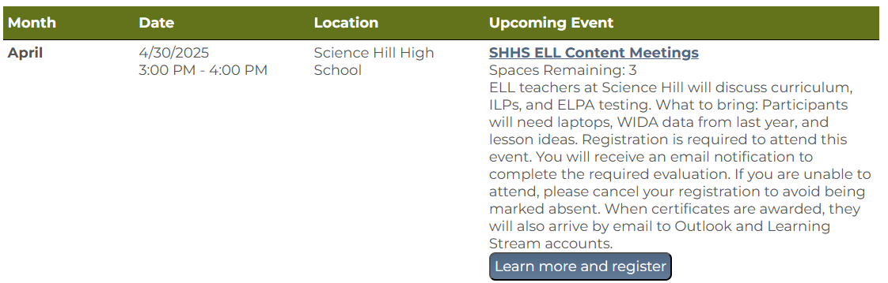

8. Read the details of the session, then click the blue button labeled “Register Now”.

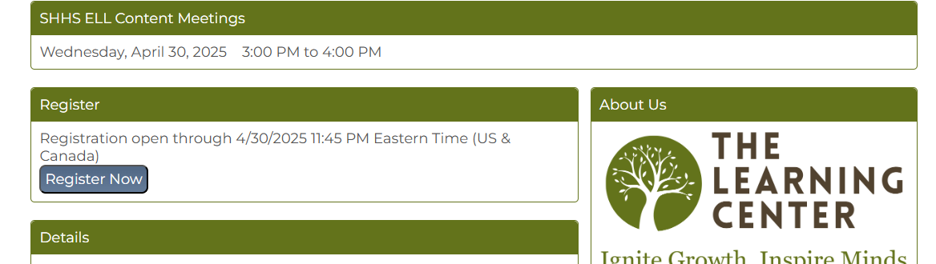

9. Enter a registration access code if it is required. Instructors will email these to their groups. Complete the form and click “Submit Registration”.

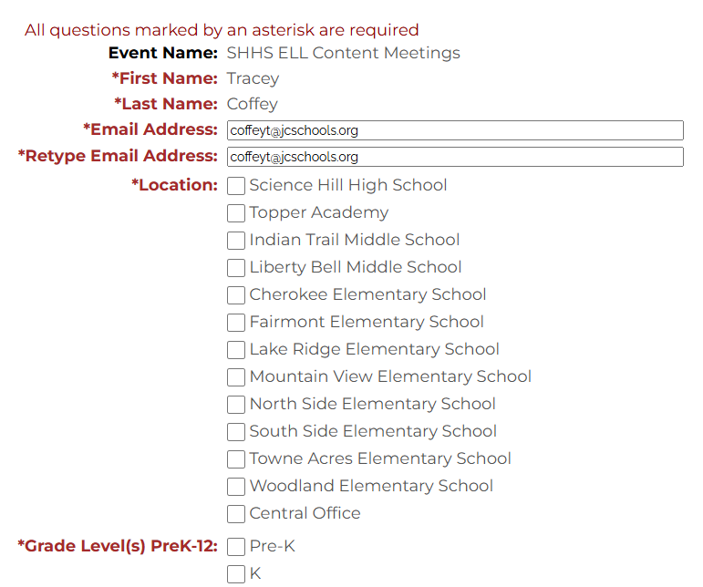

10. To complete registration, select “Click Here to Checkout Now”.

To register more sessions, select “Click Here to See A List of Events”.

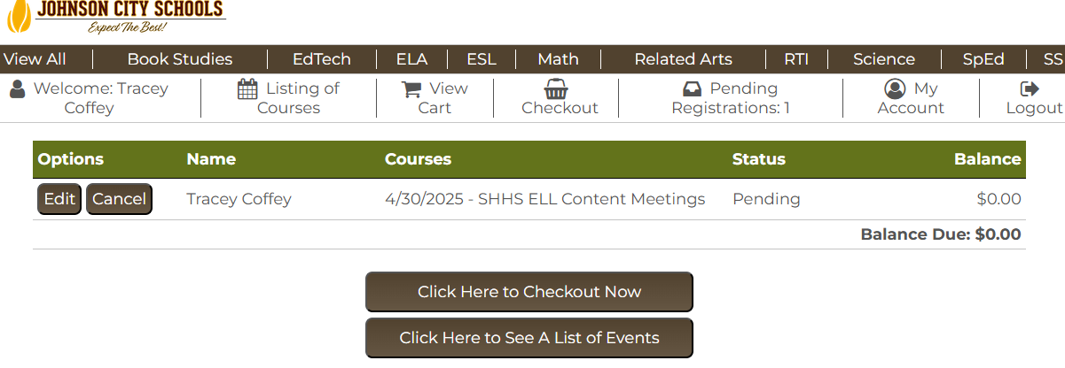

Contact Tracey Coffey at 434-5218 with Learning Stream registration questions. You must register to receive required evaluations and PDP certificates.

