Registering for a Course in PLZ
How do I register for a course in PLZ?
To register for session in PLZ use the steps outlined below.
Step 1: Open PLZ. To open PLZ visit: https://shelby.truenorthlogic.com
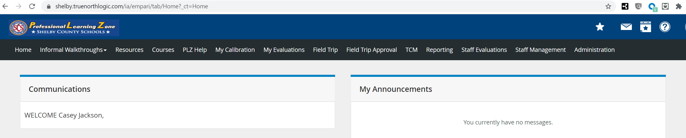
Step 2: Go to the Courses tab.
Step 3: Type the Course Number in the Search box.
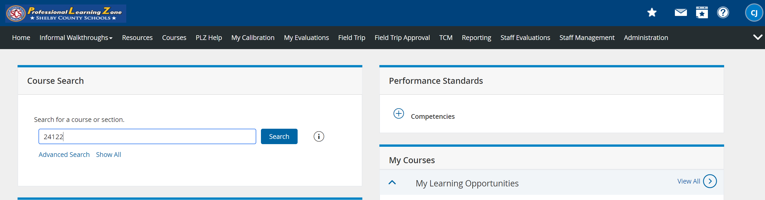
Step 4: Click Search.

Step 5: Identify the appropriate section.
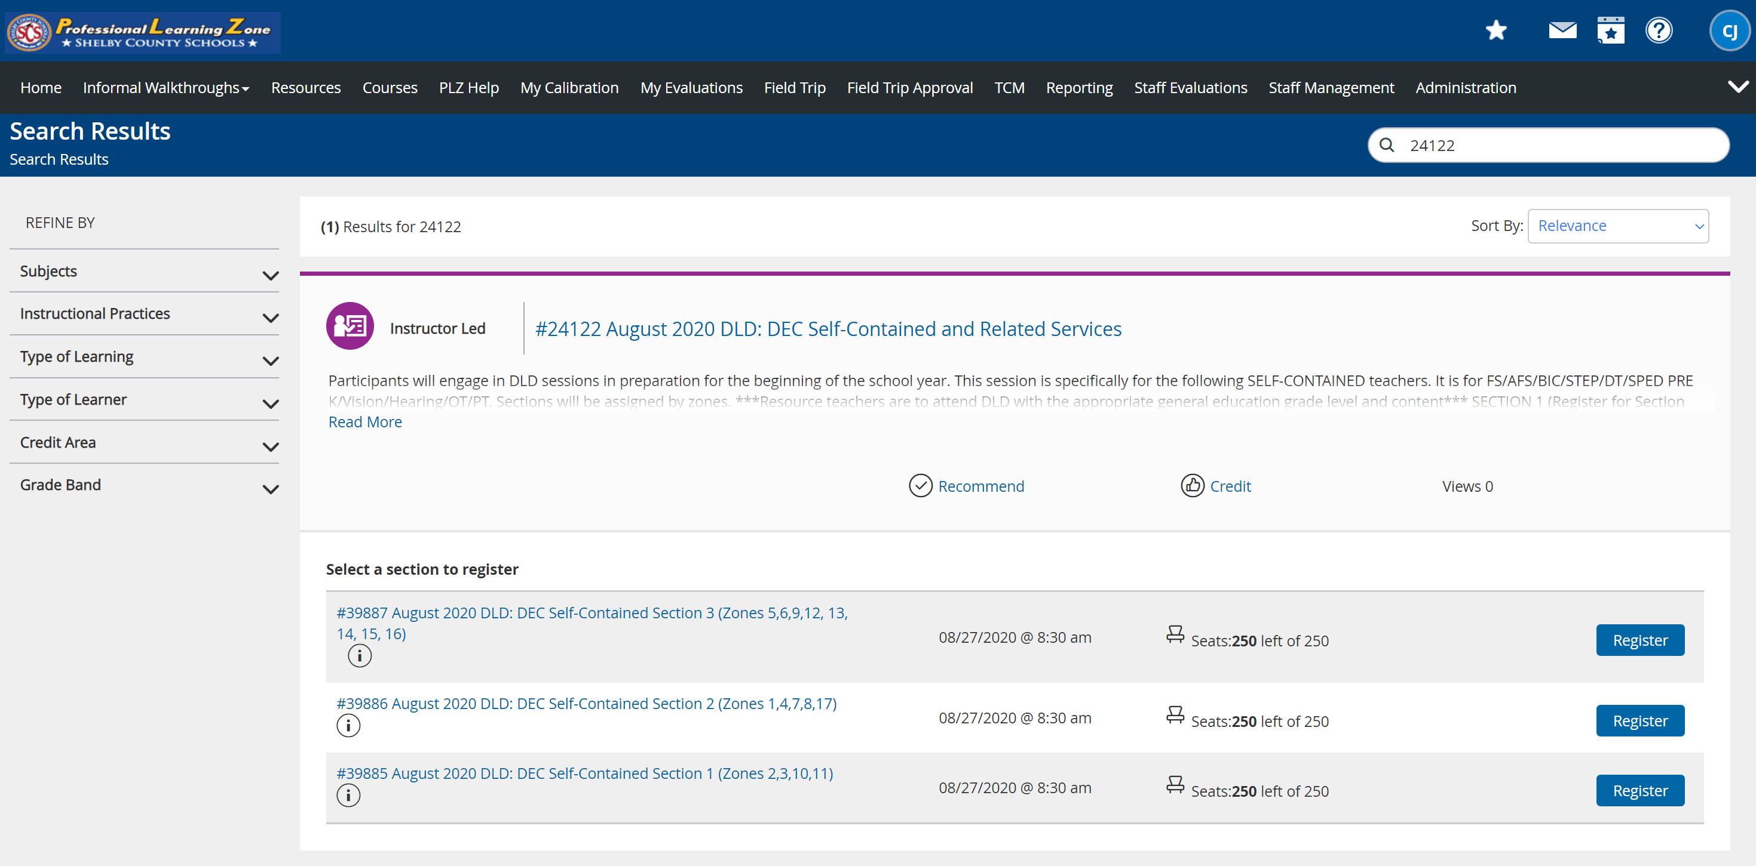
Step 6: Click Register.

