How to take attendance in Microsoft TEAMS meetings
Keep track of the meeting participates by downloading and viewing the attendance report
Downloading the attendance list
- Click on the ‘Show participants’ option on the call toolbar.
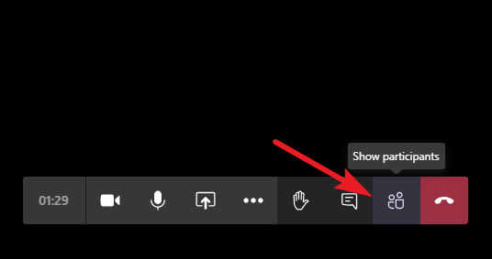
- The participant list will appear on the right side of your screen and there you will click on the three dots for more options. You will then click Download attendance list.

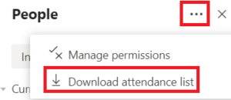

Viewing the Attendance List
Microsoft Teams saves the attendance report on your computer in a “.CSV” file format that you can open in Excel or any other compatible software. It contains the names of all meeting participants, along with their ‘Join time’ and ‘Leave time’.
To access the attendee list file in Teams app
- Go to the ‘Files’ tab from the navigation bar on the left in Microsoft Teams.
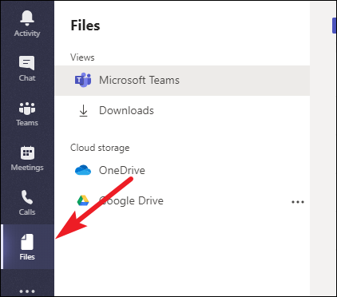

- Go to ‘Downloads’. The file will be listed there.
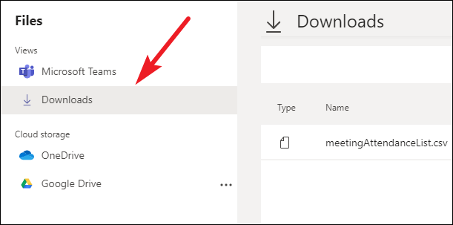

- You will then click on the file meetingAttendancelist.csv and will be provided with your meetings participants activity.
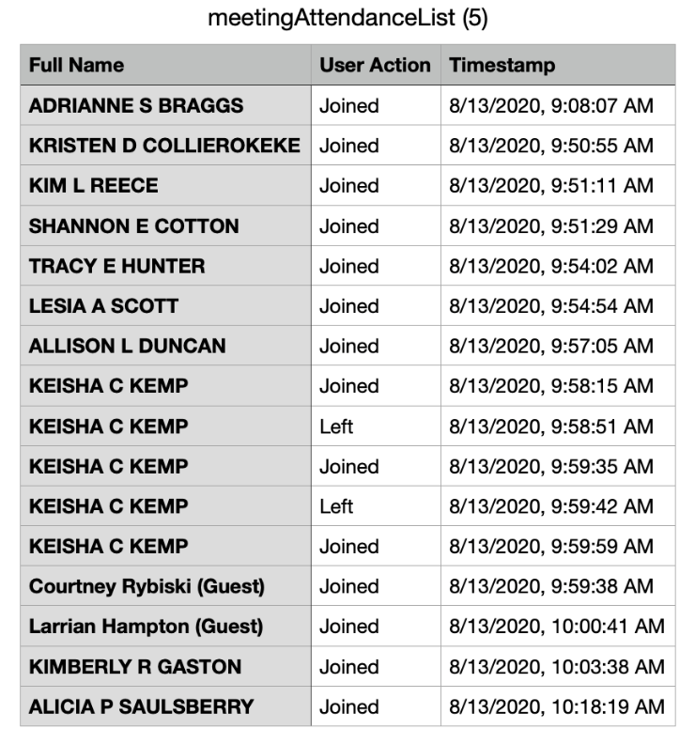
Alternatively, Microsoft Teams saves attendee list in the default ‘Downloads’ folder location on your computer. You can access the reports from your computers downloads there as well without opening the Microsoft Teams app.
Go to your computer’s downloads and click on the file named meetingAttendancelist.csv
Notes:
- Only meeting organizers can download attendance reports. This option isn't available to other attendees.
- You will only be able to download the attendance report while the meeting is in progress and participants are still present.
- If attendees join a meeting before the organizer, their join times will match the time that the organizer joined the meeting.

