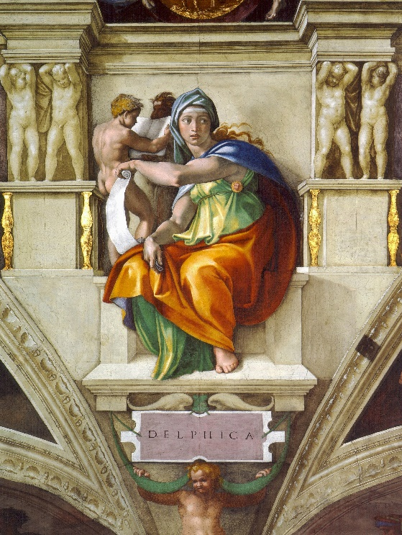 | Writing Sample for AP ART HISTORY  1..Respond to the following questions:  Number of AP classes you will take in 2021-22________  2. Fully identify the work shown from the Sistine Chapel, painted by Michelangelo c. 1508–1512CE. (Title, media, location)  In paragraph form:  Describe the visual characteristics of the identified work.  Using at least two examples of specific visual evidence, explain how the visual characteristics of the work reference and/or depart from the classical tradition of Ancient Greece and Rome.  Describe the place that the figure occupies within the larger iconographic program of the Sistine Chapel (the location within the chapel and within the ceiling as a whole).  Using specific contextual evidence, explain how the inclusion of the figure within the larger iconographic program of the Sistine Chapel represents the ideals of the Renaissance. (Context is significant background information pertaining the any of the following: culture, gender, geography, history, philosophy, politics, religion, etc…)

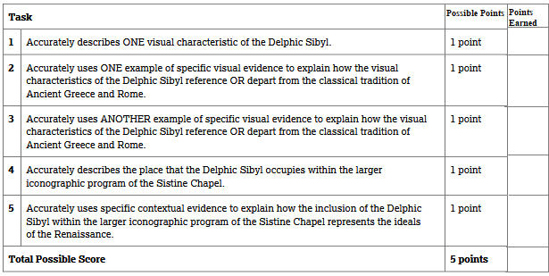
READ: SmartHistory “Ceiling of the Sistine Chapel” by Christine Zappella Paragraph on The Sibyls https://smarthistory.org/michelangelo-ceiling-of-the-sistine-chapel/ AND WATCH the VIDEO (around minute 3 to 4:35).

