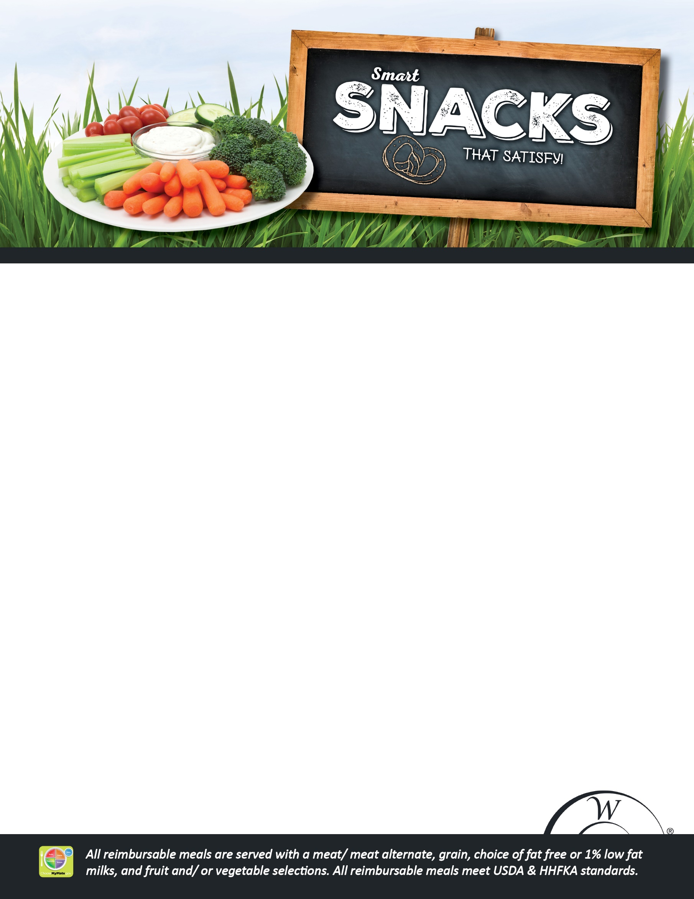
K-8 Snacks
Whole Fresh Fruit $1.00
Fresh Veggies & Dip 9oz $2.50
Fresh Fruit Cup 9oz $2.50
Baby Carrots 1.3oz $1.00
Pop Chips (Assorted) 3oz ……………………………… $1.50
Smartfood Popcorn .5oz……………………….………….$1.25
Chobani Yogurt 4oz………………………………………...$1.50
Baked Tostito Scoops .875oz w/salsa…………..….$1.75
Cheese, Crackers, and Fruit Plate ……………………$2.00
Whole Grain Goldfish .75oz $1.00
Low Fat, Low Sodium Mozzarella Stick 1oz ….... $0.50
K-8 Beverages
16.9oz boxed water ……………………………………..$2.00
8.5oz boxed water …………………………..………....$1.00
Soy Milk ……………………………………………………….$1.50
Milk 8oz: Lactose Free ………………..……………..…$1.50

http://www.mass.gov/eohhs/gov/departments/dph/programs/community-health/mass-in-motion/school/nutrition-regs/

Milk 8oz: Skim, 1%..........................................$0.75
http://www.mass.gov/eohhs/gov/departments/dph/programs/community-health/mass-in-motion/school/nutrition-regs/

