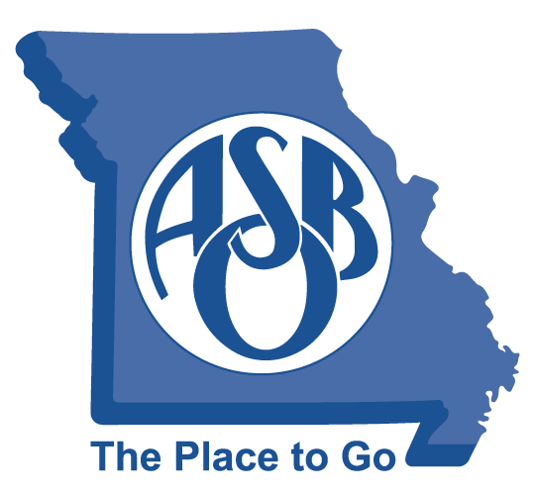
MoASBO Board of Directors
Meeting Minutes
January 31, 2025 at 10:30 AM
The Lodge – Lake of the Ozarks

- Call to Order (Dr. Steve Shelton) Time: 10:30 AM

- Roll Call (Dr. Steve Shelton)
X Dr. Luke Boyer X Stephanie Norris X Dr. Steve Shelton
X Cyndee Byous X Paul Northington
X Dr. Geoff Macy X Cindy Sullivant
Dr. Laura Nelson
X Kim Cranston, Patty Bedborough, Amber Branson, Susie Gorrell, and Tracy Payne

- Adopt Agenda (Dr. Steve Shelton)
- Move to adopt agenda: Cyndee Byous
- Motion seconded: Cindy Sullivant
- Approved: 7 – 0
- Approval of Board Minutes (Dr. Steve Shelton)
- Move to approve 10-17-24 board minutes: Stephanie Norris
- Motion seconded: Dr. Geoff Macy
- Approved: 7 – 0
- Identify Mega-Issues Impacting Members
Mike Lodewegen and Boo Foley shared info about SAC and provided a Legislative update on hot-topic issues.
- Strategic Plan
Kim Cranston provided updates on the R Program, Online Demand Learning, and the summer board retreat.

- Approval Nominating Committee Recommendation

Dr. Steve Shelton shared that Dr. Luke Boyer has submitted a letter of interest for Vice-President. Dr. Geoff Macy will move to the 2025-26 Board President.

- Move to approve: Cindy Sullivant
- Motion seconded: Stephanie Norris
- Approved: 7 – 0
- Other business
Board Recommendations:

Steve recommended that Cindy Sullivant fill the unexpired term of Luke Boyer and Paul Northington fill the unexpired term of Laura Nelson.

- Move to approve: Cyndee Byous
- Motion seconded: Dr. Geoff Macy
- Approved: 7 – 0
BOY, SSMOY, and Emerging Leader nominations are being solicited. Board members are encouraged to submit nominee(s).
Kim Cranston requested suggestions for Honorary Membership and the Hall of Fame.

XI: Treasurer’s/Financial Report:
Cindy Sullivant and Tracy Payne shared the Treasurer’s/Financial Report.

- Move to approve Treasurer’s/Financial report: Stephanie Norris
- Motion seconded: Dr. Geoff Macy
- Approved: 7 – 0

XII. Executive Director Update
Kim Cranston provided an update on the following items:
MWAEDG and WAEDG
Upcoming events:
- Leadership Forum – March
- Spring Conference – April
- MSBA (10/22-26) and ASBO (10/21-24)
XIII: Adjourn (Dr. Steve Shelton) Time: 1:25 PM
- Move to adjourn: Cindy Sullivant
- Motion seconded: Paul Northington
- Approved: 7 – 0
MoASBO provides community, education, resources and advocacy for public school finance and operations professionals to empower their critical work in support of teachers and students.

