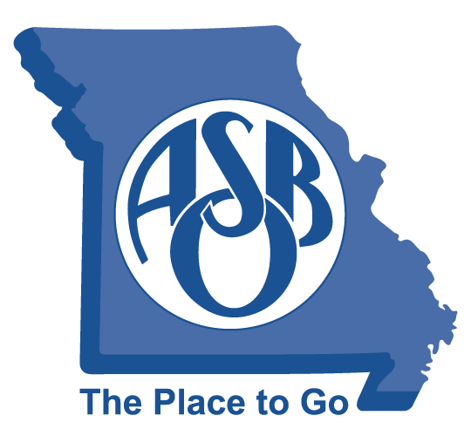
MoASBO Board of Directors
Meeting Minutes
October 17, 2024 at 3 PM
The Westin - Kansas City

- Call to Order (Dr. Steve Shelton) Time: 3:04 PM

- Roll Call (Dr. Steve Shelton)
_ _ Dr. Luke Boyer X Stephanie Norris X Dr. Steve Shelton
X Cyndee Byous X Paul Northington X Dr. Robert Sigrist
X Cindy Sullivant
X Dr. Geoff Macy (Arrived at 3:45 p.m.)
X Dr. Laura Nelson (Arrived at 3:10 p.m.)
X Kim Cranston, Patty Bedborough, Amber Branson, Susie Gorrell, and Tracy Payne

- Adopt Agenda (Dr. Steve Shelton)
- Move to adopt agenda: Dr. Robert Sigrist
- Motion seconded: Cindy Sullivant
- Approved: 6 – 0
- Approval of Board Minutes (Dr. Steve Shelton)
- Move to approve 9-13-24 board minutes: Dr. Robert Sigrist
- Motion seconded: Paul Northington
- Approved: 6 – 0
- Identify Mega-Issues Impacting Members
MAPT Exec. Director, Keith Henry, and board president, Scott Speer, shared info about MAPT and discuss collaborative efforts between our two associations.
- Strategic Plan
Kim Cranston provided text updates on the Strategic Plan developed by the Board during the planning retreat.

- Move to approve: Stephanie Norris
- Motion seconded: Cyndee Byous
- Approved: 8 – 0

- Other business
Treasurer’s/Financial Report:
Cindy Sullivant and Tracy Payne shared the Treasurer’s/Financial Report.

- Move to approve Treasurer’s/Financial report: Stephanie Norris
- Motion seconded: Paul Northington
- Approved: 8 – 0

990:
Cindy Sullivant and Tracy Payne shared that an outside accountant prepared the 990; this document was provided prior to the meeting.
- Move to approve 990: Cyndee Byous
- Motion seconded: Cindy Sullivant
- Approved: 8 – 0

Legislative Priorities:
On behalf of the Legislative Committee, Geoff Macy submitted the 2024-25 Legislative Priorities for
all board members to review.
- Move to approve the 24-25 Legislative Priorities: Dr. Robert Sigrist
- Motion seconded: Dr. Laura Nelson
- Approved: 8 – 0

MoASBO Board VP:

Dr. Steve Shelton reminds the board any members that wish to be considered for the Vice-President
role must submit a letter of interest to the nominating committee no later than Nov. 30.
VIII. Executive Director Update
Kim Cranston provided an update on the following items:
- 2024 Support Staff Conference
- Women in School Finance Symposium
- Equitable and Leader Pass – series of Master Class videos (105 lesson clips)
- The theme for the MoASBO 71st Annual Spring Conference in April.
- MSBA schedule of events

IX: Adjourn (Dr. Steve Shelton) Time: 4:40 PM
- Move to adjourn: Dr. Geoff Macy
- Motion seconded: Dr. Laura Nelson
- Approved: 8 – 0
MoASBO provides community, education, resources and advocacy for public school finance and operations professionals to empower their critical work in support of teachers and students.

