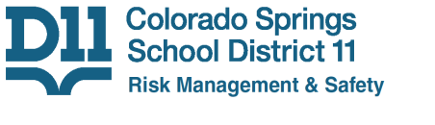

1115 N. El Paso St., Colorado Springs, CO 80903 phone (719) 520-2262

All District Staff:

As we approach the cooler weather months, this is a reminder that portable space heaters can be dangerous if used improperly. If your working area is too cold, please notify you building manager and have a work order submitted to address the issue. If you are going to utilize a space heater, please remember the following Fire Code rules:
- Heater must be “UL 1278” rated. This type of heater is designed to turn off its power when it is tipped over.
- Heater must be plugged directly into a wall outlet; not into an extension cord nor a surge protector.
- The area around the heater should be clear of all combustible (flammable) materials.
- The heater should never be left unattended. If you leave the heater, ensure you turn it off first.
- Ensure students stay clear of the heater at all times!

For questions regarding specific heaters and their usage, please contact Brian Garcia.

Brian Garcia
Environmental Life Safety Supervisor
Office: 719-477-6021
Email: Brian.Garcia@D11.org

