HS Civil Rights Template for Lesson 3: Equity, Gender Respect and Gender Harassment (Inappropriate touch, boundaries, “upstander” expectations, how to be an ally **Add Slides as needed

Objectives  Students will be able to...  - To support students in recognizing personal boundaries for themselves and their peers  - To promote upstander behavior  - To increase awareness of gender respect and equity | Materials Needed  Continuum (Where do you draw the line?) – COPY HANDOUT FOR STUDENTS | Key Vocabulary  - Gender Harassment  - Gender Respect  - Stereotypes  - Racial Discrimination  - Upstander

Time | Description and Talking Points | PPT Slides
5 min. | Optimistic Opener:  Ask students: Have you ever heard of the term harassment?  What’s your definition of harassment? | 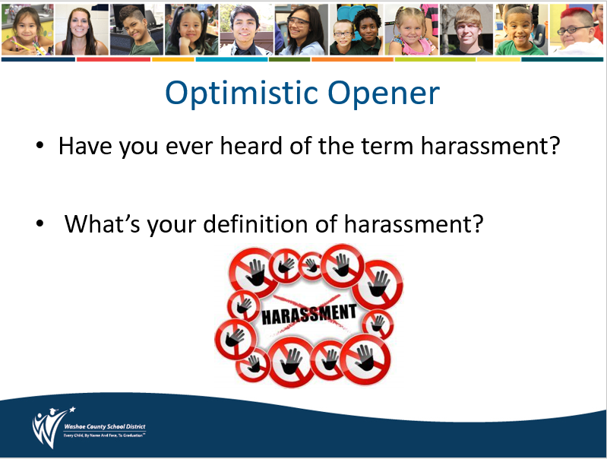
5 min. | Engaging Strategies:  Discuss that there are multiple forms of harassment including:  Sexual Harassment – any unwelcome, unwanted pressure, verbal, visual, or physical contact of a sexual nature. It is any repeated or deliberate action or behavior that is hostile, offensive, or degrading to the recipient.  AND  Gender Harassment – when girls, queer students, or boys are bothered, teased, or bullied because of their gender. (Their gender identity, gender performance, or for breaking typical gender norms.)  ALSO  Racial Discrimination can be a form of harassment. | 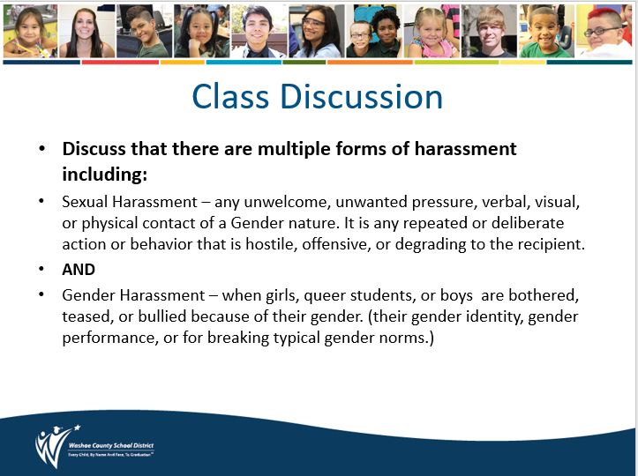
15 min. | Engaging Strategies: THINK -PAIR-SHARE  Ask participants to read through the sentences and place each statement on the “Flirting/joking” to “Harassment” continuum, according to where they think each belongs.  Allow small group or partner discussion to note where they placed each statement on the continuum.  Note:  Flirting/joking Harassment  …is wanted or welcomed …is unwanted or unwelcomed  …is two-sided …one-sided  …feels good …does not feel good  …is a compliment …is threatening or insulting | 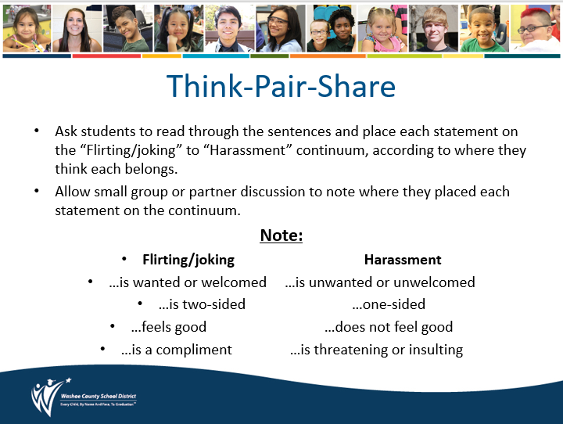
5-7 min. | Engaging Strategies: Where Do you Draw the Line?  Teacher will select speciﬁc statements, read them aloud and ask for volunteers to report where they placed that statement on their continuum.  To generate discussion, ask others in the class whether they placed the same statement in the same place, or closer to either ends of the continuum, and why they placed it where they did. | 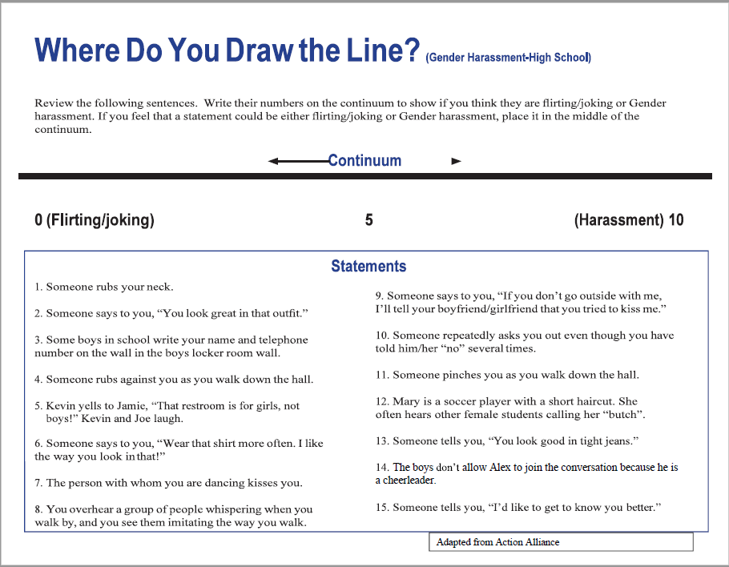
5-7 min. | Engaging Strategies: Where Do you Draw the Line?  Ask participants to refer to their own continuums. When deciding where to place a statement, ask them:  - why they considered one statement ﬂirting and another Gender harassment (and everything in between).  - Ask students to decide for themselves where on their continuum does ﬂirting cross the line to Gender harassment.
5-7 min. | Reflective Closer:  Teacher will close by discussing the “eye of the beholder” standard. This means looking at Gender harassment from the receiver’s point of view. Regardless of the intent of an individual, it is the receiver’s perspective that is important to consider.  Define Gender Respect – Treating people with social and physical respect regardless of gender identities, stereotypes or societal roles  Closing question: What are two ways you can be an upstander in situations of Gender harassment? | 