MS Civil Rights Template for Lesson 4: Embracing, Respecting and Accepting Differences **Add Slides as needed

Objectives  Students will be able to...  - Identify and understand the importance of diversity and inclusivity in the classroom, community, and school.  - Students will reflect on how any, one identity aspect shapes the way they view the world.  - Students will understand the many reasons that miscommunication can occur. | Materials Needed  - Teacher prepares model of their own identity before presentation  - Copy of student handout for each student. (COPY HANDOUT FOR STUDENTS)

Time | Description and Talking Points | PPT Slides
1-5 minutes | Warm-up:  Think of/Write down 1 word that describes you. | 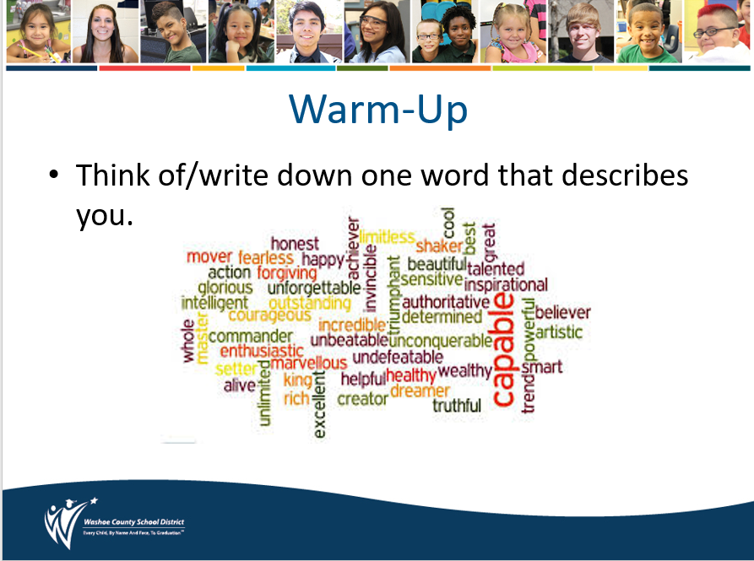
3-5 minutes | Discuss/Think-Turn-Tell:  Ask students to brainstorm the question “What is Culture?”  Culture – Is the set of practices and beliefs shared by members of a particular group that distinguish that group from other groups.  This includes: all characteristics of human description including age, gender, socioeconomic status, geography, ancestry, religion, language, history, sexual orientation, physical and mental level of ableness, occupation, and other affiliations | 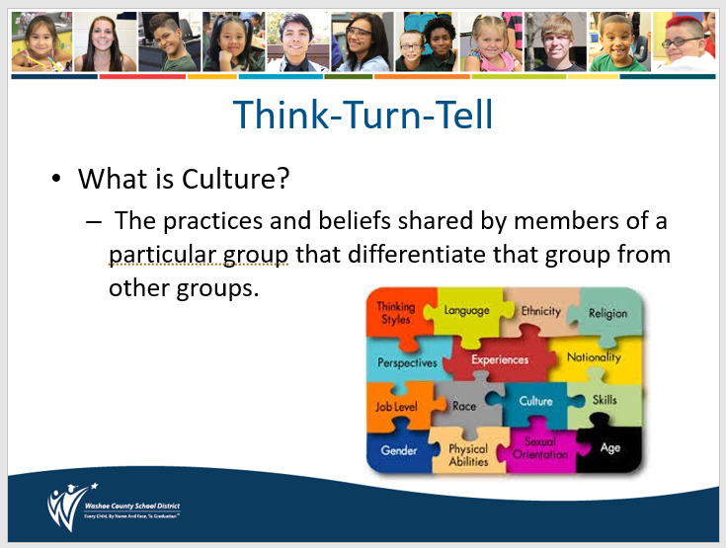
5 -7  minutes | Activity Introduction: My Multicultural Self  Explain: The following exercise helps us to name aspects of our identity that are important and unique to each of us as individuals. It helps us identify the different pieces of our identity and how that impacts who we are.  The teacher should complete a handout in advance to serve as a model for students. Use PowerPoint or Flipchart to display the components of your multicultural self. Example:  (Using the definition of culture from above)  Mrs. Adams  Mother – Teacher – Writer – Biracial – Marathon Runner  Note: Share how each of your identity bubbles is a lens through which you see the world. | 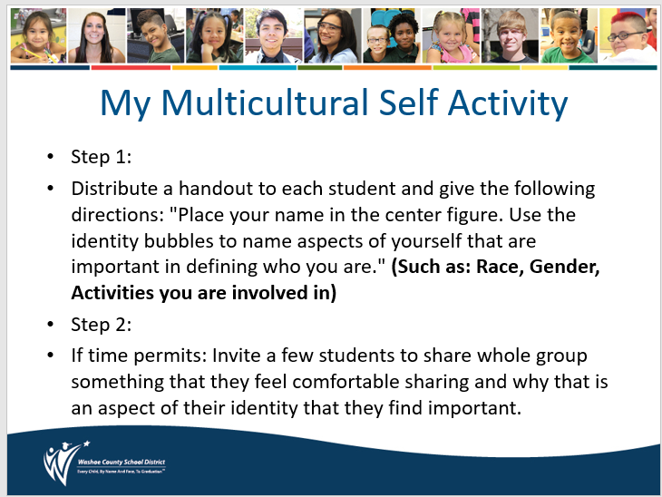
10  minutes | Activity: My Multicultural Self  Step 1:  Distribute a handout to each student and give the following directions: "Place your name in the center figure. Use the identity bubbles to name aspects of yourself that are important in defining who you are." (Such as: Race, Gender, Activities you are involved in)  Step 2:  If time permits: Invite a few students to share whole group something that they feel comfortable sharing and why that is an aspect of their identity that they find important. | 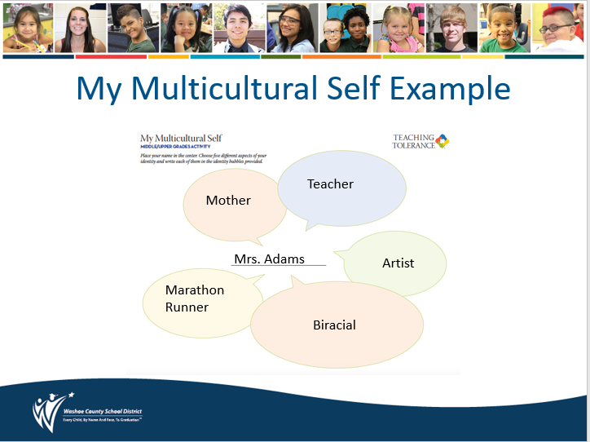
5-7  minutes | Think-Turn-Tell:  Discuss as a class or in small groups:  - How would you feel if someone ignored one of your multicultural identity bubbles?  - Can you see how ignoring one of your identity bubbles could cause miscommunication? Can anyone give an example?  - Do you have more than these 5 identities?  Note: Tell students that we have many identities in our multicultural selves. Not being aware of our own or others' identities causes miscommunication. | 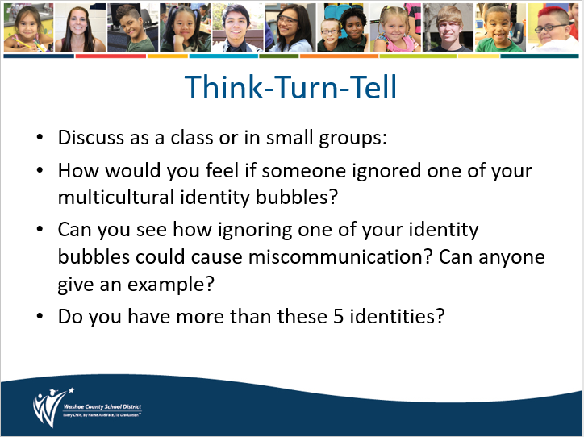
5-7  minutes | Lesson Wrap-Up:  Teacher Explains:  Our identities are NOT static. We are shaped and reshaped by what goes on around us and our identities constantly change as well. For example:  - If a parent dies this reshapes the way we see the world.  - If we fall in love this reshapes the way we see the world.  - If our best friend moves this reshapes the way we see the world.  - If we experience an act of violence this reshapes the way we see the world. | 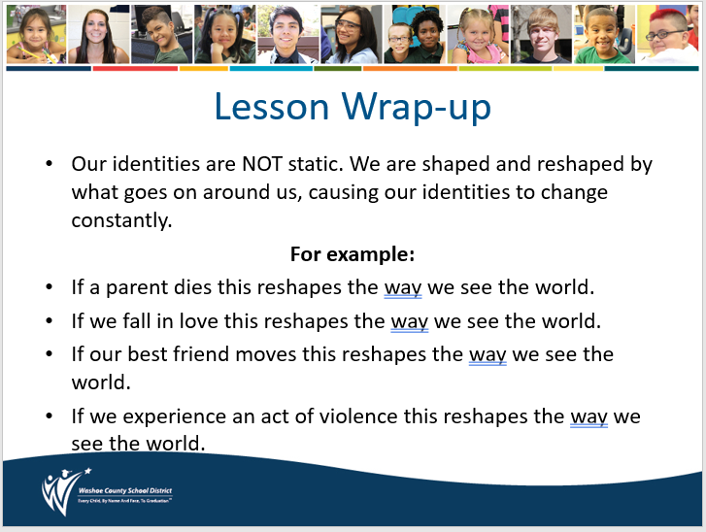
3-5 minutes | Closing:  So, what we once knew to be true about ourselves and others can change over time. For this reason, we should always try to suspend judgment, ask questions of others and talk with those different from us as much as possible.  Review SafeVoice:  - Review SafeVoice (lesson 1 information) and ways students can report incidents involving bullying, cyberbullying and racial or gender harassment.  - This is a re-occurring theme in all four lessons for the Civil Rights and Me.  - Reporting empowers students to make a difference and correct an issue they witness at school or in the community  - Along with notifying administrators, teachers, and filing incident reports, Safe Voice is how WCSD students should report ANY form of harassment.  - Reporting and Informing are different from tattling and “snitching” | 