
Volusia County Schools
Transition Services and Supports for Students with an IEP

Volusia County Schools offer numerous opportunities for students who defer receipt of their standard diploma that are designed to prepare the student for employment. The programs include instruction in social skills, self-advocacy, self-determination, and employment competencies.

A student whose IEP requires special education, transition planning, transition services, or related services through the age of 21 may defer receipt of a standard diploma. School districts are required to provide all students with disabilities and their parent(s) information and resources related to the deferment process beginning no later than when the student turns 14, or by the first day of high school, whichever occurs first. This information will be provided annually and includes:

Eligibility criteria to defer a standard diploma.
Timelines of deferment process activities and communication requirements.
Relevant information on deferment programs.

Students may defer to enroll in the programs listed below:
1. Accelerated College Credit Instruction
2. Industry Certification Courses
3. Collegiate High School program
4. Scholar Designation courses
5. Structured work-study/Internship or pre-apprenticeship program

Community-Based Instruction (CBI): Is an instructional method that promotes the teaching and use of academic and functional skills in the student's natural environment, such as a grocery store, library, or community center.

Community-Based Vocational Education (CBVE)- Community Based Vocational Education, or CBVE is the term used to define vocational education and training provided to students with disabilities in community work settings. This training is non-paid vocational exploration and assessment.
The goal of the CBVE program is to help students identify career interests, assess employability skills and develop the skills and attitudes necessary for paid employment. CBVE services are incorporated into the school day. The supervision of the CBVE training is provided by the school staff. Training sites vary at each school.

Work-Based Learning Experiences (WBLE)- Students who are a client of Vocational Rehabilitation are eligible to receive Work-readiness skills training to help prepare you for employment and life after school. The student will work with a VCS Employment Specialist to gain employability skills while participating in various unpaid work experiences. The student’s case manager at the school can submit a VR referral with parent permission Contact Cathy Galotti for additional information.

Supported Competitive Employment (SCE) Program-Volusia County Schools has 5 employment specialist who assist a student in finding and maintaining competitive paid employment. The SCE program is a unique employment service for individuals with an Individualized Education Plan (IEP) who require ongoing support services to succeed in competitive employment. The employment specialist works with the student during their last year of school. Please submit a SCE referral to Cathy Galotti for any student who wants assistance finding and maintaining employment.

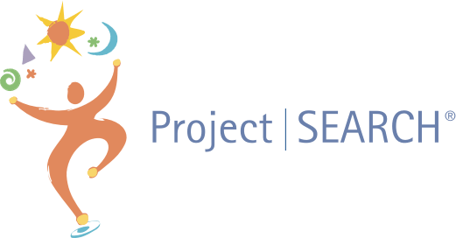Volusia County Schools currently has three Project SEARCH Programs in the district. Project SEARCH is a one-year internship program for Volusia County Schools students who defer receipt diploma and are between the ages of 18-21. The goal of the program is competitive employment. The program takes place at a host business site where total immersion in the workplace facilitates the teaching and learning process, as well as the acquisition of employability and marketable work skills. Students participate in three unpaid internships to explore a variety of career paths. The three Project SEARCH sites are:
Halifax Health Medical Center Daytona Beach
Halifax Medical Center of Deltona
Halifax Health Medical Center Port Orange
A student must completed the Project SEARCH Application and be a client of Vocational Rehabilitation in order to be considered for an internship at one of the three Project SEARCH sites. Students must submit the Project SEARCH Application to Cathy Galotti, ESE Coordinator (contact information below).

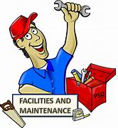Specific Practical Observation Training (SPOT) Program- SPOT is an on-the-job training program that provides students with disability exposure to specific content areas and related careers with Volusia County Schools (VCS) Facilities & Maintenance Department. Students receive training for future careers within the Facilities & Maintenance Department. It is a one- year internship program for students who have deferred receipt of their diploma and are a client of Vocational Rehabilitation. The student reports to one of the 5 Facilities and Maintenance Hubs instead of their zone school each day and joins the crew at different locations throughout the district. They work with the crew from 7:00am -12:00 pm. Students must have their driver’s license before completion of the program. Please have the student complete the Volusia Explores application and submit it to Cathy Galotti, (see contact information below)
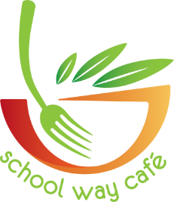Volusia County Schools, Exceptional Education Department (ESE) and the School Way Café (SWC) have partnered together to create an on-the-job training opportunity for high school students with disabilities. The program is designed to teach the student the skills needed for a career in the culinary/hospitality field. It is recommended that the student is a client of Vocational Rehabilitation. Please have the student complete the Volusia Explores application and submit it to Cathy Galotti, see contact information below.
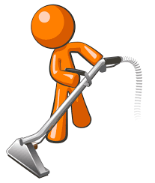Volusia County Schools Custodial Training Program-Volusia County Schools, Exceptional Education Department (ESE) and the Custodial Department have partnered together to create an on-the-job training opportunity for his school students with disabilities. The program is designed to teach the students the skills needed for a career in with the Custodial Department of Volusia County Schools. Please have the student complete the Volusia Explores application and submit it to Cathy Galotti, see contact information below.

PAES Lab-Practical Assessment Exploration System -PAES is a research-based assessment system that identifies aptitude for community-based employment, functional skills, interests and work behavior strengths and barriers to success.
PAES is a hands-on assessment of employment potential. The program exposes students to a broad range of hands-on, generalizable work skills. The activities prepare students for community work experiences, future employment and an independent life. The students have the opportunity to explore nearly 300 jobs in five career areas that are based upon typical skills found at community-based job sites. Students find out what job skills they are good at, and what job skills they like to do.
School-Based Enterprise-(SBE) is a small business run by students within a school that provides goods or services to the school community. SBEs are a type of work-based learning (WBL) that help students develop real-world skills and prepare for the transition to work or college. If selling food to students, the items must meet Federal Smart Snack Nutrition Standards outlined in the Healthy Hunger-Free Kids Act of 2010.
For additional information regarding any of the programs listed above, please contact:
Cathy Galotti, ESE Coordinator
Volusia County Schools
386-255-6475 extension 33263
cgalotti@volusia.k12.fl.us

