STEP 1: Log into your PowerSchool Parent Portal

https://ps-re.metasolutions.net/public/home.html
This link is also available on the district/school website in the “For Parents” tab at the top of the website page.

If you have previously created an account, you may continue to sign into the portal with your Username & Password.

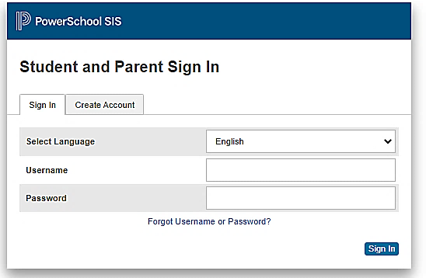
If you DO NOT currently have a PowerSchool account, please click on the Create Account tab to create a new account.

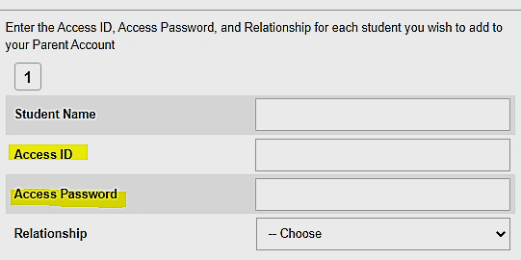
To link your PowerSchool account to your child, you will need to enter the student’s Access ID and Access Password. This information is found on the parent portal letter that your school will provide. Otherwise, you may contact your school for this information.

STEP 2: Complete Enrollment Forms for RETURNING STUDENTS

After you successfully log into the system you are now ready to update the renewal forms. Click on the Forms link within the left navigation menu. The school forms will be located in the General Forms tab which should be the default tab located at the top of the page.

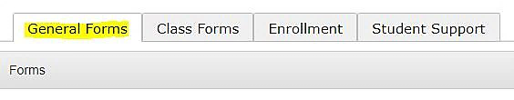
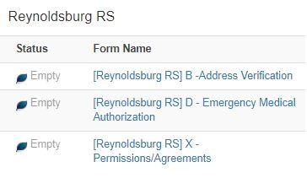
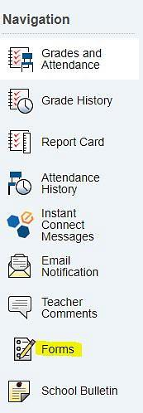
Parent/Guardian MUST REVIEW/UPDATE
ALL FORMS (3) to renew your child’s enrollment for the school year.

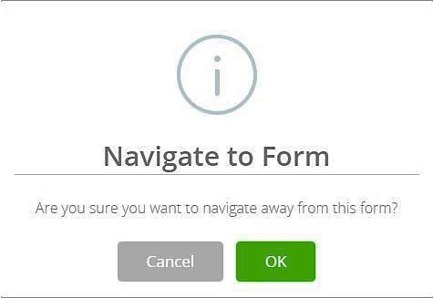
Make sure after completing each form that you click on the submit button at the bottom of each page, otherwise, your changes will not be saved.

As you navigate between the listed forms, you will need to click on OK to proceed.

Again, make sure after making any updates that you click on the submit button at the bottom of each form to save any changes prior to moving onto the next form(s).

Please note: If you have moved from the current address of record or have a change in custody arrangements for your child, you must provide supporting documentation to the Welcome Center within 10 days of the initial change.
Failure to present required documents will constitute a falsification of applications and/or enrollment documents . resulting in denial of all new or existing Open Enrollment, Intra-district Agreement or School of Choice requests.

Please call the Welcome Center at 614-501-1033 to schedule an appointment to update these changes.

Thank you for verifying your student’s information for Reynoldsburg City Schools.

