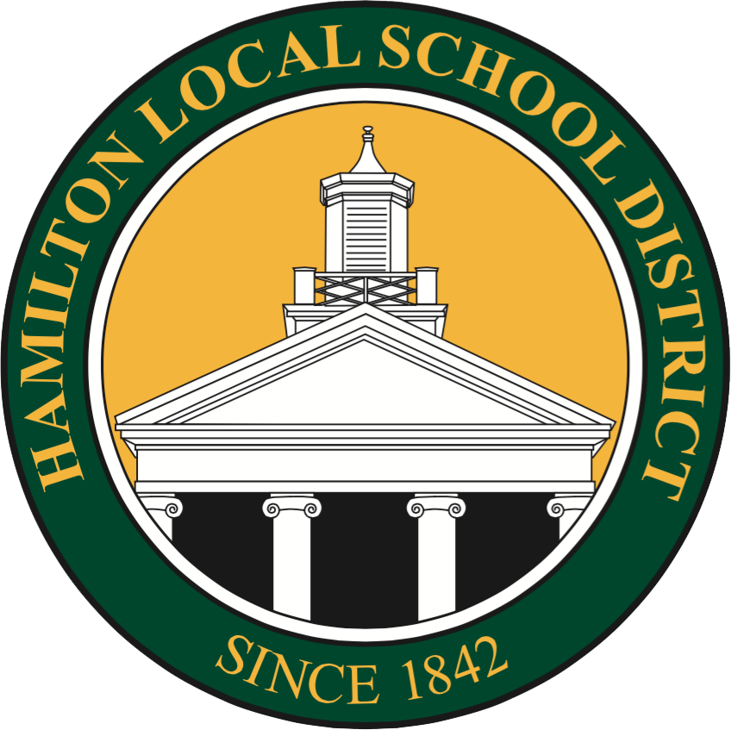
Hamilton Local School District

Google Workspace for Education

Hamilton Local School District utilizes Google Workspace for Education, providing students with a suite of productivity tools including Gmail, Calendar, Docs, Classroom, and more. These tools support assignment completion, teacher communication, and the development of digital citizenship skills in the 21st century.
Google's commitment to privacy in the educational context is detailed in the Google Workspace for Education Privacy Notice, accessible at Google Workspace Privacy. Here are key points for consideration:
- Advertising: Google does not use personal information from K-12 Google Workspace users for ad targeting.
- Information Disclosure: Google will not disclose personal information outside the company without consent, except in specific circumstances such as legal requests or with parental consent for users below the age of consent.
- Data Processing: Google may process personal information through trusted external parties under strict privacy and security terms.
- Legal Compliance and Safety: Google may share personal information when legally required or to protect Google, its users, or the public.
Google also shares aggregated, non-personal information publicly and with partners.

