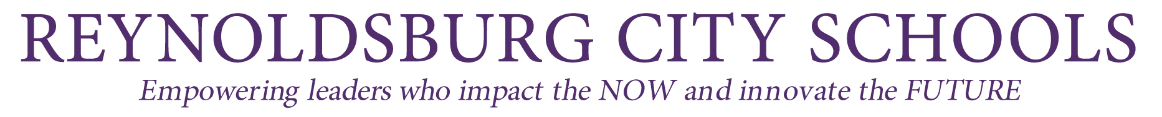


Parent Notification - Student Participation in State Assessment

Reynoldsburg City School District receives Title I-Part A funds and is required to notify the parents of each student attending Title I-Part A school that the parents may request, and the district will provide to the parents on request (and in a timely manner), information regarding any state or district policy regarding student participation in any assessments mandated by section 1111(b)(2) and by the state or district, including a policy, procedure, or parental right to opt the child out of such assessment, where applicable.

Information on State and Local Assessments

Students are subject to the administration of district and state assessments. These tests will provide the student, parents, teachers, district, and state with important information on the student’s academic progress according to state standards. Upon request, the school will promptly provide the district’s testing policy and state information mandated by section 1111(b)(2). When the results of state-mandated assessments are sent to the district, those reports will be forwarded to the parents. District assessment results will be sent home with the student, mailed to the house, or distributed during parent-teacher conferences. Please contact your building principal if you have any questions about district or state tests.

The District’s most recent State Report Card can be found at: Ohio School Report Cards

Information for Students and Families about Ohio’s State Tests: Testing Information

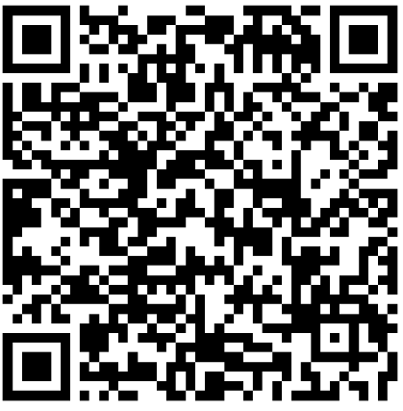
Testing Dates: Test Dates
नपाल Nepali

Español Spanish Français French Portuguese

Board of Education
Angela Abram, President • Jeni Quesenberry, Vice President Kendra McKay • Neal Whitman • Mandy Young
Dr. Tracy R. Reed, Superintendent • Angéle Latham, Treasurer

www.reyn.org 7244 E. Main Street, Reynoldsburg, Ohio 43068 (614) 501-1020

