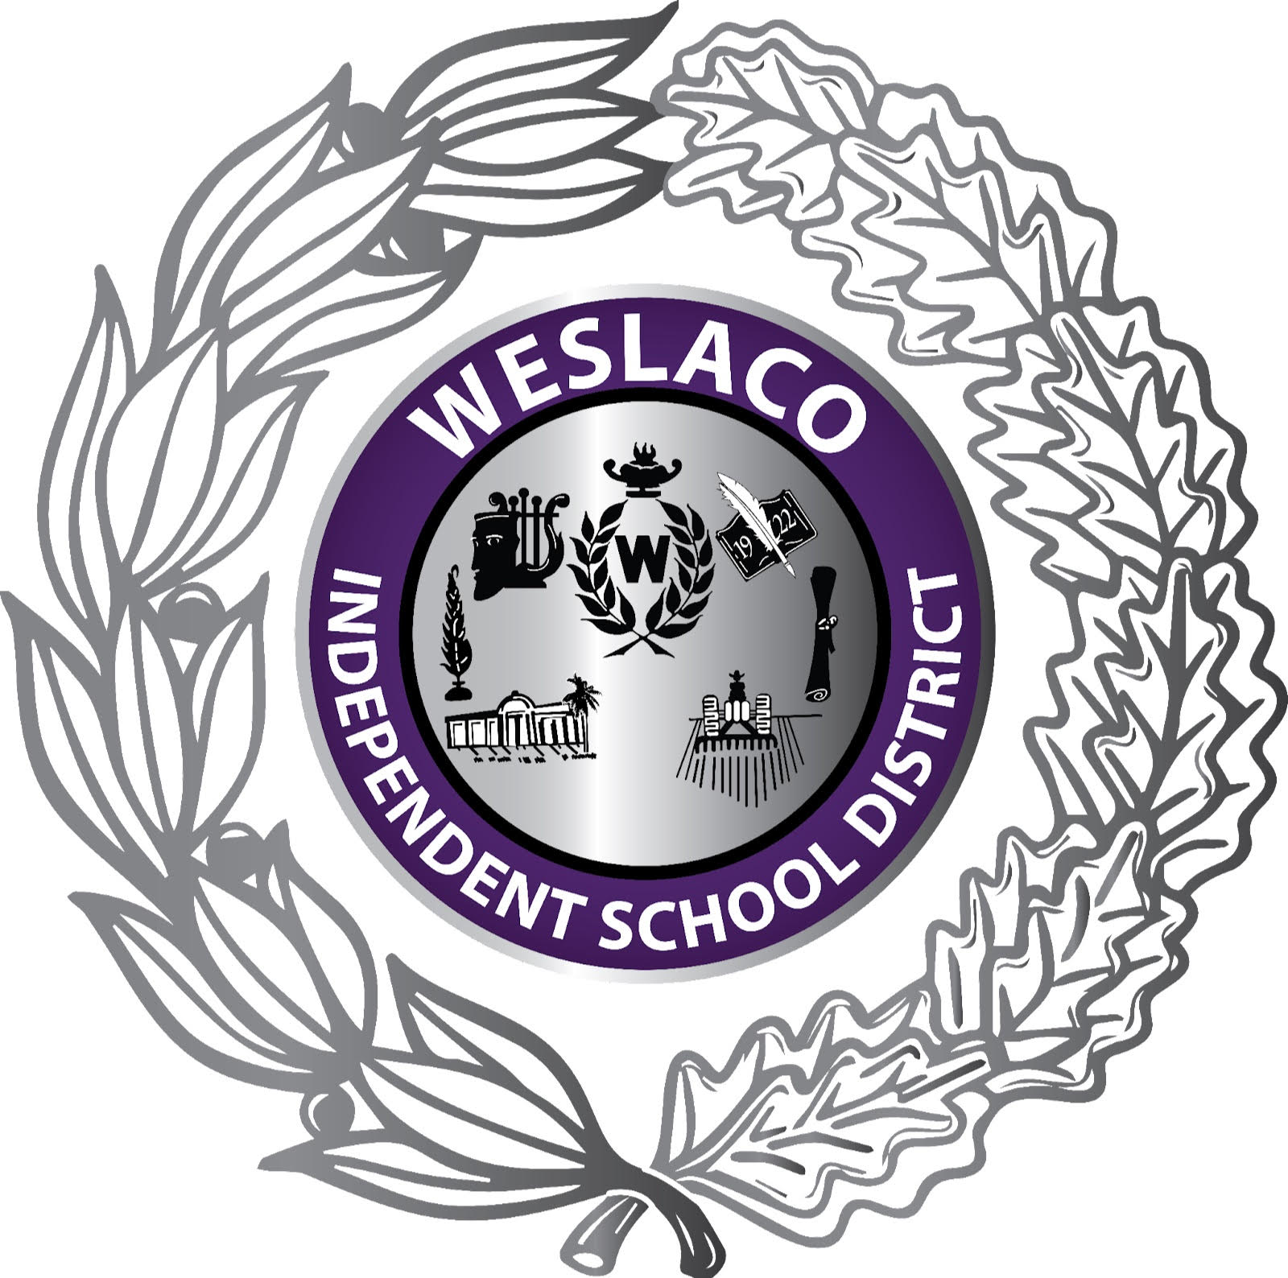

Activity Funds
FAQ - 2024-2025 Fiscal Year

GENERAL INFORMATION

What are Activity Funds?

Activity funds are used to account for district, campus and student funds generated from vending machines, rentals, gate receipts, concessions, fundraisers, and other sources of revenue. These funds are to be used to promote the general welfare of the school and the educational development and morale of all students. All funds collected by school district personnel from students are defined as activity funds and must be handled through the activity fund accounts.

Campus Activity funds - 461 Fund
District or campus activity funds support cocurricular and extracurricular activities and are generally under the control of the campus principal. The revenue sources in this activity fund generally include vending machines, concessions, campus wide fundraisers, and commissions from school pictures. These funds are expended to benefit the student body and promote campus goals, such as improving employee morale and provide a direct or indirect benefit to students.

Student Activity Funds – 865 Fund
Student Activity Funds are held by the school as a trustee to be expended only for the purpose authorized by the student club, class, or organization. All student activity funds must be expended exclusively for the benefit of the students. Examples include student council, Class of 2024, Cheerleading, Chess club. Student activity funds are comprised of monies raised and collected by students typically through school – approved fundraising activities, club dues, or donations. Student activity funds, therefore, fall into the fiduciary fund category. That is, student activity funds are assets held by the district as an agent for the student organization that cannot be used by the district to support its own programs. Approval to spend money from a student activity fund rests solely with the student organization with a help of a sponsor, rather than administrators.

Common Questions

- Who determines how to spend activity funds money? The answer depends on whether it is a student activity fund or a district or campus activity fund. If the money comes from a student activity fund, students decide how to spend it.

- Can activity funds be spent on travel? Yes. If the funds for the trip come from student activity funds, the students can decide to spend the money on a trip. If the funds come from district tor campus activity funds, the trip must be related to the district’s educational purpose, and provide a commensurate benefit to the district or students.

- Can we spend campus activity funds on a teacher appreciation lunch? Expenditures intended to improve staff moral are related to the district’s educational purpose and provide a benefit to the district, so they would be a legitimate use of campus activity funds.

- Can we have an employee activity fund? Funds can be collected or received from teachers or other employees for a specific purpose, such as a “flower fund” or break-room fund. Under no circumstance can a faculty account generate money by selling or receiving monies from students.

- Can a student organization hold a raffle or have a bingo night as a fundraiser? No. Raffles and bingo are highly regulated by the State of Texas. State law specifically prohibits “raffles” as a fundraiser for Texas public school districts. An unauthorized raffle is considered gambling under the Texas Penal Code – Class C misdemeanor.

- Are a booster club or PTA funds activity funds? No. Booster clubs and parent-teacher organizations are separate legal entities from the school district. These organizations must maintain separate federal tax identification numbers and bank accounts.

- Are purchases made from student activity funds tax-exempt? All purchases made for the exclusive use of a school district should be made tax exempt. Purchases are tax-exempt if they are related to the educational process and will be used for educational purposes. A Texas Sales and Use Tax Exemption Certificate form should be issued to the vendor. When reimbursing a district employee for purchases made on behalf of and for the exclusive use of a school, sales taxes should not be reimbursed to that person. Purchases for their own use by individuals, even though connected with a school or organization, are not exempt from the tax. As an example, cheerleaders purchasing their own uniforms, athletic teams purchasing their own jackets are not tax exempt.

- Do purchases from student activity funds have to comply with competitive procurement laws? Purchases from campus or district funds MUST comply with the district’s purchasing procedures and relevant statutes. Purchases made from student activity funds may not be legally required to comply with procurement laws if a purchase is made directly by students.

- What account code do we use for activity funds? If activity fund decisions rest solely with students, the money should be account for in Fund 865 – Student Activity Account. If other persons besides students such as a teacher, sponsors, or administrators have access to the activity fund, the money should be accounted for in Fund 461- Campus Activity Funds.

- What happens when activity funds are lost or stolen? The responsibility for activity funds involves principals, staff such as the school secretary, and sponsors. Because student activity funds consist of cash, a high risk of mishandling or misappropriation of funds exists. District policy typically prohibits fraud and financial impropriety, including misappropriation of funds, at policy CAA (LOCAL). An employee who is found to have violated school district policy could be subject to discipline including termination depending on the circumstances. In addition, the loss or misappropriation of funds could cause problems with the district’s financial audit and affect the district’s financial accountability rating from TEA.

- Do we need prior approval to conduct a fundraiser? Fundraising activities by student groups and/or for school sponsored projects shall be allowed, with prior administrative approval and under the supervision of the sponsor. All fundraising activities shall be subject to the approval of the campus principal. Student participation in fundraising activities shall not interfere with the regular instructional program.

- Which fundraising activities are allowable? The list below represents some of the most common fundraisers at the district and/or campus level:

  - Fall Festival
  - School Pictures
  - Concessions
  - Cookie Dough
  - Spirit Shirts
  - Yearbook

** Please contact food service department when selling food items to ensure you are following food and nutrition service department guidelines

- Do we have to pay sales tax for the revenue activities of our activity funds? It depends on whether the revenue activity meets the definition of a sale, non-sale, taxable sale, and non-taxable sale. Additionally, each school is allowed two, one-day tax –free sales each calendar year. The tax payments must be submitted to the Texas Comptroller of Public Accounts. Examples of revenue activities and the determination of whether sales tax is owed is provided in a separate document.
