

Reynoldsburg City Schools Expenditure Reductions, January 9, 2025
Empowering leaders who impact the NOW and innovate the FUTURE

Work Session Goals

1. Share with the BOE current proposed reductions of expenditures (There will be additional reductions to meet the goal of $8.5 million).

2. Provide data to support proposed reductions and possible implications.

3. Solicit feedback and questions from board members to inform proposed reductions now and future reductions.

Empowering leaders who impact the NOW and innovate the FUTURE
Meeting Agenda

Overview of Current Financial Landscape: Angele Latham, Treasurer

Immediate Response to the Levy’s Failure and FAQ: Dr. Tracy R. Reed, Superintendent

Proposed Expenditure Reductions:

• Valerie Wunder, Executive Director of Communications & Outreach
• Andre Rudolph, Assistant Superintendent of Human Capital Management • Kelley Brazeau, Executive Director of Diverse Learners and Whole Child • Naim Sanders, Assistant Superintendent of Leadership & Learning
• Tim Wagner, Executive Director of Business & Operations

Boundary, Feeder Patterns and Transportation: Dr. Tracy R. Reed

Empowering leaders who impact the NOW and innovate the FUTURE
Financial Landscape

Voters last passed an operating levy in 2010 • Additional funds in 2011, 2012, 2013

Prior forecast showed that the District would enter a period of deficit spending in 2021:
• COVID Relief Funds
• Fair School Funding Plan

Current forecast shows that District began deficit spending in 2023 and is projected to continue throughout the forecast without additional revenue or a decrease in expenses

Empowering leaders who impact the NOW and innovate the FUTURE
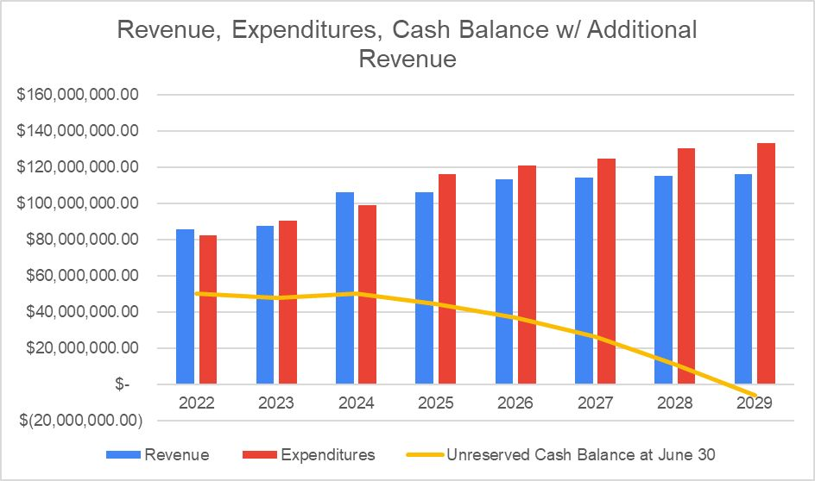
Financial Landscape - Revenues and Expenditures

Empowering leaders who impact the NOW and innovate the FUTURE
Financial Landscape - Revenues and Expenditures

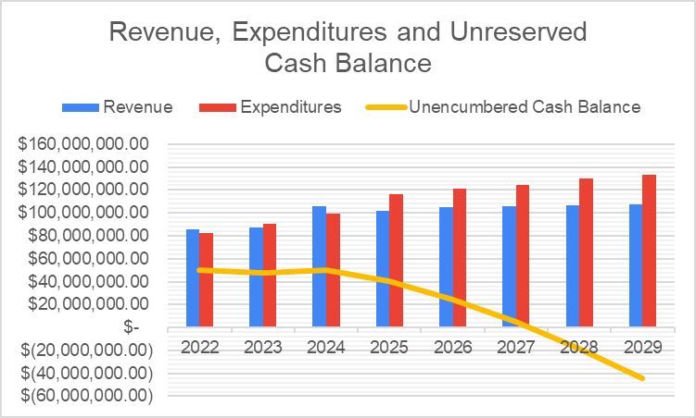
Empowering leaders who impact the NOW and innovate the FUTURE
Immediate Response

• Pause on hiring

• Redistribution of duties

• Review of staffing levels across the District

• Intense review of expenditures
• Analysis of restricted fund expenditures

• Review of negotiated agreements and contracts

Empowering leaders who impact the NOW and innovate the FUTURE
Future Levy Considerations

Will there be a levy on the May ballot?

Currently, there is no recommendation to the BOE for a May levy. The total amount needed remains to be $40 million.

A larger millage request would be needed.

Engaging and building trust with the community is our priority.

Empowering leaders who impact the NOW and innovate the FUTURE
Community Outreach & Parent Engagement

Proposed Expenditure Reductions:

• Open Position: Family Liaison ($40,000)
• Reduce/eliminate expenditures for recognitions and RCS branded items, such as the RCS calendar and retirement gifts ($10,000)
• Reduce printing and mailing communications pieces ($14,000)
• Reduce overhead and costs associated with livestreaming events, except graduation ($4,000 hard costs + $2,000 in OT)
• Absorb the Athletic website into reyn.org, reducing overhead and hosting costs ($5,500)
• Discontinue use of Archive Social ($7,500)

Estimated Total: $83,000 Empowering leaders who impact the NOW and innovate the FUTURE
Office of Human Capital Management

Proposed Expenditure Reductions:

• Reduce • Reduce • Reduce
one departmental FTE ($75,000)
departmental budget by a minimum of 10% ($22,000) recruitment and retention budget ($5,000)

Estimated Total: $102,000

Empowering leaders who impact the NOW and innovate the FUTURE
Office of Diverse Learners and Whole Child

Proposed Expenditure Reductions:

• Reduce contracted service programs, curriculum supports, and digital resources (~$230,000)

• Reduce DLWC department staff and contracted staff by 11 (~$770,000)

Estimated Total: $1 million

Empowering leaders who impact the NOW and innovate the FUTURE
Office of Leadership & Learning

Proposed Expenditure Reductions:

Proposed Reductions In Program Spending
• Contracted Foreign Language Courses ($450,000) • Contracted Program Offerings ($325,000)

Proposed Reduction in Staffing
• Do not fill Coordinator positions (Math Coordinators -2, ELA Coordinator-2)
• Reduce a significant number of assistant principals in elementary schools, (~$600,000)
• Reduction in general education paras (Unknown)

Reduced Estimated Total: $1 million Empowering leaders who impact the NOW and innovate the FUTURE
Business & Operations

Athletic Programing

Income:
• Ticket Sales, Pay to Participate
• District pays $165 per athlete, per season

Expenses
• Coaches, refs, game days support staff, security, trainers, uniforms, equipment, rentals and entrance fees
• Transportation - Paid by the District

How to evaluate where to make cuts:
• What is the CPP?: Income-expenses/# of participants = Cost Per Participant (CPP) • Is there an opportunity for the student to participate in the sport outside of school? • What has the least negative impact?
• What is financial impact on transportation?

Empowering leaders who impact the NOW and innovate the FUTURE
Business & Operations

Proposed Expenditure Reductions - Technology

• Delayed purchase of Chromebooks ($1.2 million)
• Chrome OS on old machines is now good through 2027 and 2029

Estimated Total: $1.2 million

Empowering leaders who impact the NOW and innovate the FUTURE
Business & Operations

Proposed Expenditure Reductions - Security

• Bring SRO’s in house and eliminate two SRO’s positions ($240,000) • Reduce software and miscs expenses ($9,000)

Estimated Total: $250,000

Empowering leaders who impact the NOW and innovate the FUTURE
Business & Operations

Proposed Expenditure Reductions - Transportation

• Reduce buses, each cost $82,000 in 2022-23 to operate ($820,000) • No transportation zones, up to 1.5 miles with a goal of 1 mile
• Board to approve final no transportation zones • Students walk up to a half mile to their stop
• Bring van services in house ($400,000)
• In |  | 2024, a SPED student cost $8,087 to transport while typical students cost $780 each
• | We spent $1.3 million for outside transportation services
• Reduced replacement of new buses ($140,000) • Reduce ESCCO contract ($65,000)

Estimated Total: $1.425 Million

Empowering leaders who impact the NOW and innovate the FUTURE
Business & Operations

Proposed Expenditure Reductions - Facilities, Utilities Cost

• Last year we spent $1.5 million in utilities
• A 10% reduction in uses could net $150,000 in savings • Some options to reduce energy usage
• Eliminate Personal Electric Appliances
• Reduce Temps in buildings a half hour after school and on weekends
• JV & Varsity games to be played at RHS - Summit Campus, practices will be at RHS - Livingston Campus

Estimated Total: $150,000

Empowering leaders who impact the NOW and innovate the FUTURE
Business & Operations

Proposed Expenditure Reductions - Facilities - Cleaning Services

• Reduce contract with ABM, our 2nd shift cleaning company
• Move to a time and material contract with a limit of $1.6 million • No raises for 2025/26
• Take over supply purchasing
• Reduce the work day by half an hour, 7.5 hours plus .5 for lunch
• Teaching staff will empty classroom trash into large trash receptacles in the hallways • Reduction of summer cleaning staff
• Only cut 44 acres of lawn three times a year

Estimated Total: $500,000

Empowering leaders who impact the NOW and innovate the FUTURE
Business & Operations

Proposed Expenditure Reductions - Facilities - Delayed Maintenance

• Postpone Waggoner Road Elementary School roof ($800,000)
• Cancel parking lot sealing and striping at RHS - Livingston Campus & Slate Ridge Elementary School ($100,000)
• Postpone radon testing ($250,000) • Reduce furniture budget ($50,000)
• Reduce parking lot replacement budget ($250,000)

Estimated Total: $1.45 million

Empowering leaders who impact the NOW and innovate the FUTURE
Business & Operations

Proposed Expenditure Reductions - Food Nutrition Service Food Nutrition Service is self-funded
• No Cuts
• Collect Overdue Student Accounts -
• We currently have $358,000 in uncollected meal charges • In 2023/24 we had $50,000 in unpaid accounts
• This year we are already at $70,000
• Change Policy to allow for alternate meals

Empowering leaders who impact the NOW and innovate the FUTURE
Business & Operations

Estimated Total Savings from Operations: $5.2 million

Empowering leaders who impact the NOW and innovate the FUTURE
Building Utilization & Capacity

Current Situation:

• Two buildings over utilized
• Three buildings at 90%+ utilization
• Growing enrollment of English learners (EL) and students with disabilities (SWD)
• Transportation efficiency is a concern

Empowering leaders who impact the NOW and innovate the FUTURE
Building Utilization & Capacity

Recommendation

Adjust boundaries and feeder patterns to: • Reduce over utilization
• Support transportation efficiency
• Provide ninth grade at both RHS campuses

Empowering leaders who impact the NOW and innovate the FUTURE
Building Utilization & Capacity

Things to Consider:

• The boundary options use the 2024-25 student data (most recent)
• This includes the Spring Hill Farm development geography between Taylor Road and Waggoner Road elementary schools
• Some scenarios selected may result in elementary schools with higher utilization by 2028-29
• Benefits of clean feeder patterns
• Middle school utilization is high in all scenarios

Empowering leaders who impact the NOW and innovate the FUTURE
Building Utilization & Capacity

Goals central to modifying boundaries:

• As much as possible, maximize the utilization of buildings while reducing over utilization where needed
• Increase transportation efficiency and increase the number of students

who attend their closest schools

Empowering leaders who impact the NOW and innovate the FUTURE

Next Steps:

• Transportation simulations will be developed by Transportation for the board to review prior to a decision being made
• Simulations will indicate savings associated with changes

Empowering leaders who impact the NOW and innovate the FUTURE
Transportation & Boundary Changes

The changes in boundaries and feeder patterns will result in the following:

• Improved bus utilization
• Reduces the number of buses needed by eight to twelve
• We average 24 student per bus, the new plan would average 43 kids per bus
• Less miles will be driven as drivers will not be going back and forth in the District • Less idling and miles = Less fuel used
• Routes limited to two hours, currently 86% of routes are above two hours
• Eliminates waiting time a RHS - Livingston Campus from the RHS - Summit Campus shuttle
• Pre-school picked up around 3:00pm instead of 4:30pm
• Bus begin picking up later in the am and drop off all kids earlier in the pm

Empowering leaders who impact the NOW and innovate the FUTURE
Transportation & Boundary Changes

The changes in boundaries and feeder patterns will result in the following:

• Aligned school start and stop times to reduce the number of transportation tiers
• We will still have four tiers, but no route will be longer than 30 minutes. We will no longer have five tier routes.
• Reduced number of bus routes needed (8 to 12 buses to be eliminated; each bus costing $82k to operate)

Empowering leaders who impact the NOW and innovate the FUTURE
Timeline for Stakeholder Engagement

January 2025: February 2025:
1/16/25: BOE Work Session 2/5/25: Community & Staff 1/21/25: January BOE Meeting Conversation

TBD: Strategic Plan Focus Groups
2/20/25: Strategic Plan Listening Session #1 (Principals, District Personnel, Teachers in the evening)

2/18/25: Regular BOE Meeting

Empowering leaders who impact the NOW and innovate the FUTURE
Board Member Feedback

Wonderings? Questions? Feedback?

Empowering leaders who impact the NOW and innovate the FUTURE

www.reyn.org

Empowering leaders who impact the NOW and innovate the FUTURE

