
REYNOLDSBURG CITY SCHOOLS
Empowering leaders who impact the NOW and innovate the FUTURE

Dear Reynoldsburg City Schools’ Families,

With the school year in full swing, we wanted to send a reminder about the Ohio laws regarding stopping for school buses. It is imperative that we all follow the law to keep our students safe. This information, which includes when to stop for a bus, and bus stop safety tips are important for the drivers in your family, no matter the age.

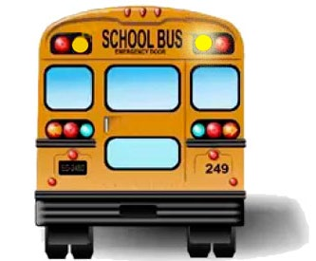
Yellow flashing lights at the top of a bus indicate the bus is preparing to stop to pick-up or drop-off students. Although you are not required to stop when the yellow lights are flashing, you should be prepared to stop as soon as the bus comes to a complete stop.

NOTE: Please treat the flashing yellow lights the same as a yellow traffic light

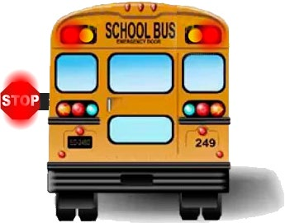
When the bus stops, red lights on top of the bus and on the STOP sign will be flashing, signaling drivers that children are entering or exiting the bus. This may require the children to cross the street. Stop and wait until the red lights stop flashing, the extended STOP sign is withdrawn and the bus begins moving.

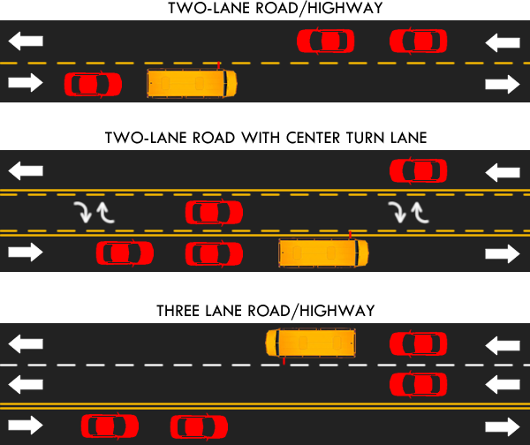
On a road with fewer than four lanes, all traffic must stop regardless of which direction it is heading.

All traffic must stop within 10 feet of the front and back of the bus and remain at a complete stop until the bus begins to move.

This is the most confusing situation for drivers. Likewise, this is the largest problem in the District.
REYNOLDSBURG CITY SCHOOLS
Empowering leaders who impact the NOW and innovate the FUTURE

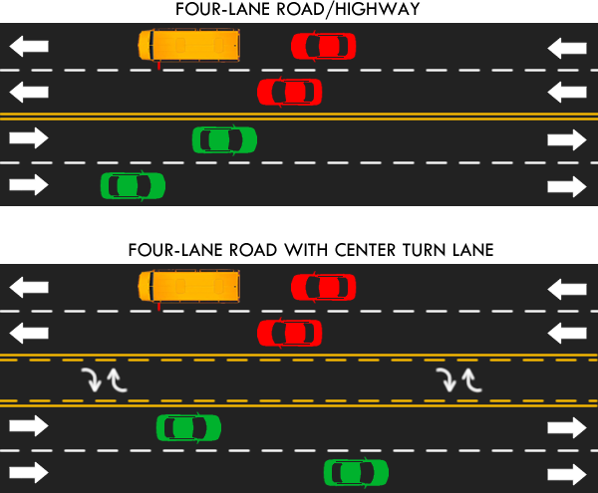
On a road with four or more lanes, only the traffic traveling in the same direction must stop with the bus.

All traffic must stop within 10 feet of the bus and remain at a complete stop until the bus begins to move.

Please keep these additional tips in mind as you are on the road:

● Never pass a school bus on the right
● All school buses must stop before crossing railroad tracks ● Never pass a bus at a railroad crossing
● Be aware of school zone signals and always obey the posted speed limits

Leave a little early so you are not rushed as you travel

Failure to comply to bus stop laws and rules can result in a series of penalties including points on your license, fines and license suspension. Injuries that occur due to disobeying the law can result in criminal charges and civil liability.

Please take a few moments to review the above information with all the drivers in your family. Thank you for your help in keeping the students of our District safe as they travel to and from school.

