

HOW CAN YOU SUPPORT YOUR CHILD IN AND OUT
OF SCHOOL.

Social networking and building a
community Increase self-worth
SOCIOEMOTIONAL
BENEFITS OF Increase feeling “heard”
SOCIAL MEDIA

Connecting with friends/family

Increased exposure to other worlds
HEALTHY VERSUS UNHEALTHY USE OF SOCIAL MEDIA

Healthy

Maintaining reasonable hours

Connecting online and in person

Maintaining balance between social media, home, and school
Unhealthy

Being on the phone/computer all night Only connecting with others online
Distracting from school and family obligations

Interrupted sleep patterns
Increased anxiety

WARNING SIGNS &
BEHAVIORS TO LOOK FOR:

Negative social media

Extreme mood changes
Lack of insight into owns feelings, behavior or personality

Confused thinking or problems concentrating
Changes in eating habits and lack of appetite

Feeling excessively sad or low
Not caring about learning, friends or school

Excessive angry or bulling

Thinking/talking/writing about suicide
Somatic complaints (headaches, stomach aches, etc.)

4




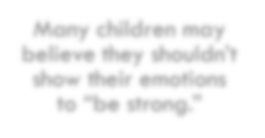

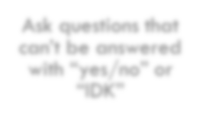

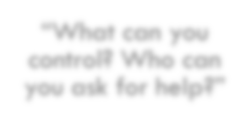

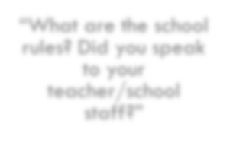


GET THEM TO TALK

Many children may
believe they shouldn’t show their emotions
to “be strong.”

“What can you
control? Who can
you ask for help?”
Ask questions that
can’t be answered with “yes/no” or
“IDK”

“What are the school
rules? Did you speak to your
teacher/school
staff?”

“Tell me what has
been the hardest
part for you”
WHY IS IT IMPORTANT TO HELP YOUR KIDS CONNECT?


There is no more effective neurobiological intervention than a safe relationship" -- Bruce Perry, PhD, MD, researcher & child psychiatrist

Relationships bring our brain back into regulation Remember to connect before you redirect

Having a trusted adult is a significant to building resiliency. It models co-regulation
During times of crisis many communities look for “the helpers” for support. You could be their main source of support and information.
You can help with providing some normalcy, structure and providing resources and information

Be creative and flexible with strategies



PROTECTIVE FACTORS

High self esteem

Rules and limits set in the home


Physical and psychological safety

Emotion regulation abilities

Clear expectations and structured environments

Adequate housing

Good coping and problem-solving skills

Supportive relationships with family members

Access to health care
Sense of belonging in school, community, spiritual and/or culture

Presence of mentors/ role model

Positive Self Talk





HOW TO PROVIDE SUPPORT

BE SPECIFIC

ASK PERMISSION TO PROVIDE ADVICE
ARE THERE OTHER DYNAMICS THAT ARE OR COULD EXACERBATE THEIR CONFLICT?
DON’T ALWAYS TRY TO FIX IT. HAVE THEM BRAINSTORM AN ANSWER.
HOW TO RESPOND TO URGENT CONCERNS OF CHILD SAFETY IMMEDIATELY.
EMOTIONAL CHECK-INS

PHONE APP’S THAT SUPPORT STUDENTS

Phone App’s for
Anxiety/Stress

• Moods

• Breath

• Calm

• Headspace

• Stop, Think,
Breath

• Worry Watch

• Colorfy

• Breath2Relax • Sleep Time • What’s Up?

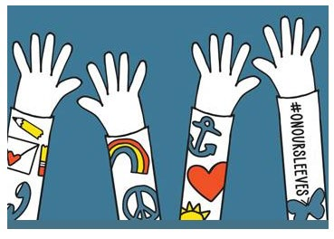

How to Get Involved

Sign up | Sign up to receive On Our Sleeves updates and resources  at https://www.onoursleeves.org/get-involved/sign-up

Learn | Learn how to advocate for children’s mental health responsibly at https://www.onoursleeves.org/get-  involved/advocate

Educate | Educate yourself on how to talk to your kids about mental health at https://www.onoursleeves.org/find-  help/support/how-to-talk-to-your-kids-about-mental-health

10

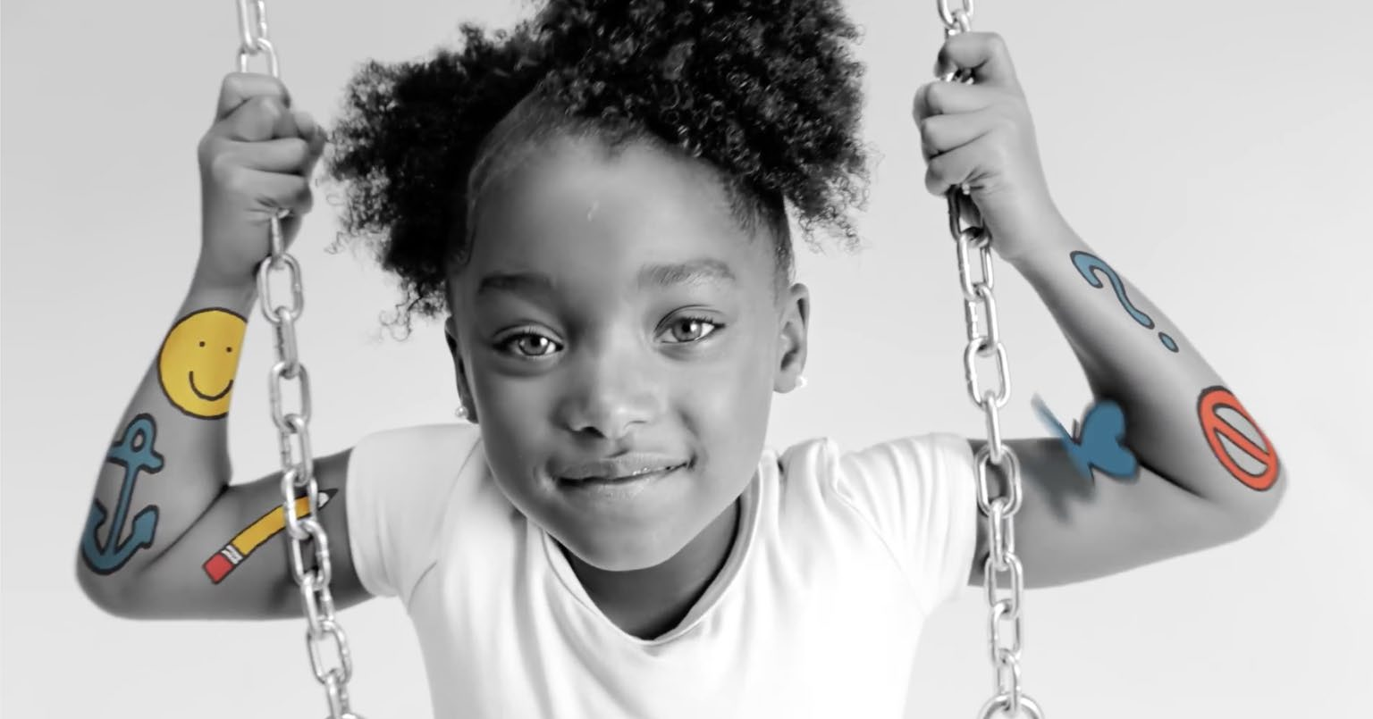
Thank You for What You Do!

• Aden Moges LISW-S BH Clinical Lead Supervisor: Aden.Moges@nationwidechildrens.org 614-935-8516

11

